Test Yourself: HDFS Command Line

Problem Statement: Using Command line of HDFS, perform following tasks.

- Create a directory /hadoop/hdfs/ in HDFS
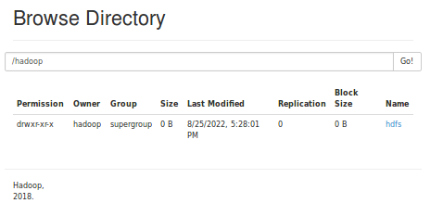
- Create a temp directory in Hadoop. Run HDFS command to delete “temp” directory.
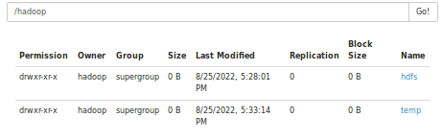
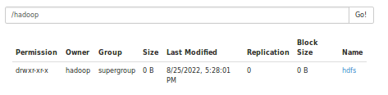
- List all the files/directories for the given hdfs destination path.
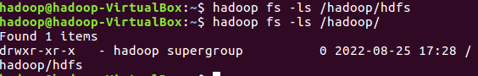
- Command that will list the directories in /hadoop folder.
- Command to list recursively all files in hadoop directory and all subdirectories in hadoop directory
- List all the files inside /hadoop/hdfs/ directory which starts with 'dir'.
- Create a temp.txt file. Copies this file from local file system to HDFS
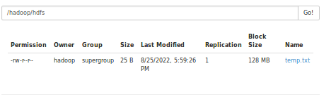
- Copies the file from HDFS to local file system.
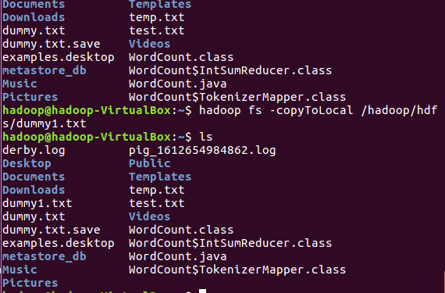
- Command to copy from local directory with the source being restricted to a local file reference.
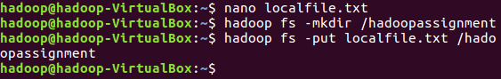
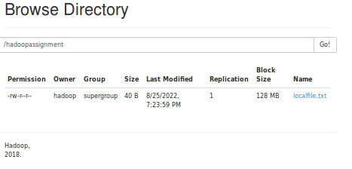
- Command to copies to local directory with the source being restricted to a local file reference.
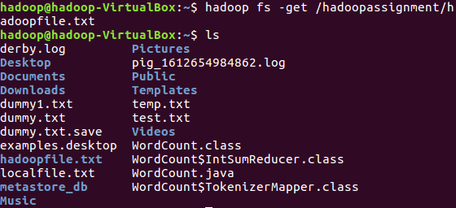
- Command to move from local directory source to Hadoop directory.
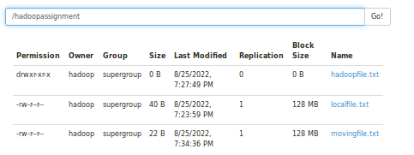
- Deletes the directory and any content under it recursively.
- List the files and show Format file sizes in a human-readable fashion.
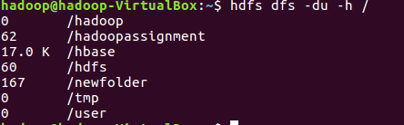
- Take a source file and outputs the file in text format on the terminal.
- Display the content of the HDFS file test on your /user/hadoop2 directory.
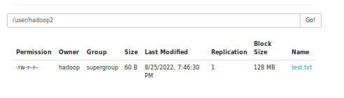
- Append the content of a local file test1 to a hdfs file test2.
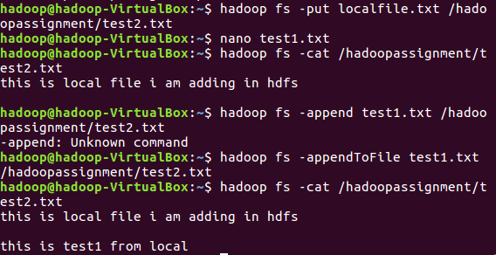
- Show the capacity, free and used space of the filesystem
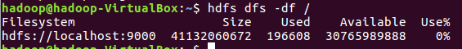
- Shows the capacity, free and used space of the filesystem. Add parameter Formats the sizes of files in a human-readable fashion.
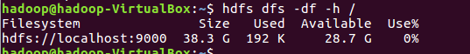
- Show the amount of space, in bytes, used by the files that match the specified file pattern.
- Show the amount of space, in bytes, used by the files that match the specified file pattern. Formats the sizes of files in a human-readable fashion.
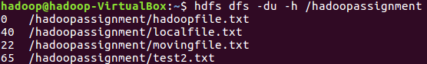
- Check the health of the Hadoop file system.
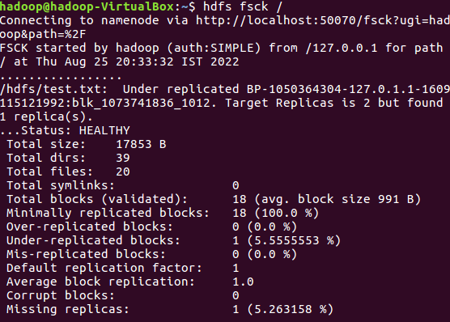
- Command to turn off the safemode of Name Node.
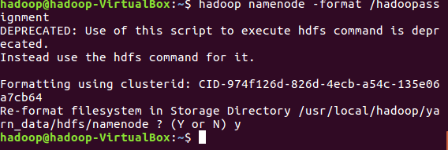
- HDFS command to format NameNode.
- Create a file named hdfstest.txt and change it number of replications to 3.
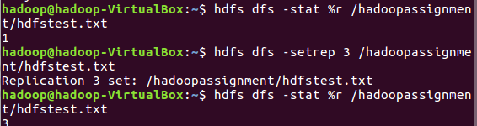
- Write command to display number of replicas for hdfstest.txt file.
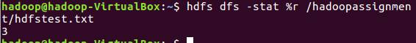
- Write command to Display the status of file “hdfstest.txt” like block size, filesize in bytes.
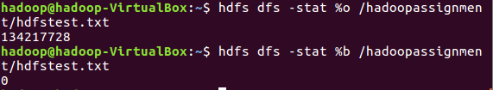
- Write HDFS command to change file permission from
rw – r – r to rwx-rw-x for hdfstest.txt.
