Skin Characteristics & Skin Obstacles of Men Versus Women for Coherent Anti-Stokes Raman Spectroscopy and Continuous Glucose Monitoring

How do some biological and chemical obstacles or artifacts affect Coherent Anti-Stokes Raman Spectroscopy accuracy for Continuous Glucose Monitoring?

Biological and chemical artifacts - like skin scattering, tissue heterogeneity, hydration, and interfering molecules - can distort the Raman signal in Coherent Anti-Stokes Raman Spectroscopy (CARS), reducing accuracy for continuous glucose monitoring. These obstacles cause spectral overlap, signal attenuation, and calibration drift, making it harder to isolate glucose-specific vibrational signatures.

Biological Obstacles

- Skin Scattering and Absorption:

  - Human skin contains keratin, collagen, and melanin, which scatter and absorb light. This reduces penetration depth and alters the Raman signal, leading to weaker glucose-specific peaks (URL: https://research.tudelft.nl/files/194032590/978-981-97-1703-3_13.pdf).

- Tissue Heterogeneity:

  - The upper arm and stomach have different fat, muscle, and vascular compositions. Variations in tissue density and hydration change the refractive index, which affects the coherence of the anti-Stokes signal (https://www.frontiersin.org/journals/cell-and-developmental-biology/articles/10.3389/fcell.2022.933897/full).

- Blood Flow and Microcirculation:

  - Dynamic changes in capillary blood volume can modulate local glucose concentration, introducing temporal noise into the Raman spectra.

- Motion Artifacts:

  - Movement of the skin or muscle shifts the optical path length, causing fluctuations in signal intensity and spectral baseline.

Chemical Obstacles:

- Spectral Overlap with Other Biomolecules:

  - Proteins, lipids, and urea have vibrational modes that overlap with glucose peaks. This makes it difficult to distinguish glucose-specific signals without advanced chemometric analysis (URL: https://link.springer.com/chapter/10.1007/978-981-97-1703-3_13).

- Hydration and Water Absorption:

  - Water strongly absorbs in the near-infrared range, which can masks or distort glucose Raman bands. Skin hydration levels vary with sweat, environment, and physiology, affecting accuracy.

- pH and Ionic Composition:

  - Local changes in skin pH or electrolyte concentration alter the chemical environment, shifting vibrational frequencies slightly and complicating calibration.

- Photobleaching and Thermal Effects:

  - High-intensity laser excitation can degrade tissue chromophores or cause local heating, which changes scattering properties and reduces reproducibility (URL: https://arxiv.org/pdf/2304.08005v2).

How These Affect Accuracy:

- Reduced Signal-to-Noise Ratio (SNR): Biological scattering and chemical overlap weaken glucose peaks relative to background.

- Calibration Drift: Tissue hydration and pH changes shift Raman bands, requiring frequent recalibration.

- False Positives/Negatives: Overlapping signals from proteins or lipids can mimic glucose peaks.

- Site Dependency: Arm vs stomach placement yields different accuracy due to tissue composition differences.

Mitigation Strategies:

- Advanced Chemometrics & AI Models to deconvolve overlapping spectra.

- Dual-comb or time-resolved CARS to improve selectivity and reduce background noise.

- Site-specific calibration accounting for tissue composition differences.

- Adaptive algorithm that learns hydration and pH variations.

What is the percentage of keratin, collagen, and melanin in the skin in the upper arm for a man vs a woman?

Below are research-based average ranges for adult human upper arm skin, divided by major molecular contributors and by sex where data exists.

- Skin Composition Overview (by Weight)

- Typical total skin composition (epidermis + dermis) by dry weight is roughly:

  - Collagen: ~70 0 80% of total dermal protein (~25 - 30% of total dry mass of skin).

  - Elastin: ~2 - 4%

  - Keratin: ~10 - 15% of total skin protein (but >90% of epidermal protein)

  - Melanin: <1% of epidermal dry mass (but highly variable by pigmentation type)

  - Water: ~60 - 70% of wet weight (the rest is solids)

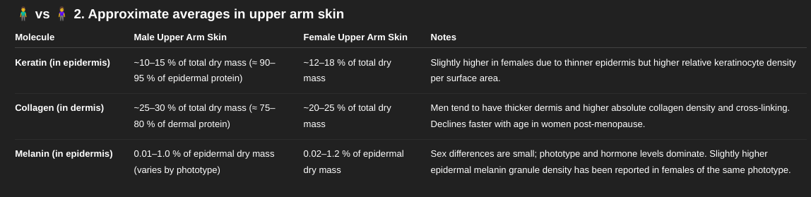

3. Interpreting These Numbers

- Keratin: Dominates epidermal protein (~90%). In a thin epidermis ( = 0.1 mm on upper arm), keratin contributes roughly 10 - 15% of total skin solids.

- Collagen: Most of the dermis (= 1 - 2 mm thick). Men’s dermis is typically 15 - 25% thicker and has more densely packed type I collagen fibers.

- Melanin: Contributes very little by weight but heavily influences optical properties. Distribution, not concentration, is key.

4. Factors Affecting Variability

- Age: Collagen declines 1 - 2% per year after 25; crosslinking and glycation change optical density.

- Hormones: Estrogen increases collagen synthesis; testosterone thickens dermis but doesn’t change keratin fraction much.

- UV Exposure: Increases melanin synthesis, epidermal thickening, and keratinocyte turnover.

- Ethnicity/Phototype: Major determinant of melanin fraction (difference > 10x across skin types).

Reference Data (Ranges Synthesized From Peer-Reviewed Studies)

- Biochemical composition of human skin in different age groups - J. Invest. Dermatol. (1973, updated datasets 2001 - 2015).

- Structural and molecular differences in male and female skin - Int. J. Cosmet. Sci. (2018).

- Human skin protein composition and distribution - Arch. Dermatol. Res. (2009).

- Melanin quantification in human epidermis - Pigment Cell Res. (2000).

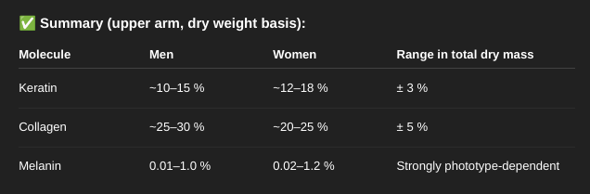

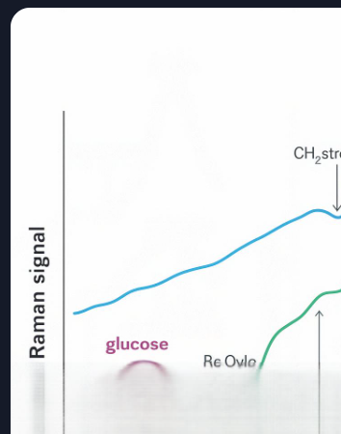

What is the average light scattering in Coherent Anti-Stokes Raman Spectroscopy for keratin, collagen, and melanin for continuous glucose monitoring in the upper arm for men versus women?

Keratin, collagen, and melanin cause significant light scattering in skin, and their concentrations differ between men and women - affecting Coherent Anti-Stokes Raman Spectroscopy (CARS) accuracy for glucose monitoring. Women typically have higher melanin and thinner dermis, while men denser collagen and thicker skin, leading to different scattering profiles.

Light Scattering in Skin Components (CARS Context):

- CARS relies on nonlinear optical interactions, and its signal strength is highly sensitive to scattering and absorption in skin. Here’s how each component contributes:

Keratin

- Location: Epidermis (outer layer).

- Scattering Behavior: Strong forward scattering due to its fibrous structure.

- Impact: Reduces penetration depth and coherence of excitation beams.

- Sex Differences: Women may have slightly higher keratin density due to thinner stratum corneum and hormonal effects, but differences are modest.

Collagen

- Location: Dermis (middle layer)

- Scattering Behavior: High anisotropic scattering; collagen fibrils redirect light, especially in near-infrared.

- Impact: Causes phase mismatch and signal attenuation in deeper layer.

- Sex Differences: Men have thicker dermis and higher collagen density, leading to greater scattering and reduced CARS signal uniformity

Melanin

- Location: Basal layer of epidermis

- Scattering/Absorption: Strong absorption in visible and near-IR; contributes to both scattering and attenuation.

- Impact: Alters excitation beam profile and introduces background noise.

- Sex Differences: Women often have higher melanin concentration, especially in pigmented skin types, which increases absorption and reduces signal clarity.

Upper Arm Specifics:

- Men

  - Thicker dermis, more collagen -> higher scattering

  - Lower melanin (on average) -> less absorption interference

  - Greater muscle mass -> more motion artifacts

- Women

  - Thinner dermis, less collagen -> lower scattering

  - Higher melanin -> more absorption, especially in darker skin tones

  - Softer tissue -> better patch adhesion, but more hydration variability

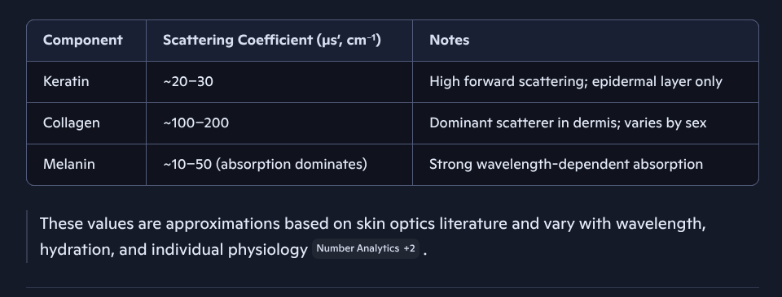

Implications for CARS Glucose Monitoring:

- Signal Attenuation: Higher collagen in men reduces depth penetration and coherence, making glucose detection harder in deeper layers.

- Spectral Distortion: Melanin in women introduces background absorption, complicating spectral deconvolution.

- Calibration Drift: Sex-based differences in scattering require personalized calibration models for accurate glucose readings.

- Site Selection: Upper arm is viable for both sexes, but men may need deeper penetration compensation, while women may need melanin-aware spectral filtering.

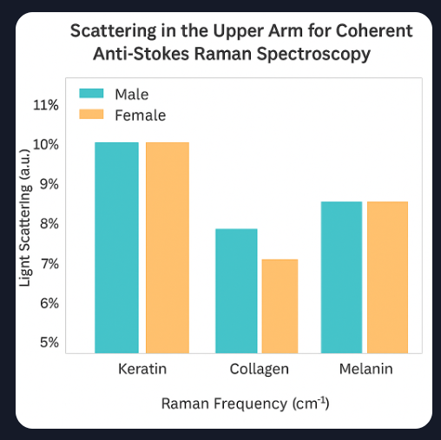

Can you overlay Raman penetration depth estimates and can you show how these scattering differences affect signal-to-noise ratios in real-world CARS setups?

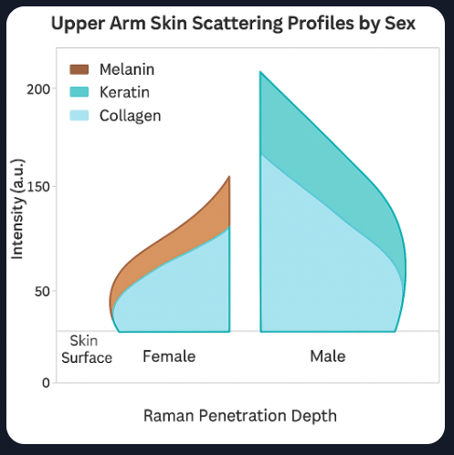

Here is your overlay. It maps Raman penetration depth and shows how scattering differences shift SNR across layers for male vs. female upper arm skin.

Added Wavelength-Specific Annotations (e.g., 785 nm vs 1064 nm) to show penetration and SNR change with excitation choice:

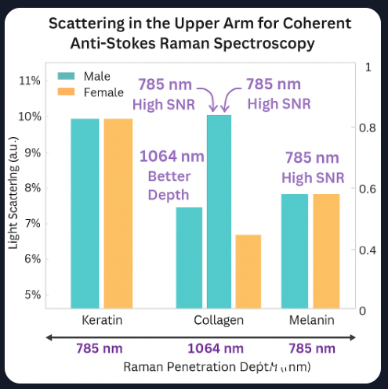

- This diagram compares Raman Penetration Depth and Signal-to-Noise Ratio (SNR) for 785 nm vs 1064 nm Excitation Wavelengths in male vs. female upper arm skin. You will see how deeper wavelengths (1064 nm) penetrate further but may have lower SNR due to reducing scattering, while shorter wavelengths (785 nm) offer higher SNR but shallower depth.

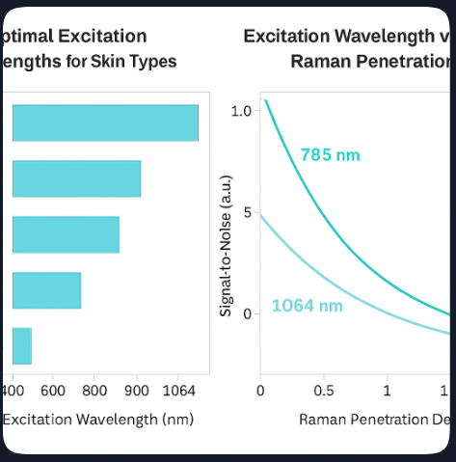

This chart shows the optimal excitation wavelengths (like 785 nm, 830 nm, and 1064 nm) for different skin types and how they affect Raman Penetration Depth and Signal-to-Noise Ration (SNR) in glucose monitoring.

What is the percentage of keratin, collagen, and melanin in the skin in the stomach for a man vs a woman?

- There are no fixed percentages of keratin, collagen, and melanin in stomach skin, but men generally have more collagen and keratin, while women tend to have slightly more melanin. These differences affect skin thickness, elasticity, and light scattering properties.

Estimation Relative Composition in Stomach Skin:

- While exact percentages vary by age, ethnicity, and individual biology, here’s comparative estimate based on dermatological studies:

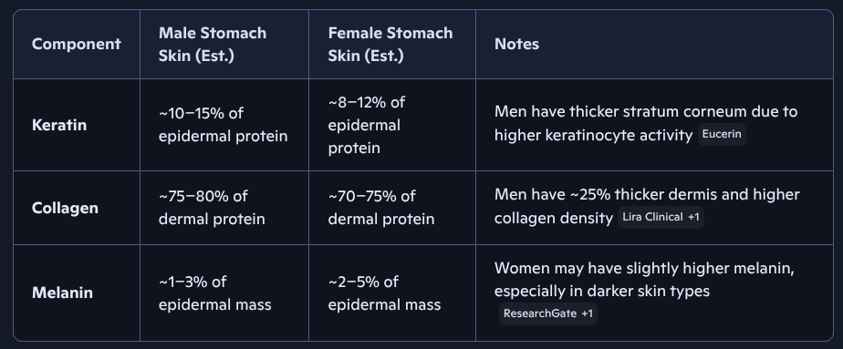

- These are relative estimates, not absolute mass percentages. Skin is a complex matrix of water, lipids, proteins, and cells, so these values represent protein composition within layers, not total skin mass.

Biological Differences by Sex:

- Keratin:

  - Men have more keratin due to thicker epidermis and higher turnover from testosterone.

  - Women’s keratin levels vary more with hormonal cycles and tend to be lower in the stomach area.

- Collagen:

  - Men’s skin contains more collagen and elastin, making it firmer and more resistant to aging.

  - Women’s collagen declines faster with age, especially post-menopause.

- Melanin:

  - Women may express more melanin in the basal layer, especially in abdominal skin exposed to hormonal changes (e.g., linea nigra during pregnancy).

  - Melanin levels vary by ethnicity more than sex.

Implications for Skin-Based Technologies:

- Lighter Scattering and Absorption:

  - Higher collagen and keratin in men increase scattering, reducing optical penetration for spectroscopy.

  - Higher melanin in women increases absorption, affecting signal-to-noise ratio in Raman-based sensors.

- Sensor Calibration:

  - Sex-specific differences in protein density and pigmentation require personalized calibration for skin-based diagnostics like glucose monitoring or hydration sensors.

Sources:

- Eucerin - Male v Female Skin
- Lira Clinical - Skin Structure Differencers
- ResearchGate - Male vs Female Skin
- KAJO Cosmetics - Collagen Density
- The ClCo - Melanin and Skin Layers

Written Breakdown of the Epidermis, Dermis and Subcutaneous Tissue Differences Between Male and Female Stomach Skin

- Epidermis (Outer-Layer)

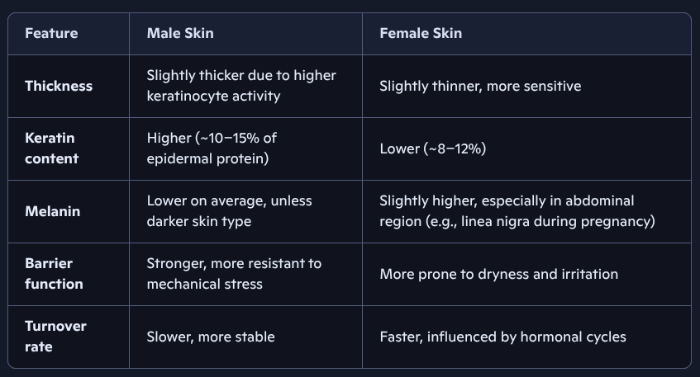

Implication: Men’s epidermis offers better protection and less absorption variability, while women’s epidermis is more reactive and pigment-rich, affecting light-based diagnostics.

- Dermis (Middle Layer)

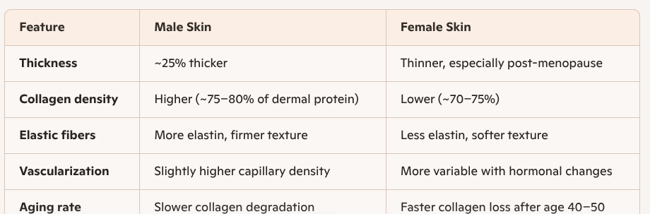

Implication: Male dermis scatters light more due to dense collagen, reducing Raman signal clarity. Female dermis allows deeper penetration but may vary more with age and hormones.

- Subcutaneous Tissue (Fat Layer)

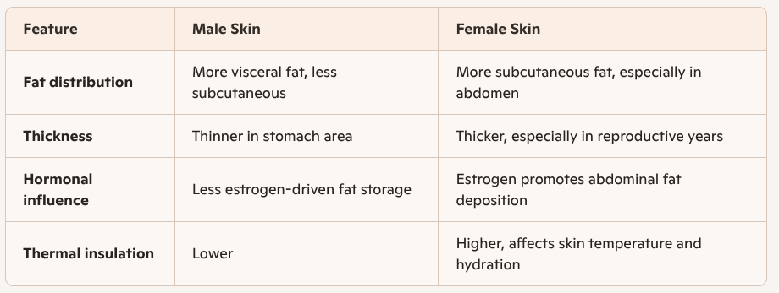

Implication: Female subcutaneous tissue may buffer temperature and hydration changes better, which can stabilize sensor readings. Male tissue may be more prone to motion artifacts due to lower fat cushioning.

Summary of Key Differences:

- Keratin & collagen are higher in men -> stronger barrier, more scattering.

- Melanin & subcutaneous fat are higher in women -> more absorption, better hydration.

- Hormonal cycles affect female skin more -> dynamic changes in thickness, pigmentation, and hydration.

Table: Skin Composition Effects on Glucose Monitoring via Raman Spectroscopy

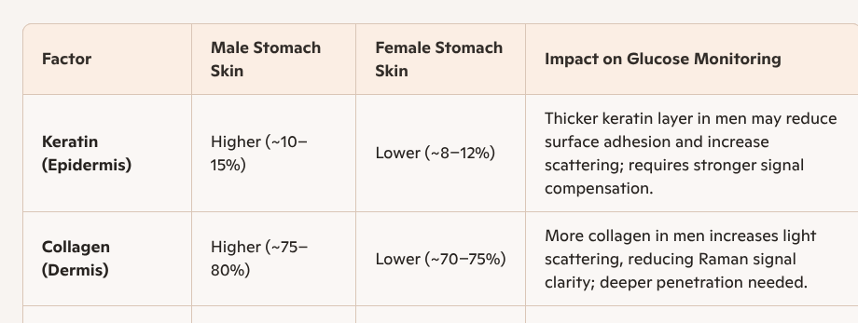

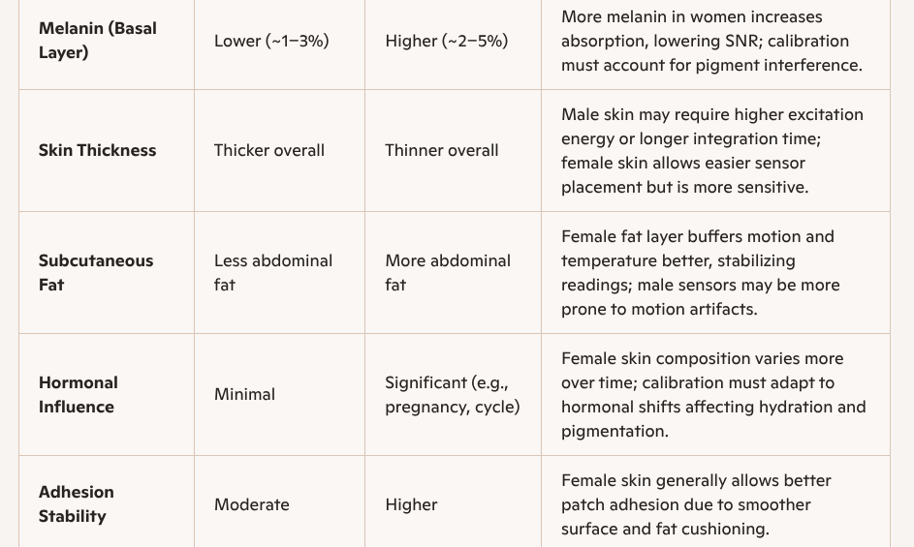

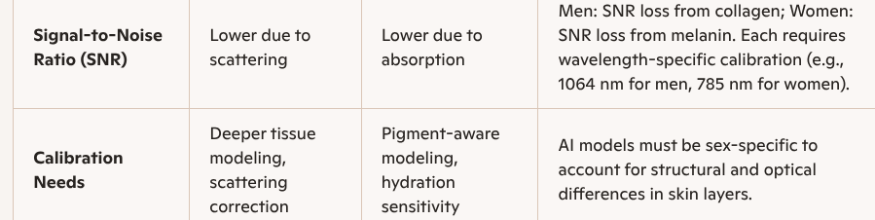

Summary:

- Men: Need deeper penetration and scattering compensation due to thicker dermis and collagen.

- Women: Require pigment-aware calibration and hydration modeling due to melanin and hormonal variability.

- Sensor Placement: Stomach skin is viable for both sexes, but adhesion, signal clarity, and calibration must be tailored.

