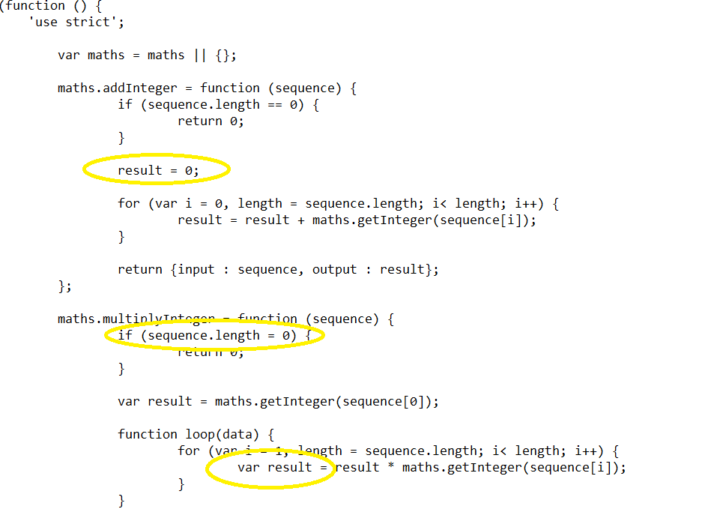

New variable result is declared and assigned instead of using previously declared variable – scope variable error

= is used instead of == where comparison is needed

Undeclared variable

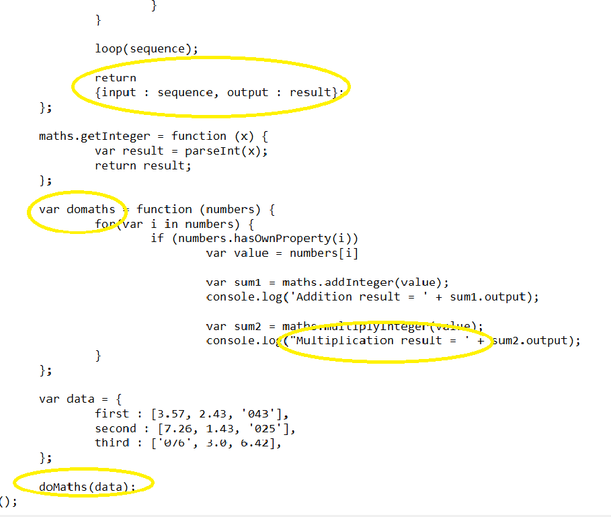

Mismatch in quotes (single quote and double quote used)

Incorrect variable name used while retuning result, variable names are case sensitive

New line space is added after return