**Usability Testing of Journal Websites**

Akshata Balghare

Dr. Stewart Whittemore

ENGL 7010

**INDEX**

**1. Background2**

**2. Purpose2**

**3. Methodology2**

3.1 Research questions2

3.2 Study design3

3.3 Test participants and audience4

3.4 Tasks conducted in the usability test4

**4. Heuristic evaluation results5**

4.1 Journal of vibration and control5

4.2 Formatting documents belonging to the SAGE website6

4.3 IEEE transactions of industry applications (publishing house - IEEE explore)8

4.4 IEEE transactions on communications (publishing house - IEEE communication society)9

**5. Findings11**

5.1 Results for Tasks 1–3 of Participant 111

5.2 Results for Tasks 1–3 of Participant 212

5.3 Results for Tasks 1–3 of Participant 313

5.4 Results for Task 4 by Participants 1, 2, and 315

**6. Recommendations16**

6.1 Website 1: Journal of vibration and control16

6.2 Website 2: IEEE transactions of industry applications16

6.3 Website 3: IEEE transactions on communications17

6.4 Formatting instructions for the SAGE template17

**7. Conclusion18**

**Appendix 119**

**Appendix 228**

# Background

Getting a paper published is a major milestone in the life of an academician, and publishing a paper has always been a laborious and time consuming task. Having said that, publishing a paper demands a level of professionalism in writing and organizing data. Having an exceptional research topic is not enough; the way the paper is presented matters to a great extent, and in turn affects publication chances. Almost every journal has its own paper formatting standards, and if these standards are not met, the paper has less chances of being accepted. Many academic writers struggle with the formatting task, which leads to too much back and forth between them and the reviewers of the publishing house. This formatting struggle starts right from searching formatting instructions on the journal website, to accurately applying the instructions in the paper.

# Purpose

On a journal website, there could be several links indicating guidelines, and identifying the correct link is difficult. The guidelines may be located in a path or web page that is too complicated to find. In addition, following and implementing the formatting instructions could also be a grueling task. Hence, in this study, I have attempted to focus on two things: evaluate time and effort that academic writers take to locate formatting guidelines on a journal website (thus find out the user friendliness of the website); and evaluate comprehensibility of the formatting instructions (thus find out how useful and usable the content is). This study consists of usability tests conducted on three journal websites and on a set of formatting instructions from one of the three websites. Note that I have used the word “guideline” to indicate direction provided on the website to locate the information on formatting, and “instructions” to indicate the actual formatting requirements specific to the journal.

# Methodology

## 3.1 Research questions

This study collected qualitative and quantitative data to answer several research questions, including:

1. Findable - How well do these websites support users’ ability to locate formatting guidelines?
2. Accessible - Can users effortlessly navigate to locate what they are looking for, and can they accomplish their tasks quickly and efficiently? How many and which particular paths do they take to successfully reach the page containing guidelines?
3. Useful - Do users understand the content and does it help them accomplish their tasks? Are there ambiguous directions on the page?
4. Usable - Once users locate the guidelines, do they feel the instructions are comprehensible? Are they able to accurately follow the formatting instructions? Are they able to successfully apply those formatting styles?
5. Credible and valuable - What are users’ overall impressions about the website? Does it adequately communicate how users are required to navigate and utilize the website?

## 3.2 Study design

I conducted an in-person usability study in order to gather insights into user performance and unmet needs. I performed this usability test on the following three journal websites:

1. Journal of vibration and control (SAGE Publications): http://jvc.sagepub.com/
2. IEEE transactions of industry applications (Publishing house - IEEE Explore): http://ieeexplore.ieee.org/xpl/RecentIssue.jsp?punumber=28
3. IEEE transactions on communications (Publishing house - IEEE communication society): http://www.comsoc.org/tc

I chose these websites because my participants were from the field of engineering, particularly industrial engineering.

I conducted the study in the IDEA (instruction in design, evaluation, and accessibility) Lab located in Auburn University’s Department of English. Using a video camera with tripod and Morae software, I collected information such as time on task, areas of concern, and unmet needs. **I requested the participants to accomplish two tasks: locate formatting guidelines on the three journal websites; and use the formatting template document from the SAGE publications website to format a sample research paper.** I used this template for the test particularly because I believe it has partly ambiguous instructions. Usability testing of the formatting document eventually aided in understanding the level of ambiguity of the instructions.

## 3.3 Test participants and audience

I conducted this study with three participants who are graduate engineering students. I chose to test with participants from the field of engineering because engineering students and researchers often publish papers to demonstrate their findings in the evolving world of technology. Moreover, it has always been debated that engineers have poor writing and formatting skills because they primarily focus on producing results. This study is directed toward journal publishers who deal with formatting of papers, and toward journal website developers.

## 3.4 Tasks conducted in the usability test

At first, I requested the three participants to sign consent forms for the test. I gave them a pretest and a post-test questionnaire (see Appendix 1). After they filled the pretest questionnaire, I gave them the following instructions:

### Use Google to accomplish the below:

Task 1: Locate formatting instructions on journal website 1: Journal of vibration and control, SAGE publications

Task 2: Locate formatting instructions on journal website 2: IEEE transactions of industry applications, publishing house - IEEE Explore

Task 3: Locate formatting instructions on journal website 3: IEEE transactions on communications, publishing house - IEEE Communication Society

### Review formatting instructions provided on all three journal websites to determine which one seems easier to comprehend and follow. Note the observations.

### Task 4: Open the formatting template provided by SAGE publications (website 1). Follow instructions in the templates and apply those on the sample research paper.

# Heuristic evaluation results

Following is my expert usability review for the three websites as well as the formatting template from SAGE publications. For this review, I used the ten heuristics designed by Jacob Nielsen.[1]

## 4.1 Website 1: Journal of vibration and control (SAGE publications)

For locating formatting instructions on this website, one must start by clicking “Submit a Manuscript” tab. A user may easily overlook this tab because the terminology “Submit a Manuscript” suggests that it is the last step in the process to upload a paper. Figure 1 shows a screenshot of the webpage for the journal of vibration and control. The encircled part denotes the first step in locating the formatting instructions. Table 1 states the heuristic evaluation results.

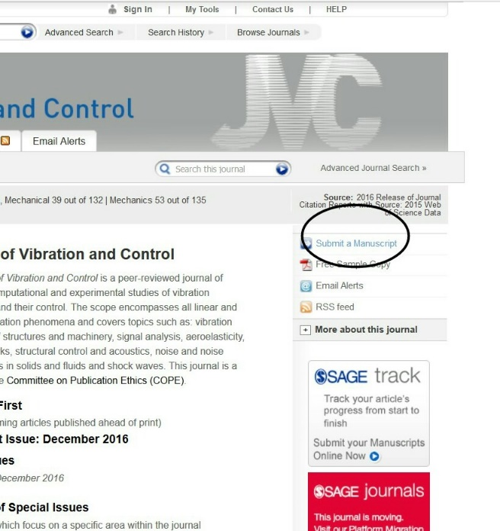

Figure 1. Screenshot of the webpage for the journal of vibration and control

Table 1. Heuristic evaluation of the webpage for the journal of vibration and control

| **Heuristic parameters** | **Expert evaluation** |
| --- | --- |
| Visibility of system status | Webpages open in a timely manner. |
| Match between system and real world | Information needs to be filtered. Information such as publication ethics, journal layout, other style guides (ACS, AMA, ASA, CSE) etc. may cause confusion to the users when looking for the formatting template. |
| User control and freedom | There is a single way to locate the formatting instructions.Users tend to go back and forth leading them to end up in a loop. |
| Error prevention | Account creation process is smooth except for personal information section where users are supposed to enter the name of their institution, since the drop down does not list all institutions. However, there is a feedback tab, where this issue can be reported. |
| Consistency and standards | Not all users are familiar with the ACS, AMA, ASA, CSE etc. styles; also, not all users need those styles.Extraneous information may make the formatting task look daunting. |
| Recognition rather than recall | Site can be easily navigated, but locating the exact webpage containing formatting instructions is bewildering because of information overload. |
| Flexibility and efficiency of use | There is a single way to locate formatting instructions. Webpages load quickly. |
| Aesthetic and minimalist design | Overall look is nice.Extraneous information present. |
| Help user recognize, diagnose, and recover from errors | Error messages are timely. |
| Help and documentation | Page contains easy to follow steps. |

## 4.2 Website 1: Formatting documents belonging to the SAGE website

For the journal of vibration and control, there are two Word documents containing formatting instructions. Document 1 is short, and the link to it is labeled “Word template.” It lists the steps for changing style settings in a Word file. However, user must know to start with “Styles” tab under the “Home” menu in order to change style settings; other formatting changes can only be made if the change in style settings is achieved. Document 2 is long; it has an exhaustive list of formatting instructions, and the link to it is labeled “Guidelines.” The document shows step by step directions using pictures to change style settings. Figure 2 shows a screenshot of document 2. In the picture, the MS Word version is outdated; specially, the “Tools” tab does not exist anymore. It is difficult to understand the connection between document 1 and document 2. Table 2 lists the heuristic evaluation results for these two documents.

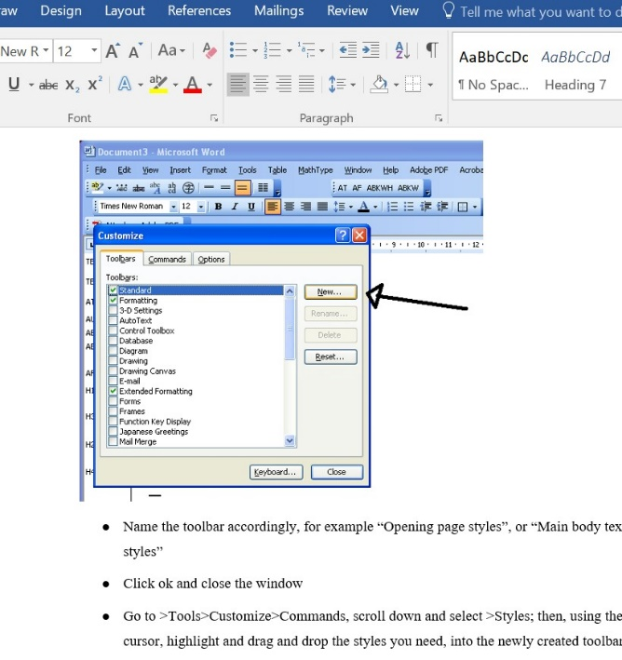

Figure 2. Screenshot of document 2 containing formatting instructions for the journal of vibration and control

Table 1. Heuristic evaluation of the two documents containing formatting instructions for the journal of vibration and control

| **Heuristic parameters** | **Expert evaluation** |
| --- | --- |
| Match between system and real world | Shortcuts and directions mentioned in the instructions do not seem to work on a newer version of MS Word. Overload of information; directions are overwhelming because not everyone is familiar with changing style settings. |
| Consistency and standards | There is no information that explains the relation between the two Word documents. The formatting documents do not look like regular formatting templates. |
| Recognition rather than recall | Users try to follow and compare both Word documents in parallel in an effort to understand their connection. In the second Word document, users scroll up and down to try and comprehend the exhaustive list of instructions. |
| Aesthetic and minimalist design | Considering document design principles, the look is fine. However, the list of instructions is too long; it results in users tending to skip important instructions in the document. |

## 4.3 Website 2: IEEE transactions of industry applications (publishing house - IEEE explore)

This website is user friendly; user is taken to the formatting template in a few clicks. Figure 3 shows a screenshot of the webpage for IEEE transactions of industry applications. The encircled part denotes the first step in locating the instructions. A user must click the “Author Digital Toolbox” tab to reach the formatting instructions. Table 3 states the heuristic evaluation results.

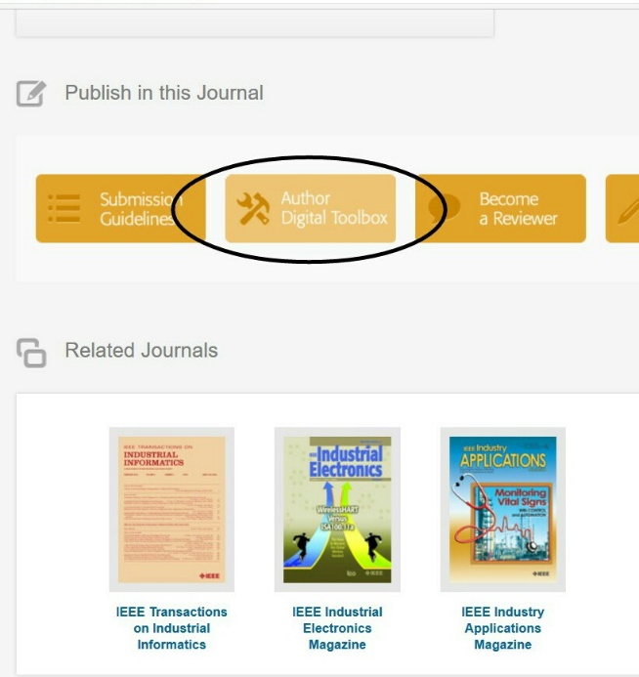

Figure 3. Screenshot of the webpage for IEEE transactions of industry applications

Table 3. Heuristic evaluation of the webpage for IEEE transactions of industry applications

| **Heuristic parameters** | **Expert evaluation** |
| --- | --- |
| Visibility of system status | Webpages open in a timely manner. |
| Match between system and real world | Language is clear and concise. |
| User control and freedom | Although there are multiple ways to find formatting instructions, the directions are precise.  Rare chances of users ending up in a loop. |
| Error prevention | Account creation process is smooth. Error messages pop up in a timely manner if user encounters failures in accessing account. |
| Consistency and standards | Follows familiar conventions of paper formatting and submission. |
| Recognition rather than recall | Site can be easily navigated. |
| Flexibility and efficiency of use | Multiple ways to locate formatting guidelines.  Webpages load quickly. |
| Aesthetic and minimalist design | Overall look is nice. |
| Help user recognize, diagnose, and recover from errors | Error messages are timely. |
| Help and documentation | Page contains easy to follow steps. |

## 4.4 Website 3: IEEE transactions on communications (publishing house - IEEE communication society)

This website, though is IEEE, is different from IEEE Explore mentioned above. Here, there is no explicit information about the formatting template, and the template is present in a very unusual location. Figure 4 shows a screenshot of a document on the webpage for the journal IEEE transactions on communications. The encircled part denotes the location where the formatting instructions are located. Table 4 states the heuristic evaluation results.

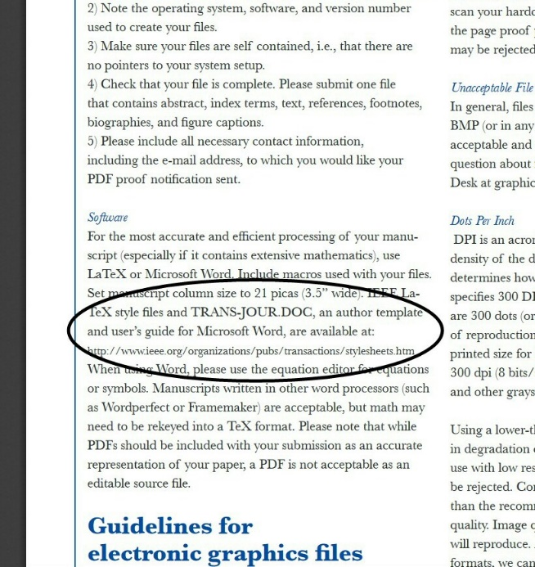

Figure 4. Screenshot of the webpage for IEEE transactions on communications

Table 4. Heuristic evaluation of the webpage for IEEE transactions on communications

| **Heuristic parameters** | **Expert evaluation** |
| --- | --- |
| Visibility of system status | The main link to the formatting template (the one mentioned above in Figure 4) is broken. |
| Match between system and real world | Formatting link in present under a section called “Software” (see Figure 4), which is a very unusual location to place formatting guidelines. |
| User control and freedom | Multiple ways to find formatting instructions.  Users tend to go back and forth leading them to end up in a loop. |
| Error prevention | Account creation process is smooth. Error messages pop up in a timely manner if user encounters failures in accessing account. |
| Consistency and standards | Formatting instructions are present under paths that have unusual names. |
| Recognition rather than recall | Site can be easily navigated. |
| Flexibility and efficiency of use | Multiple ways to locate formatting guidelines.  The main link to the formatting template is broken, otherwise webpages load quickly. |
| Aesthetic and minimalist design | Overall look is nice. |
| Help user recognize, diagnose, and recover from errors | Error messages are timely. |
| Help and documentation | Help and documentation page has easy to follow steps. |

# Findings

Following information and graphs show the time taken by each participant for completing the tasks: Task 1 through Task 4. Appendix 2 includes comments made by the participants while performing the tasks.

## 5.1 Results for Tasks 1–3 of Participant 1

Participant 1 took the least time in completing Task 1 (locating instructions for journal of vibration and control) as compared to the other two participants. Task 2 (locating instructions for IEEE transactions of industry applications) being slightly easier, did not require as much time. Participant 1 took the longest time for Task 3 (locating instructions for IEEE transactions on communications), compared to that of the other two participants. It was noticed that time spent by Participant 1 on websites 1 and 3 was at least 7 minutes each, implying that website 2 was easier to navigate. Figure 5 below shows time taken by Participant 1 for Tasks 1, 2, and 3.

### Errors made in Task 1

Participant 1 clicked on “Free sample copy” assuming it would provide her a template. She ignored the tab “Submit a manuscript” (which contains the guidelines), assuming that would be the last step in paper submission. Later she clicked on two more incorrect links “Journal layout” and “Guidelines for author names.”

### Errors made in Task 2

Participant 1 clicked on “Submit your manuscript” because in Task 1 the guidelines were present under a tab with the same name. However, this website did not have the guidelines placed under “Submit your manuscript.” Next, she clicked on “File requirements” under “Preparing your manuscript” menu.

### Errors made in Task 3

Participant 1 clicked on “Submit a manuscript” because in Task 1 the guidelines were present under a tab with the same name. However, this website did not have the guidelines placed under “Submit a manuscript.” Next, she downloaded a LaTeX template.

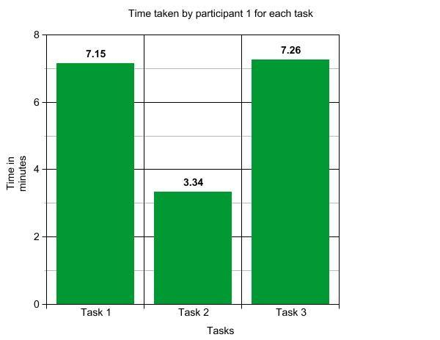

Figure 5. Time taken by Participant 1 for Tasks 1, 2, and 3.

## Results for Tasks 1–3 of Participant 2

Here, for Task 1, it was observed that Participant 2 spent about 10 minutes on website 1, which is too long. For Task 2, the participant downloaded the incorrect template. Thus, she failed to complete the task, and it was the participant’s fault as she did not read the name of the website properly and opened an incorrect one in haste. However, she took the least time for Task 3 in comparison with other two participants. Figure 6 shows time taken by Participant 2 for Tasks 1, 2, and 3.

### Errors made in Task 1

Participant 2 clicked on “Free sample copy” assuming it would provide her a template. She ignored the tab “Submit a manuscript” (which contained the guidelines) assuming that would be the last step in paper submission. Later she clicked on two more incorrect links “Journal layout” and “Style for writing author names.”

### Errors made in Task 2

Participant 2 opened an incorrect website “IEEE Industry applications society” and downloaded an incorrect template “IAS paper template.” I have considered that as an outlier in the study.

### Errors made in Task 3

Participant 2 clicked on “Submit a manuscript” because in Task 1 the guidelines were present under a tab with the same name. However, this website did not have the guidelines placed under “Submit a manuscript.”

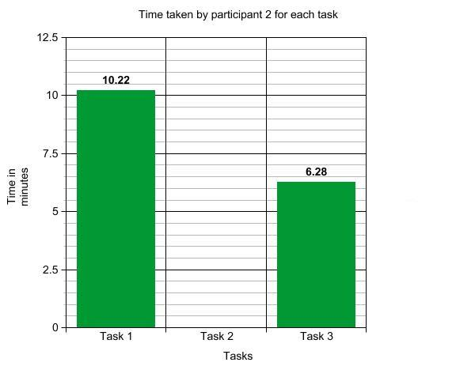

Figure 6. Time taken by Participant 2 for Tasks 1, 2, and 3.

## 5.3 Results for Tasks 1–3 of Participant 3

Participant 3 took slightly less time for Task 1 as compared to Participant 2. Task 2 was easier for this participant as we can see in the graph the task consumed the least time. For Task 3, the Participant 3 took about the same amount of time as Participant 1 did. Here, it was again observed that Participant 3 spent more than 7 minutes on websites 1 and 3, thus indicating that these websites are not easy to navigate as compared to website 2. Figure 7 shows time taken by Participant 3 for Tasks 1, 2, and 3.

### Errors made in Task 1

Participant 3 clicked on “All issues.” Next, he clicked on “Free sample copy.” Further, he clicked on “Submitting your manuscript” and opened the links for “Title, keywords, and abstract.” He went back to the previous page and clicked “Journal layout.”

### Errors made in Task 2

Participant 3 clicked on “Submit your manuscript” because in Task 1 the guidelines were present under a tab with the same name. However, this website did not have the guidelines placed under “Submit your manuscript.”

### Errors made in Task 3

Participant 3 clicked on “Submit a manuscript” because in Task 1 the guidelines were present under a tab with the same name. However, this website did not have the guidelines placed under “Submit a manuscript.”

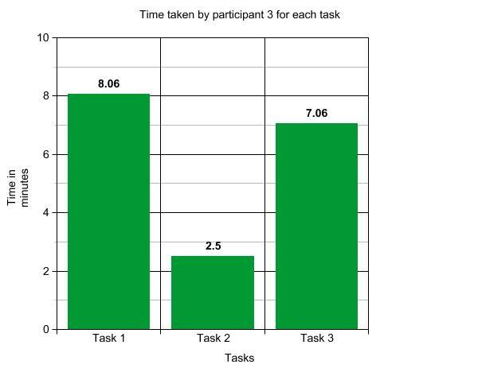

Figure 7. Time taken by Participant 3 for Tasks 1, 2, and 3.

## 5.4 Results for Task 4 (applying the SAGE formatting instructions on a sample paper) by Participants 1, 2, and 3

Following graph in Figure 8 shows the time taken by each participant for completing the formatting task.

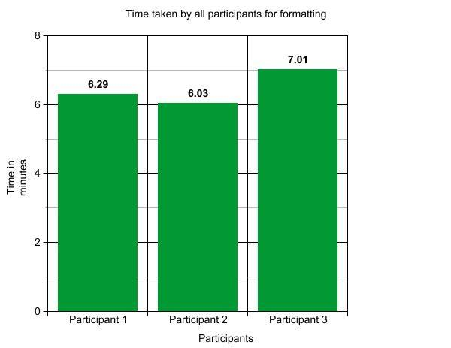

Figure 8. Time taken by each participant for Task 4.

Per the graph, Participant 3 took the longest time in formatting, followed by Participant 1 and then Participant 2. The formatting task was difficult since the instructions in the document were not very clear to the participants. I let them do mere one or two formatting changes in the sample paper because the instructions were too demanding for them. All three participants required help in understanding the formatting instructions. Thus, if the participants were not provided help, they would have taken more time to format.

### Errors made by all participants in applying the SAGE formatting instructions on a sample paper:

None of the participants understood the connection between the two formatting documents on SAGE. They could not have performed this task without help. They were most confused with document 1 that had very few instructions. Participant 1 assumed that document 1 had formatting instructions only for the abstract because it had the word “Abstract” written in large font, and in a prominent red color. In document 2, the participants did not understand the information the table conveyed about paragraph styles. They were more confused with the pictures that explained how to change the style settings, because the pictures showed an older version of MS Word with tabs that do not exist on a newer version of Word.

# Recommendations

The participants gave following recommendations based on their experience of performing the tasks.

## Website 1: Journal of vibration and control (SAGE publications)

1. It was observed that all three participants ignored the tab “Submit a manuscript” because they assumed it would be the last step in manuscript submission. The heading “Submit a manuscript” should be changed. It does not insinuate that it contains formatting guidelines.

# Participants opened links such as “Free sample copy,” “Journal layout,” and “guidelines for author names” because it sounded like the links contain the formatting template. The path to reach the guidelines is complicated; it requires many pages to be opened because participants keep hovering back and forth and clicking on the above-mentioned links. There are many links to various types of guidelines, which may cause confusion. A simple or direct path should be created that has the actual template.

# There are two Word documents that have instructions on formatting. One is named “Word template,” and the other “guidelines.” The Word template made the participants believe that it is a sample paper; hence the word “template” in the name is misleading. This name should be changed because it has mere four to five instructions on changing style settings.

## 6.2 Website 2: IEEE transactions of industry applications (publishing house - IEEE explore)

1. Accessing this website was easier for Participants 1 and 3, so they did not have suggestions for it. Also, they mentioned that the template on this website was comprehensible and clear enough with respect to the formatting instructions.
2. Participants 1 and 3 were able to find the formatting instructions in no time, and they were confident about using the template they downloaded.

## 6.3 Website 3: IEEE transactions on communications (publishing house - IEEE communication society)

### On the webpage, only a LaTeX template has been explicitly stated. Instructions for the Word template should be clearly mentioned.

### The link to a PDF “Guidelines for author supplied electronic text and graphics” at the end of the webpage contains information about formatting instructions, but it does not give direct indication that it contains information about formatting. This link should specify that it has the information for formatting.

### The PDF has a section with the heading “Software.” This section has a link that suggests it contains the formatting template. However, the link is broken and should be fixed. The heading “Software” should be changed since it is misleading, as users overlook it thinking it may not be related to formatting instructions.

## 6.4 Formatting instructions for the SAGE template

1. Participants initially downloaded the “Word template” file and ignored the “guidelines” file. When they opened it, they were confused looking at the mere four to five instructions. They had to be told that both files must be used; however, they did not understand the relation between the two files. The instructions on the webpage should explain the relation between the two files, while also stating that both files must be used.
2. The instructions on how to change setting of the Styles tab is shown in the form of a picture which shows an older version of MS Word. These instructions are obsolete, and should be updated to comply with newer versions of MS Word.
3. Very few people know how to change these settings, so additional pictures that show step-by-step instructions should be inserted.
4. The shortcut Alt+Ctrl+Shift+5 mentioned in the “Word template” file does not work. This should be fixed as per newer version of MS Word, or perhaps should be updated to the latest.
5. There is too much information in the “guidelines” file, and the participants looked worried after scrolling through the entire file. The content should be checked for redundancy, and important and necessary formatting changes should be highlighted.

# Conclusion

# All three participants had utmost difficulty using website 1, journal of vibration and control, because the terminology used on the website was confusing for them. They faced similar issues with website 3, IEEE transactions on communications. Website 2, IEEE transactions of industry applications, was easier to navigate as the terminology was easy to comprehend. Next, the SAGE template had outdated instructions. Moreover, the instructions were exhausting.

# Formatting instructions on journal websites should be easily accessible and understandable because users do not want to invest time in finding and/or comprehending the instructions, and be able to effortlessly apply required formatting on their papers. Thus, international journals should ensure the following to enhance user experience on the websites:

# Formatting instructions are easily searchable and accessible such that academicians spend less than five minutes to get to such information on the journal website.

# The instructions are comprehensive, useful, and easily implementable by the academicians for them to comply with the guidelines and standards of the journal.

# Guidelines are credible and valuable; language is simplified and extraneous content is reduced.

**Appendix 1**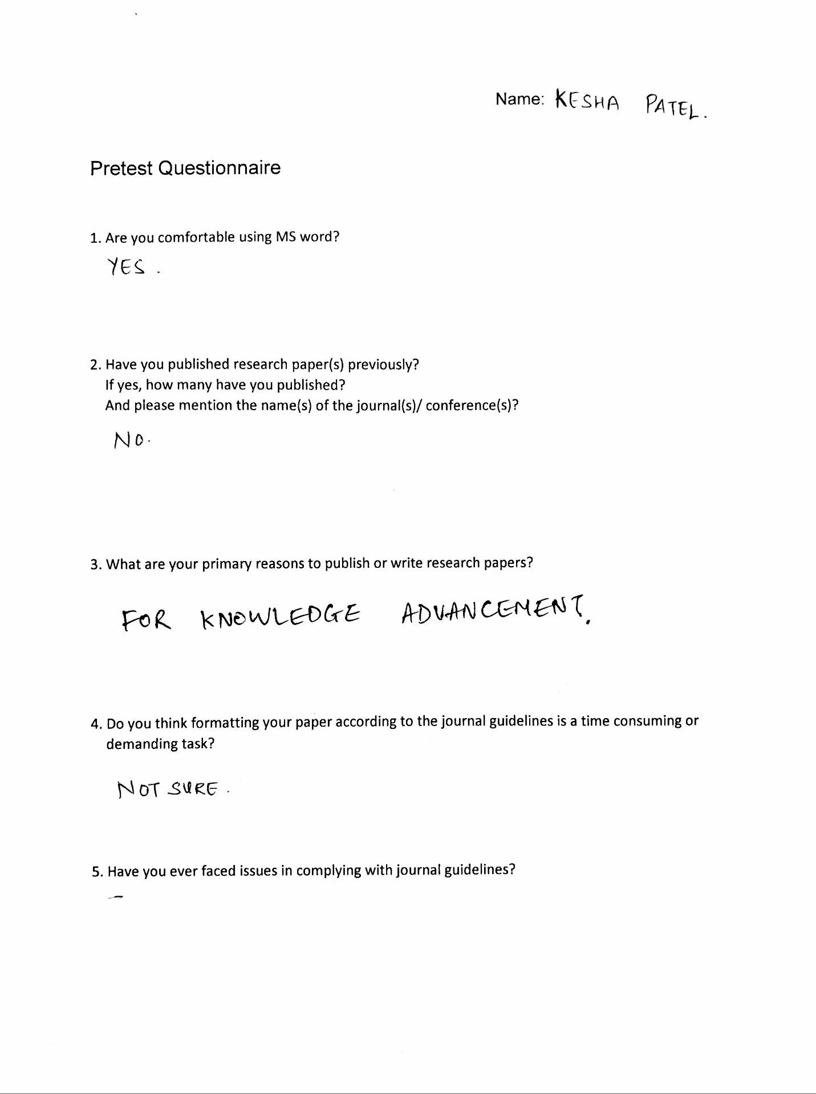

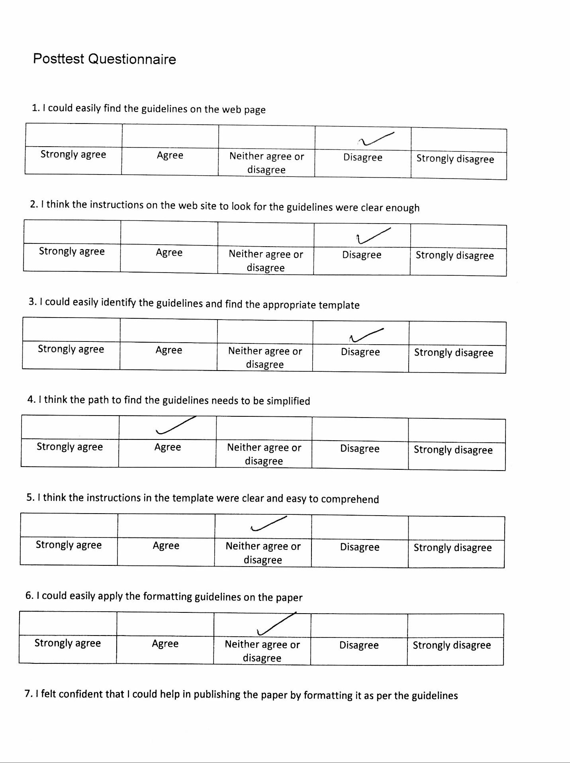

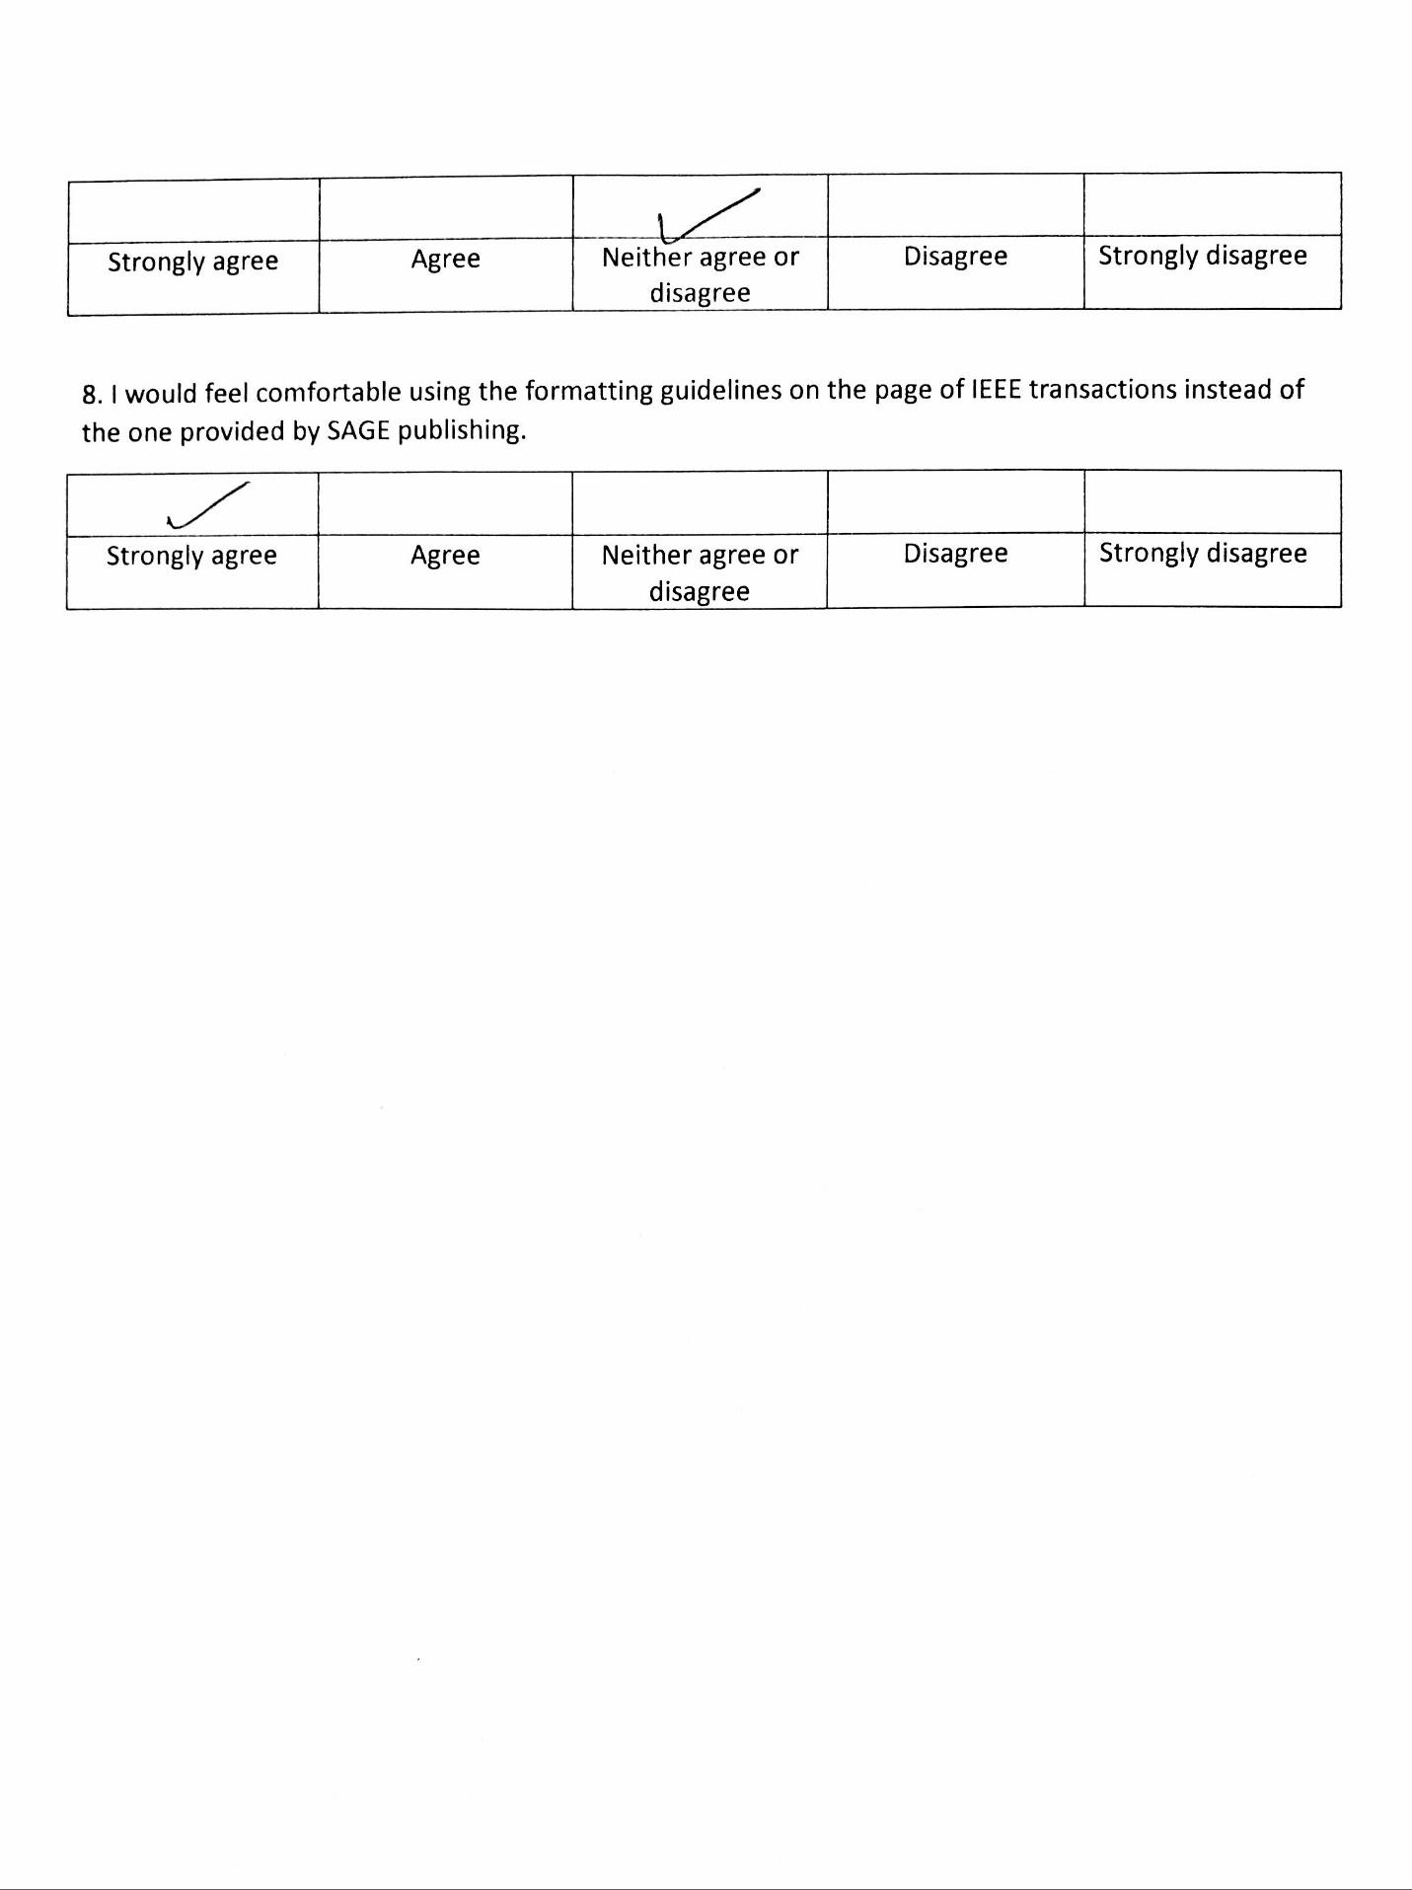

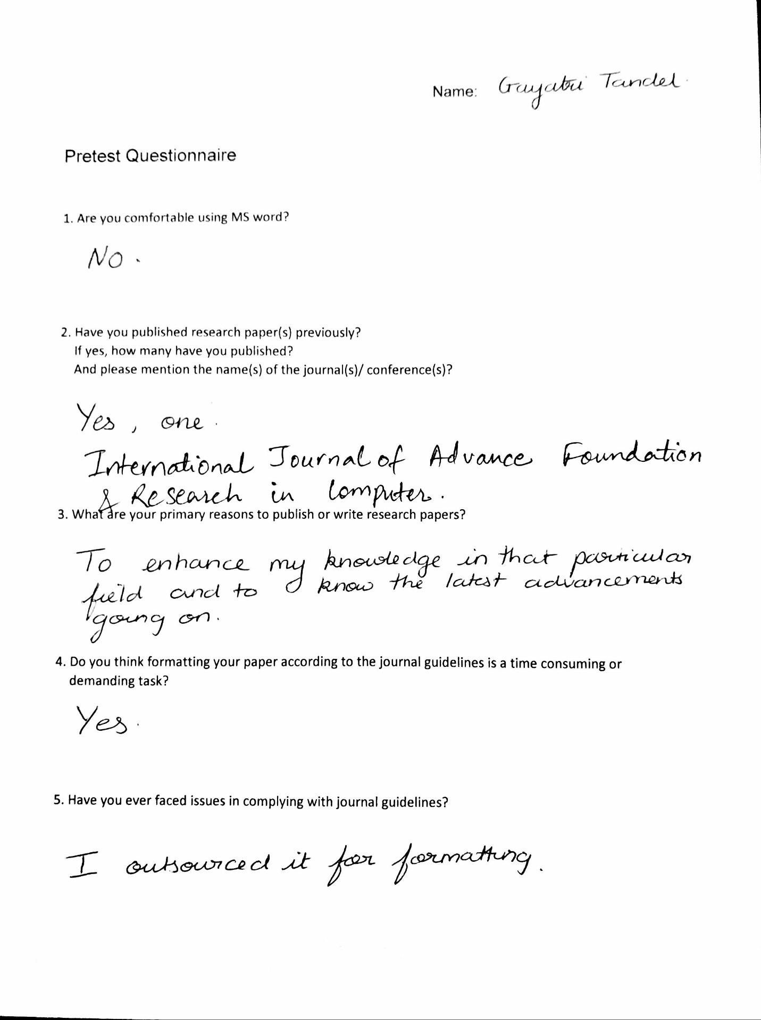

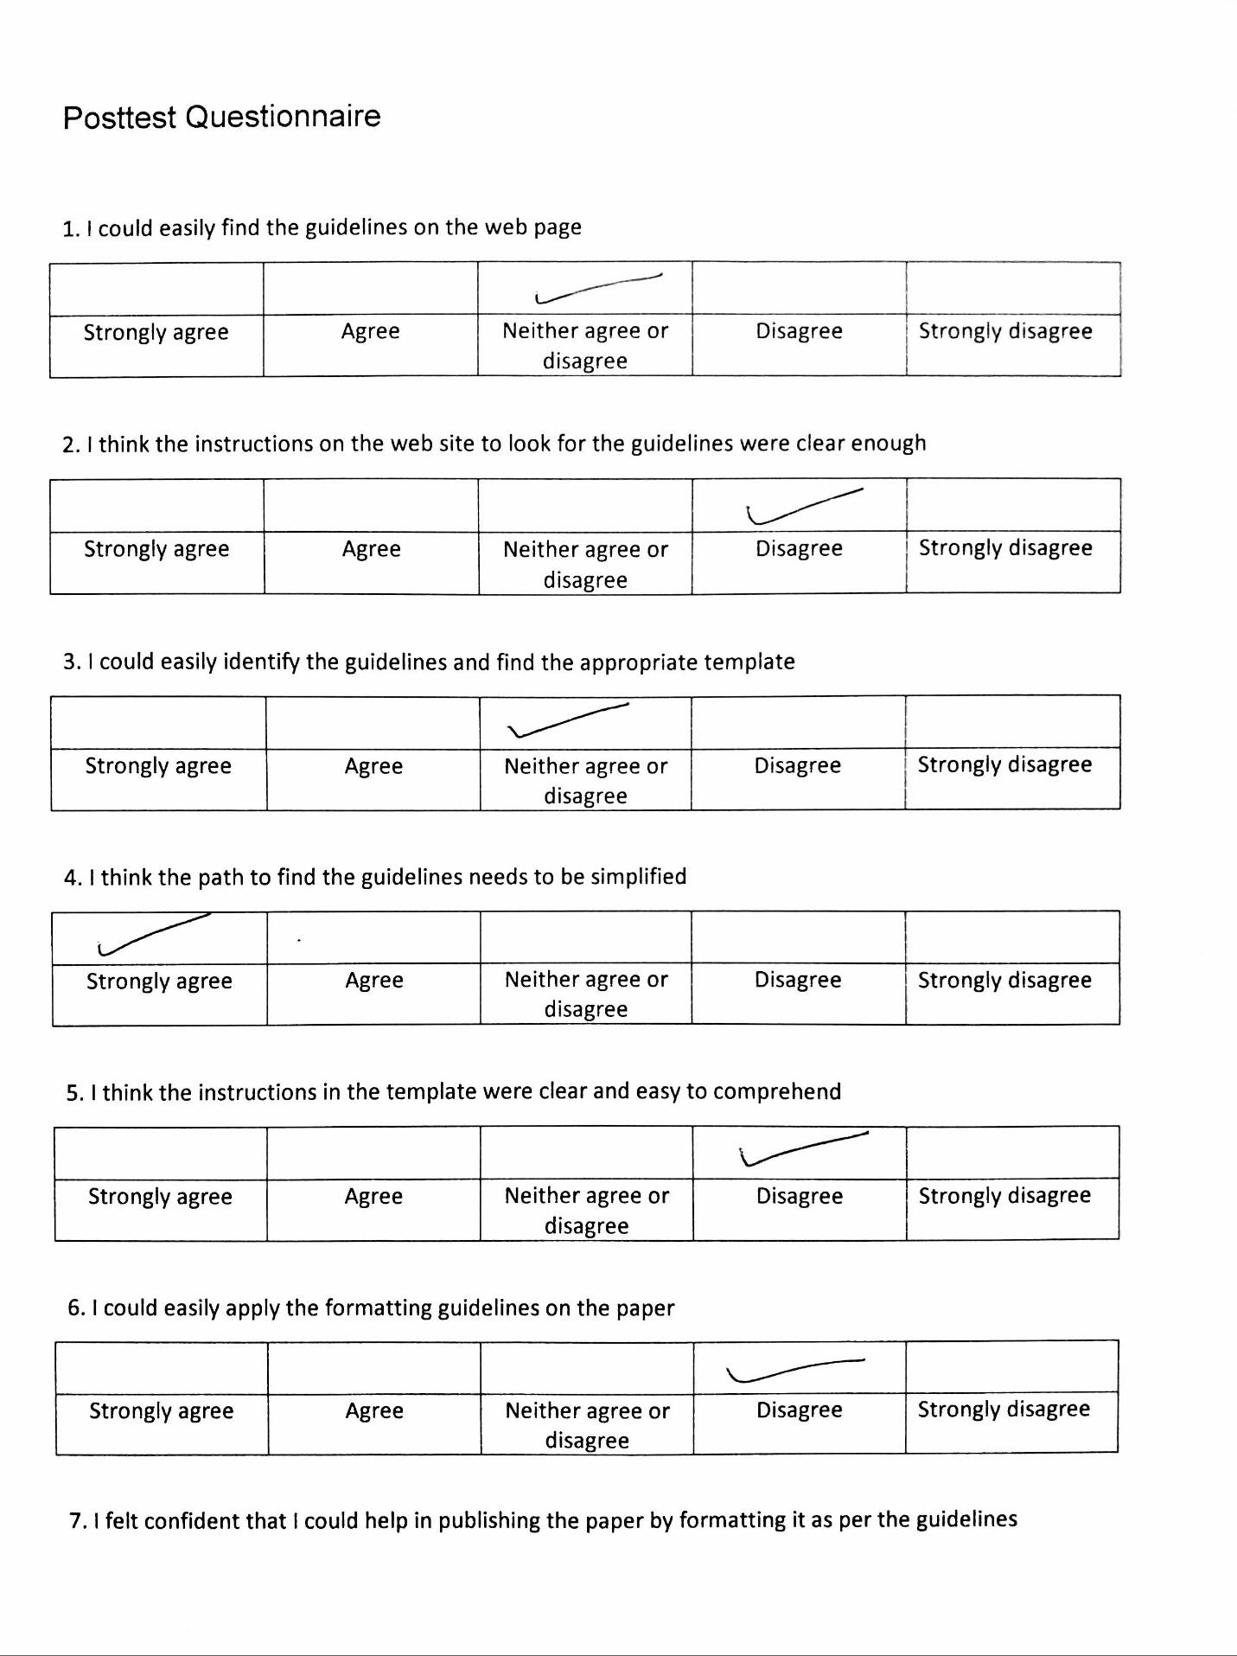

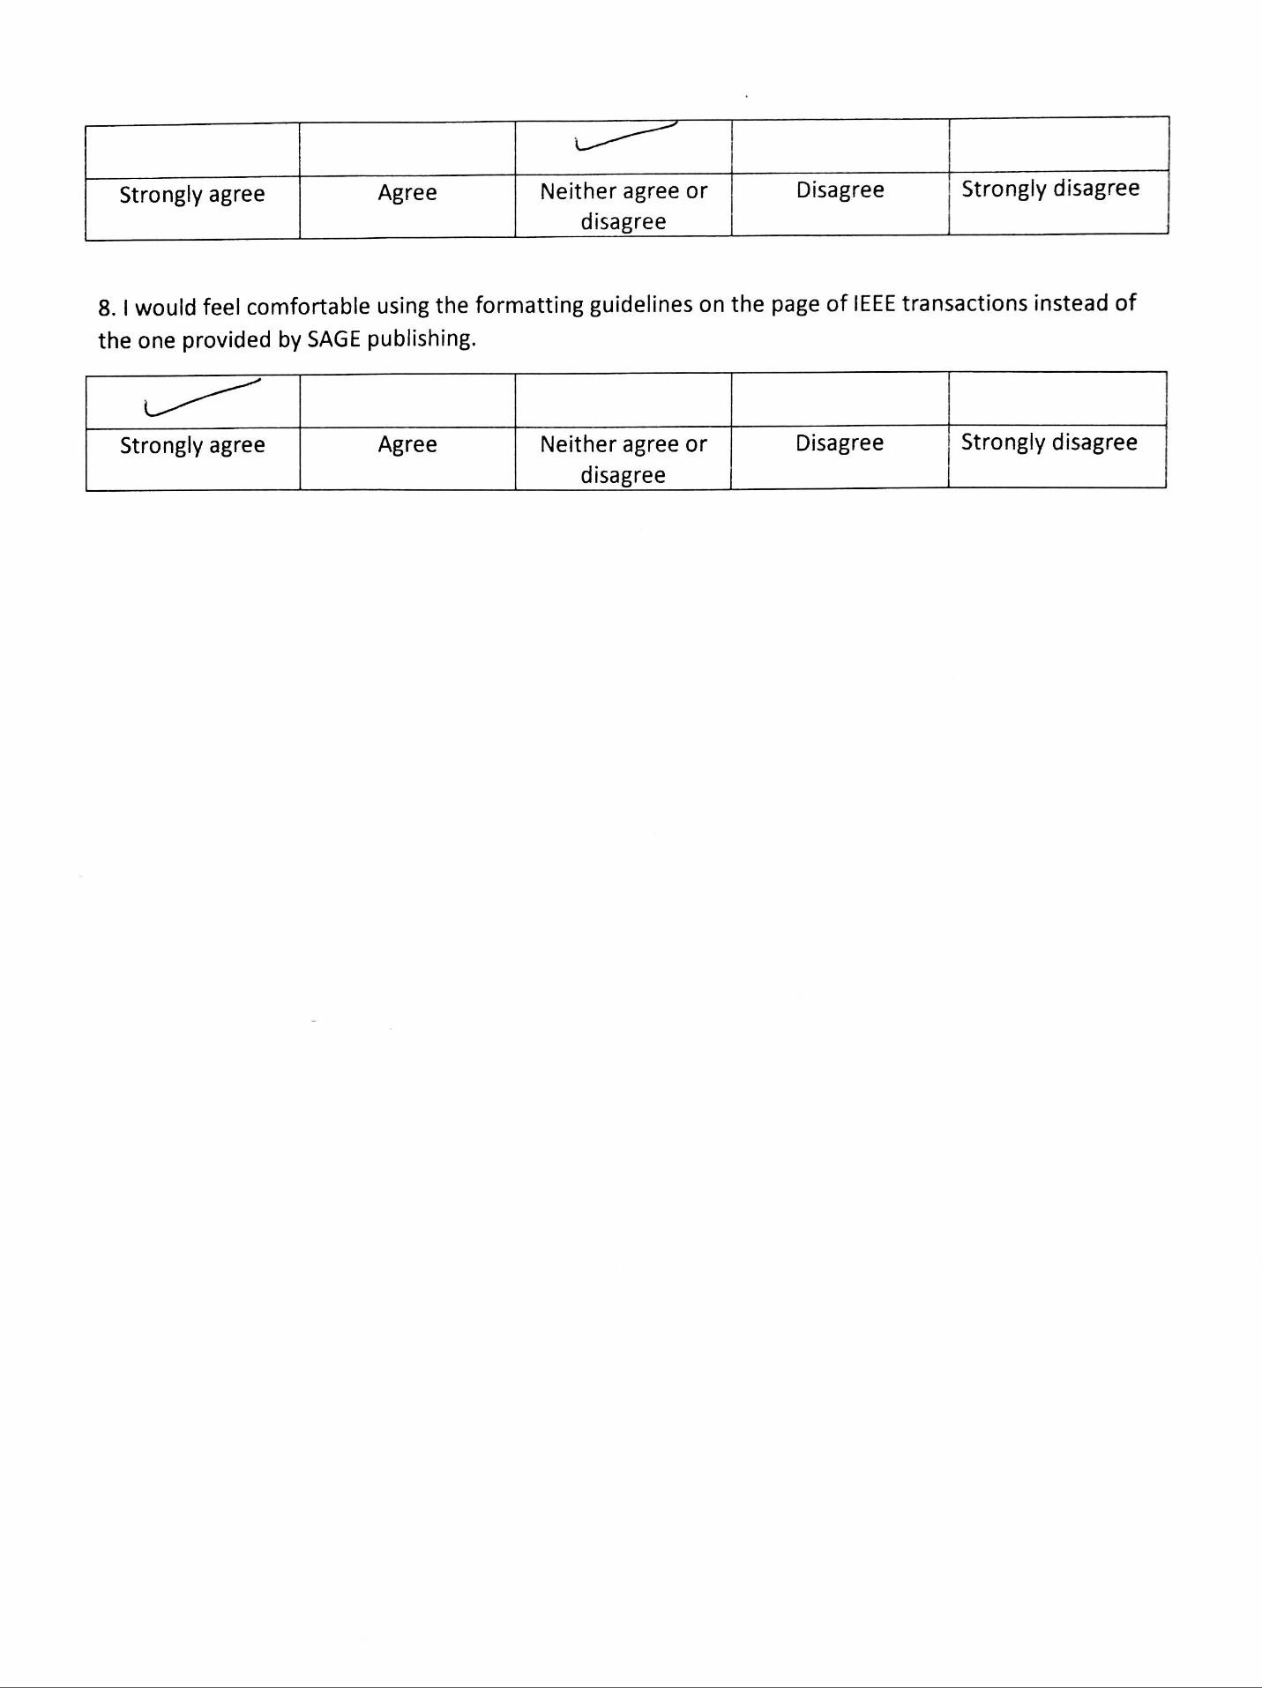

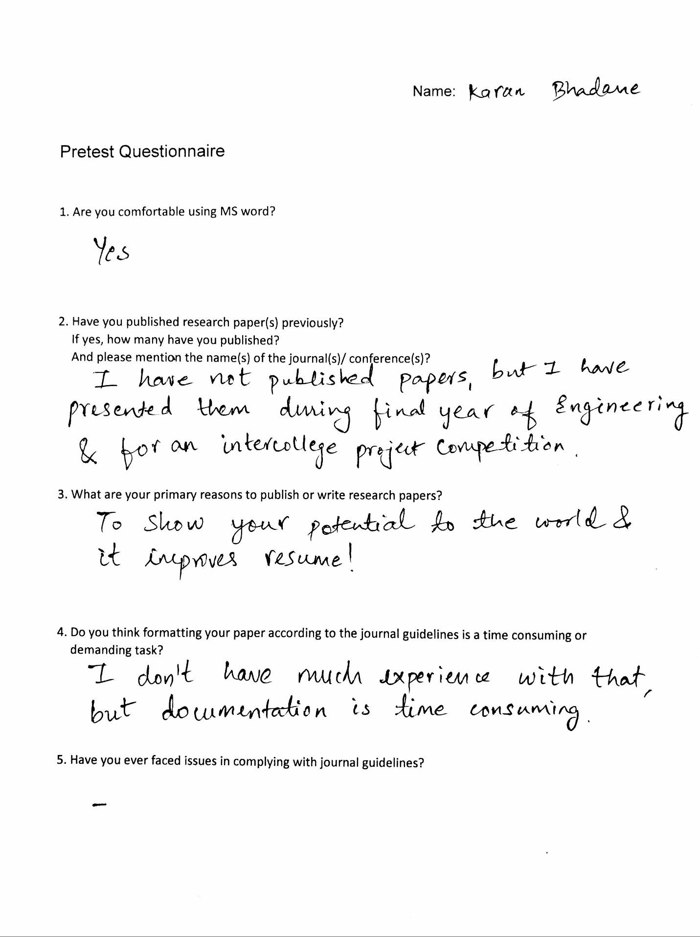

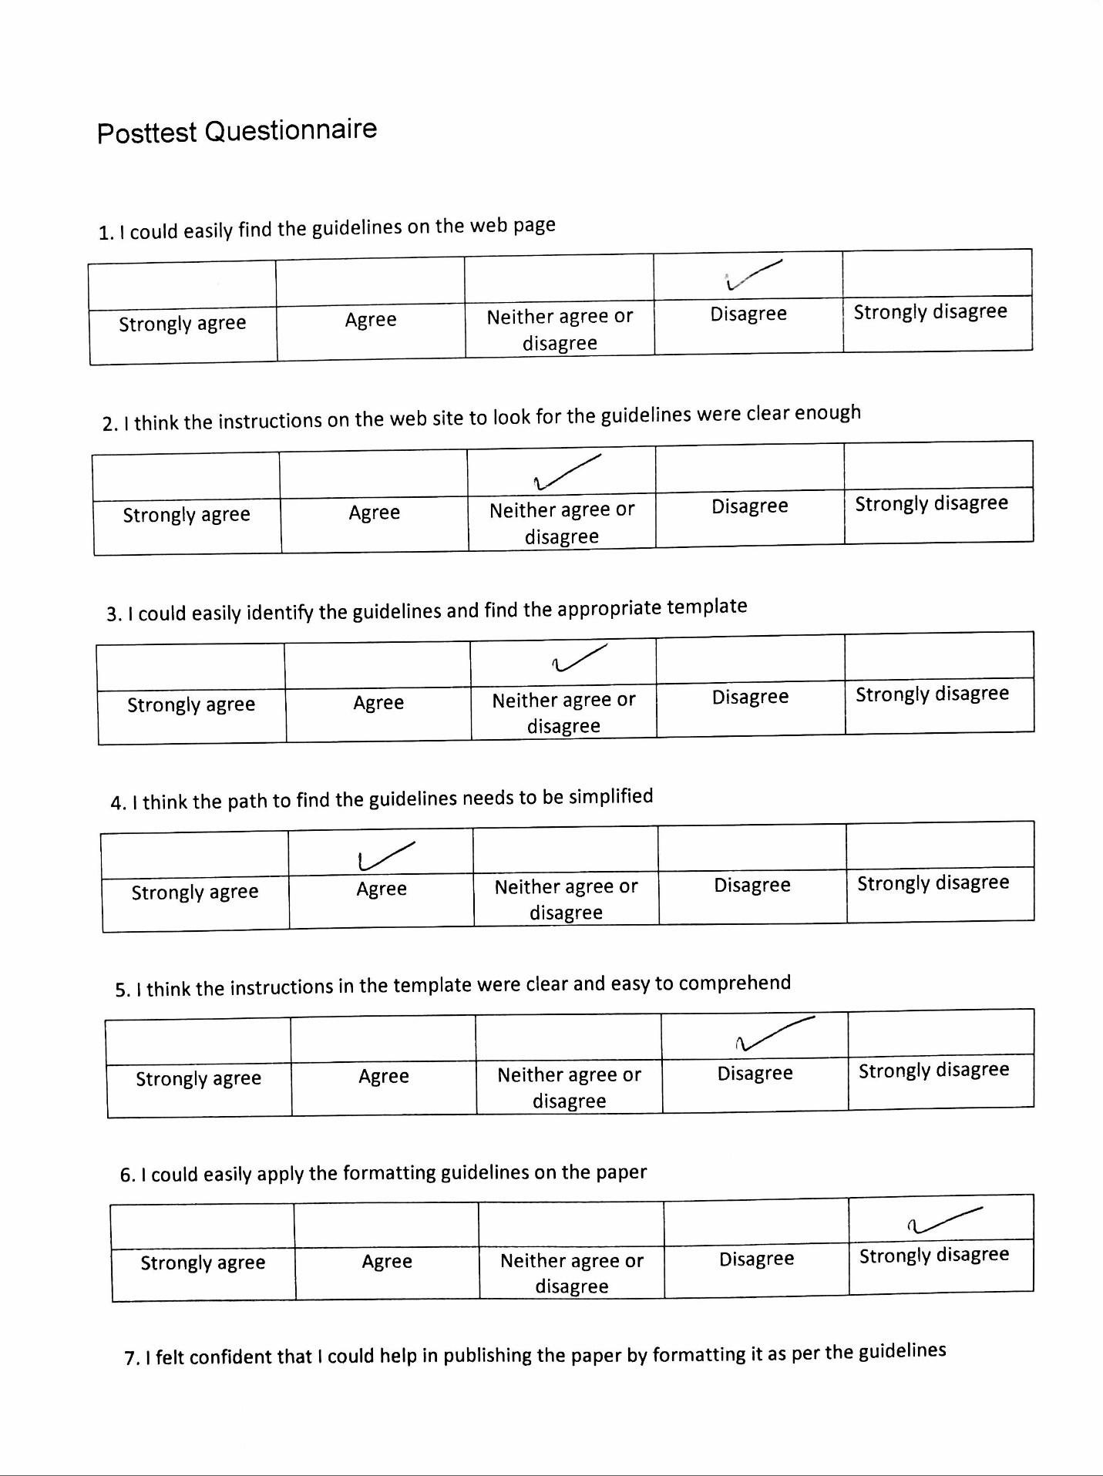

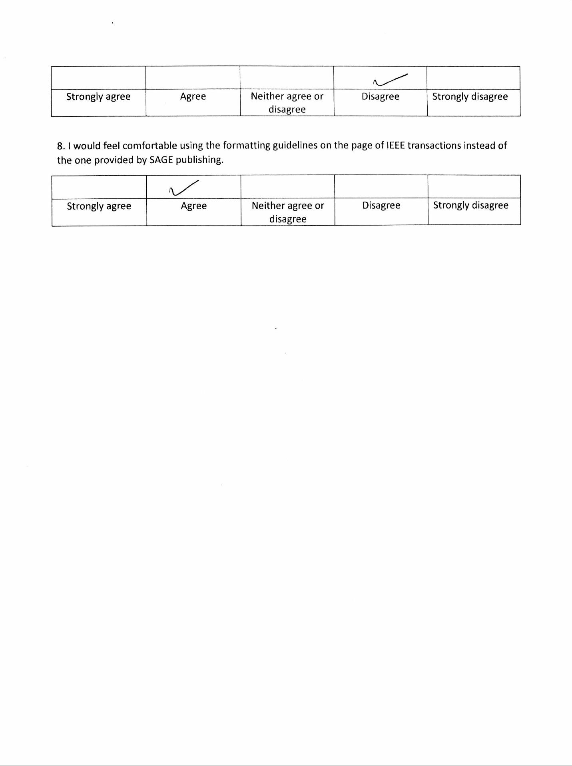

**Appendix 2**

Participant quotes/comments

CQ: Comment/Quote

O: Observation

E: Error made by participant

**Task 1**

| **Participant** | **Time** | **Detail** | **Notes** |
| --- | --- | --- | --- |
| Participant 1 | 15:24.9 | CQ | Asks “are these the guidelines?” looking at the incorrect page. |
|  | 15:26.6 | O | Does not see the link to the guidelines, and scrolls down. |
|  | 15:27.7 | E | Downloads the incorrect file containing styles for writing author names. |
|  | 15:27.7 | CQ | Asks “are these the guidelines?” looking at the incorrect page. |
|  | 15:28.4 | CQ | Says “these guidelines are not very useful, not precise, not useful for a first-time user” looking at Word document 1 that has less information. |
| Participant 2 | 17:29.8 | CQ | Asks “do I have to refer to a sample copy?” |
|  | 17:30.5 | O | She searches guidelines in the “Search” option. |
|  | 17:31.7 | O | Misses the fourth option “Preparing your manuscript” that has guidelines. |
|  | 17:32.6 | E | Opens an incorrect template. |
|  | 17:32.7 | CQ | While downloading the file, participant says “these instructions are only for author names.” |
|  | 17:33.8 | CQ | Says “this is too confusing; I have to go back and forth.” |
|  | 17:35.3 | CQ | Says “this is confusing; there are links under links.” |
|  | 17:36.4 | E | Opens LaTeX template. |
|  | 17:36.6 | CQ | Says “these instructions look like they are only for abstract”, looking at the Word document 1 that has less information. |
|  | 17:37.6 | CQ | Says “there is redundant information”, looking at the Word document 2 that has an exhaustive list of instructions. |
|  | 17:37.8 | CQ | Says “this does not look like a template, it just mentions shortcuts”, looking at the Word document 2 that has an exhaustive list of instructions. |
|  | 17:38.5 | CQ | Says “these are just abbreviations”, looking at the table in the Word document 2 that has an exhaustive list of instructions. |
| Participant 3 | 9:5.02 | CQ | Says “there are too many instructions that give the impression like they might have the guidelines. Do I have to read everything on the page to understand where the guidelines are?” |
|  | 9:6.36 | E | Opens an incorrect template and asks whether it is the right one. |
|  | 9:7.56 | CQ | Says “why are there two templates?” |

**Task 2**

|  |  |  |  |
| --- | --- | --- | --- |
| **Participant** | **Time** | **Detail** | **Notes** |
| Participant 1 | 15:29.3 | O | Does not see the option “Article template.” Keeps going back and forth. |
| Participant 2 | 17:31.9 | E | Searches for the website on google and opens the incorrect website. |
| Participant 2 | 17:32.7 | E | Downloads the incorrect template. |

**Task 3**

| **Participant** | **Time** | **Detail** | **Notes** |
| --- | --- | --- | --- |
| Participant 1 | 15:35.6 | O | Misses the option “Information for authors.” |
|  | 15:38.2 | E | Downloads LaTeX template. |
|  | 15:39.4 | O | Opens the right link but closes it again thinking it is not useful. |
|  | 15:40.0 | CQ | Looks at the right PDF and asks “do I have to read everything to know where the guidelines are?” |
|  | 15:40.53 | CQ | Asks “is this PDF the actual file of guidelines?” |
| Participant 2 | 17:44.6 | CQ | Says “the link to the template was not hyperlinked so I missed it” referring to the PDF. |
| Participant 3 | 9:10.92 | CQ | Says “I don’t think a Word template is present on this page.” |
|  | 9:13.04 | CQ | Asks “is this PDF the actual file of instructions?” |
|  | 9:13.57 | O | Closes the PDF thinking it is not useful. |
|  | 9.13.57 | O | Misses the link to the guidelines in the PDF. |

**Task 4**

Word document 1: word template (the document with fewer instructions)

Word document 2: guidelines (the document with an exhaustive list of instructions)

| **Participant** | **Time** | **Detail** | **Notes** |
| --- | --- | --- | --- |
| Participant 1 | 15:45.5 | CQ | Says “the instructions are just for the font I guess” looking at Word document 2. |
|  | 15:46.1 | CQ | Asks “are these instructions for spacing?” looking at Word document 2. |
|  | 15:48.4 | O | Tries to use the shortcuts mentioned in the instructions on the sample paper, but fails because she does not change the setting of the Styles tab. |
| Participant 2 | 17:47.5 | CQ | Asks “are these instructions only for the abstract?” looking at Word document 1. |
|  | 17:47.8 | O | Applies the shortcut mentioned in the Word document 1 but fails. |
|  | 17:48.7 | E | Clicks on the incorrect the tab to change style settings; does not know how to change style settings. |
|  | 17:49.6 | CQ | Says “I’ve never used the Styles tab before.” |
|  | 17:50.8 | CQ | Asks “what should I do next” looking at the second table in the Word document 2. |
| Participant 3 | 9:14.0 | CQ | Says “I can’t figure out the relation between Word documents 1 and 2.” |
|  | 9:14.9 | CQ | Says “(there is) too much information. I can’t figure out which is important and where to start from.” |
|  | 9:16.0 | O | Tries to use the shortcuts mentioned in the instructions on the sample paper, but fails because he does not change the setting of the Styles tab. |
|  | 9:16.5 | O | Tries to do the steps mentioned in Appendix C in Word document 2. |
|  | 9:17.1 | CQ | Says “I can’t find the Tools menu.” |
|  | 9:18.0 | O | Searches on google for the Tools menu on MS Word. |
|  | 9:18.5 | O | Figures out that Tools menu was present in previous Word versions. |
|  | 9:19.0 | CQ | Asks “how can I change the style settings now?” |
|  | 9:21.0 | CQ | Says “how will a layman know that he has to change style settings?” |

1. “Heuristics evaluations and expert reviews.” Usability.gov. <https://www.usability.gov/how-to-and-tools/methods/heuristic-evaluation.html>. Accessed 28 November 2016