MEAL-BRIDGE

ABSTRACT:

The Food Cycle project helps stop food from going to waste by connecting people or groups who have extra food with those who really need it, like orphanages, old age homes, and poor communities. Donors can easily share details of the food through a website or mobile app. People in need can send requests, and the admin checks and approves them, then assigns delivery to volunteers. The system uses HTML, CSS, and JavaScript for the look, PHP for handling work, and MySQL for saving data. Tools like PHPMailer and Google Maps help with messages and finding exact locations.

INTRODUCTION:

Overview

Food wastage and hunger are major social challenges faced by society today. While large quantities of edible food are wasted daily by households, restaurants, hotels, and social events, many people continue to struggle to access nutritious meals. This situation highlights the need for an efficient system to redistribute surplus food to those in need.
Meal-Bridge is a socially driven, web-based digital platform developed to minimize food wastage and reduce hunger through organized food redistribution. The platform connects food donors with requestors such as NGOs, shelters, and needy individuals through a centralized system. Donors can list surplus food, requestors can view and claim available food, and administrators supervise the process to ensure transparency and smooth operation.

Purpose, Scope, and Applicability

Purpose
The purpose of the Meal-Bridge system is to minimize food wastage and reduce hunger by providing a centralized digital platform where donors can list surplus food, requestors can access and claim it, and administrators can monitor and manage the process. The system ensures timely food redistribution, reduces spoilage, and promotes transparency, accountability, and social responsibility.

Scope
The scope of the Meal-Bridge system includes a web-based platform for donors, requestors, and administrators with role-based authentication. It supports food listing, requesting, and administrative management through a centralized dashboard and database, along with notifications for food availability and request status. The system focuses on community- level food redistribution and can be extended to larger-scale implementation.

Applicability
The Meal-Bridge system is applicable for restaurants, hotels, catering services, and event organizers to donate surplus food. It can be used by NGOs, community welfare groups, and government initiatives for hunger relief and food waste reduction, and can be implemented on web and mobile platforms for real-time coordination.

PROBLEM STATEMENT:

Identification of the Social Issue

The Food Cycle project is designed to minimize food wastage and address hunger by creating a digital platform for food redistribution. It allows donors to offer surplus food, while requestors can view and claim available donations. The system integrates an admin panel, delivery module, email notifications, and map tracking to streamline the redistribution process.
The Food Cycle project is designed to minimize food wastage and address hunger by creating a digital platform for food redistribution. It allows donors to offer surplus food, while requestors can view and claim available donations. The system integrates an admin panel, delivery module, email notifications, and map tracking to streamline the redistribution process.

The Food Cycle project is designed to minimize food wastage and address hunger by creating a digital platform for food redistribution. It allows donors to offer surplus food, while requestors can view and claim available donations. The system integrates an admin panel, delivery module, email notifications, and map tracking to streamline the redistribution process.

Relevance of the Problem in Current Context

In the current era of technological advancement and rapid urbanization, food wastage has emerged as a critical global concern. While a significant portion of society discards edible food every day, millions still go hungry, unable to access basic nutrition. This disparity highlights an urgent societal imbalance that demands immediate attention.
According to the Food and Agriculture Organization (FAO), nearly one-third of the food produced globally is wasted annually. In India, a large volume of surplus food from functions, restaurants, and households is either thrown away or allowed to rot due to a lack of efficient redistribution mechanisms. At the same time, economically weaker sections of society continue to suffer from malnutrition and hunger.

OBJECTIVES:
The main objectives of the proposed system are:

Primary Objective

To develop a comprehensive web-based platform named Food Cycle that facilitates the donation and redistribution of surplus food to the needy, thereby reducing food wastage and contributing to hunger alleviation.

3.2.2Secondary Objectives
    - To bridge the gap between food donors and recipients using an intuitive online interface.
    - To create a centralized system where individuals or organizations can register as donors or requestors.
    - To provide an efficient delivery tracking system for food redistribution operations.
    - To incorporate features like real-time status updates, notification alerts, and email confirmations using PHPMailer.
    - To ensure visibility of donor and requestor contact information in a secure and controlled manner.
    - To include an Admin panel for managing users, approvals, and monitoring all food requests and donations.
    - To offer a mobile-friendly and responsive design ensuring accessibility across devices.

3.2.3Long-Term Objectives
    - To create awareness about food wastage and promote social responsibility through technology.
    - To scale the project to work with NGOs, food retailers, and community kitchens for

3.Methodology
The methodology of the Meal-Bridge system describes the step-by-step process followed to achieve efficient redistribution of surplus food from donors to requestors. It explains how different users interact with the system, how data flows between modules, and how the system ensures transparency, coordination, and timely food distribution. The methodology is designed to minimize food wastage, reduce delays, and improve communication among all stakeholders.

Food Donation and Request Processing Methodology
This methodology explains how food donations and requests are handled within the Meal-Bridge system from start to completion.

Initially, a donor logs into the system and submits details of surplus food such as food type, quantity, and availability. These details are validated by the backend and stored securely in the database. Once the food is listed, it becomes visible to requestors on their dashboard.

Requestors such as NGOs or needy individuals can view available food listings and place a request based on their requirements. The system records the request and forwards it to the administrator for review. The administrator verifies the request and either approves or rejects it based on availability and fairness.

After approval, notifications are sent to both the donor and the requestor through the in-application messaging system. The food is then collected and distributed. Finally, the system updates the status of the donation and stores the transaction details for future reference and reporting.

Steps:

- Donor logs in and submits surplus food details.
- Food data is validated and stored in the database.
- Requestor views available food and places a request.
- Admin reviews and approves or rejects the request.
- Notifications are sent to donor and requestor.
- Food distribution is completed and status is updated.

RESULTS

Result and Performance Analysis

The Mealbridge system was thoroughly tested to evaluate its functionality, performance, and reliability. Testing was carried out by simulating real-world usage scenarios involving different user roles such as food donors, requesters, and administrators.

The results obtained from these tests demonstrate that the system operates efficiently and fulfills the objectives defined during the project planning phase. During functional testing, the user registration and login modules performed accurately for all roles. Authentication and authorization mechanisms ensured that only valid users could access the system and perform actions based on their assigned roles. This confirms that the system provides secure access control and prevents unauthorized usage. The food donation module was tested by adding multiple food listings with varying quantities, locations, and descriptions.

The system successfully stored all donation details in the database and displayed them correctly to requesters. The food request module allowed requesters to view available food items and submit requests without errors, indicating smooth interaction between system components. Performance analysis showed that the system responded quickly to user requests such as adding food items, retrieving food listings, and submitting requests. Database operations including data insertion, retrieval, and updates were executed efficiently with minimal delay.

This indicates that the system is capable of handling multiple operations without significant performance degradation. Error handling and validation mechanisms were also tested by providing invalid inputs and incomplete data. The system handled such cases gracefully by displaying appropriate error messages and preventing incorrect data from being stored in the database. This improves system reliability and user experience.

Overall, the results and performance analysis confirm that the MealBridge system is stable, reliable, and user-friendly. The application successfully supports food donation and redistribution processes, making it an effective solution for reducing food wastage and supporting social welfare initiatives.

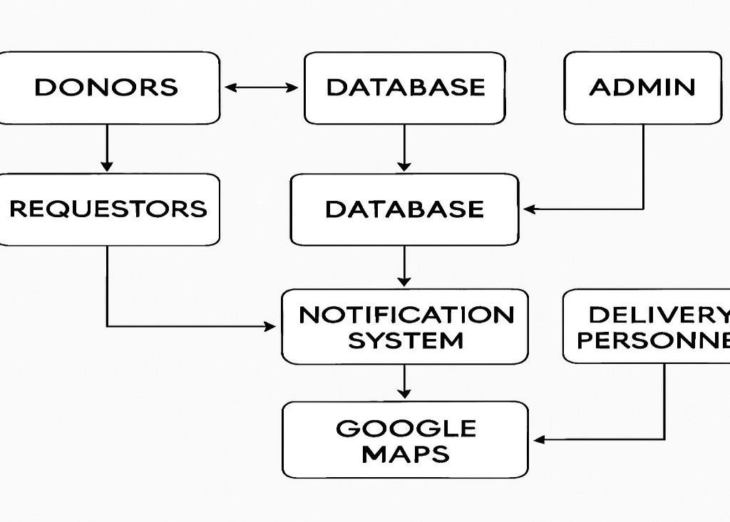
BLOCK DIAGRAM:

COMPONENTS DESCRIPTION:

User Module
  - Purpose: Handle activities of donors and requesters.
  - Components:
- Donor Registration & Login (signup, login, profile)
- Post Food Availability (food details, quantity, location, expiry time)
- Requester Registration & Login
- Request Food (browse available food, send request)
- User Dashboard (view history, status of posts/requests)

Admin Module
  - Purpose: Manage the entire system and verify requests.
  - Components:
- Admin Login
- View & Approve Donations
- View & Approve Requests
- Assign Delivery Personnel
- Generate Reports (donations made, requests fulfilled)

Delivery Module

  - Purpose: Assign, track, and complete deliveries.
  - Components:
  - Delivery Personnel Login
  - Assigned Delivery List
  - Navigation Support (Google Maps API)
  - Delivery Status Update

Notification & Communication Module

- Purpose: Keep everyone informed.
- Components:
- Email Notifications (PHPMailer)
- SMS / Push Notifications (optional)
- Status Alerts (request approved, food on the way)

Database & Backend Module

- Purpose: Store and manage all data.
- Components:
- User Data Management
- Donation & Request Records
- Delivery Logs
- Reports Storage

Location & Tracking Module

- Purpose: Ensure quick and accurate deliveries.
- Components:
- Google Maps Integration
- Route Optimization (optional)
- Location Sharing

Conclusion
MealBridge delivers a reliable and socially impactful platform for managing and redistributing surplus food in an efficient and organized manner. By digitizing the process of food donation and request handling, the system successfully addresses major challenges such as food wastage, lack of coordination between donors and receivers, and delays in food distribution. The platform bridges the gap between surplus food sources and people in need, thereby promoting sustainability and social responsibility.

Through its structured modules for user registration, food listing, request management, and real- time communication, MealBridge ensures smooth interaction among donors, receivers, and administrators. The system maintains data accuracy and transparency while simplifying the overall donation workflow. Features such as role-based access, food availability tracking, and admin communication enhance usability and trust within the platform.

The implementation of modern web technologies enables MealBridge to provide a responsive, user- friendly, and scalable solution. During testing, the system demonstrated stable performance, efficient handling of multiple requests, and accurate data management. The modular architecture makes the application adaptable to different environments such as restaurants, educational institutions, event venues, NGOs, and corporate offices.

OUTCOMES:

  - Reduced Food Wastage – Surplus food from events, hotels, and households will be redirected to people in need instead of being thrown away.
  - Improved Food Access for Needy Groups – Orphanages, old age homes, and underprivileged communities will receive timely food supplies.
  - Easy Donor-Recipient Connection – Donors and requesters can connect quickly through a simple web or mobile platform.
  - Efficient Delivery Management – Delivery personnel will be able to receive assignments, track locations, and confirm deliveries in real time.
  - Centralized Monitoring – Admins can approve requests, assign deliveries, and generate reports from one dashboard.
  - Awareness Creation – Encourage community participation in reducing food waste and helping the needy.

References:
1] M. Sharma and R. Gupta, “Food waste management: A case study approach,” International Journal of Environmental Sciences, vol. 10, no. 2, pp. 145–152, 2023.

- S. Kumar, A. Singh, and P. Verma, “Design and implementation of a web-based food donation management system,” International Journal of Computer Applications, vol. 185, no. 34, pp. 25–30, Feb. 2023.

- Google, “Google Maps Platform Documentation,” Google Developers, 2024. [Online]. Available: https://developers.google.com/maps. [Accessed: 11-Aug-2025].

- PHPMailer, “PHPMailer Documentation,” GitHub, 2024. [Online]. Available: https://github.com/PHPMailer/PHPMailer. [Accessed: 11-Aug-2025].

- United Nations, “Goal 12: Ensure sustainable consumption and production patterns,” UN Sustainable Development Goals, 2024. [Online]. Available: https://sdgs.un.org/goals/goal12. [Accessed: 11-Aug-2025].

