Meal-Bridge

Chapter 1 Introduction

Chapter 1

INTRODUCTION

Overview

Food wastage and hunger are major social challenges faced by society today. While large quantities of edible food are wasted daily by households, restaurants, hotels, and social events, many people continue to struggle to access nutritious meals. This situation highlights the need for an efficient system to redistribute surplus food to those in need.
Meal-Bridge is a socially driven, web-based digital platform developed to minimize food wastage and reduce hunger through organized food redistribution. The platform connects food donors with requestors such as NGOs, shelters, and needy individuals through a centralized system. Donors can list surplus food, requestors can view and claim available food, and administrators supervise the process to ensure transparency and smooth operation.

Purpose, Scope, and Applicability

Purpose
The purpose of the Meal-Bridge system is to minimize food wastage and reduce hunger by providing a centralized digital platform where donors can list surplus food, requestors can access and claim it, and administrators can monitor and manage the process. The system ensures timely food redistribution, reduces spoilage, and promotes transparency, accountability, and social responsibility.

Scope
The scope of the Meal-Bridge system includes a web-based platform for donors, requestors, and administrators with role-based authentication. It supports food listing, requesting, and administrative management through a centralized dashboard and database, along with notifications for food availability and request status. The system focuses on community- level food redistribution and can be extended to larger-scale implementation.

Applicability
The Meal-Bridge system is applicable for restaurants, hotels, catering services, and event organizers to donate surplus food. It can be used by NGOs, community welfare groups, and government initiatives for hunger relief and food waste reduction, and can be implemented on web and mobile platforms for real-time coordination.

Existing Systems

In the existing system, food donation and distribution processes are largely manual and unorganized. Most food donors, such as restaurants or event organizers, rely on phone calls, personal contacts, or physical visits to NGOs and charitable organizations to donate surplus food. This approach is time-consuming and often leads to delays, resulting in food spoilage and increased wastage.
There is no centralized digital platform to connect donors, requestors, and volunteers on a single system. Communication gaps, lack of real-time updates, and absence of tracking mechanisms reduce transparency and accountability. Many NGOs face difficulties in managing multiple donations efficiently, while needy individuals are often unaware of available food resources. Overall, the existing system is inefficient, lacks coordination, and fails to utilize technology effectively for large-scale food redistribution.

Problem Statement
To address the increasing problem of food wastage and hunger caused by the lack of a centralized and well-organized food redistribution system. To overcome delays, poor coordination, and food spoilage resulting from manual food donation methods and the absence of real-time communication between donors, requestors, and administrators. To develop a digital platform that enables efficient, transparent, and timely redistribution of surplus food, ensuring that edible food reaches needy individuals and organizations while promoting accountability and social responsibility.

Objectives
The objectives of the Meal-Bridge project are outlined below:

- To reduce food wastage by enabling the redistribution of surplus food to needy individuals and organizations.
- To develop a centralized digital platform that connects food donors, requestors, and administrators.
- To simplify and automate the food donation and request process through a user-friendly web interface.
- To ensure timely collection and distribution of food to minimize spoilage.

Meal-Bridge
- To implement secure user registration and role-based access for donors, requestors, and administrators.
- To provide transparency and accountability through monitoring and tracking of donations and requests.
- To support NGOs and charitable organizations in managing food donations efficiently.

Organization of the Report
This report has been structured into multiple chapters to provide a clear and comprehensive understanding of the Meal-Bridge web based platform:
- Chapter 1 presents an introduction to the project, including the overview, motivation, existing system, problem statement, objectives, and organization of the report.
- Chapter 2 focuses on system analysis, covering requirement analysis, feasibility study, workflow components, and limitations of the existing system.
- Chapter 3 describes the system design, including the architecture diagram, module interactions, database design, and data flow diagrams.
- Chapter 4 explains the implementation of the Meal-Bridge system, detailing the technologies used, frontend and backend development, and module integration.
- Chapter 5 discusses the results of the system, highlighting outputs, user interfaces, notifications, and performance observations.
- Chapter 6 outlines the applications, limitations, and future scope of the Meal-Bridge system, focusing on scalability and possible enhancements.
- Chapter 7 concludes the report by summarizing the work carried out, key achievements, and the overall impact of the Meal-Bridge platform.

Chapter 2

Tools and Technologies

Chapter 2

TOOLS AND TECHNOLOGIES
The development of the Meal-Bridge system required a combination of modern frontend, backend, database, and development tools that work together to deliver a scalable, secure, and user-friendly food redistribution platform. This chapter explains each tool and technology used in the project, highlighting their purpose, role, advantages, and relevance to the successful implementation of the system.

Frontend Technologies

HTML5
HTML5 forms the structural foundation of the Meal-Bridge web interface. It defines the layout, sections, forms, headings, buttons, and overall organization of the content displayed to users.
Key Features and Benefits:

      - Structural Foundation: HTML5 provides the basic structure of the Meal-Bridge web application, defining pages such as login, registration, donor dashboard, requestor dashboard, and admin panel.
      - Form Handling: HTML5 is used to create forms for user registration, login, food listing, and food requests, ensuring proper input fields and labels for user interaction.
      - Semantic Elements: HTML5 semantic tags such as <header>, <section>, <nav>, and
<footer> improve content organization, readability, and accessibility of the web pages.

CSS3
CSS3 provides the design, layout, and visual styling for the Meal-Bridge application. It enhances the user interface and ensures a consistent and attractive appearance.

Key Styling Components Used

      - Flexbox & Grid: Used for responsive page layouts and dashboards.
      - Transitions and Animations: Applied to buttons, alerts, and notifications for smoother interaction.
      - Media Queries: Ensure the interface adapts to different screen sizes and devices.
      - Custom Styles: Define colours, buttons, and visual indicators for request status.

Meal-Bridge

JavaScript
JavaScript enables interactive elements and dynamic updates on the frontend. It
      - Validates user inputs before sending data to the backend.
      - Handles asynchronous calls using Fetch and Axios.
      - Updates item lists based on expiry categorization.
      - Manages UI events such as sorting, filtering, and searching items.
    - Bootstrap

Bootstrap is a front-end CSS framework used to develop responsive and mobile-friendly web pages for the Meal-Bridge system.

Advantages:

      - Provides ready-made components such as forms, buttons, cards, and navigation bars.
      - Ensures uniform design across all pages.
      - Reduces development time while maintaining professional UI standards

Backend Technologies
    - Python
Python is a high-level, interpreted programming language widely used for backend web development. In the Meal-Bridge system, Python is used to implement server-side logic, handle user requests, manage data processing, and ensure smooth interaction between the frontend and database.
Why Python:
      - Simple and easy-to-read syntax, which reduces development complexity.
      - Supports rapid development and easy debugging.
      - Extensive library support for web development and database connectivity.

Meal-Bridge

Flask Framework
Flask is a lightweight Python web framework used to develop the backend of the Meal- Bridge system. It manages routing, request handling, and integration between the frontend and database.
Core Functionalities:
      - Handles HTTP requests and responses.
      - Implements routing for donor, requestor, and admin modules.
      - Integrates frontend components with backend logic.

Flask-Mail
Flask-Mail is an extension used to enable email notifications in the Meal-Bridge system. It improves communication by sending timely alerts to users.
Core Functionalities:
      - Sends email notifications to donors when food is requested.
      - Alerts requestors about request approval or rejection.
      - Provides status updates related to food distribution.

Database Technology

SQLite
SQLite is a lightweight, relational database management system used in the Meal-Bridge application to store and manage all system data. It is a serverless database that provides reliable data storage and efficient retrieval, making it suitable for small to medium-scale web applications like Meal-Bridge
Functionalities:

      - Stores user registration details for donors, requestors, and administrators.

      - Maintains food donation information such as food type, quantity, and availability.

      - Stores food request data along with request status and timestamps.

      - Maintains transaction history for tracking food distribution activities.

      - Supports data integrity and consistency through relational tables.

Meal-Bridge
      - Enables fast data retrieval for backend processing and dashboard display.
      - Provides persistent data storage even after system restarts.

      - Integrates smoothly with the Flask backend framework.

Notification Technologies

Messaging
The Meal-Bridge system uses an in-application notification and messaging mechanism to enable communication between donors, requestors, and administrators. This notification technology allows users to receive updates and exchange messages directly within the platform, ensuring timely coordination without relying on external email or third-party messaging services.
Features:

      - Enables in-app messaging between donors, requestors, and administrators.
      - Notifies donors when a food request is placed or updated.
      - Informs requestors about approval, rejection, or status changes of their requests.
      - Allows administrators to send updates or instructions to users within the system.
      - Displays notification alerts on user dashboards for quick visibility.
      - Improves coordination, transparency, and real-time communication within the platform.

.

Development and Collaboration Tools
Development and collaboration tools are used in the Meal-Bridge project to support coding, testing, debugging, and teamwork among project members. These tools help in efficient development, proper coordination, and smooth execution of the project tasks.

Visual Studio Code
Visual Studio Code is used as the primary development environment for building the Meal- Bridge application. It provides a flexible and efficient platform for writing and managing code.

VS Code is the main coding environment. Why it was used:

      - Supports HTML, CSS, Python, and Flask in a single editor.
      - Provides syntax highlighting and debugging features.
      - Makes coding faster and easier to manage.

Flask Development
The Flask development server is used to test and run the application during the development phase before deployment.

Why it is used:

      - Allows local testing of backend logic.
      - Helps identify and fix errors early.
      - Ensures smooth integration between frontend and backend.

Testing and Debugging Tools
Why it is used:

- Helps inspect HTML and CSS elements.
- Identifies layout and responsiveness issues.
- Debugs client-side interactions and form behaviour

Chapter 3 System Design

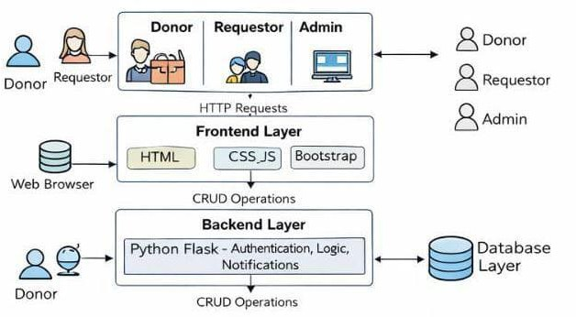
Chapter 3

SYSTEM DESIGN

3.1 Architecture
The system architecture of the Meal-Bridge platform follows a modular and layered design that separates the application into distinct functional components. This architecture improves maintainability, scalability, and ease of future enhancement. The system is divided into three main layers: the Frontend Layer, Backend Layer, and Database Layer, which interact with each other in a structured manner.

  - Architectural diagram

Frontend Layer
The frontend layer provides the user interface of the Meal-Bridge system and enables interaction between users and the application. This layer is developed using HTML5, CSS3, and Bootstrap.

      - Displays user interfaces for donors, requestors, and administrators.

      - Provides forms for user registration, login, food donation, and food requests.

      - Displays dashboards showing food listings, request status, and notifications.

      - Handles basic client-side validation and user interactions.

Backend Layer
The backend layer is responsible for processing application logic and coordinating communication between the frontend and database. It is developed using Python with the Flask framework.

      - Manages user authentication and role-based access (Donor, Requestor, Admin).

      - Processes food donation submissions and food request workflows.

      - Handles approval or rejection of requests by the administrator.

      - Manages in-app notification and messaging functionality.

      - Ensures secure data handling and system logic execution.

Database Layer
The database layer stores and manages all data required by the Meal-Bridge system. It is implemented using the SQLite database.

Responsibilities:

      - Stores user registration and authentication details.
      - Maintains food donation records and availability information.
      - Stores food request data and request status.
      - Maintains transaction history for monitoring and reporting.
      - Supports data consistency and reliable storage

Modules Description

The Meal-Bridge system is divided into multiple functional modules, each responsible for specific operations. This modular approach improves clarity, system organization, and fault isolation.

Donor Module
The Donor Module allows individuals, restaurants, and organizations to donate surplus food through the platform. It plays a crucial role in initiating the food redistribution process.

Functions:

      - Enables donors to add surplus food details.
      - Allows donors to edit or remove food listings.
      - Displays requests received for donated food.
      - Shows donation history and current status.

Requestor Module
The Requestor Module is designed for NGOs and needy individuals to access available food. It ensures that food distribution is carried out in an organized and transparent manner.

Functions:

      - Displays available food listings.
      - Allows requestors to place food requests.
      - Enables tracking of request status.
      - Displays notifications related to request updates

Admin Module
The Admin Module supervises the entire system and ensures smooth operation. It provides control and monitoring capabilities to maintain transparency and fairness.

Functions:

      - Manages donor and requestor accounts.
      - Reviews and approves or rejects food requests.
      - Monitors overall food distribution activity.
      - Ensures proper system usage and coordination.

User Authentication Module
The User Authentication Module manages secure access to the Meal-Bridge system. It ensures that only authorized users can access system features based on their assigned roles.

Functions:

      - Handles user registration and login.
      - Validates user credentials.
      - Implements role-based access for donors, requestors, and administrators.
      - Manages user sessions and logout functionality.

Analytics Module
This module enables in-application communication among donors, requestors, and administrators. It improves coordination and reduces delays.

Functions:

      - Sends in-app notifications for food requests and approvals.
      - Allows messaging between donors, requestors, and admins.
      - Displays alerts and updates on user dashboards.
      - Enhances transparency and real-time coordination.

AI Chatbot Module
Provides natural-language interactions using the Gemini API.
      - Answers expiry and storage-related questions.
      - Suggests recipes based on items nearing expiry.
      - Offers quick summaries of inventory status.
      - Enhances usability through intelligent guidance.

Meal-Bridge

Methodology
The methodology of the Meal-Bridge system describes the step-by-step process followed to achieve efficient redistribution of surplus food from donors to requestors. It explains how different users interact with the system, how data flows between modules, and how the system ensures transparency, coordination, and timely food distribution. The methodology is designed to minimize food wastage, reduce delays, and improve communication among all stakeholders.

Food Donation and Request Processing Methodology
This methodology explains how food donations and requests are handled within the Meal-Bridge system from start to completion.

Initially, a donor logs into the system and submits details of surplus food such as food type, quantity, and availability. These details are validated by the backend and stored securely in the database. Once the food is listed, it becomes visible to requestors on their dashboard.

Requestors such as NGOs or needy individuals can view available food listings and place a request based on their requirements. The system records the request and forwards it to the administrator for review. The administrator verifies the request and either approves or rejects it based on availability and fairness.

After approval, notifications are sent to both the donor and the requestor through the in-application messaging system. The food is then collected and distributed. Finally, the system updates the status of the donation and stores the transaction details for future reference and reporting.

Steps:

- Donor logs in and submits surplus food details.
- Food data is validated and stored in the database.
- Requestor views available food and places a request.
- Admin reviews and approves or rejects the request.
- Notifications are sent to donor and requestor.
- Food distribution is completed and status is updated.

Notification and Messaging Methodology
This methodology describes how notifications and communication are managed within the Meal- Bridge system.

Whenever an important event occurs, such as placing a food request or approving a request, the system automatically generates a notification. These notifications are displayed on the dashboards of the concerned users. The in-app messaging feature allows donors, requestors, and administrators to communicate directly within the platform for coordination and clarification.

This approach avoids dependence on external communication tools and ensures that all interactions related to food distribution remain within the system, improving transparency and accountability.

Steps:

- System detects an event (request placed, approved, or updated).
- Notification message is generated by the backend.
- Message is delivered to the relevant user dashboard.
- Users communicate using in-app messaging if needed.

Data Management and Validation Methodology

This methodology ensures accurate data handling and system reliability. All data entered by users is validated at the backend to prevent incorrect or incomplete information. The system checks for required fields such as food quantity and availability before storing data. SQLite database ensures secure storage and quick retrieval of data. Regular updates to food and request status help maintain data consistency across the system.
Steps:

- User input is validated by the backend.
- Valid data is stored in the database.
- Data is retrieved as needed for dashboards and reports.
- Status updates are reflected in real time.

Chapter 4 Implementation

Mealbridge
Chapter 4
IMPLEMENTATION

Implementation Approaches
The implementation of the Mealbridge system follows a structured, modular, and incremental approach to ensure reliability, scalability, and ease of maintenance. The system is developed dividing the application into independent modules such as frontend, backend, database, notifications, developed separately and then integrated through secure APIs. The following subsections.

Frontend Implementation
The frontend of the Mealbridge system is developed using HTML ,CSS ,and JavaScript to provide a user-friendly and responsive interface. Different pages are designed for donors receivers, and administrators to ensure role-based access.
Key implementation steps:
      - Designed responsive user interfaces for donor registration, receiver registration, food listing, and request management.
      - Implemented form validation to ensure correct data entry.

      - Used reusable components for headers, footers, and navigation menus.

      - Ensured compatibility across different devices and screen sizes.

Backend Implementation
The backend of the MealBridge system is implemented using Python (Flask) / Node.js (Express) (use the one you actually used). It handles all business logic, user authentication, food donation management, and request processing.
Key implementation steps:

      - Developed RESTful APIs for user registration, food donation, and food request.
      - Implemented role-based access for donors, receivers, and administrators.

      - Managed data processing and validation before storing it in the database.

Database Implementation
The database is implemented using MySQL to store user information, food details, donation history, and request records.
      - Designed normalized database tables for users, food donations, and requests.

      - Implemented relationships between tables to maintain data integrity.

      - Used CRUD operations for efficient data management.
.

Notification and Communication Implementation
The system includes a notification mechanism to inform receivers about available food donations and donors about request status.
Implementation steps :
      - Implemented email notifications for donation confirmations and request approvals.
      - Displayed real-time alerts on the user dashboard.
      - Ensured timely communication between donors and receivers.
      - Real time alerts.

Source Code

import os
from functools import wraps
from flask import Flask, render_template, redirect, url_for, flash, request, abort
from flask_login import LoginManager, login_user, logout_user, login_required, current_user from flask_mail import Mail, Message
from config import Config
from models import db, User, Listing, Request, Message
from forms import RegistrationForm, LoginForm, ListingForm, RequestForm, AdminActionForm,
MessageForm
from sqlalchemy import or_ from datetime import datetime

from flask_wtf.csrf import CSRFProtect

app = Flask(_name_) app.config.from_object(Config)

csrf = CSRFProtect(app)

db.init_app(app)
login_manager = LoginManager(app) login_manager.login_view = 'login' mail = Mail(app)

@login_manager.user_loader def load_user(user_id):
return User.query.get(int(user_id))

# Custom decorators for role-based access def role_required(role):
def decorator(f): @wraps(f)
def decorated_function(*args, **kwargs):
if not current_user.is_authenticated or current_user.role != role:

flash('You do not have permission to access this page.', 'danger') return redirect(url_for('home'))
return f(*args, **kwargs) return decorated_function
return decorator # --- Routes ---
@app.route('/') def home():
return render_template('home.html')

@app.route('/register', methods=['GET', 'POST']) def register():
if current_user.is_authenticated: return redirect(url_for('home'))
form = RegistrationForm()
if form.validate_on_submit():
user = User(username=form.username.data, email=form.email.data, role=form.role.data) user.set_password(form.password.data)
db.session.add(user) db.session.commit()
flash('Registration successful! You can now log in.', 'success') return redirect(url_for('login'))
return render_template('register.html', form=form)

@app.route('/login', methods=['GET', 'POST']) def login():
if current_user.is_authenticated: return redirect(url_for('home'))
form = LoginForm()
if form.validate_on_submit():
user = User.query.filter_by(email=form.email.data).first() if user and user.check_password(form.password.data):
login_user(user)

Mealbridge
flash('Login successful!', 'success') if user.role == 'donor':
return redirect(url_for('donor_dashboard')) elif user.role == 'requestor':
return redirect(url_for('listing_view')) elif user.role == 'admin':
return redirect(url_for('admin_dashboard')) return redirect(url_for('home'))
else:
flash('Login Unsuccessful. Please check email and password', 'danger') return render_template('login.html', form=form)

@app.route('/logout') @login_required
def logout(): logout_user()
flash('You have been logged out.', 'info') return redirect(url_for('home'))

# --- Messaging Routes ---

@app.context_processor def inject_unread_count():
if current_user.is_authenticated:
unread_count = Message.query.filter_by(recipient_id=current_user.id, read_at=None).count() return dict(unread_count=unread_count)
return dict(unread_count=0)

@app.route('/contact_admin') @login_required
def contact_admin():
admin = User.query.filter_by(role='admin').first() if not admin:
flash('Admin user not found.', 'danger') return redirect(url_for('home'))
return redirect(url_for('conversation', user_id=admin.id))

Mealbridge

@app.route('/messages') @login_required
def messages():
# Get all users who have exchanged messages with current_user sent = Message.query.filter_by(sender_id=current_user.id).all()
received = Message.query.filter_by(recipient_id=current_user.id).all()

conversations = set() for m in sent:
conversations.add(m.recipient_id) for m in received:
conversations.add(m.sender_id)

users = []
for user_id in conversations: user = User.query.get(user_id) if user:
# Get last message
last_msg = Message.query.filter( or_(
(Message.sender_id == current_user.id) & (Message.recipient_id == user_id), (Message.sender_id == user_id) & (Message.recipient_id == current_user.id)
)
).order_by(Message.timestamp.desc()).first()

users.append({ 'user': user,
'last_message': last_msg
})

# Sort by last message timestamp
users.sort(key=lambda x: x['last_message'].timestamp, reverse=True)

return render_template('messages.html', conversations=users)

Mealbridge
@app.route('/messages/<int:user_id>', methods=['GET', 'POST']) @login_required
def conversation(user_id):
other_user = User.query.get_or_404(user_id) form = MessageForm()

if form.validate_on_submit(): msg = Message(
sender_id=current_user.id, recipient_id=other_user.id, body=form.message.data
)
db.session.add(msg) db.session.commit()
return redirect(url_for('conversation', user_id=user_id))

# Fetch conversation history messages = Message.query.filter(
or_(
(Message.sender_id == current_user.id) & (Message.recipient_id == user_id), (Message.sender_id == user_id) & (Message.recipient_id == current_user.id)
)
).order_by(Message.timestamp.asc()).all()

# Mark received messages as read for msg in messages:
if msg.recipient_id == current_user.id and msg.read_at is None: msg.read_at = datetime.utcnow()
db.session.commit()

return render_template('conversation.html', form=form, other_user=other_user, messages=messages) # --- Donor Routes ---
@app.route('/donor/dashboard') @login_required

Mealbridge
@role_required('donor') def donor_dashboard():
listings = Listing.query.filter_by(donor_id=current_user.id).order_by(Listing.created_at.desc()).all() return render_template('donor_dashboard.html', listings=listings)

@app.route('/donor/listing/new', methods=['GET', 'POST']) @login_required
@role_required('donor') def new_listing():
form = ListingForm()
if form.validate_on_submit(): listing = Listing(
donor_id=current_user.id, title=form.title.data, quantity=form.quantity.data, location=form.location.data, details=form.details.data, expiry_time=form.expiry_time.data
)
db.session.add(listing) db.session.commit()
flash('Listing created successfully!', 'success') return redirect(url_for('donor_dashboard'))
return render_template('add_edit_listing.html', form=form, legend='New Listing')

@app.route('/donor/listing/<int:listing_id>/edit', methods=['GET', 'POST']) @login_required
@role_required('donor') def edit_listing(listing_id):
listing = Listing.query.get_or_404(listing_id) if listing.donor_id != current_user.id:
abort(403)
form = ListingForm()
if form.validate_on_submit(): listing.title = form.title.data listing.quantity = form.quantity.data

Mealbridge
listing.location = form.location.data listing.details = form.details.data listing.expiry_time = form.expiry_time.data db.session.commit()
flash('Listing updated!', 'success')
return redirect(url_for('donor_dashboard')) elif request.method == 'GET':
form.title.data = listing.title form.quantity.data = listing.quantity form.location.data = listing.location form.details.data = listing.details form.expiry_time.data = listing.expiry_time
return render_template('add_edit_listing.html', form=form, legend='Edit Listing')

@app.route('/donor/listing/<int:listing_id>/delete', methods=['POST']) @login_required
@role_required('donor')
def delete_listing(listing_id):
listing = Listing.query.get_or_404(listing_id) if listing.donor_id != current_user.id:
abort(403) db.session.delete(listing) db.session.commit() flash('Listing deleted!', 'success')
return redirect(url_for('donor_dashboard'))

# --- Requestor Routes ---

@app.route('/listings') @login_required
def listing_view():
listings = Listing.query.filter_by(status='Available').order_by(Listing.created_at.desc()).all() # Get IDs of listings already requested by current user
requested_ids = []
if current_user.role == 'requestor':

Mealbridge
user_requests = Request.query.filter_by(requester_email=current_user.email).all() requested_ids = [req.listing_id for req in user_requests]
return render_template('listing_view.html', listings=listings, requested_ids=requested_ids)

@app.route('/listing/<int:listing_id>/request', methods=['GET', 'POST']) @login_required
@role_required('requestor') def request_listing(listing_id):
listing = Listing.query.get_or_404(listing_id) if listing.status != 'Available':
flash('This listing is no longer available.', 'warning') return redirect(url_for('listing_view'))

# Check if already requested existing_request=Request.query.filter_by(requester_email=current_user.email,
listing_id=listing.id).first() if existing_request:
flash('You have already requested this listing.', 'warning') return redirect(url_for('listing_view'))

form = RequestForm()
if request.method == 'GET': form.requester_name.data = current_user.username form.requester_email.data = current_user.email

if form.validate_on_submit(): new_request = Request( listing_id=listing.id,
requester_name=form.requester_name.data, requester_email=form.requester_email.data
)
db.session.add(new_request)

# Create initial message initial_msg = Message(
sender_id=current_user.id,

Mealbridge
recipient_id=listing.donor_id,
body=f"I would like to request your listing: {listing.title}. Please let me know when I can pick it up."
)
db.session.add(initial_msg) db.session.commit()
# Send email to donor send_notification_email(listing.donor, new_request, listing)

flash('Request sent! You can now chat with the donor in your messages.', 'success') return redirect(url_for('conversation', user_id=listing.donor_id))
return render_template('request_listing.html', form=form, listing=listing)

@app.route('/my_requests') @login_required @role_required('requestor') def request_history():
requests =
Request.query.filter_by(requester_email=current_user.email).order_by(Request.created_at.desc()).all() return render_template('request_history.html', requests=requests)
@app.route('/admin/dashboard') @login_required @role_required('admin')
def admin_dashboard(): user_count = User.query.count()
listing_count = Listing.query.filter_by(status='Available').count() request_count = Request.query.filter_by(status='Pending').count()
return render_template('admin_dashboard.html', user_count=user_count, listing_count=listing_count, request_count=request_count)

@app.route('/admin/users') @login_required @role_required('admin') def view_users():

Mealbridge
users = User.query.all()
form = AdminActionForm()
return render_template('view_users.html', users=users, form=form)

@app.route('/admin/user/<int:user_id>/delete', methods=['POST']) @login_required
@role_required('admin') def delete_user(user_id):
user = User.query.get_or_404(user_id) if user.role == 'admin':
flash('Cannot delete admin user.', 'danger') return redirect(url_for('view_users'))
db.session.delete(user) db.session.commit() flash('User deleted.', 'success')
return redirect(url_for('view_users'))

@app.route('/admin/requests') @login_required @role_required('admin')
def view_requests():
requests = Request.query.filter_by(status='Pending').order_by(Request.created_at.desc()).all() form = AdminActionForm()
return render_template('view_requests.html', requests=requests, form=form, title="Pending Requests")

@app.route('/admin/requests/history') @login_required @role_required('admin')
def view_request_history_admin():
requests = Request.query.filter(Request.status != 'Pending').order_by(Request.created_at.desc()).all() return render_template('view_request_history_admin.html', requests=requests, title="Request
History")

@app.route('/admin/request/<int:request_id>/<action>', methods=['POST']) @login_required
@role_required('admin')

Mealbridge
def admin_request_action(request_id, action): req = Request.query.get_or_404(request_id) if action == 'approve':
req.status = 'Approved'
req.listing.status = 'Claimed' # Mark listing as claimed elif action == 'reject':
req.status = 'Rejected'
# Listing remains available db.session.commit()
flash(f'Request {action}ed.', 'success') return redirect(url_for('view_requests'))

# --- Helpers ---

@app.context_processor def inject_now():
import pytz def to_ist(dt):
if dt is None: return ""
utc = pytz.utc
ist = pytz.timezone('Asia/Kolkata') if dt.tzinfo is None:
dt = utc.localize(dt)
return dt.astimezone(ist).strftime('%Y-%m-%d %I:%M %p') return {'to_ist': to_ist}

@app.route('/profile') @login_required
def profile():
return render_template('profile.html')

def send_notification_email(donor, request_obj, listing): try:
msg = Message('New Food Request - MealBridge',

Mealbridge
recipients=[donor.email])
msg.body = f'''Hello {donor.username},

You have received a new request for your listing: "{listing.title}".

Requester: {request_obj.requester_name} Email: {request_obj.requester_email}

Please log in to your dashboard to view more details.

Best regards, MealBridge Team '''
mail.send(msg) except Exception as e:
print(f"Error sending email: {e}") # --- Main ---
if _name_ == '_main_': with app.app_context():
db.create_all() app.run(debug=True)

FRONTEND CODE

{% extends "base.html" %}

{% block content %}
<div class="container">
<div class="form-container">
<h2 class="text-center mb-4">Join MealBridge</h2>
<form method="POST" action="">
{{ form.hidden_tag() }}
<div class="form-group">
{{ form.username.label(class="form-label") }}

{{ form.username(class="form-control") }}
{% if form.username.errors %}
<div class="text-danger mt-2">
{% for error in form.username.errors %}
<span>{{ error }}</span>
{% endfor %}
</div>
{% endif %}
</div>
<div class="form-group">
{{ form.email.label(class="form-label") }}
{{ form.email(class="form-control") }}
{% if form.email.errors %}
<div class="text-danger mt-2">
{% for error in form.email.errors %}
<span>{{ error }}</span>
{% endfor %}
</div>
{% endif %}
</div>
<div class="form-group">
{{ form.role.label(class="form-label") }}
{{ form.role(class="form-control") }}
{% if form.role.errors %}
<div class="text-danger mt-2">
{% for error in form.role.errors %}
<span>{{ error }}</span>
{% endfor %}
</div>
{% endif %}
</div>
<div class="form-group">
{{ form.password.label(class="form-label") }}
{{ form.password(class="form-control") }}
{% if form.password.errors %}

<div class="text-danger mt-2">
{% for error in form.password.errors %}
<span>{{ error }}</span>
{% endfor %}
</div>
{% endif %}
</div>
<div class="form-group">
{{ form.confirm_password.label(class="form-label") }}
{{ form.confirm_password(class="form-control") }}
{% if form.confirm_password.errors %}
<div class="text-danger mt-2">
{% for error in form.confirm_password.errors %}
<span>{{ error }}</span>
{% endfor %}
</div>
{% endif %}
</div>
<div class="form-group">
{{ form.submit(class="btn btn-primary", style="width: 100%") }}
</div>
<div class="text-center">
<small>Already have an account? <a href="{{ url_for('login') }}">Login</a></small>
</div>
</form>
</div>
</div>
{% endblock %}

Chapter 5 Results

Chapter 5
RESULTS

Result and Performance Analysis

The Mealbridge system was thoroughly tested to evaluate its functionality, performance, and reliability. Testing was carried out by simulating real-world usage scenarios involving different user roles such as food donors, requesters, and administrators.

The results obtained from these tests demonstrate that the system operates efficiently and fulfills the objectives defined during the project planning phase. During functional testing, the user registration and login modules performed accurately for all roles. Authentication and authorization mechanisms ensured that only valid users could access the system and perform actions based on their assigned roles. This confirms that the system provides secure access control and prevents unauthorized usage. The food donation module was tested by adding multiple food listings with varying quantities, locations, and descriptions.

The system successfully stored all donation details in the database and displayed them correctly to requesters. The food request module allowed requesters to view available food items and submit requests without errors, indicating smooth interaction between system components. Performance analysis showed that the system responded quickly to user requests such as adding food items, retrieving food listings, and submitting requests. Database operations including data insertion, retrieval, and updates were executed efficiently with minimal delay.

This indicates that the system is capable of handling multiple operations without significant performance degradation. Error handling and validation mechanisms were also tested by providing invalid inputs and incomplete data. The system handled such cases gracefully by displaying appropriate error messages and preventing incorrect data from being stored in the database. This improves system reliability and user experience.

Overall, the results and performance analysis confirm that the MealBridge system is stable, reliable, and user-friendly. The application successfully supports food donation and redistribution processes, making it an effective solution for reducing food wastage and supporting social welfare initiatives.

Snapshots
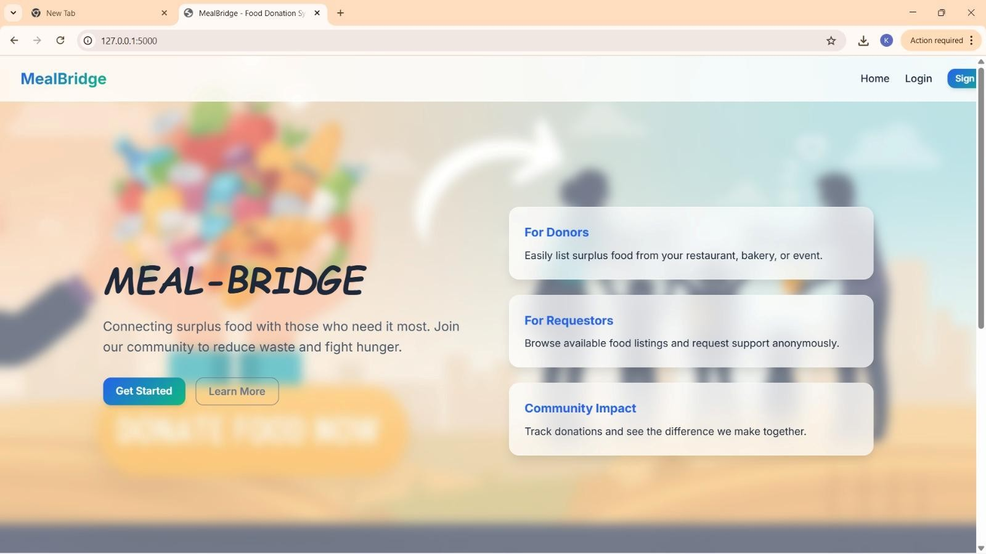
Figure 5.2.1 Home page
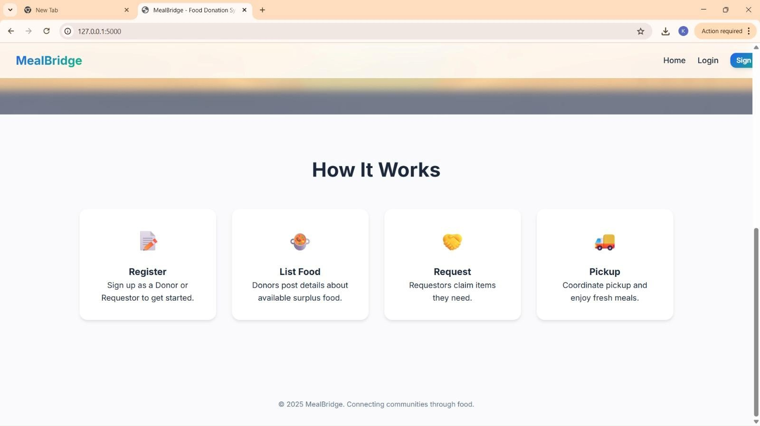
Figure 5.2.2 Workflow

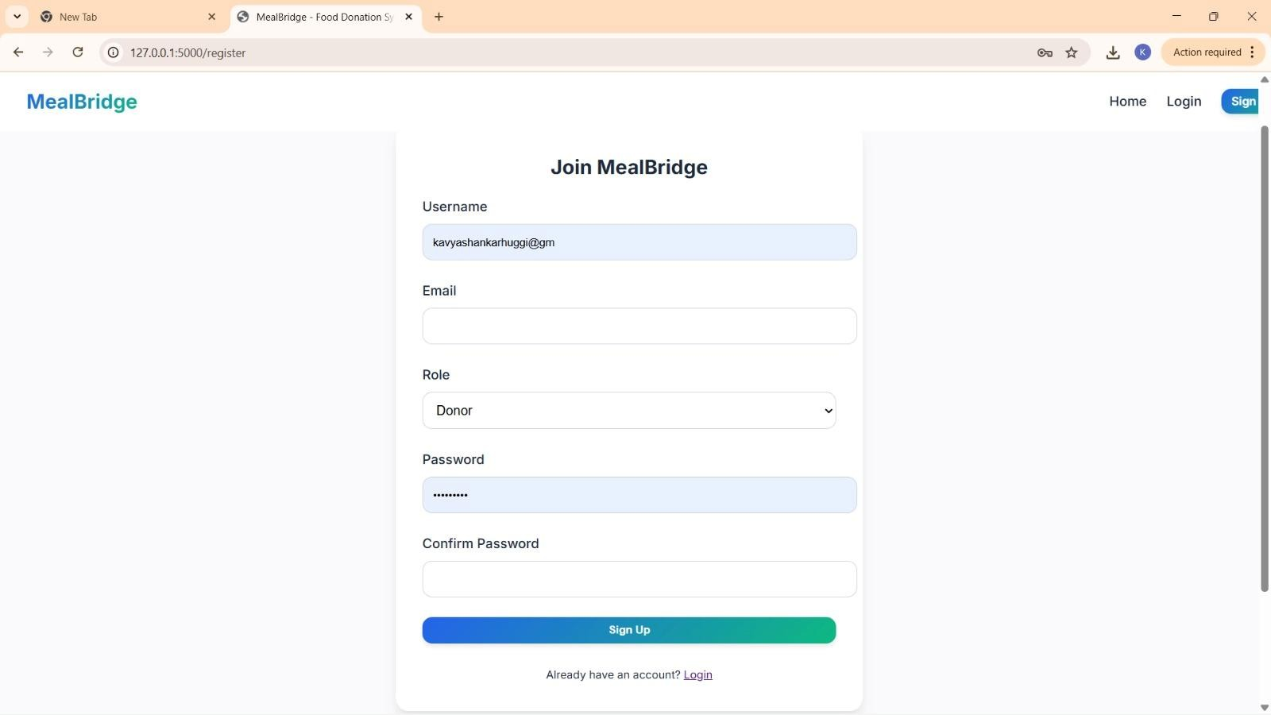
Figure 5.2.3 User Registration Page

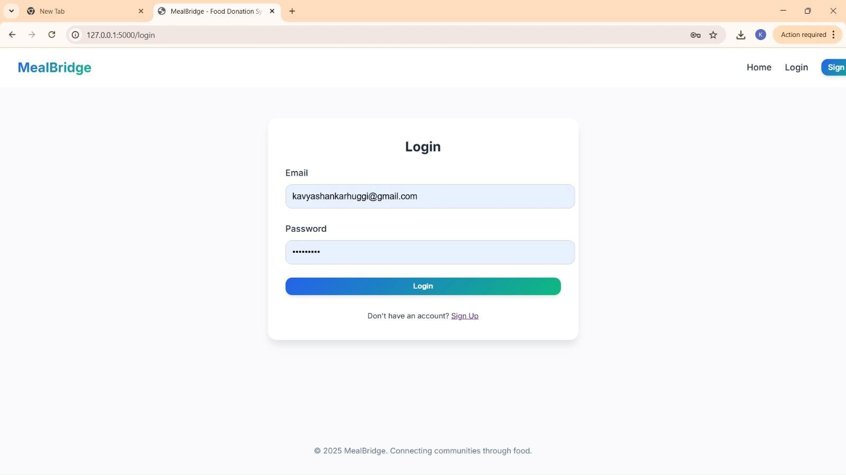
Figure 5.2.4 Login Page

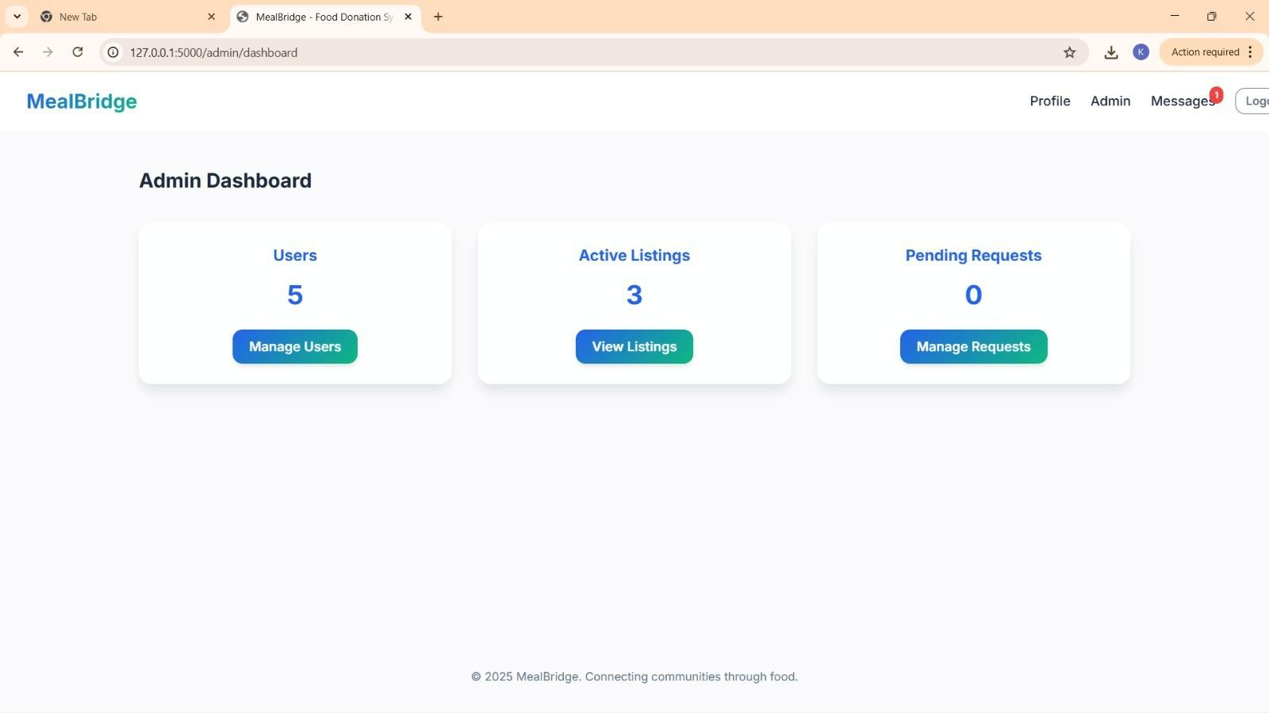
Figure 5.2.5 Admin Dashboard

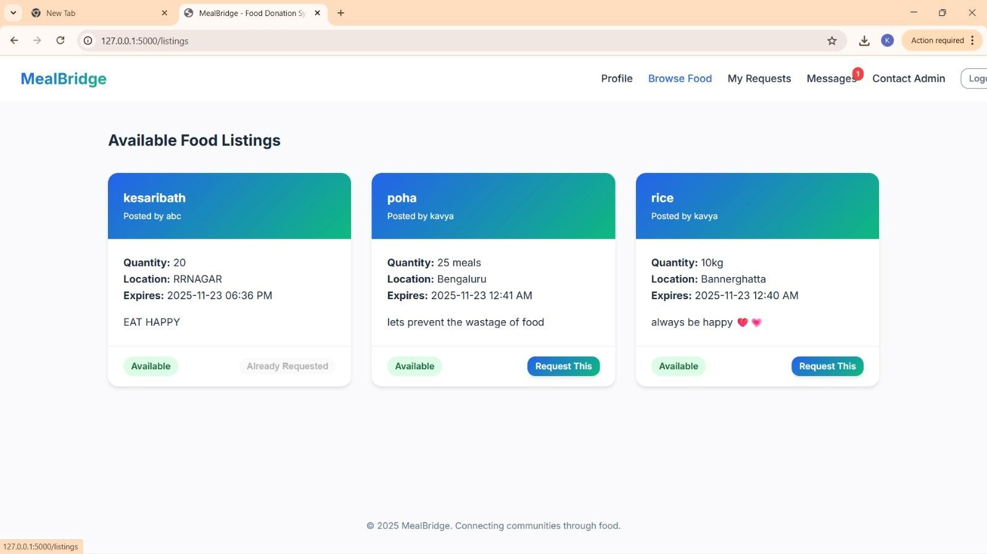
Figure 5.2.6 Available Food Listing

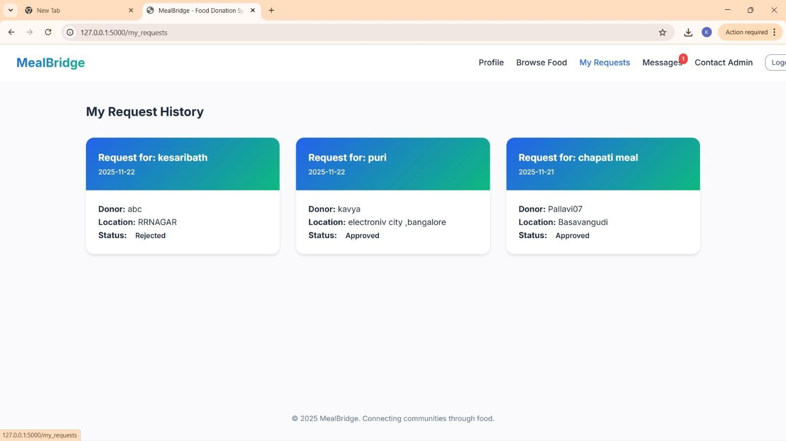
Figure 5.2.7 Requestor Dashboard
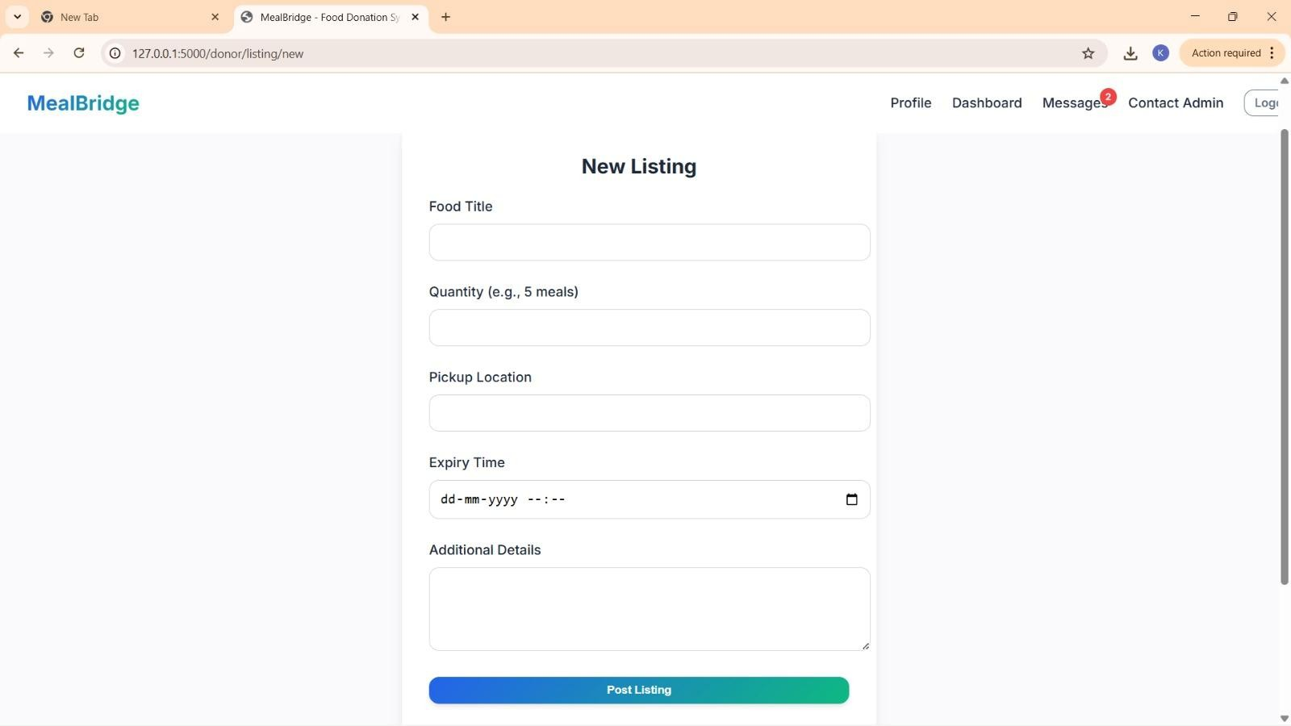
Figure 5.2.8 New Listing Interface

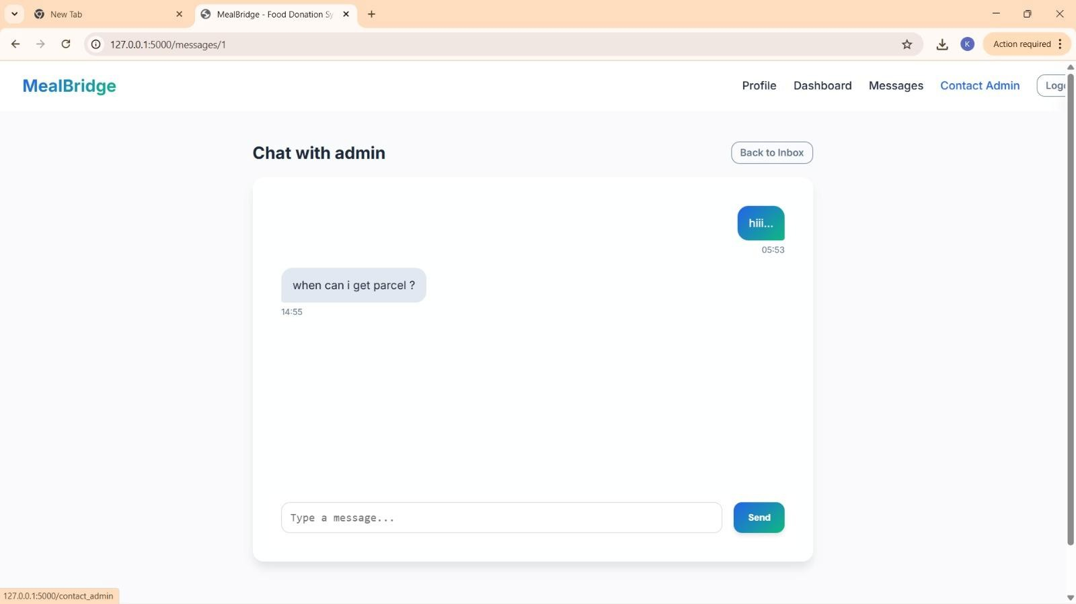
Figure 5.2.9 Communication Interface

Chapter 6 Applications and Conclusion

Chapter 6
APPLICATIONS & CONCLUSION

Applications
MealBridge is designed to reduce food wastage and improve food redistribution by connecting food donors with receivers through a digital platform. The system can be applied in various real-world environments where surplus food is generated and needs efficient.

Restaurants and Hotels
Restaurants and hotels often generate surplus food due to overproduction or cancellations. MealBridge allows these establishments to list excess food in real time, enabling nearby.

Marriage Halls and Event Management Services
Large events such as weddings and conferences generate significant amounts of leftover food. MealBridge helps event organizers donate surplus food efficiently, ensuring timely pickup and proper utilization instead of disposal.

NGOs and Food Distribution Centers
Non-governmental organizations working to fight hunger can use MealBridge to discover available food donations nearby. The platform helps NGOs coordinate pickups, manage requests, and serve food to needy people more effectively.

Educational Institutions
Colleges, schools, and hostels often have leftover food from canteens and events. MealBridge can be used to donate this surplus food to nearby shelters or communities, promoting social awareness and reducing waste

Corporate Offices and IT Parks
Corporate offices frequently organize meetings and events that result in excess food. MealBridge provides a structured way to donate this food responsibly and maintain proper coordination with receivers.

Community Welfare and Public Distribution
Local communities and volunteer groups can use MealBridge to share food resources, especially during emergencies, natural disasters, or festivals, ensuring food reaches those in need on time..

Future Scope of the Work
Although MealBridge achieves its current objectives, several enhancements can be implemented in the future to improve functionality and reach.:

Mobile Application Development
Developing a dedicated mobile application would provide easier access, faster notifications, and better user experience for donors and receivers.

Automated Notifications
SMS and push notification services can be added to alert users instantly when food is available or a request is approved.

Admin Analytics Dashboard
An advanced dashboard can be developed for administrators to analyze food donation

Integration with Government and NGOs
MealBridge can be integrated with government food programs and large NGOs to expand its impact and reach a wider population.

Quality and Safety Verification System
In the future, MealBridge can include a food quality and safety verification feature where donors upload images and preparation details of food. This helps receivers ensure the food meets basic hygiene and safety standards before collection..

Rating and Feedback Mechanism
A rating and feedback system can be introduced where donors and receivers provide feedback after each transaction. This improves trust, transparency, and reliability within the MealBridge platform.

Conclusion
MealBridge delivers a reliable and socially impactful platform for managing and redistributing surplus food in an efficient and organized manner. By digitizing the process of food donation and request handling, the system successfully addresses major challenges such as food wastage, lack of coordination between donors and receivers, and delays in food distribution. The platform bridges the gap between surplus food sources and people in need, thereby promoting sustainability and social responsibility.

Through its structured modules for user registration, food listing, request management, and real- time communication, MealBridge ensures smooth interaction among donors, receivers, and administrators. The system maintains data accuracy and transparency while simplifying the overall donation workflow. Features such as role-based access, food availability tracking, and admin communication enhance usability and trust within the platform.

The implementation of modern web technologies enables MealBridge to provide a responsive, user- friendly, and scalable solution. During testing, the system demonstrated stable performance, efficient handling of multiple requests, and accurate data management. The modular architecture makes the application adaptable to different environments such as restaurants, educational institutions, event venues, NGOs, and corporate offices.

Overall, MealBridge not only simplifies the process of surplus food redistribution but also contributes to reducing hunger and minimizing food waste. With its scalable design and scope for future enhancements, the system provides a strong foundation for wider adoption and real-world deployment. MealBridge represents a meaningful step toward building a technology-driven, sustainable, and socially responsible food sharing ecosystem. ecosystems.

References

REFERENCES
- H. Zhang, et al., “A Smart Food Donation Management System Using Web Technologies,” in
Proceedings of the International Conference on Smart Computing and Applications, 2018.
- M. A. Islam, et al., “Design and Development of an Online Food Sharing Platform to Reduce Food Wastage,” in Proceedings of the International Conference on Information Technology, 2019.
- K. Li, W. Duan, and H. Zhang, “Technology-Driven Solutions for Food Waste Reduction,” Journal
of Food Systems and Sustainability, vol. 12, no. 3, pp. 210–218, 2017.
- Y. Wang, et al., “Web-Based Applications for Community Food Redistribution,” in Proceedings of
the International Conference on Web Engineering, 2020.
- S. U. Rahman and M. Hasan, “A Digital Platform for Surplus Food Redistribution,” International
Journal of Computer Applications, vol. 176, no. 25, pp. 15–20, 2020.
- M. Sami, S. Atalla, and K. F. B. Hashim, “Introducing Innovative Food Donation Systems for Smart Cities,” in Proceedings of the International Conference on Communication Engineering and Technology (ICCET), IEEE, 2019.
- Government of India, “Food Safety and Standards Authority of India (FSSAI) Guidelines on Food Donation,” Available: https://www.fssai.gov.in

