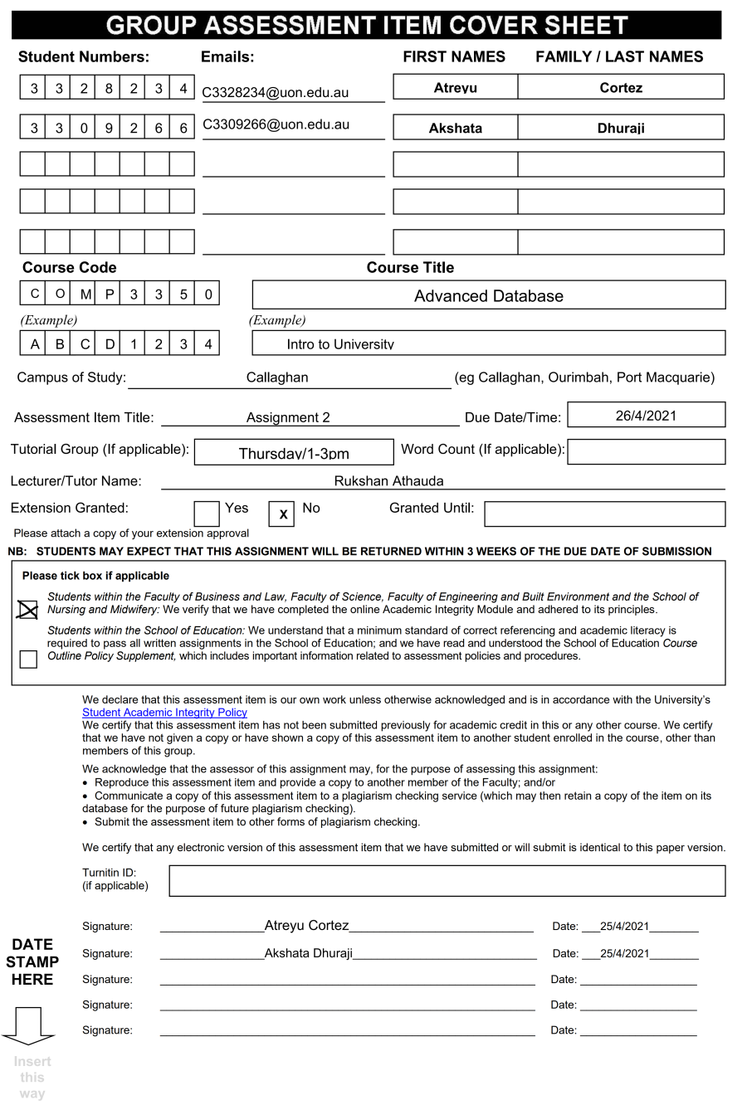

COMP3350

Business Intelligence Report

Semester 1, 2021

World Wide Importers (WWI)

**Table of Contents**

**Objectives4**

**Purpose5**

**Analysis6-13**

**Conclusion14**

**Objectives:**

The primary objective of WorldWide Importers is to ensure customer satisfaction, providing a variety of goods and services to meet the demands of existing and new customers. Recently, as part of a crucial business decision to expand market and sellable items, WorldWide Importers started to sell varieties of edible novelties such as Chili Chocolates.

The following business intelligence behind the new food handling services offered by WorldWide Importers will provide insight into its current state in the hopes of deducing possible changes to business fundamentals and/or improve current handling and finance of the newly introduced services.

**Purpose:**

World Wide Importers had not previously handled chilled items hence, to understand the progress behind the company’s new food handling services, a few key metrics were devised to understand if such food items were a success.

* The quantity of chilled items sold.
* The cost price of perished chilled items vs chilled items sold.
* The number of items sold for each chilled item vs perished chilled items.
* Sale value

**Hypothesis:**

From the key metrics mentioned above, a hypothesis can be derived:

***The cost/sale price of perished chilled goods overweight the cost/sale price of chilled items sold.***

**Analysis:**

Delving deeper into the chiller item category, it can be broken down to specific chiller items sold, according to Figure 1.

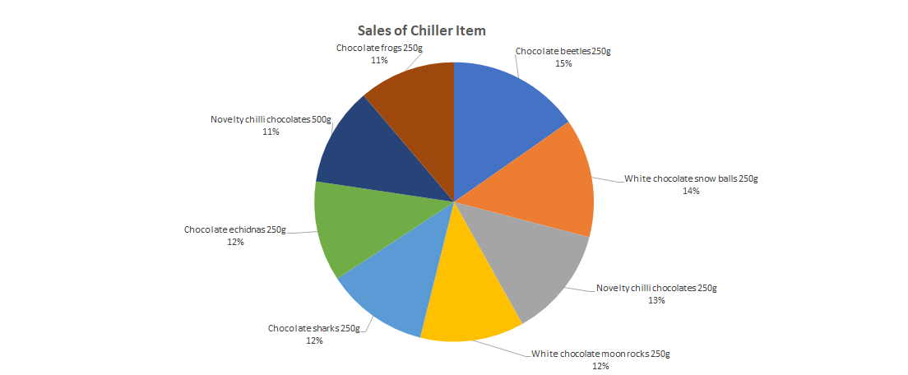

Figure 1: Percentage of chiller items sales within chiller item category

The sales of items in the category of chiller items indicates that Chocolate Beetles ($174,625.20), White Chocolate Snowballs ($157,388.40) and Novelty Chili Chocolates 250g ($146,512.80) are amongst the popular choices whilst Chocolate Frogs ($128,044.80) and Novelty Chili Chocolates 500g ($130,674.0) are the least popular items sold.

There could be a variety of reasons for such purchases:

* Greater demand for well-known chocolates consisting of the 3 chiller item categories.
* Successful marketing of the popular choices.
* Chili Chocolates (250g) are uncommon and could be purchased by curious customers as trial products resold/consumed.

However, the bottom 2 items produced lower sales than expected. Due to the success of Chili Chocolates 250g, it was assumed that Chili Chocolates 500g would also be a success due to its counterpart. Likewise, the use of animal/insect designs for such chocolates was thought to be a major hit due to Chocolate Beetle sales reaching ($174,625.20), this could have been caused by a few factors:

* Chili Chocolates that were initially trialed by other customers saw unpopular demand and dissatisfaction, again possibly due to its rarity in the realm of sweetened snacks.
* Lack of demand for chocolates shaped as animals compared to its insect counterpart.
* Affinity towards uncommon animal designs for chocolate snacks.

Thus, it can be deduced that Chocolate Beetles, White Chocolate Snowballs and Novelty Chili Chocolates 250g are amongst the popular choices that should be a key product focus. However, further analysis is needed regarding item quantities.

Next, an analysis of in-stock chiller item quantities has been observed.

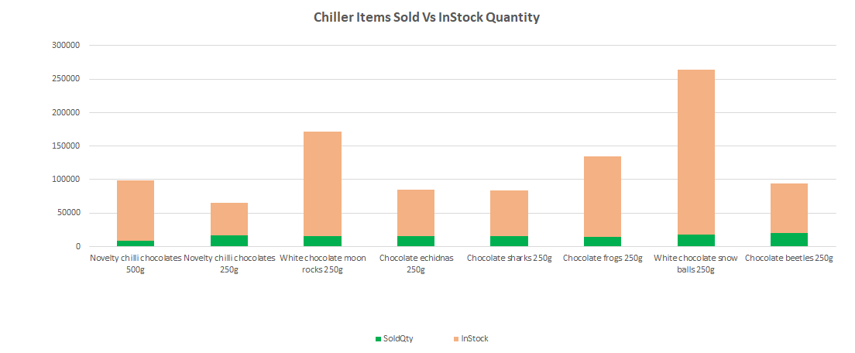

Figure 2: Quantity of chiller items sold from overall stock available

The most noticeable characteristics show that the in-stock quantities greatly outweigh the number of items sold and that White Chocolate Snowballs and Moon rocks are the top 2 most overly stocked items. From the previous analysis, chiller categories contained some meaningful insight into popular sales however after comparing the quantity of such sales made from the number of items available in stock, it can be seen that:

* White Chocolate Snowballs 250g:

Total stock-245,352

Sold- 18,480.

* Chocolate Frogs 250g:

Total Stock-74,256

Sold-20,424.

* Novelty Chili Chocolates 250g:

Total Stock-48,228

Sold- 17,136.

From the top 3 categories and an overarching problem is that there are too many items in stock whilst only a small percentage of the items are sold. There are a few possible reasons to why this happened:

* Mistakes in marketing: The introduction of the new food handling business in a diversified and well-known company such as World Wide Importers was thought to be a marketing asset in helping sell chiller items.
* Overconfidence: Due to WWI being such an established company in the San Francisco Bay Area, it was thought that existing customers could purchase other items alongside snacks whilst gaining the attention of new customers due to novelty snacks and goods. Hence by assuming a large network, it was thought that increasing the stock was a suitable choice in meeting demands.

Due to such decisions, this could cause a multitude of problems such as:

* Costs for purchasing and reselling.
* Manpower: The number of staff to distribute such large proportions would be wasted and costly.

Most importantly is the issue of perishability. The following analysis provides insight into the perishability of such items.

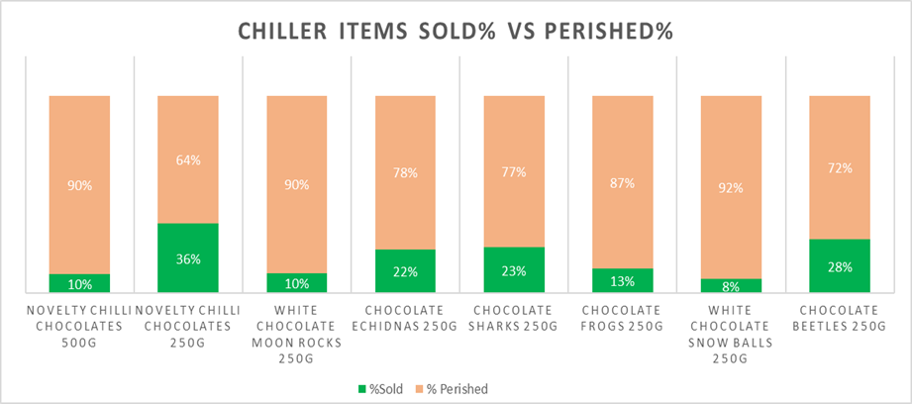

Figure 3: Percentage of perished chiller items to sold chiller items.

Due to the large stock availability of each item at WorldWide Importers and the small percentage of those items sold, many of the items will perish overtime and that is the case with the analysis shown above.

The top 3 products that perished due to its prolonged state in stock are:

* Novelty Chili Chocolates 500g: 90% perished whilst only 10% was sold. This was expected as it was one of the most unpopular items sold.
* White Chocolate Moon Rocks 250g: 90% perished whilst 10% was sold. This was unexpected as Moon Rocks were amongst the top 5 most popular items sold.
* Finally, White Chocolate Snowballs: 92% perished whilst only 8% was sold. This was the most unexpected result throughout the analysis as it was shown to be amongst the top 2 most popular items.

Hence, the rest of the perished items range from 64% to 87%, indicating that more than 60% of each item’s available stock at Wide World Importers have perished due to such large quantities housed in stock.

This can ultimately lead to a significant loss in cost and sales price of such items.



Figure 4: Sales of chiller items compared to dried items.

WorldWide Importers have made thousands of purchases from suppliers to ensure that the minimum stock threshold has been met and as such Wide World Importers must gain insight into the saleable value of such items.

Firstly, the Chiller item’s total sale value only makes up 5% of the total sales of all products sold compared to the other 95% of sales made from other goods. With a sale value of $1,074,533.02 making up the chiller items versus the $20,416,127.33 worth of sales made from other items, it can be deduced that other items were sold as frequently as the chiller items. This could be caused by:

* Lack of marketing
* Greater customer preferences towards other items
* Availability of the chilled items can be purchased elsewhere.
* Demand for chiller items is lower compared to other items.
* Customers have other networks to purchase such chilled items, possibly for a lower price.

Thus, the chiller items only make-up a small percentage of total sales, indicating a lack of purchasing and buying power of the items and due to this reason, it is believed that many items in stock perished.

Lastly, the cost price of the chiller items can be categorized under the cost of Chiller items that were eventually sold and the cost price of chiller items that perished.

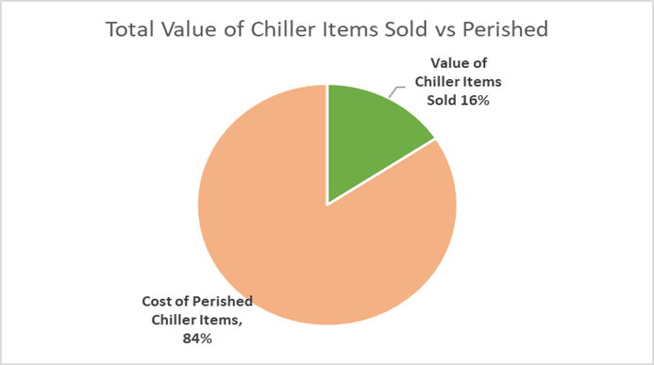

Figure 5: Total value of chiller items compared to perished.

Seen above, it is evident that the cost price for perished chiller items greatly exceed that of the cost price of chiller items that were sold. Only 16% of the chiller items purchased and resold managed to turnover a profit whilst the other 84% perished indicating a major loss in profits. This indicates that the company is turning over a loss in potential profits due to large quantities of perished goods.

**Conclusion:**

After such analysis, the main themes can be observed:

* High quantities of overstocked goods
* Animal designs for sweetened goods are unpopular.
* Chiller items are of lower demand compared to other items sold
* Cost price exceeds that of potential profits.
* Majority of stocked goods perished.
* Operating costs for cooling facilities/transport will be detrimental to the company’s finance and funding.

Thus, the following actions could take place to help mitigate such problems:

* Reduce the number of stocked items.
* If the food handling business continues, focus on the top 3 purchased items: Chocolate Beetles, White Chocolate Snowballs and Novelty Chili Chocolates 250g.
* Delve deeper into other designs for chocolates
* Focus on demographics and place particular emphasis on products purchased from specific groups.
* Place a great emphasis on marketing the food items, increase its exposure to potential customers.
* Expand locations nationally.
* Expand network too small to midsize businesses, not just well-known and established companies.