**COMP2240- Operating Systems Assignment 3**

Testing of the problems: It is tested using the S1 and S2 input files provided below are the results for both the files

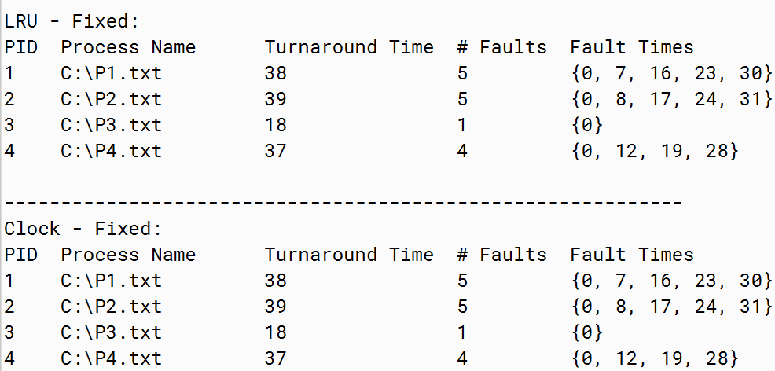

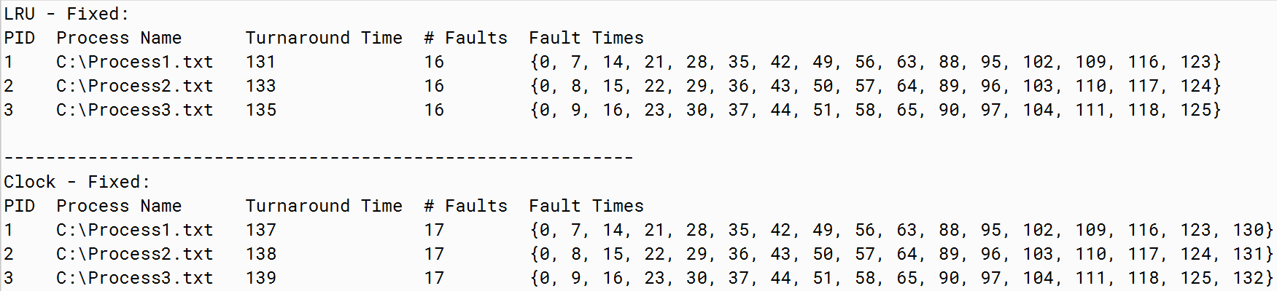

While in the first file the outputs are exactly similar for both the algorithms, however for S2, there is an additional fault and longer turnaround time for Clock algorithm. For S2 data LRU is a more suitable algorithm, though the answer to this efficiency lies in the nature of the data in S2, where the pages are repeated in a sequence. Thus, the most suitable algorithm is based on the dataset.