Database screenshots of working

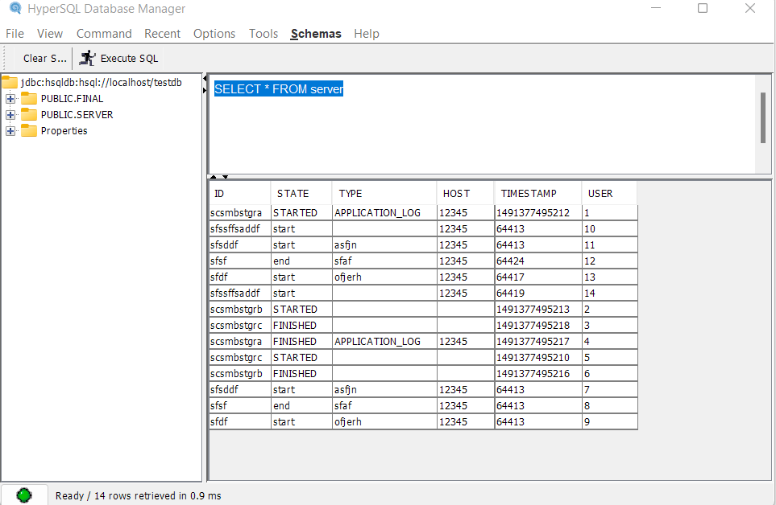

Table server screenshot

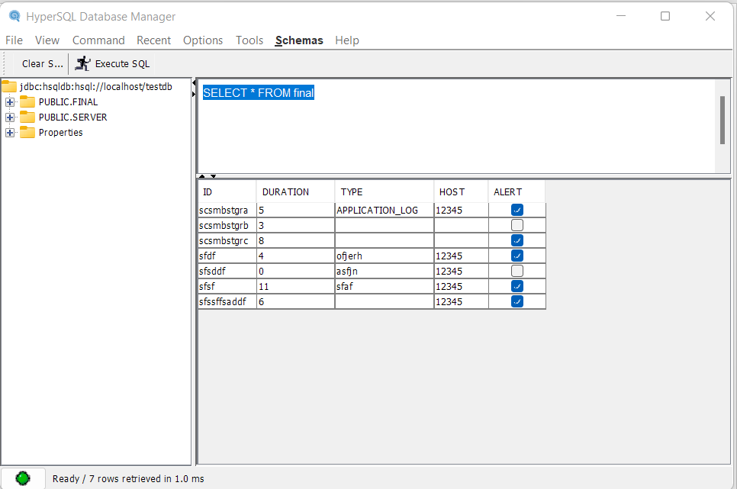

Table final screenshot

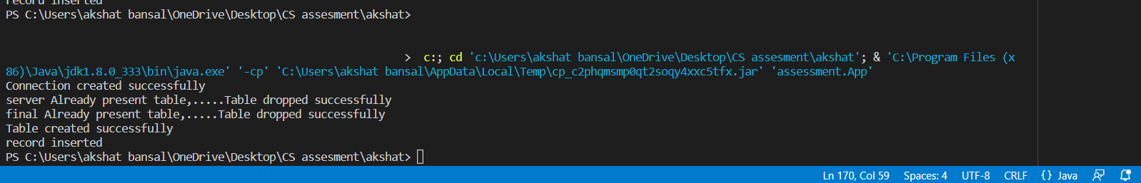

Cmd result