Description of the mobile for calculation of soil components
The mobile app viz. soilPortion is developed to estimate the components of soil viz. organic carbon, nitrogen and clay from the photo captured through camera of the mobile phone. Apart from the photo the texture of the soil is taken as an input for estimating the proportion of each component present in that instance of soil. The estimation is based on the linear regression established between the color component of the photo and the laboratory results obtained from ground. The complete workflow of the mobile app is as follows:

Step 1: After installing the application, the user is asked to provide the necessary permissions to the app to access its storage and camera.
Step 2: The user must sign in with an account into the app, in order to keep the record of the user’s work.
Step 3: Upon invoking the mobile app the user is asked to click a photo. Optionally the user can select a photo for the mobile phone as well.
Step 4: Subsequently the user is asked to select texture of the soil i.e. coarse, medium, fine.
Stage 5: The two inputs are uploaded to a server i.e. Python Flask, where the following processing takes place through python scripts:
- Conversion of the photo from RGB to LAB format

from skimage import io, color
from numpy import average
from json import dumps
from flask import Flask, request
from werkzeug.serving import WSGIRequestHandler

app = Flask(__name__)
imagefile = request.files['image'] # Getting selected image from request sent by mobile application
img = io.imread(imagefile) # Reading image
lab = color. rgb2lab(img) # Converting RGB to LAB
lightness_avg = average (lab [0]) # Average of LAB image's pixel's value

if __name__ == "__main__": # Flask server code
app.run(debug=False,port='8000')

- Estimation of the soil components using laboratory established equation.
from skimage import io, color
from numpy import average
from json import dumps
from flask import Flask, request
from werkzeug.serving import WSGIRequestHandler

# Getting selected soiltype from request sent by mobile application
typeofsoil = request.form.get('soiltype').split(".")[1]
if(typeofsoil=="mid"):
# If soiltype is medium than oraganic_c's value = 10.44-0.1998*lightness
organic_c = 10.44-0.1998*lightness_avg
elif(typeofsoil=="coarse"):
# If soiltype is Coarse than oraganic_c's value = 9.16 – 0.163* Lightness
organic_c= 9.16-0.163 * lightness_avg
else:
# If soiltype is Fine than oraganic_c's value = 7.241 – 0.1342 * Lightness
organic_c = 7.241 - 0.1342 * lightness_avg
.
.
.

- Pushing the output in JSON format to the mobile app.
from skimage import io, color
from numpy import average
from json import dumps
from flask import Flask, request
from werkzeug.serving import WSGIRequestHandler

val = {
'message':str(organic_c) # Generating JSON for sending output to mobile.
}
return dumps(val) #Sending organic carbon value to mobile.

if __name__ == "__main__": # Flask server code
app.run(debug=False,port='8000')

Stage 6: The information about the soil is now stored in the server and, it will be visible to the user in the history section of the app. Here, all the searches made by the user is stored, which will be helpful for user to look at its past work in an efficient way.

The basic architecture is shown in figure 1

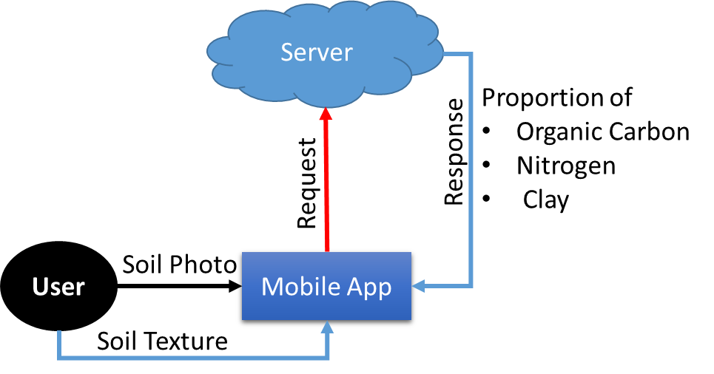

Figure 1. Architecture of the Mobile App

Wireframe of the app
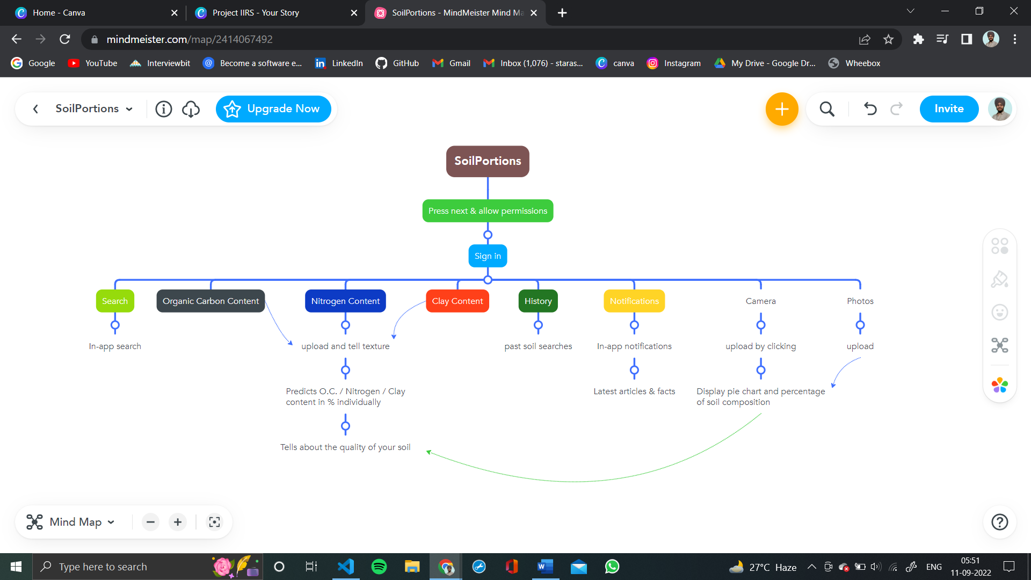

Design and Architecture of the application

