Placement Career Coach: Product Note
Akshat Chitkara · Product Manager assignment, Task 1 · October 2026 · a working prototype accompanies this note

1. The product, the user and the scope decision
The problem. Students in Semesters 3 to 6 sit through theory-heavy lectures and arrive at placement season with no clear target role, no plan for the skills it needs and no honest feedback on where they stand. A placement cell cannot coach hundreds of students one to one. The user is an undergraduate Computer Science or IT student in Semesters 3 to 6 who wants a software or IT job. The promise: choose a career, get a Semester 3 to 6 roadmap, take a short skills check, see your level and your gap, get coached on your weakest skill, follow a weekly plan, re-check, and see what improved.
Scope decision, stated plainly. The brief's examples run from Cloud Ops to an astronaut. For version one I support four computer science careers: DevOps, MEAN stack, Java backend and AI developer. Three reasons. First, technical skills have right and wrong answers that can be measured fairly; an astronaut's skills cannot be scored by a quiz. Second, these careers have widely agreed skill ladders, so a roadmap can be curated and checked instead of invented, and an invented roadmap for VLSI that nobody can verify would be worse than none. Third, depth beats breadth: four careers with questions behind every skill help students more than forty with none. A student who wants another career can leave a request that tells us what to add next, and adding a career is a content task (careers, skills, roadmap, questions), not a rewrite.
How we would know it works. Weekly plan completion (tasks done over tasks given); re-check rate within 10 days of a coaching plan; skill-gap closure (change in the weakest skill between checks); and level progression per semester.

2. The student's journey, and what brings them back every week
Stage | The student thinks | The product does
1 Choose | “Which role?” | Four careers, each showing what it is, what you do day to day and how you can grow
2 Plan | “What do I learn, and when?” | A road of 16 monthly stops across Semesters 3 to 6, each with topics and a deliverable
3 Baseline | “Where do I stand?” | A 12-question check on this semester's skills: level, per-skill scores, a “you are here” marker
4 Improve | “What do I fix first?” | A practice plan for the weakest skill; each task is tied to a question they missed, and a coach answers follow-up questions
5 Weekly | “What do I do this week?” | 3 to 5 tasks laid over seven days, at most four hours, ending with a re-check date
6 Re-check | “Did it work?” | Seven days later: new, unseen questions on the same skills, compared with last time
7 Ready | “Am I placement-ready?” | A full-path check across every roadmap skill, the only route to the Industry-ready level

Why they return each week. There is always one concrete thing to do, not a reading list: a weekly plan sized to the hours they have. There is exactly one weakest skill to fix, so the next step is never unclear. Progress is visible and close: the “you are here” marker moves along the road as each module quiz is passed, a result says “6.7 points to Advanced”, and a re-check shows “Linux 33% to 67%”. Small wins are rewarded with XP, ranks and badges, so effort counts before the score moves. Reminders and streaks come later, once the product records weekly activity.

3. The system: one controller that decides, and agents that each do one job
The product is one controller and five agents. The controller owns the journey and every decision about what happens next; each agent has a single job and may only compute, draft or explain. Anything an AI writes is checked by code before a student sees it, and each agent has a curated fallback, so no AI step can leave a student stuck.
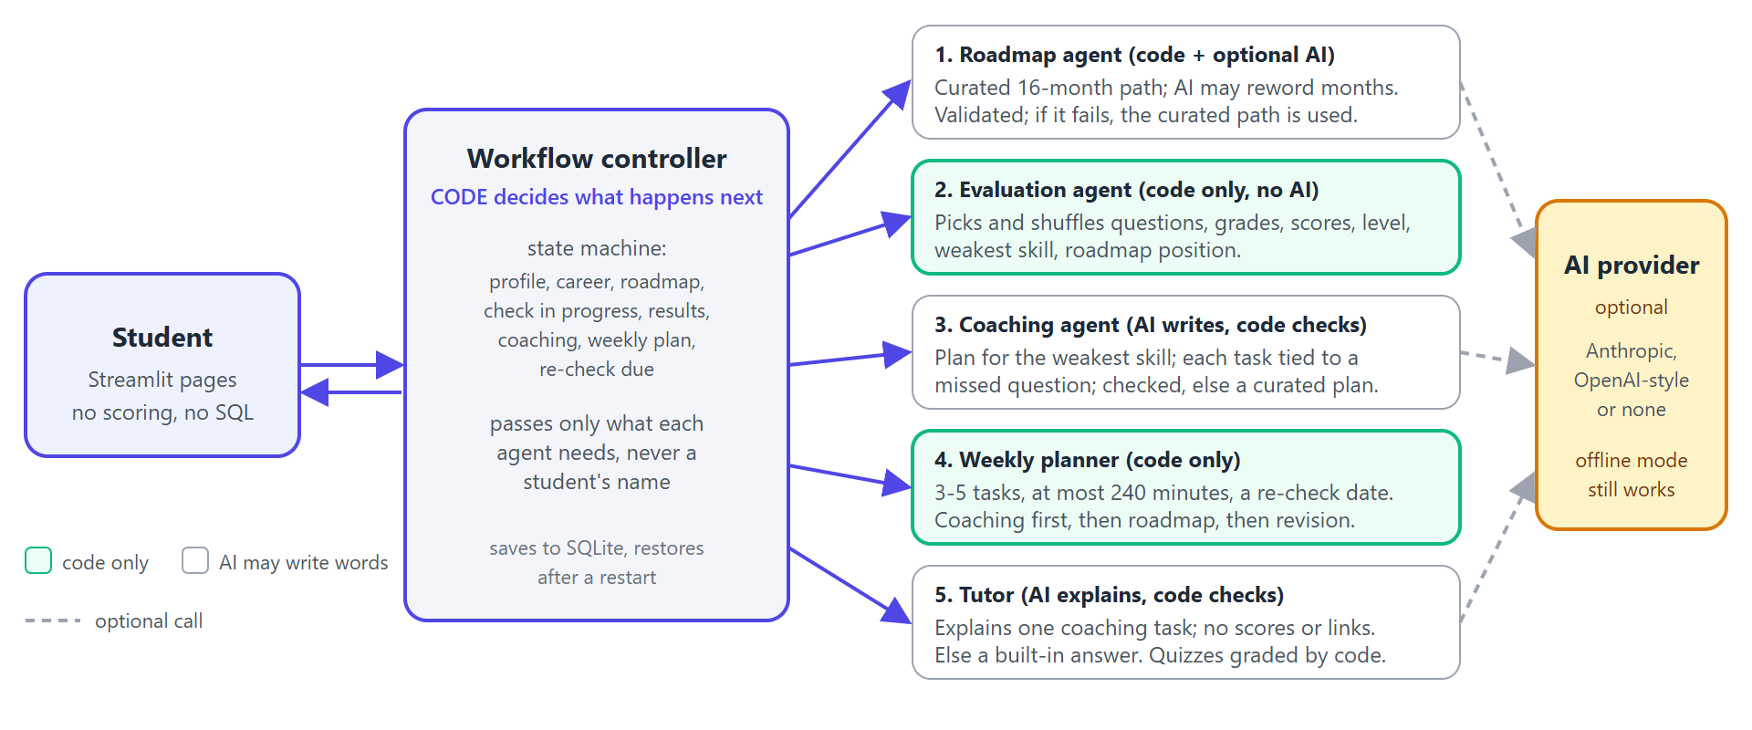
Part | Responsible for | AI or code
Workflow controller (orchestrator) | Moves the student through the states (roadmap ready, check in progress, results, coaching, weekly plan, re-check due), decides what happens next, saves progress | Code
Roadmap agent | Supplies the curated 16-month path for the career. AI may reword months, but a validator rejects any change to skill order, any missing or invented skill and any link; then the curated path is used | Code, AI wording
Evaluation agent | Picks questions with a fixed difficulty mix, shuffles options, grades, and computes skill scores, the level, the weakest skill and the position on the roadmap | Code only
Coaching agent | Writes a short plan for the weakest skill. Every task must link to a missed question; a plan that fails the checks is replaced by a curated one built from the same mistakes | AI writes, code checks
Weekly planner | Builds the week by rules: up to two coaching tasks, then the next roadmap topic, then revision, always ending with the re-check | Code only
Tutor | Explains one coaching task on request and runs a short practice quiz graded by code. Typed questions are screened before any AI call, and replies that mention scores, leak instructions or contain links are rejected | AI explains, code checks

Who decides what happens each week, and what is passed. The controller decides, by rules and never by AI. After each check: a skill at 60 or more counts as mastered and the roadmap marker moves on (60 to 79 also gets one revision task); 40 to 59 stays active and gets a new plan from the new mistakes; below 40 also produces a ready-to-send message asking a mentor for help. Information moves in one direction through narrow contracts: the evaluation agent gives the coaching agent only the weakest skill and the questions missed (never the student's name), the coaching agent gives the planner its tasks, and the planner gives the controller the week. Every AI step has a validator and a curated fallback, so with no AI at all the product still works.
Agents I would add later: a voice-interview agent and a rubric marker for written and assignment work, a content-review agent that flags weak questions, and a nudge agent for reminders. Choosing the assessment method is a rule, not an agent (next section).

4. Choosing the assessment method, and keeping scoring consistent and fair
Skill type | Method | Why | Status
Knowledge (Linux commands, SQL, HTTP) | Multiple-choice quiz | Objective, fast, repeatable | Built
Reasoning and design | Written answer marked against a rubric | Shows thinking, not recall | Later
Applied building (Docker, Terraform, APIs) | Hands-on assignment with a checklist | Proves the student can do it | Later
Communication, interview skills | Voice interview against a rubric | Tests articulation | Later

The rule. The method follows the skill's type, decided in code. If a method is not built yet, the skill is shown as “assessed later” and is never quietly scored with a quiz instead; the result is labelled a baseline knowledge check, not a hiring verdict.
Scoring that is the same for everyone. A question is right or wrong; a skill score is right over answered; the overall score is total right over total answered, with no hidden weights. Fairness comes from a fixed test shape: three questions per skill (easy, medium, hard), shuffled options, at least two answers before a skill counts as evidence, and a re-check that draws unseen questions first from a bank of at least six per skill. No AI takes part in grading. Each attempt stores the settings it was scored with, so changing a threshold later never rewrites an old result. For rubric-based methods the same principle holds: fixed criteria scored 0 to 4, converted to the same 0 to 100 skill score, with a person sampling the marks.
Levels. Below 40 is Beginner; 40 to 64.9 Intermediate; 65 to 84.9 Advanced; 85 and above Industry-ready, but only if every tested skill is at least 60 and the check covered every core skill of the career. A semester check covers a quarter of them, so it caps at Advanced and says why; the 28-question full-path check is the way to Industry-ready.
Worked example (DevOps, Semester 3). Linux 1 of 3, Shell 1 of 3, Python 2 of 3 and Git 2 of 3 give 6 of 12, which is 50.0%, Intermediate. Linux and Shell tie at 33.3%, and the earlier skill on the roadmap wins the tie, so Linux is the weakest skill, the student stands at Semester 3, Month 1, and the plan has three to five Linux tasks tied to the two Linux questions missed.

5. What I would build first, next and later, and what I would leave out
When | What | Why this order
First | Career choice; roadmap; semester check; deterministic scoring and levels; weakest skill; coaching plan; weekly plan with a re-check date; saved progress | These are the three parts of the brief, and the weekly loop is what makes the product worth using. Without trustworthy scoring nothing else can be trusted
Next | Re-check and progress view; full-path check for Industry-ready; a coach students can question; module quizzes with XP, ranks and badges; optional AI wording | Each needs the first set to exist, and each adds retention or trust once the loop works
Later | Written, assignment and voice assessments; a career finder for undecided students; more careers beyond computer science; a teacher view; reminders and streaks | They need rubrics, reviewed content or an institution to run them
Left out | Logins and roles, proctoring, leaderboards, a job marketplace, AI-written answer keys, agent frameworks | The brief did not ask for them; proctoring and leaderboards can harm learning; an AI answer key is unfair when it is wrong; frameworks add risk without proving the idea

Where the prototype stands. Built and tested: four careers, 64 roadmap months, about 320 questions, the full journey with and without an AI, the full-path check, the coach with its guardrails, and about 600 automated tests, 38 of them in a real browser. Not built: the three other assessment methods, the career finder, any career outside computer science, accounts and reminders.
Risks I would deal with before a pilot. The questions were drafted with AI help and have not been reviewed by a subject expert, and a level is only as trustworthy as its questions, so that review comes first. Roadmaps are curated, not generated per student, so personalisation today comes from the assessment and the weekly plan. And a quiz measures knowledge, not the ability to build, which is why the applied-skill assessments are the next investment.

