**CS699 Project Proposal**

**Team**: Swarupananda Dhua(22M2102), Akshat Gautam(190110004)

**Project Idea:** The name of the Game is “COVID Combat”. It’ll be a game running in 2D. There will be a battlefield consisting of empty places and obstacles through which the active objects of the game can walk and interact. The Player of the Game will have an unlimited supply of bullets using which he’ll kill the Coronaviruses. On the other hand, Coronaviruses will multiply at a certain rate and they’ll always come towards the Player and if they come in contact with the Player, the game will be over.

If time permits, we’ll add other healthy human beings and they’ll get infected but shooting them is not allowed (will cause deduction of points). All human beings will automatically recover after a certain period of time if not infected further.

If time permits, we’ll make the 2D game look like 3D using Raycasting. We’ll also add some other passive objects such ass buildings, sky, hills, trees to make the game look better.

**Technologies:**

Python and Pygame for coding the logic

Latex for creating user manual/documentation for the game

HTML/CSS for updating the status of the development.

**Progress as on 09/10/2022**

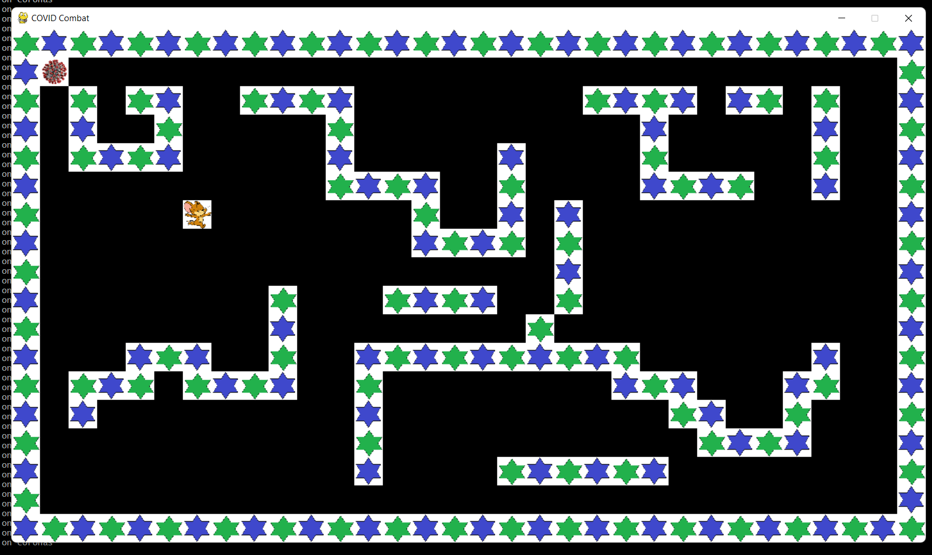

Following picture is a screenshot of the game:

1. Grid for the playground has been made.
2. The Player and Coronaviruses have been added but their behaviours are not yet fully functional.
3. Sound effects (for background music and player move) have been added.

**Next steps:** Collision detection between Player and Coronavirus, Shooting Bullets by the Player, Collision Detection between Bullet and Coronavirus.