A Software requirements specification

on

Product and Credentials NFT Platform for Business

Submitted in Partial Fulfillment for the Award of Degree of Bachelor of Technology in Computer Science and EngineeringfromRajasthan Technical University, Kota

**

**MENTOR: SUBMITTED BY:**

**Dr. Nilam Choudhary Akshat Gadodia 19ESKCS021**

(Dept. of Computer Science & Engineering) **Akshita Sharma 19ESKCS027**

**COORDINATOR:**

**Mr. Kailash Soni**

(Dept. of Computer Science & Engineering)

DEPARTMENT OF COMPUTER SCIENCE & ENGINEERING



**SWAMI KESHWANAND INSTITUTE OF TECHNOLOGY, MANAGEMENT & GRAMOTHAN**

**Ramnagaria (Jagatpura), Jaipur – 302017**

**SESSION 2022-23**

**Table of Contents**

1. Introduction
2. Methodology
3. Purpose
4. Scope
5. Definitions, Acronyms and Abbreviations
6. Tools Used
7. Technologies to be used
8. Overview
9. Overall Description
   1. Product Perspective
   2. Software Interface
   3. Hardware Interface
   4. Communication Interface
   5. Constraints
   6. E-R Diagram
   7. Use-Case Model Survey
   8. Architecture Design
   9. Database Design
10. Specific Requirements
    1. Use-Case Reports
    2. Activity Diagrams
    3. Sequence Diagrams
11. References

**Introduction**

* 1. **Methodology**

**Rational Unified Process:**

The Rational Unified Process brings together elements from all of the generic process models, sup-ports iteration and illustrates good practice in specification and design. The RUP is normally described from three perspectives:

* A ***dynamic perspective*** that shows the phases of the model over time.
* A ***static perspective*** that shows the process activities that are enacted.
* A ***practice perspective*** that suggests good practices to be used during the process.

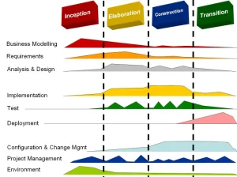

**Fig 1.1: Phases of RUP**

The different phases in RUP are:

* **Inception**

The goal of the inception phase is to establish a business case for the system. Identifying all external entities that will interact with the system and defining these interactions. This information is used to assess the contribution of a system to business.

* **Elaboration**

The goals of the elaboration phase are to develop an understanding of the problem domain, establish an architectural framework, develop project plan and identify key project risks.

* **Construction**

This phase is concerned with system design, programming and testing. Parts of the system are developed in parallel and integrated during this phase.

* **Transition**

This is the final phase of RUP and is concerned with moving the system from the development com-munity to the user community and making it work in real environment.

* 1. **Purpose**

The purpose of the Product and Credentials NFT Platform for Businesses is to provide a comprehensive and secure platform for businesses to create and manage NFTs of their physical and virtual products, as well as non-transferable documents such as certificates, diplomas, and degrees. This platform aims to enhance the authenticity and value of the products and documents by creating a unique and tamper-proof digital asset that can be easily verified by customers and other stakeholders.

The platform also aims to provide businesses with an efficient and cost-effective way of managing their product and credential data, eliminating the need for manual record-keeping and reducing the risk of data loss or theft. Additionally, the platform offers businesses the opportunity to reward their customers with a valuable and unique digital asset, which can help to build customer loyalty and trust.

Through the Product and Credentials NFT Platform for Businesses, businesses can also gain access to a wider market of buyers and investors who are interested in investing in unique and valuable digital assets. The platform provides a secure and transparent marketplace for buying and selling NFTs, offering businesses a new revenue stream and investment opportunity.

Overall, the Product and Credentials NFT Platform for Businesses aims to revolutionize the way businesses manage and monetize their products and credentials, providing a secure and efficient platform for creating, managing, and trading unique and valuable digital assets.

* 1. **Scope**
* Provide businesses with a platform to create and manage NFTs of their products, digital credentials, and other relevant assets.
* Enable businesses to offer unique and valuable assets to their customers through the creation of product and credential NFTs.
* Allow for easy verification of authenticity of NFTs, providing customers with increased trust in the businesses they purchase from.
* Offer a secure and reliable platform for businesses to manage and track their NFTs and associated assets.
* Provide businesses with tools to customize and brand their NFTs, allowing them to showcase their products and credentials in a unique way.
* Offer support and assistance to businesses throughout the NFT creation and management process, including guidance on best practices and technical issues.
* Continuously improve and update the platform based on feedback from businesses and users, ensuring it remains up-to-date and meets the evolving needs of the market.
* Expand the scope of the platform to include additional features and services that enhance the value of NFTs for businesses and customers alike.
  1. **Definitions, Acronyms and Abbreviations**
* **NFT (Non-Fungible Token)**

A unique digital asset that is verified on the blockchain network. Blockchain: a decentralized, distributed digital ledger that records transactions & information securely & transparently.

* **UML (Unified Modeling Language)**

It is a standard language for writing software blueprints. The UML may be used to visualize, specify, construct and document.

* **XML (Extensible Markup Language)**

It is a text based format that lets developers describe, deliver and exchange structured data between a range of applications to client for display and manipulation.

* **HTTP (Hypertext Transfer Protocol)**

It’s a service protocol.

* **DAO (Decentralized Autonomous Organization)**

A decentralized autonomous organization, sometimes called a decentralized autonomous corporation, is an organization constructed by rules encoded as a computer program that is often transparent, controlled by the organization's members and not influenced by a central government.

* 1. **Tools Used**
     1. **Application architecture – Node.js, Express.js, Next.js**
* **Node.js**

Node.js is an open-source, cross-platform, back-end JavaScript runtime environment that runs on a JavaScript Engine and executes JavaScript code outside a web browser, which was designed to build scalable network applications.

* **Express.js**

Express.js, or simply Express, is a back end web application framework for Node.js, released as free and open-source software under the MIT License. It is designed for building web applications and APIs. It has been called the de facto standard server framework for Node.js.

* **Next.js**

Next.js is an open-source web development framework created by Vercel enabling React-based web applications with server-side rendering and generating static websites

* + 1. **Development Tool**
* **Visual Studio Code**

Visual Studio Code, also commonly referred to as VS Code, is a source-code editor made by Microsoft for Windows, Linux and macOS. Features include support for debugging, syntax highlighting, intelligent code completion, snippets, code refactoring, and embedded Git.

* **Remix IDE**

Remix IDE, is a no-setup tool with a GUI for developing smart contracts. Used by experts and beginners alike, Remix will get you going in double time. Remix plays well with other tools, and allows for a simple deployment process to the chain of your choice. Remix is famous for our visual debugger.

* + 1. **Database platform – MongoDB**

MongoDB is a source-available cross-platform document-oriented database program. Classified as a NoSQL database program, MongoDB uses JSON-like documents with optional schemas. MongoDB is developed by MongoDB Inc. and licensed under the Server Side Public License which is deemed non-free by several distributions.

* + 1. **Design tool - Creately**

Creately is a SaaS visual collaboration tool with diagramming and design capabilities designed by Cinergix. Creately has two versions: an online cloud edition and a downloadable offline edition for desktop which is compatible with Windows, Mac and Linux.

* + 1. **1.5.5 Web server – Node Server**

A Node.js server makes your app available to serve HTTP requests. It provides the interaction between users and your application. Creating and starting a server is easy with Node.js's built-in http module. Node. js runs on chrome v8 engine which converts JavasSript code into machine code, it is highly scalable, lightweight, fast, and data-intensive.

* 1. **Technologies to be used**
* MongoDB : Non-Relational Database Management System.
* Git, Github : Version Control System
* Next.js : Front End Web Development
* Node.js, Express.js : Web Development
* Goerli : Blockchain Technology
* Solidity : Smart Contract Programming Language
* Vercel : Cloud Hosting Service
* Web3.js, Ethers, Wagmi : Blockchain Integration Libraries
  1. **Overview**

**Existing System:**

* Aims to provide a unique and valuable asset to customers in the form of NFTs.
* The platform allows businesses to create NFTs of their physical and virtual products, as well as their digital credentials such as diplomas, certificates, and other documents.
* Customers can easily verify the authenticity of their purchases and credentials by accessing the NFTs through a blockchain-based system.
* The platform offers a secure and transparent way for businesses to manage and track their products and credentials.
* The system also provides analytics and insights to businesses to help them improve their products and services based on customer preferences and feedback.
* The platform is built using cutting-edge blockchain technology and smart contract systems to ensure high security and reliability of the NFTs.
* The platform offers a user-friendly interface for both businesses and customers to manage and access their NFTs.
* The system is scalable and customizable, allowing businesses to tailor the platform to their specific needs and requirements.
* The system is scalable and customizable, allowing businesses to tailor the platform to their specific needs and requirements.
* The system is scalable and customizable, allowing businesses to tailor the platform to their specific needs and requirements.

**Drawbacks:**

* Lack of understanding and adoption
* Limited access
* Limited regulatory framework

**Proposed System:**

* Creation of a blockchain-based platform that allows businesses to create NFTs of their physical and virtual products, as well as digital credentials like diplomas and certificates.
* Creation of a blockchain-based platform that allows businesses to create NFTs of their physical and virtual products, as well as digital credentials like diplomas and certificates.
* The platform will also provide a marketplace where customers can trade their NFTs, creating a new ecosystem of digital assets.
* The platform will utilize smart contracts to automate processes such as payment and transfer of ownership.
* The platform will integrate with existing e-commerce and education systems to streamline the process of creating and verifying NFTs for businesses and customers.

**Our Plan:**

* Research and development.
* Platform development.
* Partner with businesses.
* Marketing and promotion.
* Ongoing support and maintenance.

**Overall Description**

* 1. **Product Perspective**

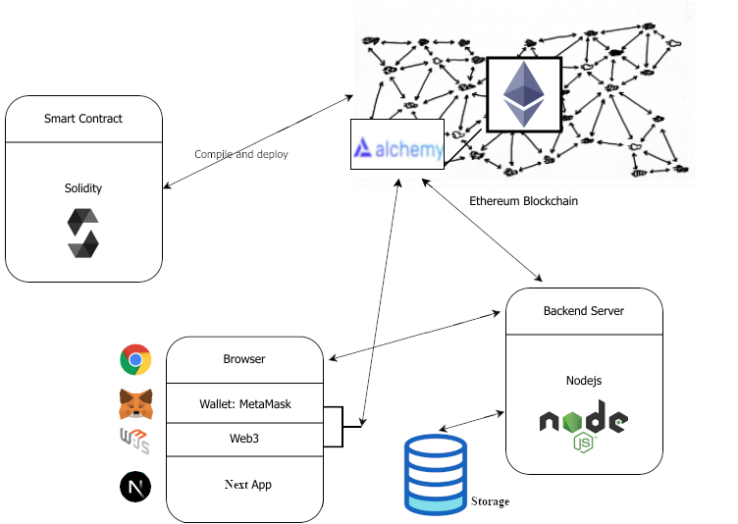

**Fig 2.1: Product Perspective**

* 1. **Software Interface**
* **Client on Internet**

Web Browser, Operating System (any)

* **Client on Intranet**

Web Browser, Operating System (any)

* **Web Server**

Node.js Server, Operating System (any)

* **Blockchain**

Goerli, Operating System (any)

* **DataBase Server**

MongoDB, Operating System (any)

* **Development End**

Node.js, Express.js, React.js, JavaScript, OS(Windows)

* 1. **Hardware Interface**

**Minimum Requirements:**

| **Client Side** | | | |
| --- | --- | --- | --- |
|  | **Processor** | **RAM** | **Disk Space** |
| Google Chrome | Intel Pentium III or AMD -800 MHz | 1 GB | 100 MB |

| **Server Side** | | | |
| --- | --- | --- | --- |
|  | **Processor** | **RAM** | **Disk Space** |
| Node.js | Intel Pentium III or AMD -800 MHz | 1 GB | 3.5 GB |
| MongoDB | Intel Pentium III or AMD -800 MHz | 512 MB | 500 MB  (Excluding Data  Size) |
| Goerli | Intel i3 Processor or AMD Ryzen 3 | 4 GB | 1 GB  (Excluding Data  Size) |

**Recommended Requirements:**

| **Client Side** | | | |
| --- | --- | --- | --- |
|  | **Processor** | **RAM** | **Disk Space** |
| Google Chrome | Intel i3 Processor or AMD Ryzen 3 | 4 GB | 1 GB |

| **Server Side** | | | |
| --- | --- | --- | --- |
|  | **Processor** | **RAM** | **Disk Space** |
| Node.js | Intel i3 Processor or AMD Ryzen 3 | 4 GB | 3.5 GB |
| MongoDB | Intel i3 Processor or AMD Ryzen 3 | 2 GB | 1 GB  (Excluding Data  Size) |
| Goerli | Intel i5 Processor or AMD Ryzen 5 | 16 GB | 1 GB  (Excluding Data  Size) |

* 1. **Communication Interface**
* Clients (business) on the Internet will be using HTTP/HTTPS protocol.
* Server on Blockchain will be using the HTTP/HTTPS protocol.
  1. **Constraints**
* GUI is only in English.
* Web3 wallet (such as Metamask) is used for the identification of users.
* Only registered businesses will be authorized to use the services.
* This system is working for a single server.
  1. **E-R Diagram**

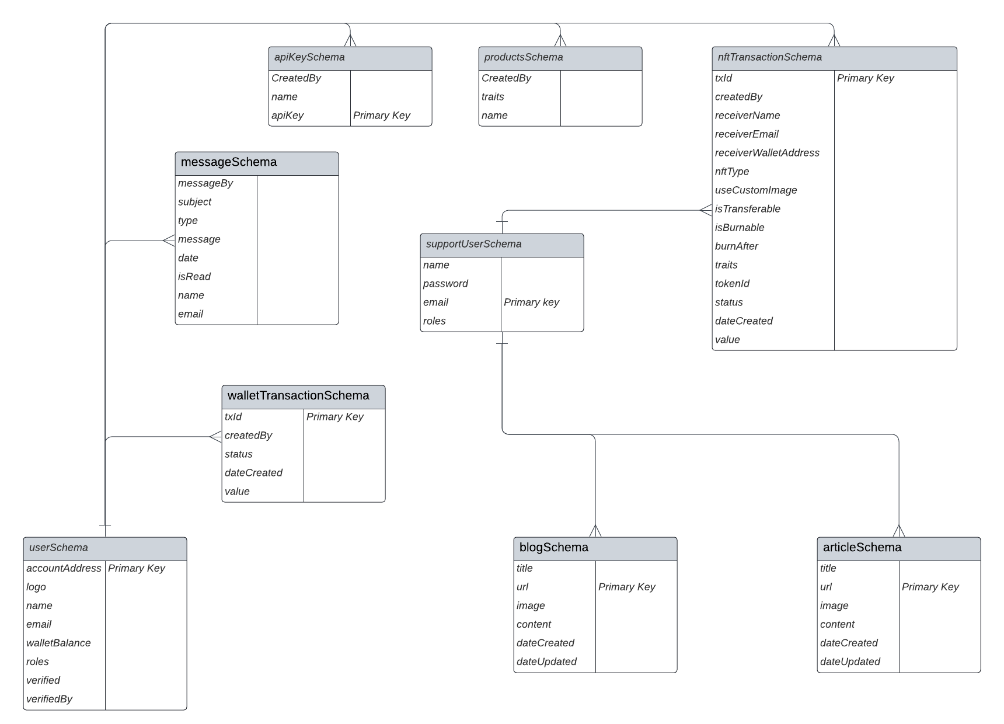

**Fig 2.2: E-R Diagram**

* 1. **Use Case Model Survey**

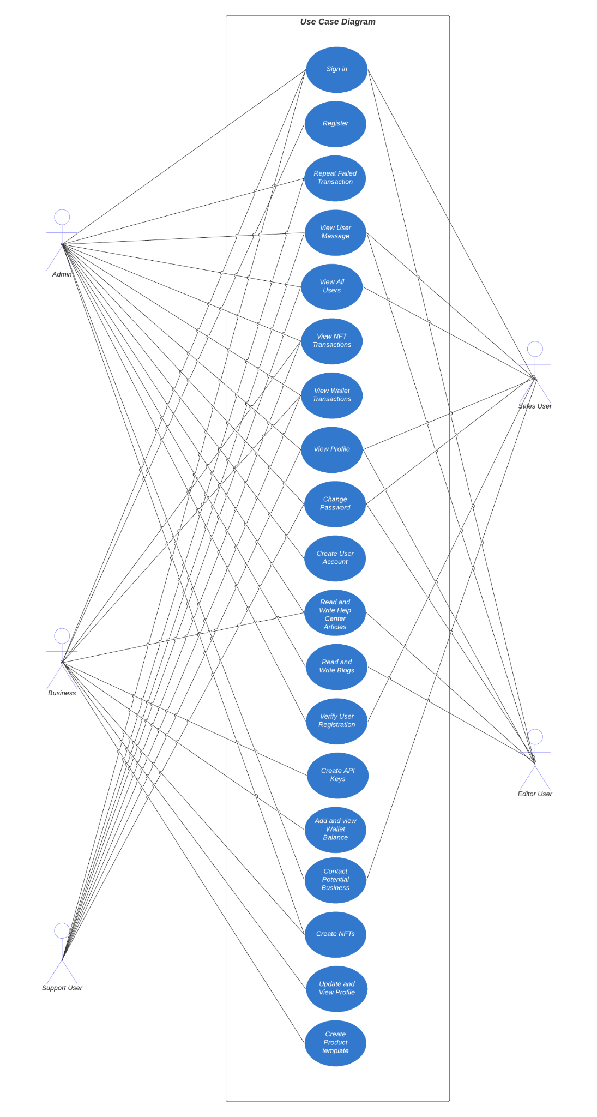

**Fig 2.3: Use Case Model Survey**

* **Business:**

Business users can create and manage NFTs for their physical and virtual products, as well as for their documents such as certificates and diplomas. They can authenticate their NFTs and connect with potential buyers or clients on the platform.

* **Support User:**

Support users can assist other users with their transactions on the platform, including troubleshooting issues related to buying, selling, or verifying NFTs. They can provide guidance on using Web3 wallets and ensure that the platform operates smoothly and securely.

* **Sales User:**

The sales user can verify user registration and assist them with their sales on the platform. They ensure a smooth sales process and help buyers and sellers navigate the platform.

* **Editor User:**

The editor user can create and manage blog posts and help articles on the platform, ensuring that they are informative, accurate, and engaging. They work closely with other teams to ensure that the content aligns with the platform's goals and values.

* **Admin:**

The admin user has complete control over the platform and can perform all tasks related to user management, content management, and system administration. They ensure that the platform is running smoothly and securely, and that all users and content adhere to the platform's policies and guidelines.

* 1. **Architecture Diagram**



**Fig 2.4: Architecture Diagram**

* 1. **Database Design**



**Fig 2.5: Database Design**

**Specific Requirements**

* 1. **Use Case Reports**
     1. **Business use-case report**

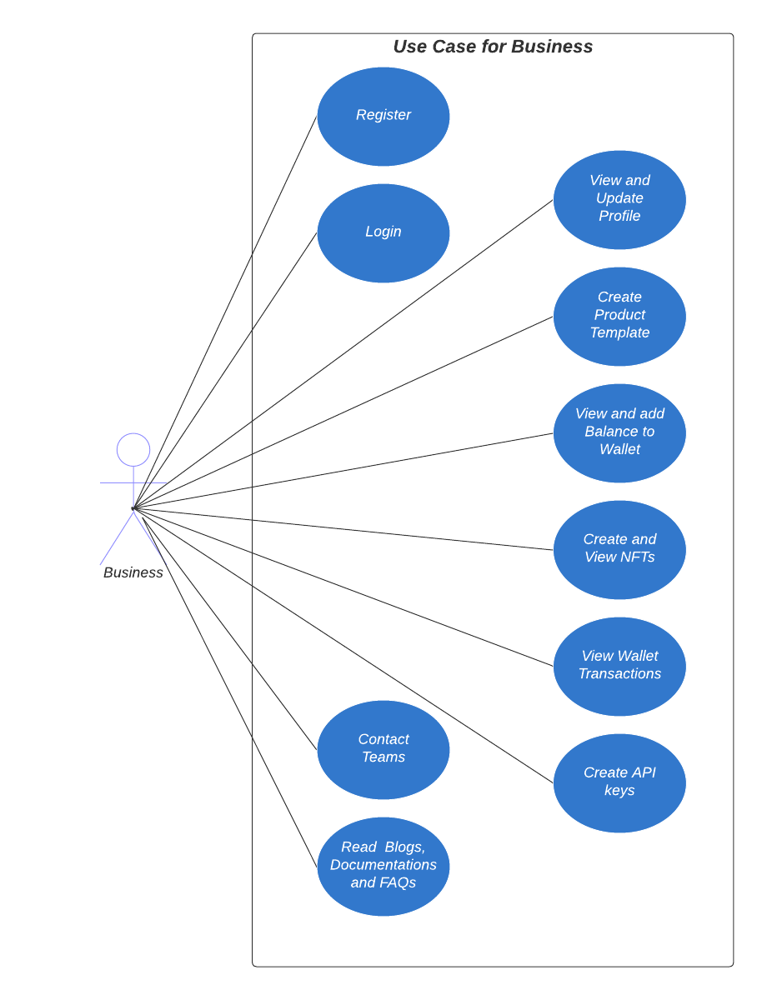

**Fig 3.1: Use case diagram for business**

| **Use Case** | **Description** |
| --- | --- |
| Register | Register for an account on the platform |
| Login | Login to the platform using a Web3 wallet |
| View profile | View their profile |
| Update profile | Update their personal information |
| Create product template | Contact support, sales, or other teams on the platform |
| View Wallet Balance | View their drunken bytes wallet balance |
| Add Balance to Wallet | Add balance to their drunken bytes wallet |
| View Wallet Transactions | View their wallet transaction history |
| Create NFT | Create Products and Documents NFTs |
| View NFT Transactions | View their NFT transactions and history |
| Contact Teams | Contact support, sales, or other teams on the platform |
| Create API Key | Can create an API Key to integrate the functionality into their existing website |
| Read Help Center Articles | Read help center articles and documentation to learn more about the platform's features and functionalities. |
| Read Blogs | Read blog posts and other content published by the platform's editorial team to stay updated on industry news and trends |
| Read Documentation | Read the platform's documentation to learn about the platform's technical specifications, integrations, and other technical details |
| Read FAQs | Read the platform's FAQs (Frequently Asked Questions) to get answers to common questions about the platform's features, functionalities, and policies |

* + 1. **Support User use-case report**

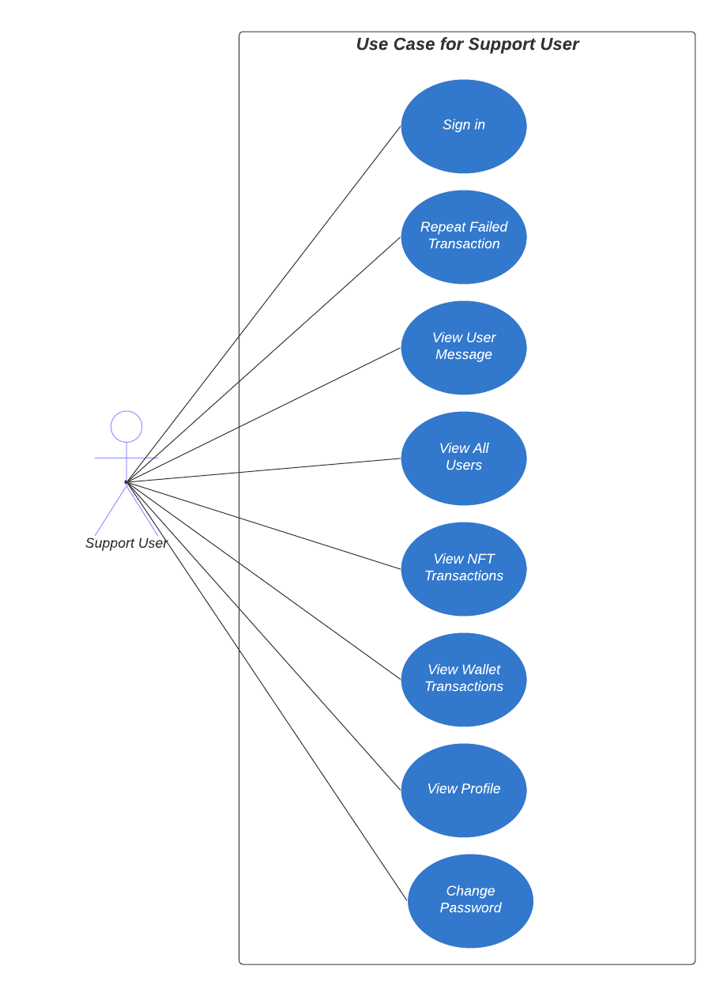

**Fig 3.2: Use case diagram for Support User**

| **Use Case** | **Description Description** |
| --- | --- |
| Sign in | The Support User has to Sign In in order to start his work. |
| Repeat Failed Transaction | Retry a transaction that failed previously. |
| View User Message | See messages sent by business for help. |
| View All Users | Browse all users on the platform. |
| View NFT Transactions | Check transaction history for NFTs. |
| View Wallet Transactions | Check transaction history for Drunken Bytes User wallets. |
| View Profile | View their profile |
| Change Password | Update their account’s login password. |

* + 1. **Sales User use-case report**

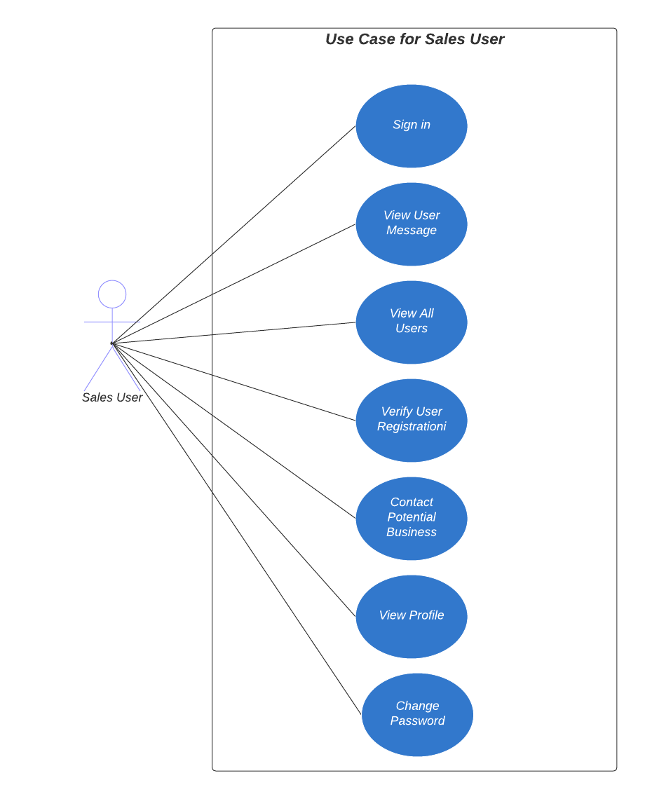

**Fig 3.3: Use case diagram for Sales User**

| **Use Case** | **Description Description** |
| --- | --- |
| Sign in | The Sales User has to Sign In in order to start his work. |
| View User Message | See messages sent by business for help. |
| View All Users | Browse all users on the platform. |
| Verify User Registration | Ensure that user account registration meets platform policies and verify that the business is verified and not fraudulent. |
| Contact Potential Business | Reach out to potential business users for platform adoption or sales. |
| View Profile | View their profile |
| Change Password | Update their account’s login password. |

* + 1. **Editor User use-case report**

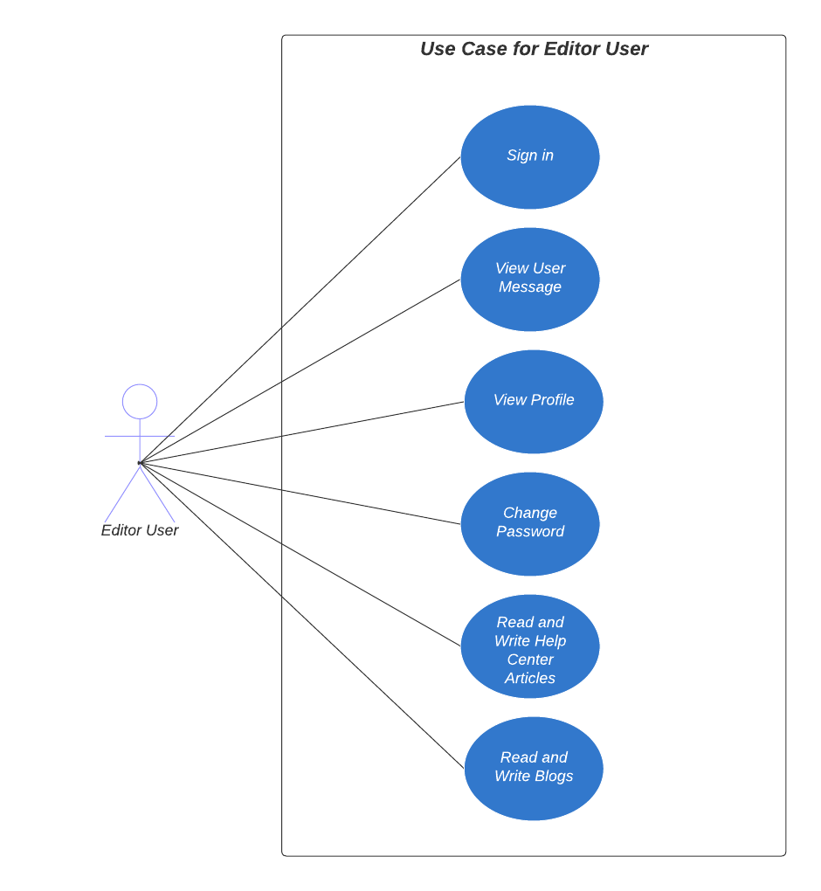

**Fig 3.4: Use case diagram for Editor User**

| **Use Case** | **Description Description** |
| --- | --- |
| Sign in | The EditorUser has to Sign In in order to start his work. |
| View User Message | See messages sent by business for help. |
| View Profile | View their profile |
| Change Password | Update their account’s login password. |
| Read Help Center Articles | Read help center articles and documentation to learn more about the platform's features and functionalities. |
| Read Blogs | Read blog posts and other content published by the platform's editorial team to stay updated on industry news and trends |
| Write Help Center Articles | Produce educational articles to aid users in platform navigation or issue resolution. |
| Write Blogs | Create informative or engaging content for platform news, insights or trends. |

* + 1. **Admin use-case report**

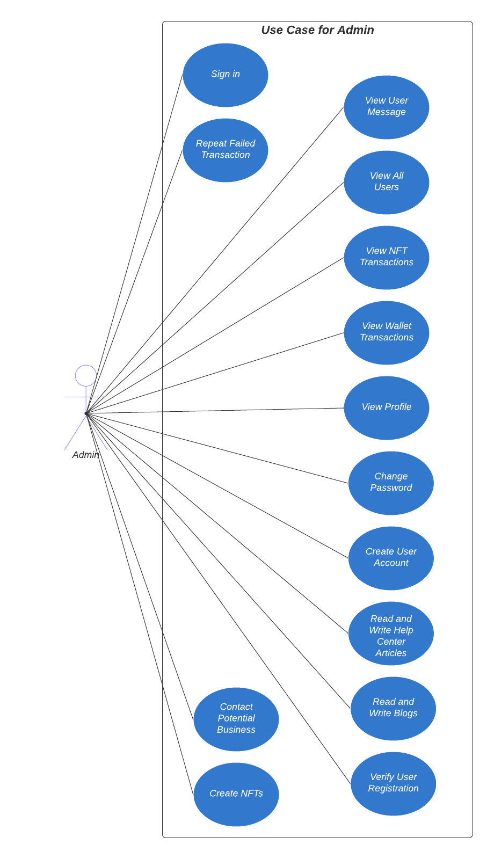

**Fig 3.5: Use case diagram for Admin**

| **Use Case** | **Description Description** |
| --- | --- |
| Sign in | The Admin has to Sign In in order to start his work. |
| Repeat Failed Transaction | Retry a transaction that failed previously. |
| View User Message | See messages sent by business for help. |
| View All Users | Browse all users on the platform. |
| View NFT Transactions | Check transaction history for NFTs. |
| View Wallet Transactions | Check transaction history for Drunken Bytes User wallets. |
| View Profile | View their profile |
| Change Password | Update their account’s login password. |
| Create User Account | Admin can create Support User, Editor User or Sales User Account |
| Read Help Center Articles | Read help center articles and documentation to learn more about the platform's features and functionalities. |
| Read Blogs | Read blog posts and other content published by the platform's editorial team to stay updated on industry news and trends |
| Write Help Center Articles | Produce educational articles to aid users in platform navigation or issue resolution. |
| Write Blogs | Create informative or engaging content for platform news, insights or trends. |
| Verify User Registration | Ensure that user account registration meets platform policies and verify that the business is verified and not fraudulent. |
| Contact Potential Business | Reach out to potential business users for platform adoption or sales. |
| Read Documentation | Read the platform's documentation to learn about the platform's technical specifications, integrations, and other technical details |
| Read FAQs | Read the platform's FAQs (Frequently Asked Questions) to get answers to common questions about the platform's features, functionalities, and policies |
| Create NFT | Create Products and Documents NFTs |

* 1. **Activity Diagrams**
     1. **User Registration Activity**

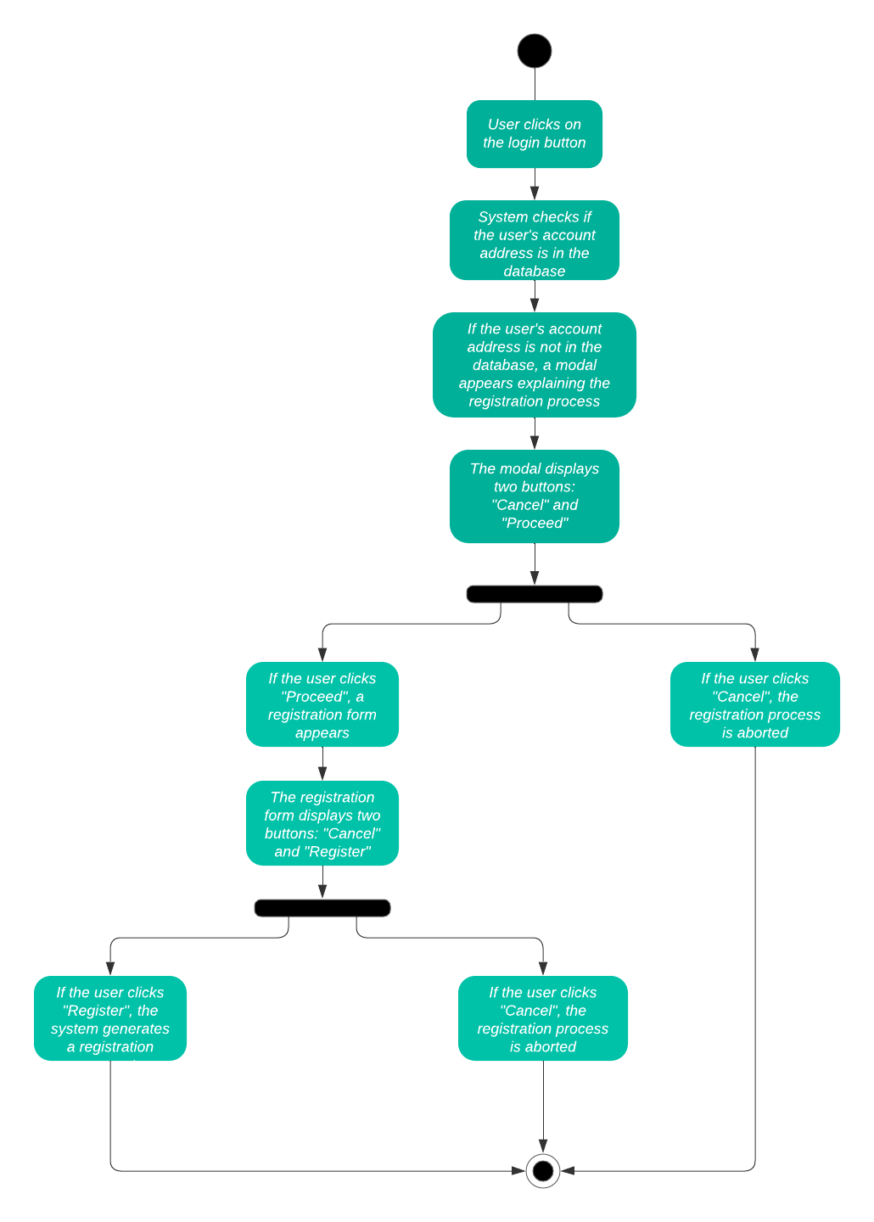

**Fig 3.6: Activity Diagram Representing User Registration**

* + 1. **User Login Activity**

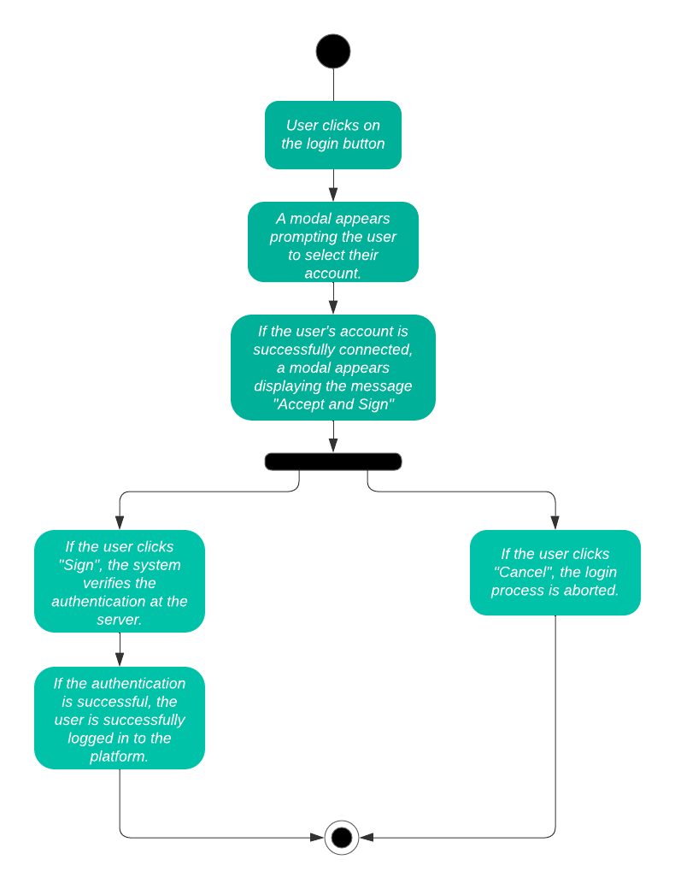

**Fig 3.7: Activity Diagram Representing User Login**

* + 1. **Create NFT Activity**

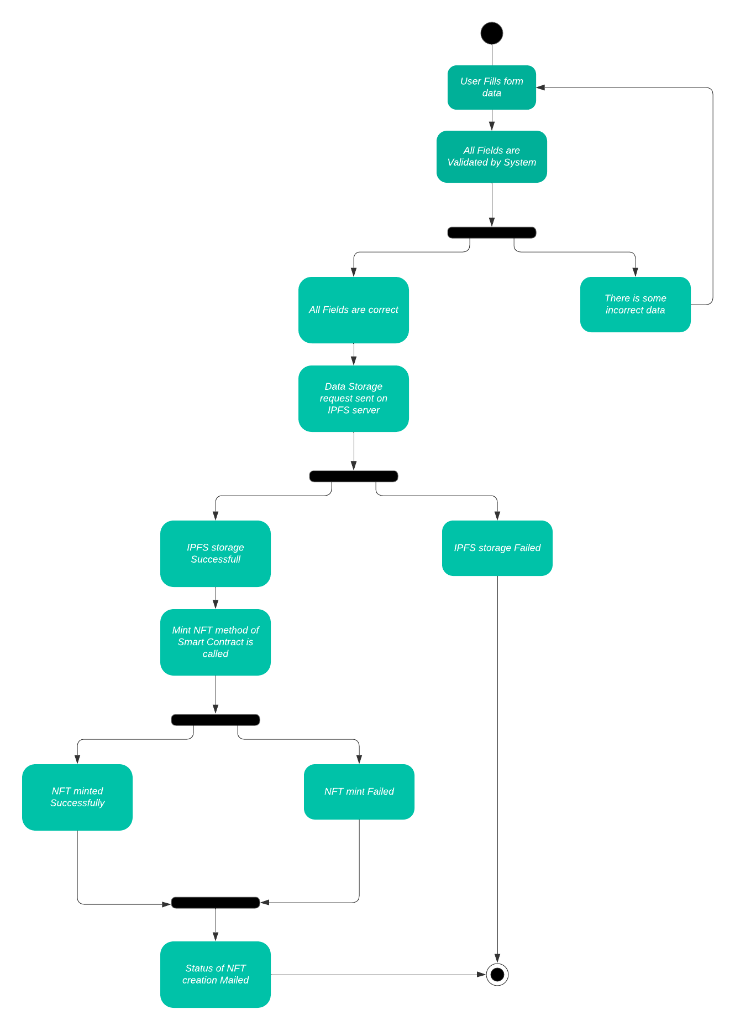

**Fig 3.8: Activity Diagram Representing Create NFT**

* + 1. **Add Wallet Balance Activity**

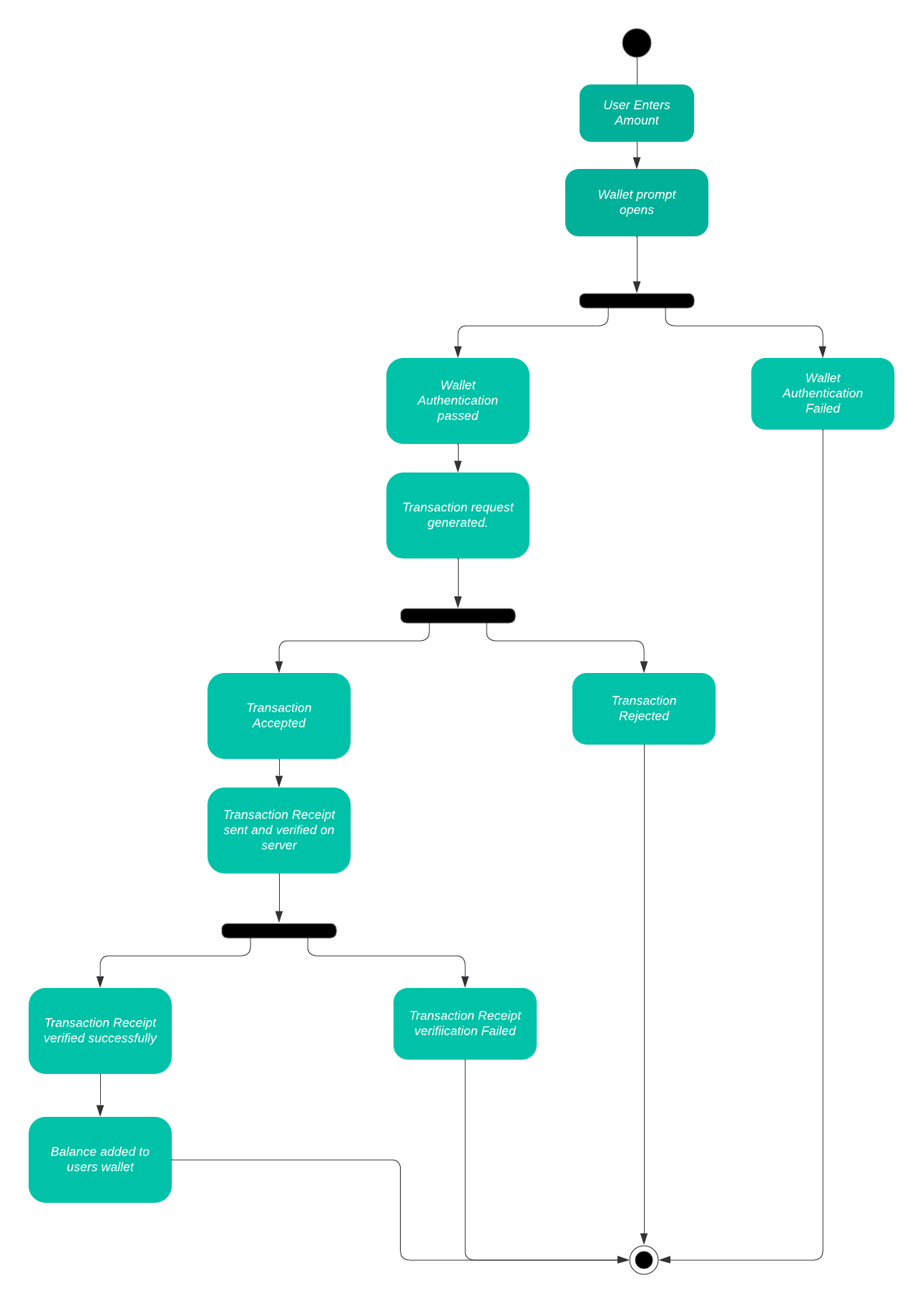

**Fig 3.9: Activity Diagram Representing Add Wallet Balance**

* + 1. **Add Product Activity**

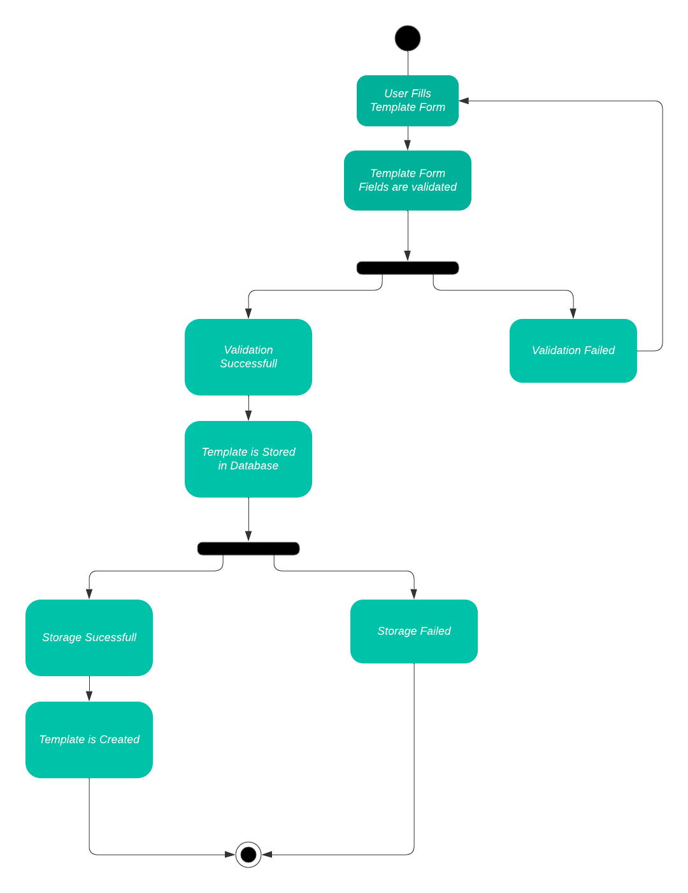

**Fig 3.10: Activity Diagram For Add Product**

* 1. **Sequence Diagrams**

**3.3.1 User Registration Sequence Diagram**

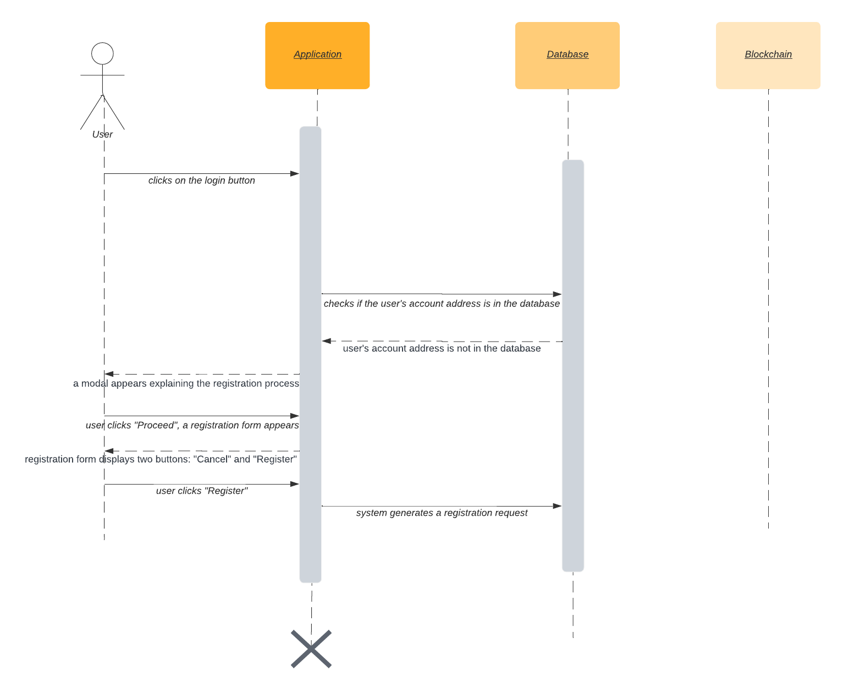

**Fig 3.11: Sequence Diagram Representing Login Process**

* + 1. **User Login Sequence Diagram**

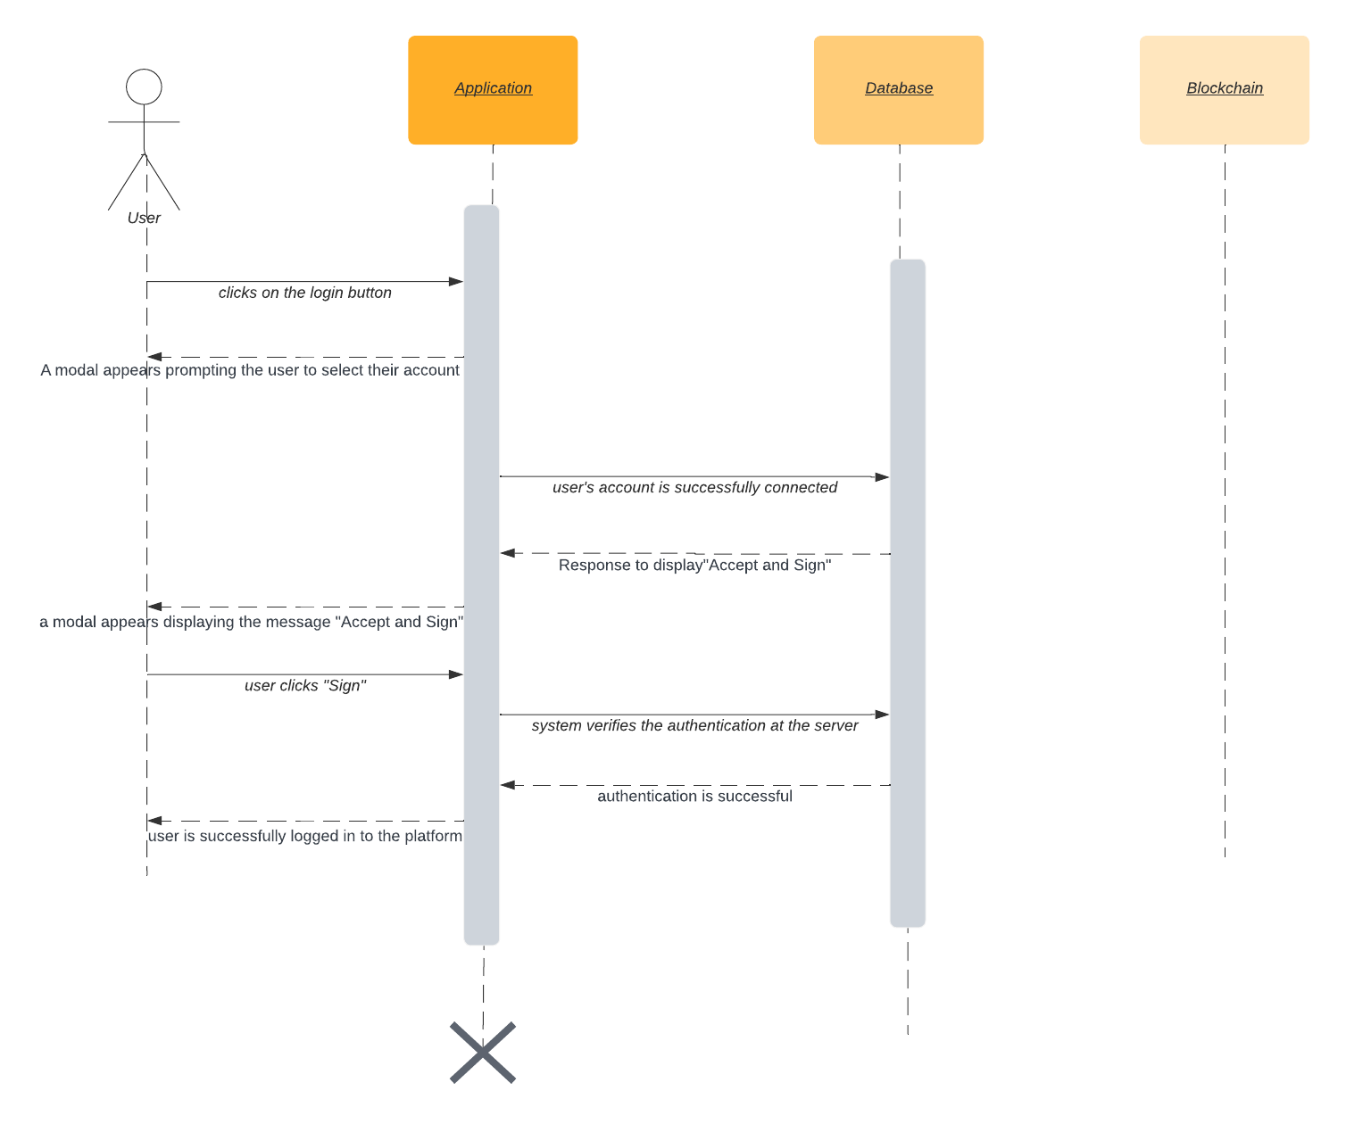

**Fig 3.12: Sequence Diagram Representing User Login**

* + 1. **Create NFT Sequence Diagram**

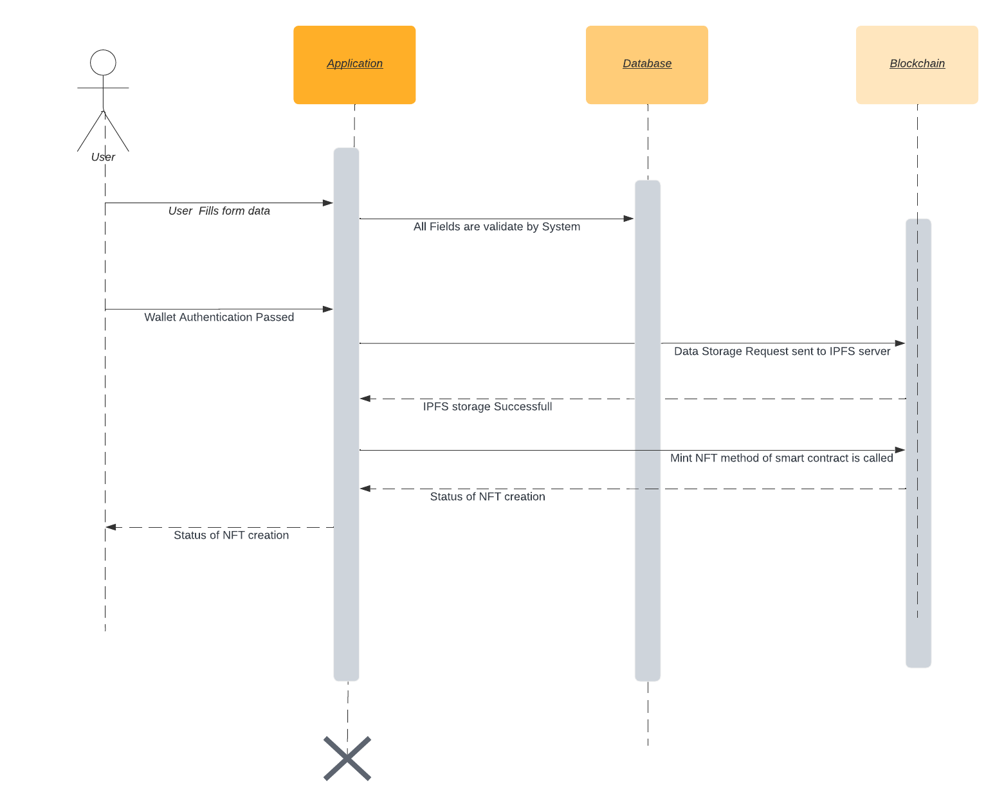

**Fig 3.13: Sequence Diagram for Create NFT**

* + 1. **Add Wallet Balance Sequence Diagram**

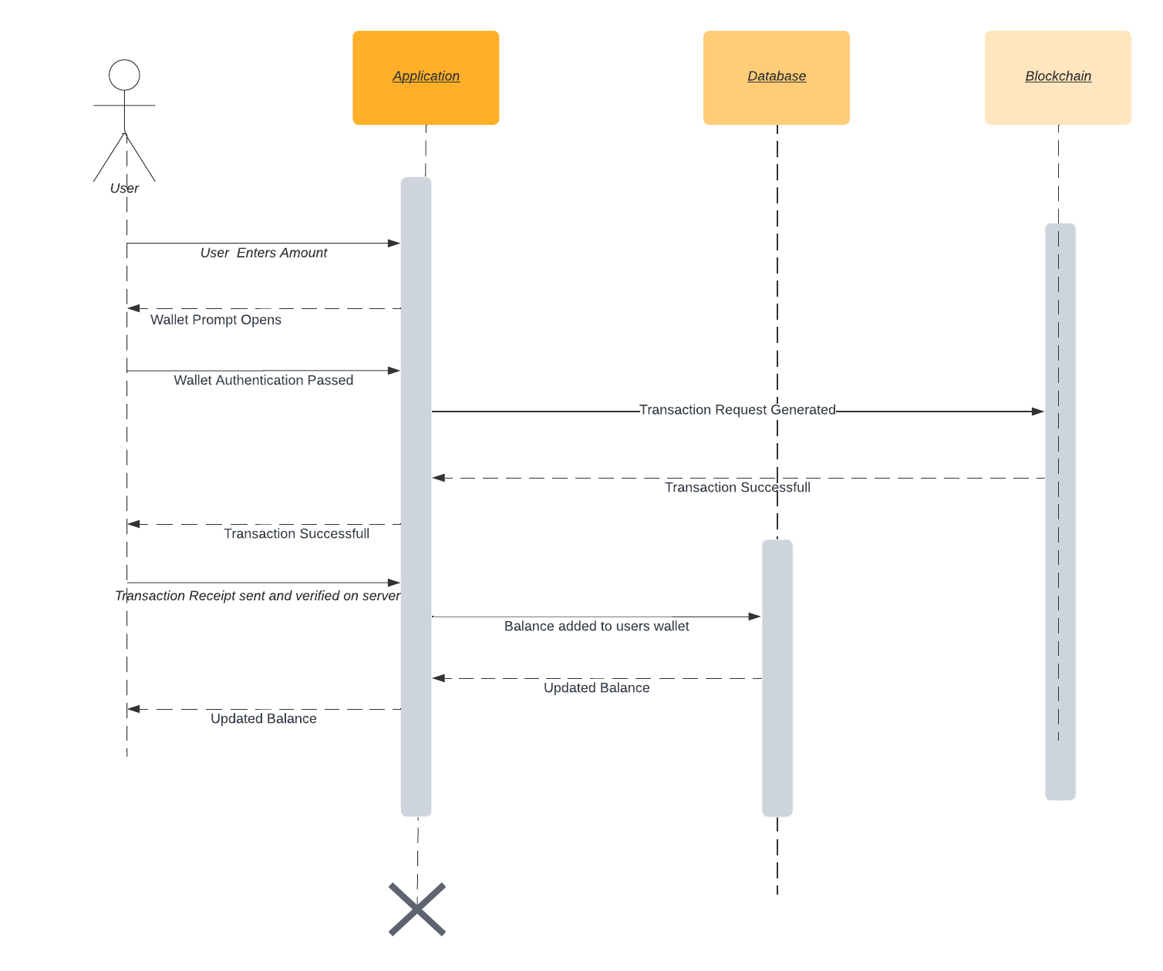

**Fig 3.14: Sequence Diagram for Add Wallet Balance**

* + 1. **Add Product Sequence Diagram**

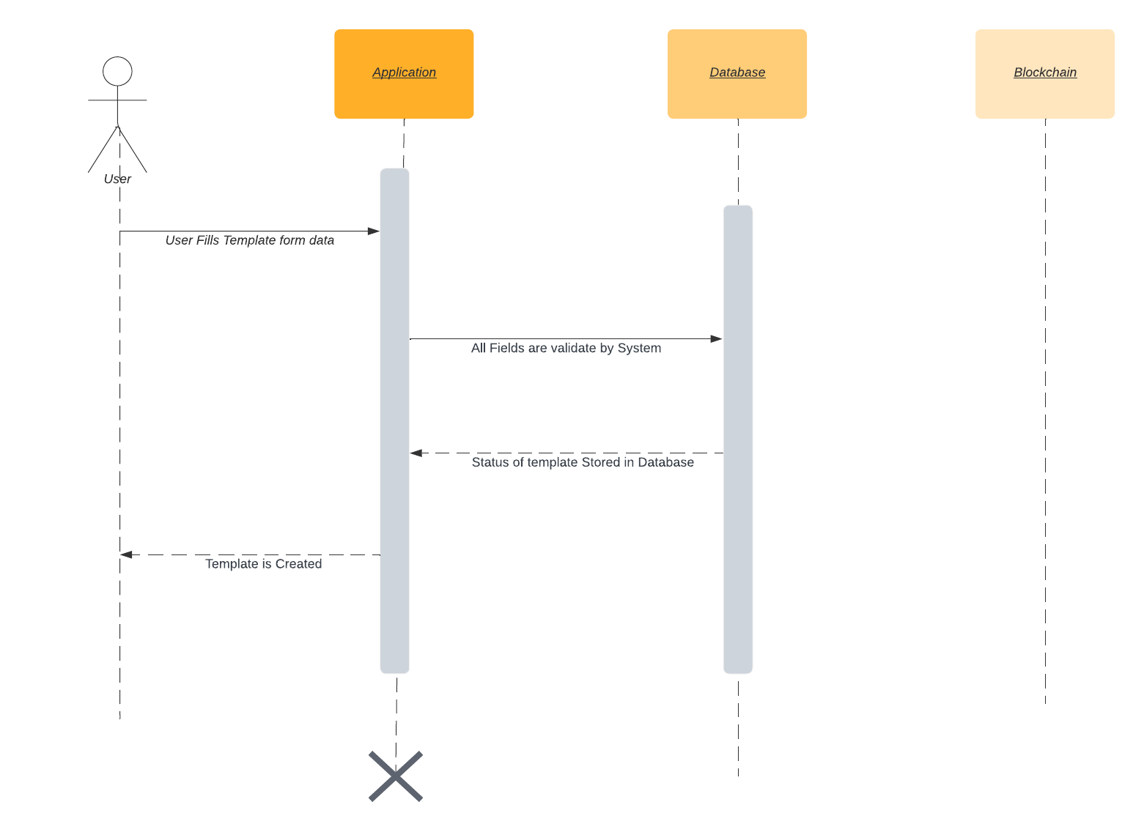

**Fig 3.15: Sequence Diagram for Add Product**

1. **References**

* Object Oriented Modeling and Design with UML-Michael Blaha, James Rambaugh.
* Software Engineering, Seventh Edition, Ian Sommerville.
* Node.js:<https://nodejs.org/en/docs/>
* Express.js:<https://expressjs.com/>
* Pinata:<https://pinata.cloud/>
* Next.js:<https://nextjs.org/docs/getting-started>
* Wikipedia - *www.wikipedia.com*
* Database Management Systems - Navathe.
* Goerli:<https://goerli.net/#about>
* web3.js:<https://web3js.readthedocs.io/en/v1.3.4/>
* ethers:<https://docs.ethers.io/v5/>
* wagmi:<https://wagmi.io/whitepaper.pdf>