**DSCI 644 Assignment 2 Akshat Garg(ag2193@rit.edu)**

**Part 1**

**God Class**

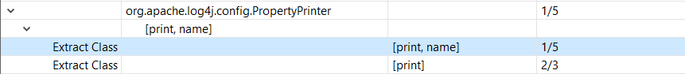

Flaw Instance for God class for 1st instance

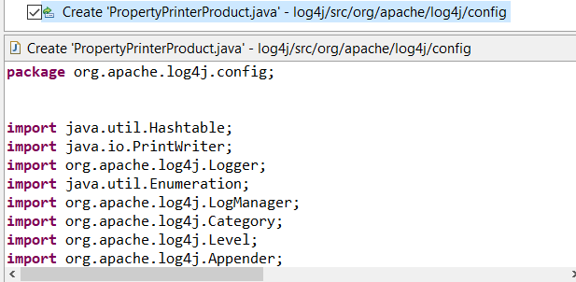

This were the refactoring operation and results for 1st instance of God class.

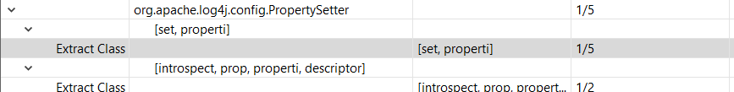

Flaw Instance for God class for 2nd instance

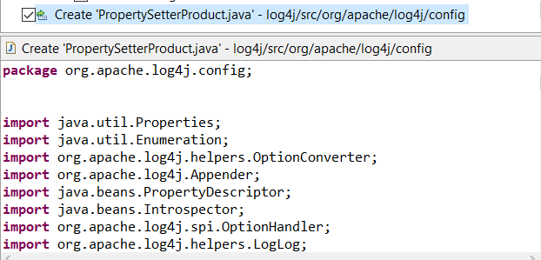

This were the refactoring operation and results for 2nd instance of God class.

**Feature Envy**



Flaw instance for the feature envy for the 1st instance.

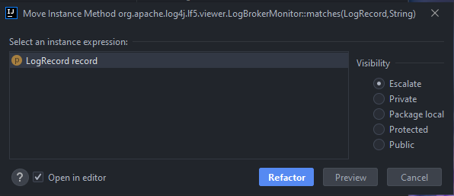

Refactoring operation that was performed on 1st instance.

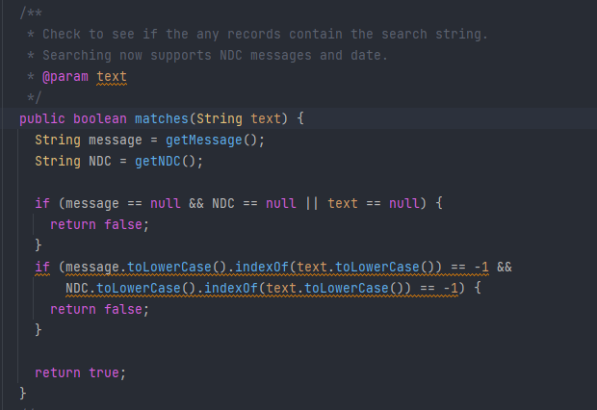

After refactoring was completed, here is the changes in code for 1st instance.



Flaw instance for the feature envy for the 2nd instance.

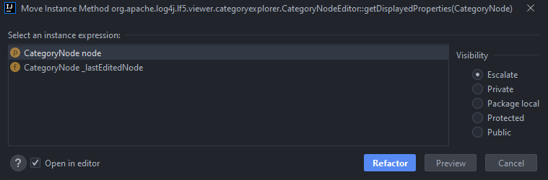

Refactoring operation that was performed on 2nd instance. It was performed on CategoryNode node.

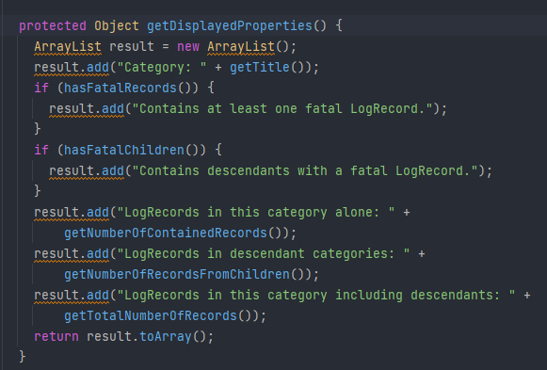

After refactoring was completed, here is the changes in code for 2nd instance.

**Long Method**



Flaw instance for the Long Method for the 1st instance. It was performed on 1st one.

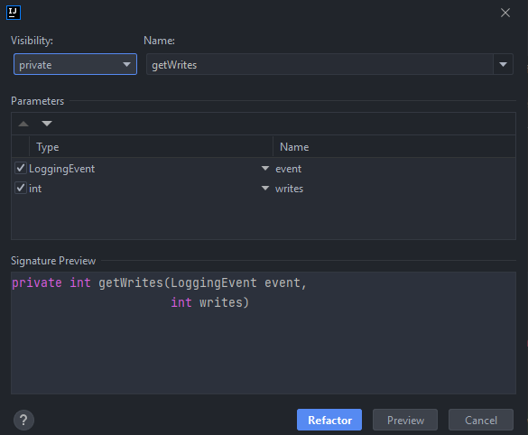

Refactoring operation that was performed on 1st instance.

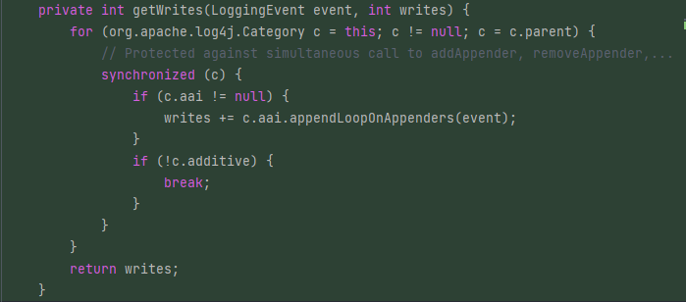

After refactoring was completed, here is the changes in code for 1st instance.



Flaw instance for the Long Method for the 2nd instance.

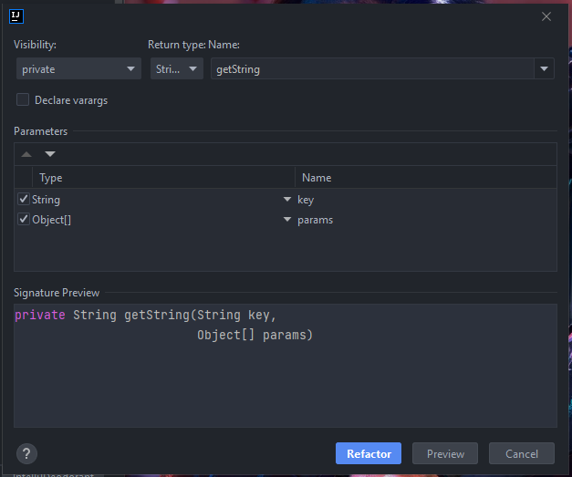

Refactoring operation that was performed on 2nd instance.

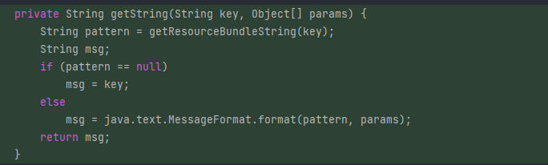

After refactoring was completed, here is the changes in code for 2nd instance.

**inFusion**

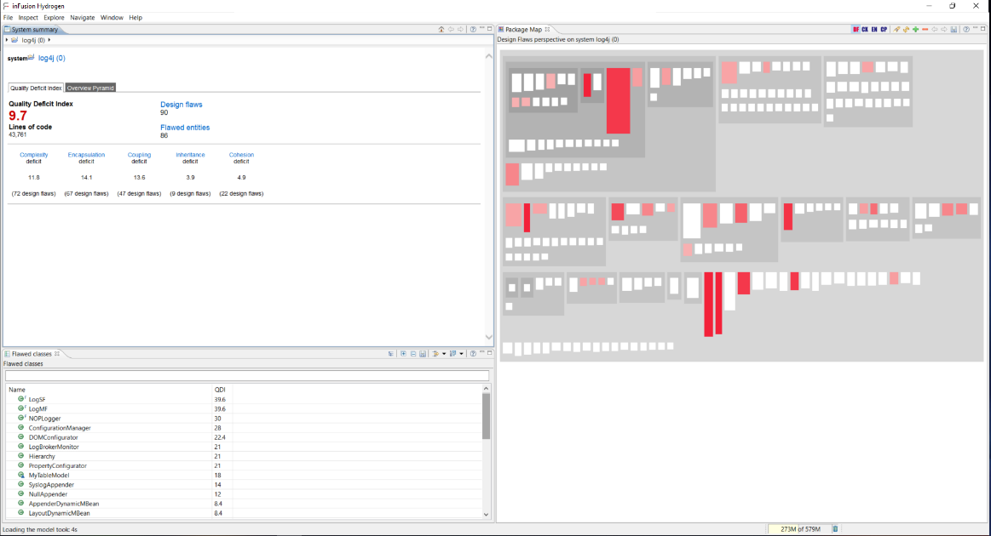

Before the refactoring applied, we had an overall quality deficit index as 9.7.

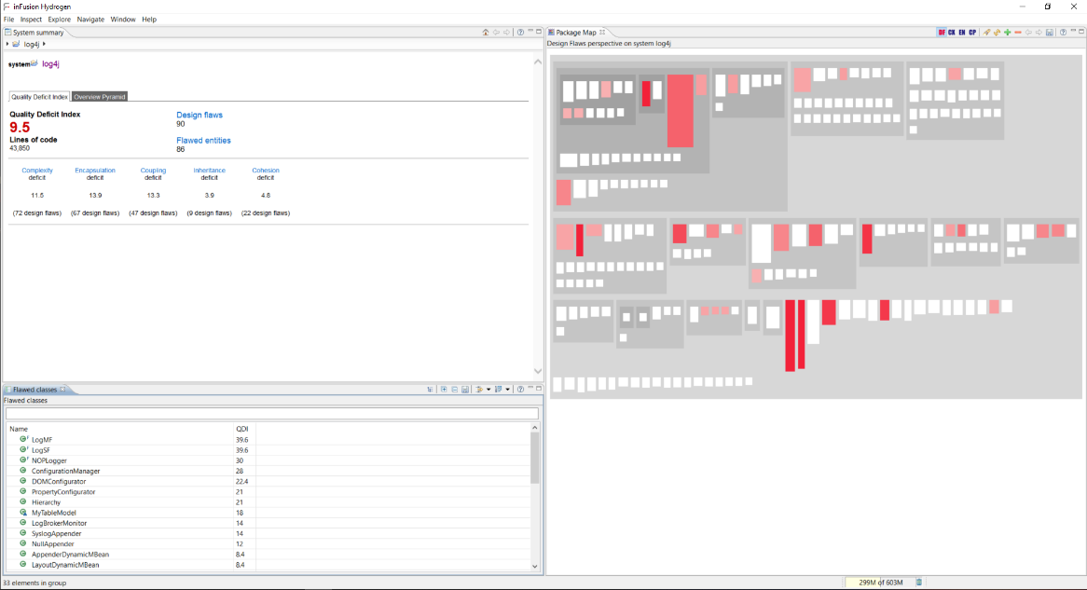

After the refactoring applied, we had an overall quality deficit index as 9.5.

**JDeodorant**

About the experience with using JDeodorant, it was really positive, it really made the job easy to refactor as it auto refactors for us. Only flaw I faced was long methods were only available in IntelliJ and God Class were only available in Eclipse.