**DSCI 644 Assignment 2 Akshat Garg(ag2193@rit.edu)**

**Part 2**

**Commits Detection using Refactoring Miner**

I choose the java project as “**Refactoring Miner**”. Link for the project is, <https://github.com/tsantalis/RefactoringMiner>

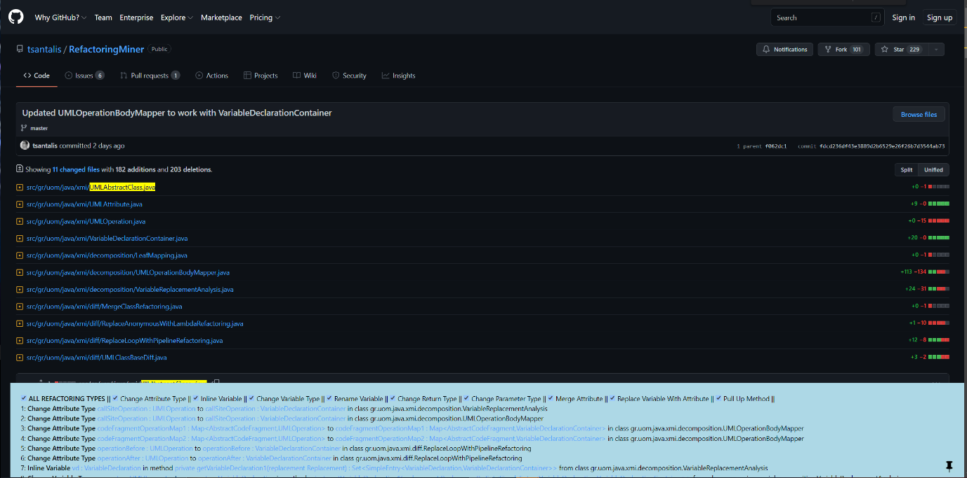

Screenshot of the commit changes that were made for the project for a particular commit.

Below is all the refactoring done and there types detected by tool. There were total of 34 refactoring detected in 11 files.





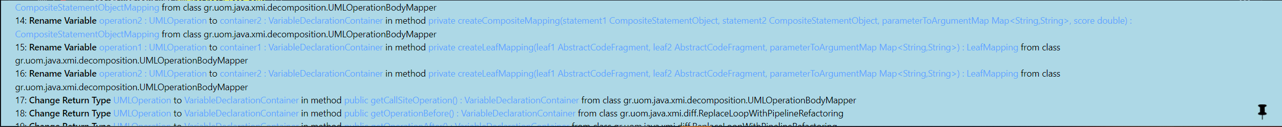





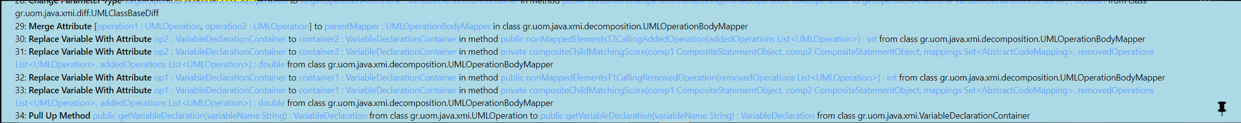

**Using Understand to analysis the CK Metrics**

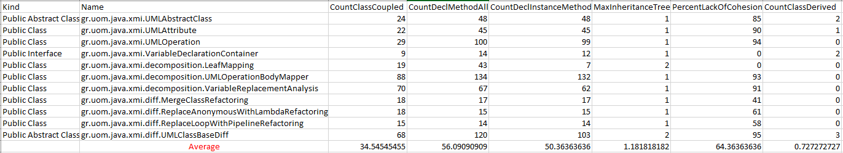

Above are CK metrics stats before the commit was made.

Below are CK metrics stats after the commit was made. (I have also added the same excel file in part2.zip)

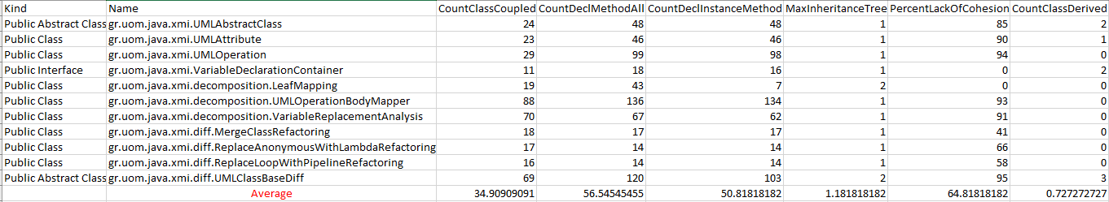

I have taken average of each metrics for the following files mentioned in commit changes.

**CBO: ”CountClassCoupled”**

We see a slight increase in CBO value from before commit to after the commit.

**RFC: “CountDeclMethodAll”**

We see a slight increase in RFC value from before commit to after the commit.

**WMC: “CountDeclInstanceMethod”**

We see a slight increase in WMC value from before commit to after the commit.

**DIT: “MaxInhertianceTree”**

We see no change in DIT value from before commit to after the commit.

**LCOM: “PercentageLackOfCohesion”**

We see a slight increase in LCOM value from before commit to after the commit.

**NOC: “CountClassDerived”**

We see no change in NOC value from before commit to after the commit.

Overall, due to this refactoring project quality has degraded very slightly as we can see from CK metrics values.