**VERIFY THE EXCITATION TABLES OF VARIOUS**

**FLIP FLOPS**

**OVJECTIVE-**

To verify the excitation tables of various flip flops.

**THEORY-**

* **S-R FLIP FLOP-**

In the flip flop, with the help of preset and clear when the power is switched ON, the states of the circuit keeps on changing, that is it is uncertain. It may come to set(Q=1) or reset(Q’=0) state. In many applications, it is desired to initially set or reset the flip flop that is the initial state of the flip flop that needs to be assigned. This thing is accomplished by the preset(PR) and the clear(CLR)

* **TRUTH TABLE-**

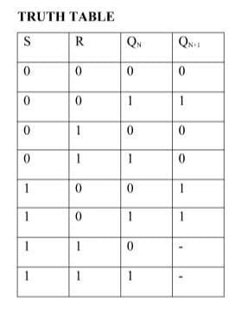

* **CIRCUIT DIAGRAM-**

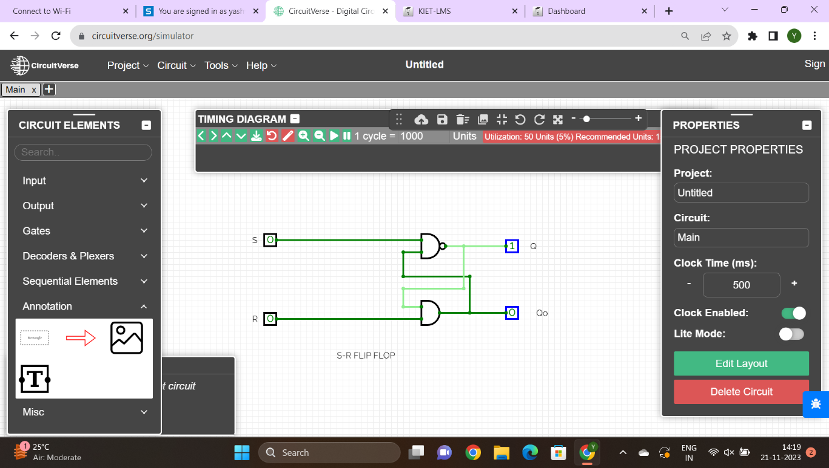

**D FLIP-FLOP-**

* **THEORY**

The basic working of D Flip Flop is as follows: When the clock signal is low, the flip flop holds its current state and ignores the D input. When the clock signal is high, the flip flop samples and stores D input. The value that was previously fed into the D input is reflected at the flip flop's Q output.

* **TRUTH TABLE-**

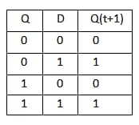

* **CIRCUIT DIAGRAM-**

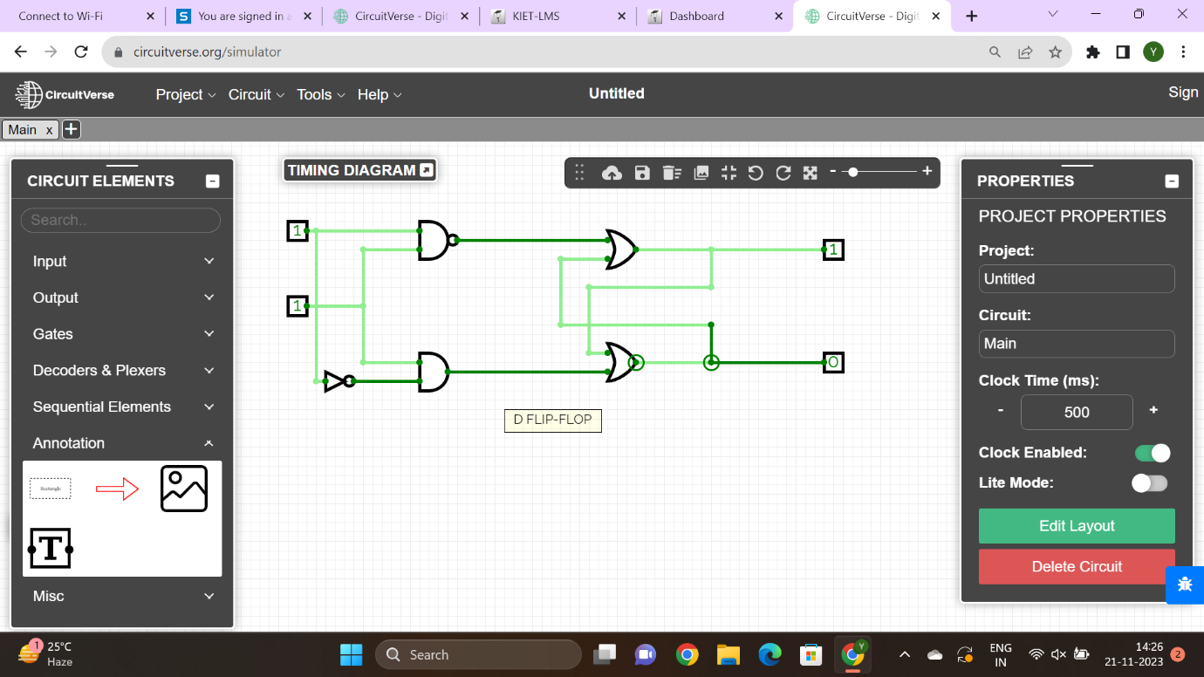

**T FLIP-FLOP-**

T Flip-Flop is a single input logic circuit that holds or toggles its output according to the input state. Toggling means changing the next state output to complement the current state. T is an abbreviation for Toggle. A good example to explain this concept is using a light switch. When you toggle a light switch you are either changing from the on state to an off state and vice versa.

* **TRUTH TABLE-**

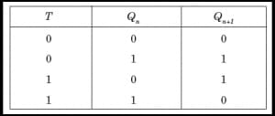

* **CIRCUIT DIAGRAM-**

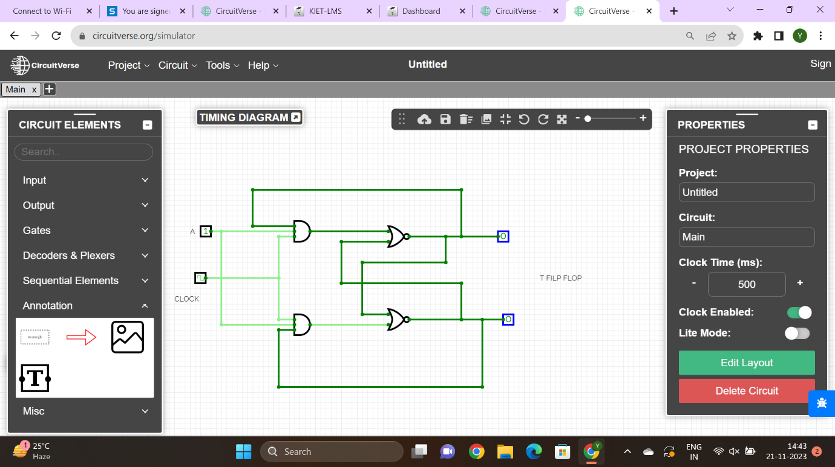

**J-K FLIP FLOP-**

* **THEORY-**

The “JK flip flop,” also known as the Jack Kilby flip flop, is a sequential logic circuit designed by Jack Kilby during his tenure at Texas Instruments in the 1950s. This flip flop serves the purpose of storing and manipulating binary information within digital systems.

* **TRUTH TABLE-**

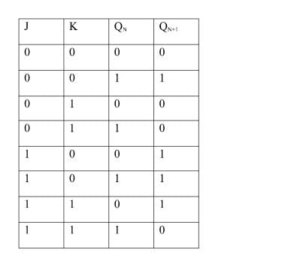

* **CIRCUIT DIAGRAM-**

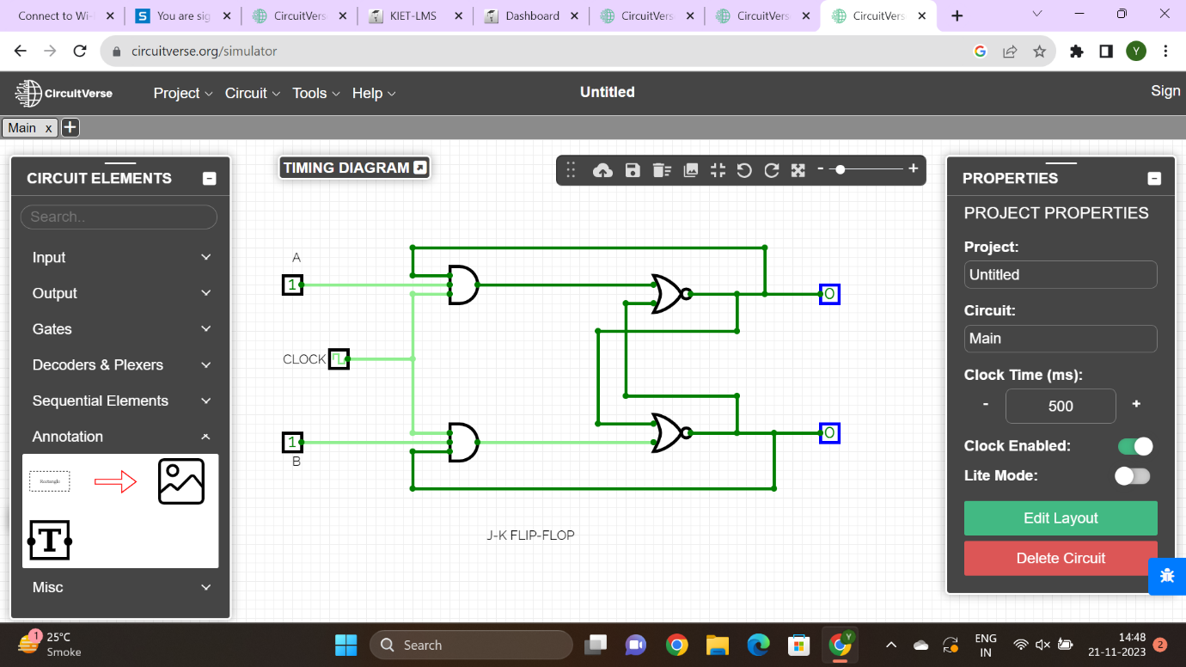

* **CONCLUSION-**

We discuss about various types of flip flops.

**NAME-Akshat Gupta**

**ROLL NO- 2200291520026**

**SECTION-A**