IMPLEMENTING BINARY TO GRAY

AND

GRAY TO BINARY

* OBJECTIVE-

Implementing binary to gray and gray to binary.

* THEORY-
* BINARY TO GRAY

The Binary to Gray code converter is a logical circuit that is used to convert the binary code into its equivalent Gray code. By putting the MSB of 1 below the axis and the MSB of 1 above the axis and reflecting the (n-1) bit code about an axis after 2n-1 rows, we can obtain the n-bit gray code.

* THE CIRCUIT-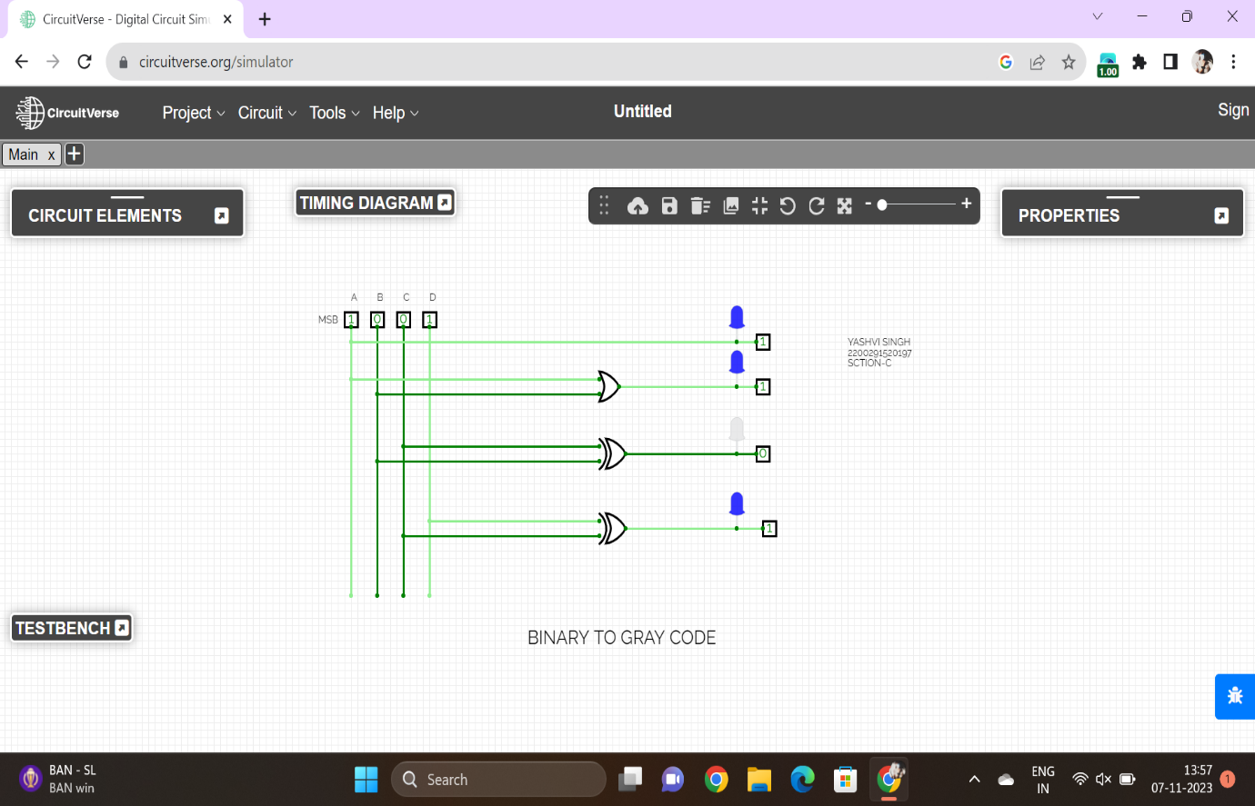
* GRAY CODE TO BINARY

Binary Number is the default way to store numbers, but in many applications, binary numbers are difficult to use and a variety of binary numbers is needed. This is where Gray codes are very useful.

Gray code has a property that two successive numbers differ in only one bit because of this property gray code does the cycling through various states with minimal effort and is used in K-maps, error correction, communication, etc.

* THE CIRCUIT

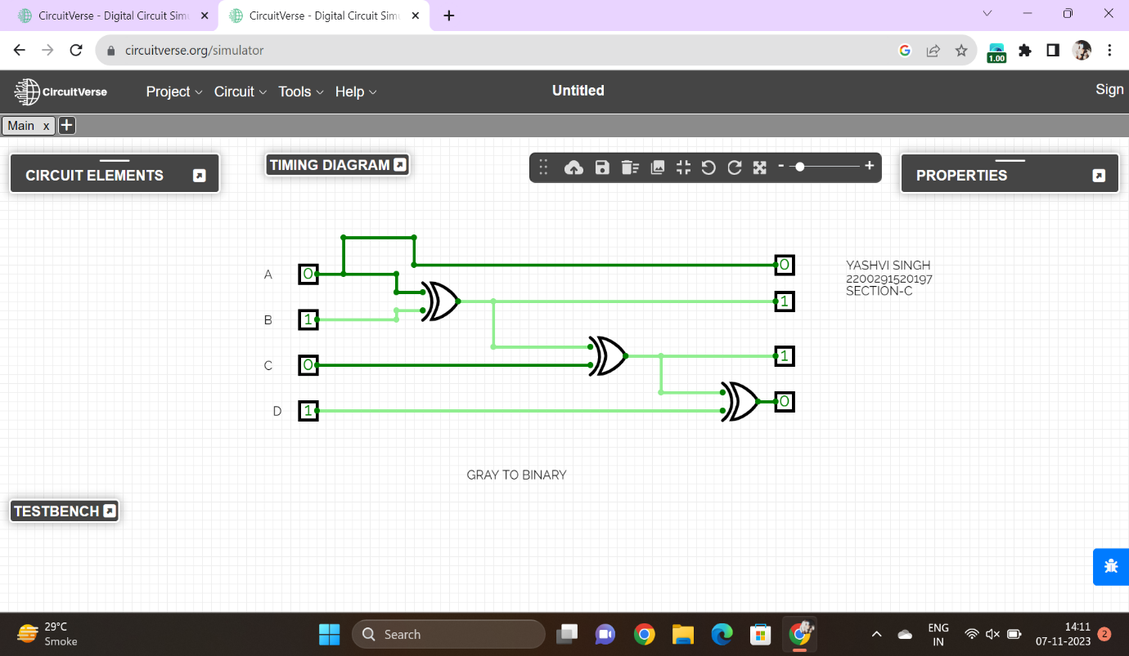

* CONCLUSION

Conversion of binary to gray code and gray code to binary is done successfully.

NAME-Akshat Gupta

2200291520026

SECTION-A