Name- Akshat Gupta
CSE(AI)
sec-A
2200291520026

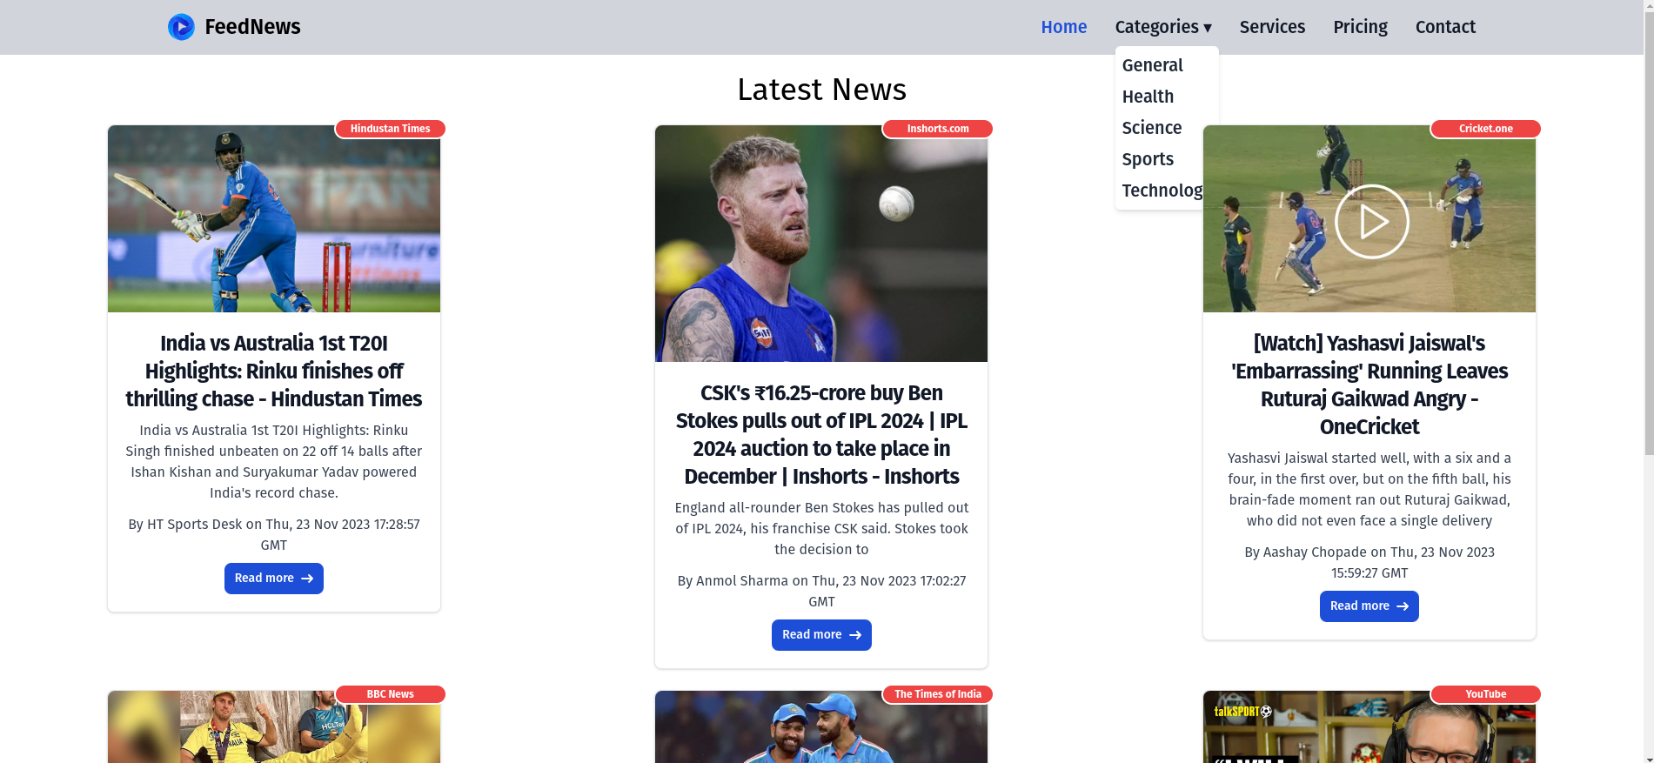

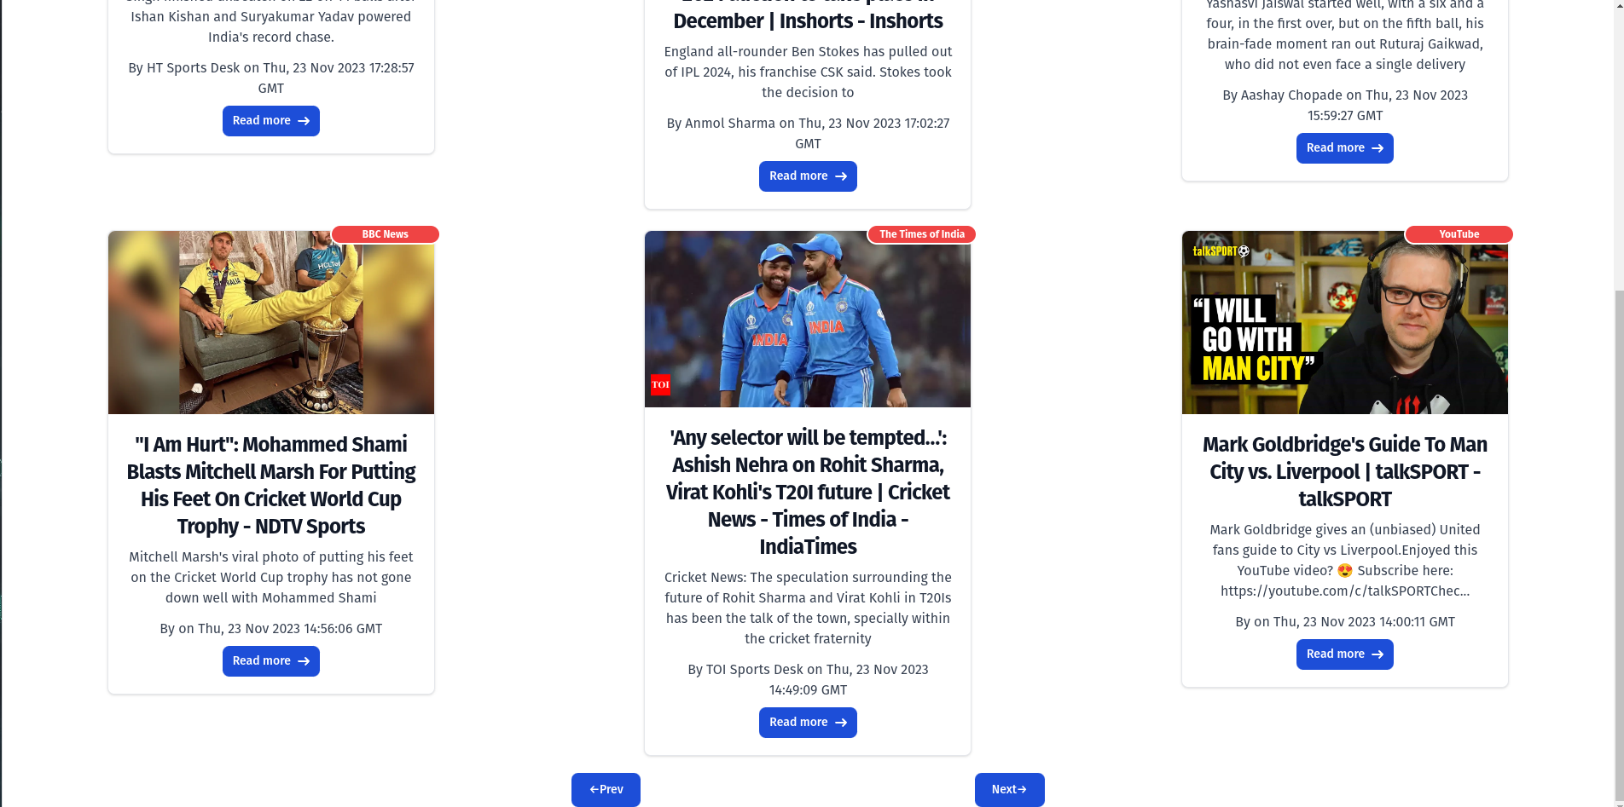
Code =>

APP.js

import React from 'react';
import { BrowserRouter as Router, Route, Routes } from 'react-router-dom';
import NavBar from './Component/NavBar';
import News from './Component/News';

let apikey = process.env.REACT_APP_API_KEY;

function App() {
return (
<div>
<Router>
<NavBar />
<Routes>
<Route exact path="/sports" element={<News key="sports" apikey={apikey} pagesize={6} categories="sports" />} />
<Route exact path="/entertainment" element={<News key="entertainment" apikey={apikey} pagesize={6} categories="entertainment" />} />
<Route exact path="/science" element={<News key="science" apikey={apikey} pagesize={6} categories="science" />} />
<Route exact path="/health" element={<News key="health" apikey={apikey} pagesize={6} categories="health" />} />
<Route exact path="/technology" element={<News key="technology" apikey={apikey} pagesize={6} categories="technology" />} />
<Route exact path="/" element={<News key="gene" apikey={apikey} pagesize={6} categories="general" />} />
</Routes>
</Router>
</div>
);
}

export default App;

NavBar.js

import React, { useState } from 'react';
import { Link } from 'react-router-dom';

function NavBar() {
const [showCategories, setShowCategories] = useState(false);

return (
<div>
<nav className="bg-gray-300 border-gray-200 dark:bg-gray-900">
<div className="max-w-screen-2xl flex flex-wrap items-center justify-between mx-auto p-4">
<a href="https://flowbite.com/" className="flex items-center space-x-3 rtl:space-x-reverse">
<img src="https://flowbite.com/docs/images/logo.svg" className="h-8" alt="Flowbite Logo" />
<span className="self-center text-2xl font-semibold whitespace-nowrap dark:text-white">FeedNews</span>
</a>
<button
onClick={() => setShowCategories(!showCategories)}
type="button"
className="inline-flex items-center p-2 w-10 h-10 justify-center text-sm text-gray-500 rounded-lg md:hidden hover:bg-gray-100 focus:outline-none focus:ring-2 focus:ring-gray-200 dark:text-gray-400 dark:hover:bg-gray-700 dark:focus:ring-gray-600"
aria-controls="navbar-default"
aria-expanded="false"
>
<span className="sr-only">Open main menu</span>
<svg className="w-5 h-5" aria-hidden="true" xmlns="http://www.w3.org/2000/svg" fill="none" viewBox="0 0 17 14">
<path stroke="currentColor" strokeLinecap="round" strokeLinejoin="round" strokeWidth="2" d="M1 1h15M1 7h15M1 13h15"/>
</svg>
</button>
<div className="hidden w-full md:block md:w-auto" id="navbar-default">
<ul className="font-medium flex flex-col p-4 md:p-0 mt-4 border border-gray-100 rounded-lg bg-gray-50 md:flex-row md:space-x-8 rtl:space-x-reverse md:mt-0 md:border-0 md:bg-gray-300 text-xl dark:bg-gray-800 md:dark:bg-gray-900 dark:border-gray-700">
<li>
<Link to="/" className="block py-2 px-3 text-white bg-blue-700 rounded md:bg-transparent md:text-blue-700 md:p-0 dark:text-white md:dark:text-blue-500" aria-current="page">Home</Link>
</li>
<li>
<Link
onClick={() => setShowCategories(!showCategories)}
to="/#"
className="block py-2 px-3 text-gray-900 rounded hover:bg-gray-100 md:hover:bg-transparent md:border-0 md:hover:text-blue-700 md:p-0 dark:text-white md:dark:hover:text-blue-500 dark:hover:bg-gray-700 dark:hover:text-white md:dark:hover:bg-transparent"
>
Categories &#9662;
</Link>
{showCategories && (
<ul className="absolute mt-2 space-y-2 bg-white p-2 rounded-md shadow-md">
<li>
<Link to="/" className="text-gray-800 hover:text-blue-700">General</Link>
</li>
<li>
<Link to="/health" className="text-gray-800 hover:text-blue-700">Health</Link>
</li>
<li>
<Link to="/science" className="text-gray-800 hover:text-blue-700">Science</Link>
</li>
<li>
<Link to="/sports" className="text-gray-800 hover:text-blue-700">Sports</Link>
</li>
<li>
<Link to="/technology" className="text-gray-800 hover:text-blue-700">Technology</Link>
</li>
</ul>
)}
</li>
<li>
<Link to="/#" className="block py-2 px-3 text-gray-900 rounded hover:bg-gray-100 md:hover:bg-transparent md:border-0 md:hover:text-blue-700 md:p-0 dark:text-white md:dark:hover:text-blue-500 dark:hover:bg-gray-700 dark:hover:text-white md:dark:hover:bg-transparent">Services</Link>
</li>
<li>
<Link to="/#" className="block py-2 px-3 text-gray-900 rounded hover:bg-gray-100 md:hover:bg-transparent md:border-0 md:hover:text-blue-700 md:p-0 dark:text-white md:dark:hover:text-blue-500 dark:hover:bg-gray-700 dark:hover:text-white md:dark:hover:bg-transparent">Pricing</Link>
</li>
<li>
<Link to="/#" className="block py-2 px-3 text-gray-900 rounded hover:bg-gray-100 md:hover:bg-transparent md:border-0 md:hover:text-blue-700 md:p-0 dark:text-white md:dark:hover:text-blue-500 dark:hover:bg-gray-700 dark:hover:text-white md:dark:hover:bg-transparent">Contact</Link>
</li>
</ul>
</div>
</div>
</nav>
</div>
);
}

export default NavBar;

News.js

import React, { useEffect, useState } from 'react'
import NewsItem from './NewsItem'
import Spinner from './Spinner';

function News({apikey,pagesize,categories}) {
const[page,setpage]=useState(1)
// const[news,setnews]=useState({
// articles:[],
// page:1
// })
const [loading,setloading]=useState(true);
const[news,setnews]=useState([])
useEffect(() => {
const fetchData = async () => {
try {
const response = await fetch(`https://newsapi.org/v2/top-headlines?country=in&category=${categories}&apiKey=${apikey}&page=${page}&pagesize=${pagesize}`);
const result = await response.json();
// articles:result.articles});
setnews(result.articles);
// setnews(result)
setloading(true)
}
catch (error) {
console.error('Error in fetching data:', error);
}
finally{
setloading(false)
}
};
fetchData();
}, []);

const Prevbtn = async () => {
console.log("prev");
try {
const response = await fetch(`https://newsapi.org/v2/top-headlines?country=in&category=${categories}&apiKey=${apikey}&page=${page - 1}&pagesize=${pagesize}`);
const result = await response.json();
setpage(page - 1);
setnews(result.articles);
} catch (error) {
console.error('Error in fetching data:', error);
}
finally{
setloading(false)
}
}

const Nextbtn = async () => {
console.log("Next")
try {
const response = await fetch(`https://newsapi.org/v2/top-headlines?country=in&category=${categories}&apiKey=${apikey}&page=${page + 1}&pagesize=${pagesize}`);
const result = await response.json();
setpage(page + 1);
setnews(result.articles);
setloading(true)
} catch (error) {
console.error('Error in fetching data:', error);
}
finally{
setloading(false)
}
}

return (
<div className='text-center '>
<p className='text-4xl mt-5 mb-5'>
Latest News
</p>
<div className='flex justify-content-center'>
{loading && <Spinner/>}
</div>
<div className='grid grid-cols-3 justify-items-center gap-y-6'>
{news.map((element) => (
<NewsItem
id={element.id}
title={element.title}
description={element.description}
author={element.author}
image={element.urlToImage}
readMore={element.url}
date={element.publishedAt}
badgeNumber={element.source.name}
/>
))}
</div>

<div className='d-flex justify-space-between space-x-96 mt-[20px]'>
{loading===false ? (<button disabled={page <= 1} type="button" class="text-white bg-blue-700 hover:bg-blue-800 focus:ring-4 focus:ring-blue-300 font-medium rounded-lg text-sm px-5 py-2.5 me-2 mb-2 dark:bg-blue-600 dark:hover:bg-blue-700 focus:outline-none dark:focus:ring-blue-800" onClick={Prevbtn}>&larr;Prev</button>):null}
{loading===false ? (<button disabled={page+1 > Math.ceil(news.totalResults / 20)} type="button" class="text-white bg-blue-700 hover:bg-blue-800 focus:ring-4 focus:ring-blue-300 font-medium rounded-lg text-sm px-5 py-2.5 me-2 mb-2 dark:bg-blue-600 dark:hover:bg-blue-700 focus:outline-none dark:focus:ring-blue-800" onClick={Nextbtn}>
Next&rarr;
</button>):null}
</div>
</div>

)
}

export default News

NewsItem.js
import React from 'react';
import "./NewsItem.css";

function NewsItem({ title, description, image, readMore, author, date, badgeNumber }) {
return (
<div>
<div className="card max-w-sm bg-white border border-gray-200 rounded-lg shadow dark:bg-gray-800 dark:border-gray-700 relative">
{badgeNumber && (
<div className="absolute inline-flex items-center justify-center w-[130px] h-6 text-xs font-bold text-white bg-red-500 border-2 border-white rounded-full -top-2 -end-2 dark:border-gray-900">
{badgeNumber}
</div>
)}
<a href="#">
<img className="rounded-t-lg" src={image} alt="" />
</a>
<div className="p-5">
<a href="#">
<h5 className="mb-2 text-2xl font-bold tracking-tight text-gray-900 dark:text-white">{title}</h5>
</a>
<p className="mb-3 font-normal text-gray-700 dark:text-gray-400">{description}</p>
<p className='mb-2 text-gray-700'>By {author} on {new Date(date).toGMTString()}</p>
<a href={readMore} className="inline-flex items-center px-3 py-2 text-sm font-medium text-center text-white bg-blue-700 rounded-lg hover:bg-blue-800 focus:ring-4 focus:outline-none focus:ring-blue-300 dark:bg-blue-600 dark:hover:bg-blue-700 dark:focus:ring-blue-800">
Read more
<svg className="rtl:rotate-180 w-3.5 h-3.5 ms-2" aria-hidden="true" xmlns="http://www.w3.org/2000/svg" fill="none" viewBox="0 0 14 10">
<path stroke="currentColor" stroke-linecap="round" stroke-linejoin="round" stroke-width="2" d="M1 5h12m0 0L9 1m4 4L9 9"/>
</svg>
</a>
</div>
</div>
</div>
);
}

export default NewsItem;

