Data loading - Connecting to SQL Server

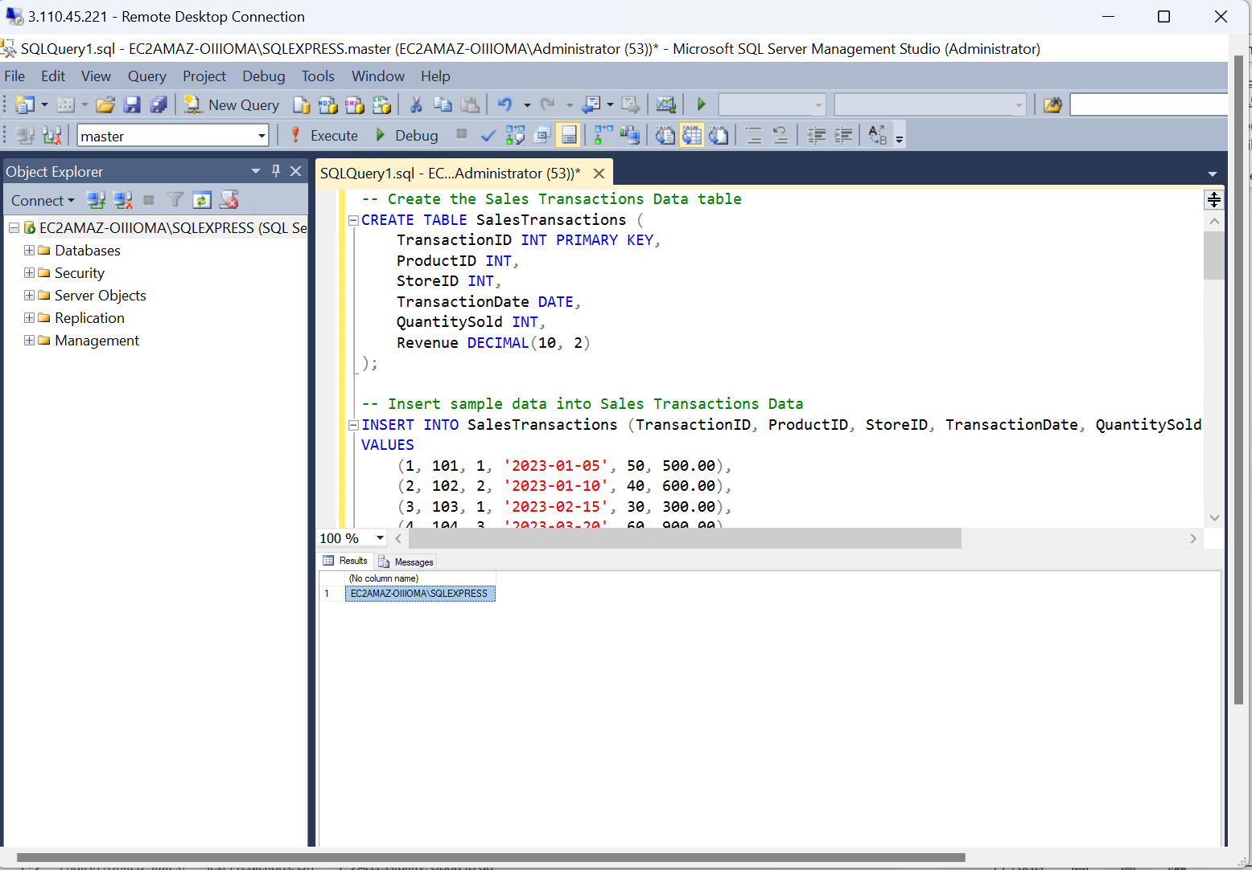

Creating database – ‘akshat’

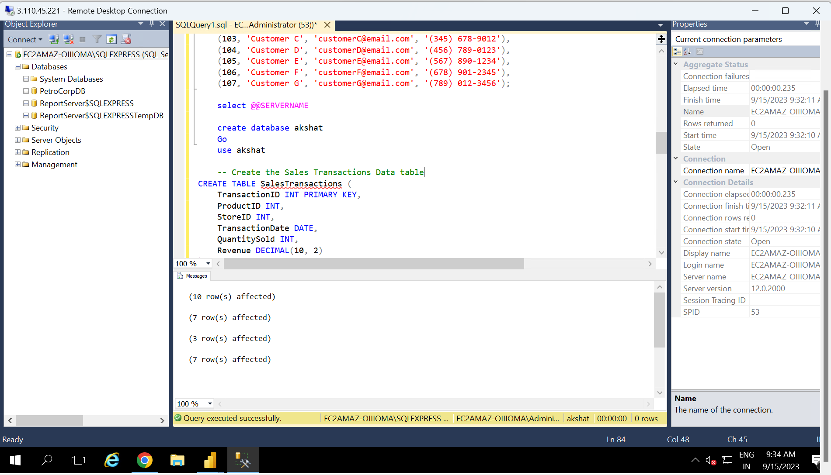

Data loading – Loading the tables after creating the database.

Data Transformation –

Merging the tables ‘Stores’ and ‘SalesTransactions’

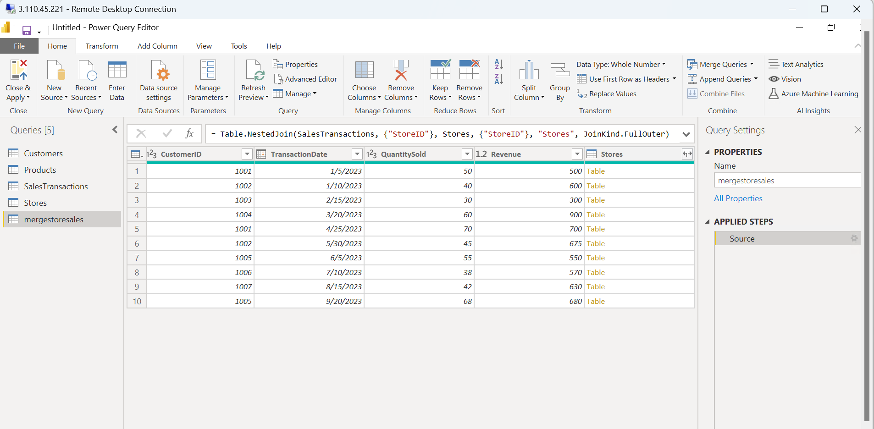

Created a new column ‘Transaction month’ and calculated the months from the date column in the newly created column.

Filtered data of the column QuantitySold -

Data Modelling

Creating relationships between tables

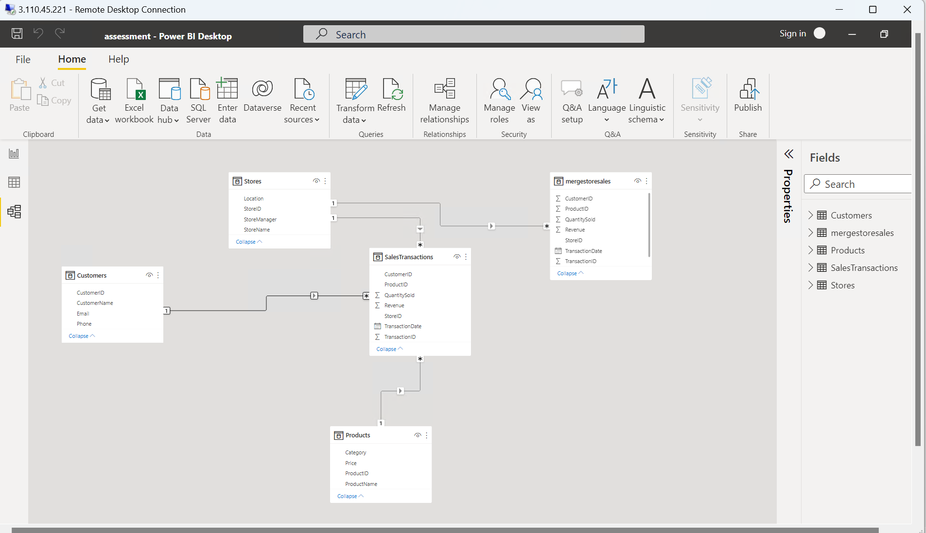

Creating hierarchies

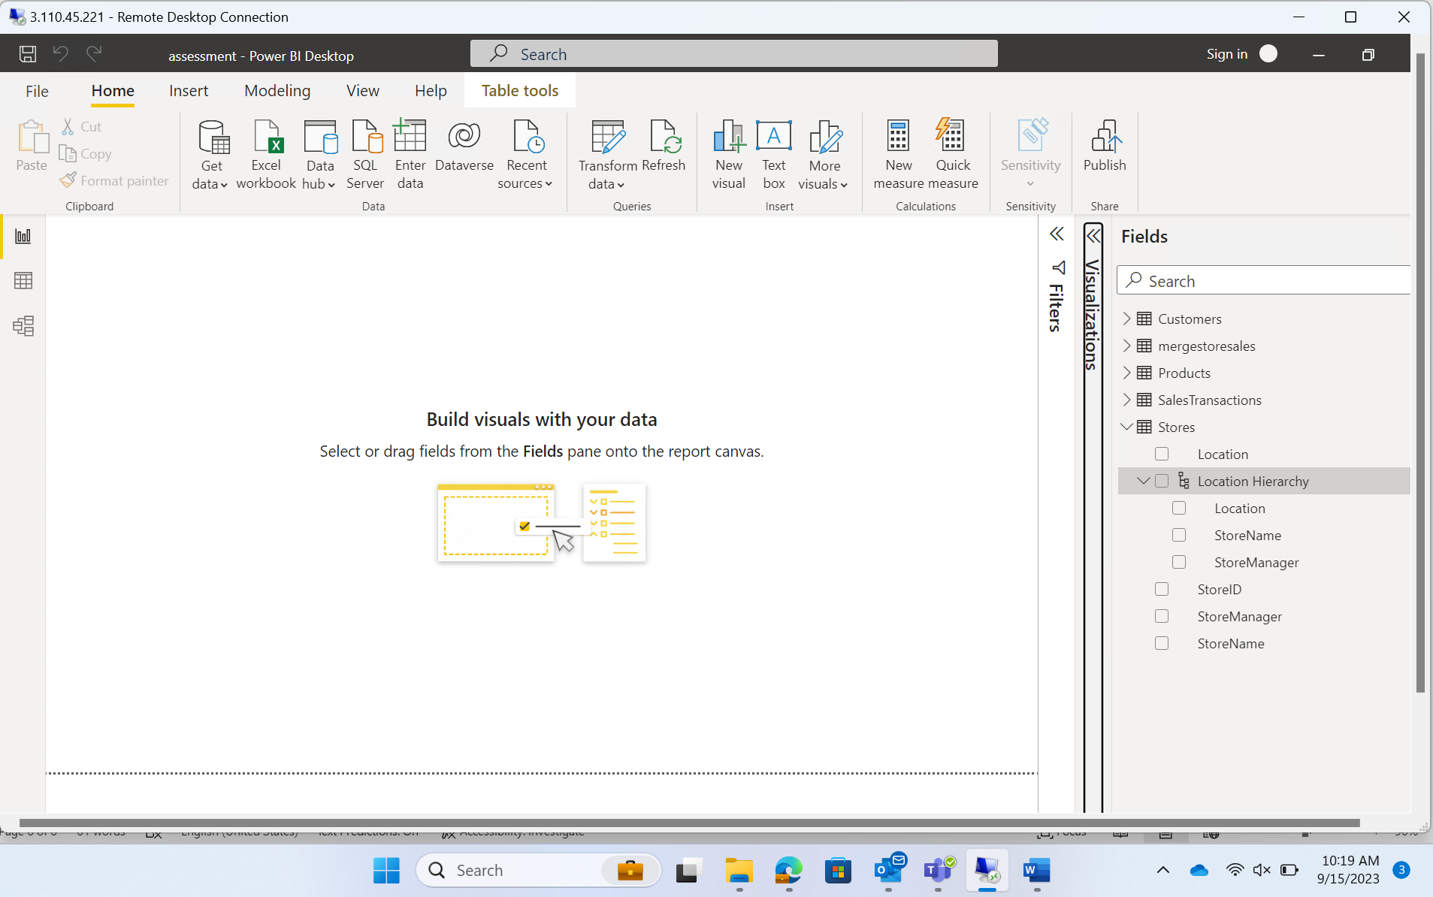

Business Queries and Analysis

1. How is sales revenue distributed among different store managers?

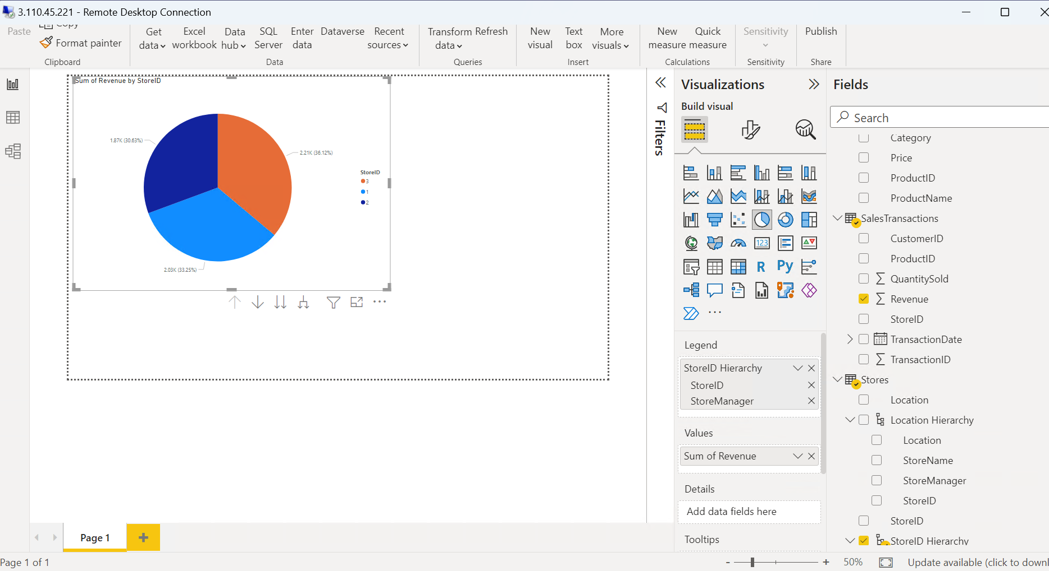

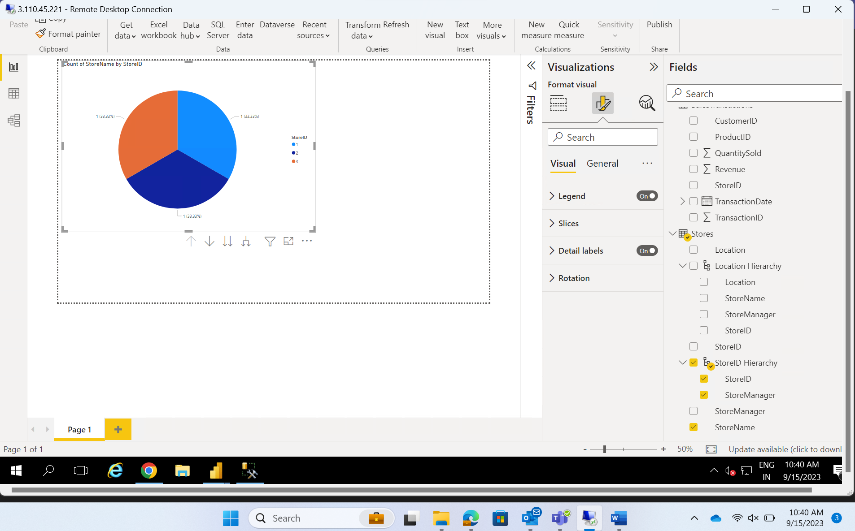

3. What is the average price of products in each category?

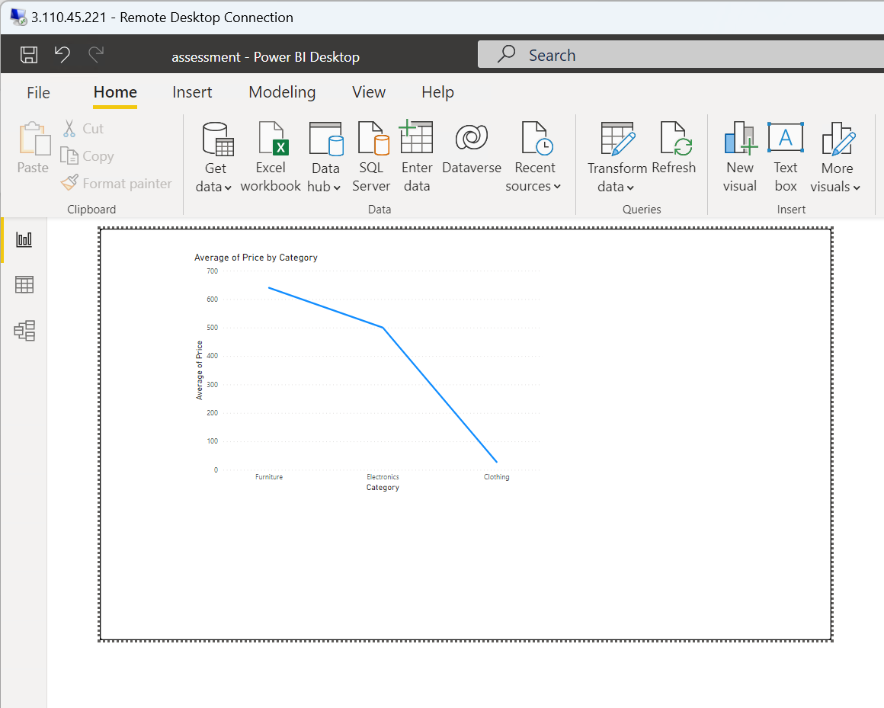

5. How do sales trends vary by product category on a monthly basis?

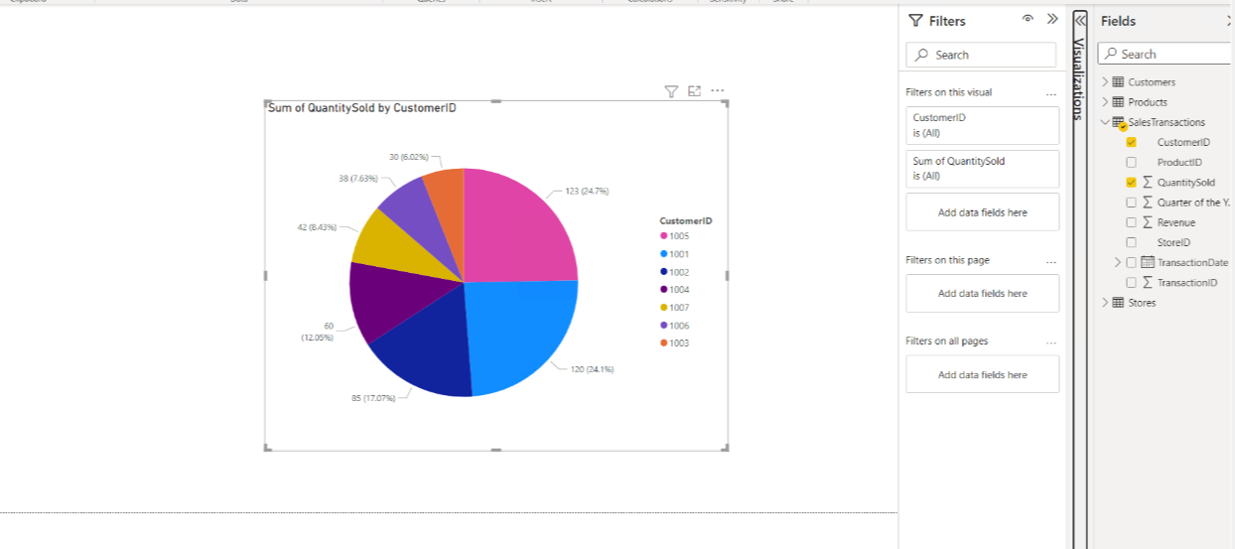

6,8,10 requirements

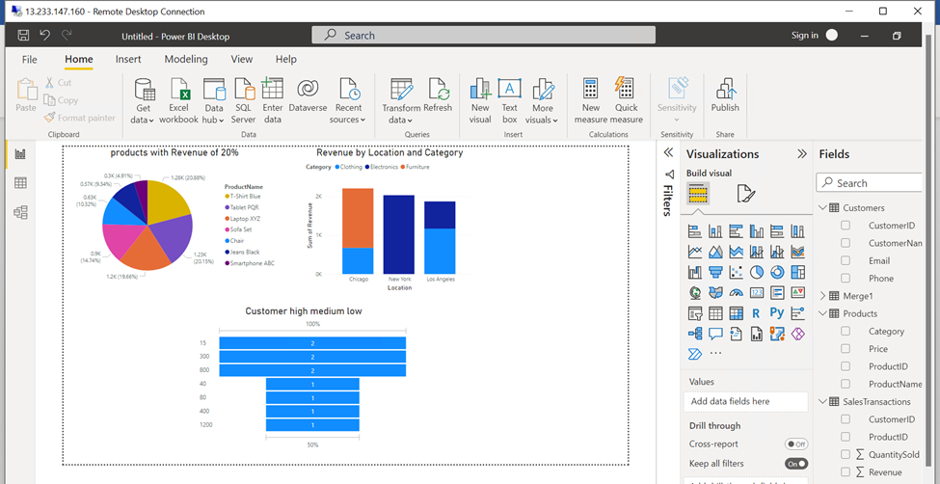

Requirement 5: Data Insights and Recommendations

* Tuesday has the highest sales.
* As the sales of electronics good are the highest, and customer buy the most between price ranges 15-800, the company should release more electronics products in that range.  
  there should be more sales on Tuesday and on the months when sales are the highest i.e. 4*th* and 9*th* months.