1. Goto rcsb.org / uniport.org – identify the target protein ciff file and download
2. Draw the plot of the protein structure using ramplot.in by uploading the ciff file

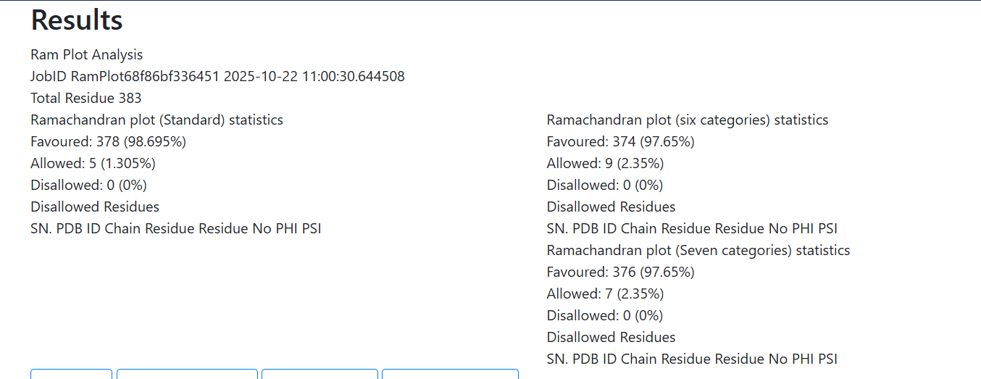

1. If the favoured is less than 90% - goto <https://swissmodel.expasy.org/> and then upload the fasta sequence file from rcsb.org
2. Use castp website – to include our molecular structure and calculate the pdbsum