import java.util.*;

class Student

{

String usn,name;

int sem;

void data1()

{

name=usn="";

sem=0;

}

}

class Test extends Student

{

float cie[]=new float[6];

int credits[]=new int[6];

void data2()

{

name=usn="";

sem=0;

for(int i=0;i<6;i++)

{

cie[i]=0.0f;

credits[i]=0;

}

}

}

class Exam extends Test

{

float see[]=new float[6];

void data3()

{

name=usn="";

sem=0;

for(int i=0;i<6;i++)

{

cie[i]=see[i]=0.0f;

credits[i]=0;

}

}

}

class Result extends Exam

{

char grade[]=new char[6];

float sgpa;

void data4()

{

name=usn="";

sem=0;

for(int i=0;i<6;i++)

{

cie[i]=see[i]=0.0f;

credits[i]=0;

grade[i]='0';

}

}

public void Accept()

{

Scanner sc=new Scanner(System.in);

System.out.println("Enter your USN");

usn=sc.nextLine();

System.out.println("Enter your name");

name=sc.nextLine();

System.out.println("Enter your semester");

sem=sc.nextInt();

System.out.println("Enter the cie marks and credits for each subject");

for(int i=0;i<6;i++)

{

cie[i]=sc.nextFloat();

credits[i]=sc.nextInt();

}

System.out.println("Enter the see marks for each subject");

for(int i=0;i<6;i++)

see[i]=sc.nextFloat();

}

void Calculate()

{

int s=0;

int m=0;

float a=0;

float marks[]=new float[6];

for(int i=0;i<6;i++)

{

marks[i]=cie[i]+see[i];

}

for(int i=0;i<6;i++)

{

if(marks[i]>=90)

{

m=10;

grade[i]='S';

}

else if( marks[i]>=80)

{

m=9;

grade[i]='A';

}

else if( marks[i]>=70)

{

m=8;

grade[i]='B';

}

else if( marks[i]>=60)

{

m=7;

grade[i]='C';

}

else if( marks[i]>=50)

{

m=6;

grade[i]='D';

}

else if( marks[i]>=40)

{

m=4;

grade[i]='E';

}

else if(marks[i]<40)

{

m=0;

grade[i]='F';

s=s+credits[i];

a=a+(credits[i]*m);

}

sgpa=a/s;

}

}

void Display()

{

System.out.println("The details of the student");

System.out.println("USN:"+usn+" Name:"+name);

System.out.println("Credits marks in CIE marks in SEE grade");

for(int i=0;i<6;i++)

{

System.out.println(credits[i]+" "+cie[i]+" "+see[i]+" "+grade[i]);

}

System.out.printf("SGPA %.2f",sgpa);

}

}

class MainStudent

{

public static void main(String args[])

{

int n;

Scanner sc=new Scanner(System.in);

System.out.println("Enter the number of students");

n=sc.nextInt();

Result r[]=new Result[n];

for(int i=0;i<n;i++)

{

r[i]=new Result();

r[i].Accept();

r[i].Calculate();

r[i].Display();

}

}

}

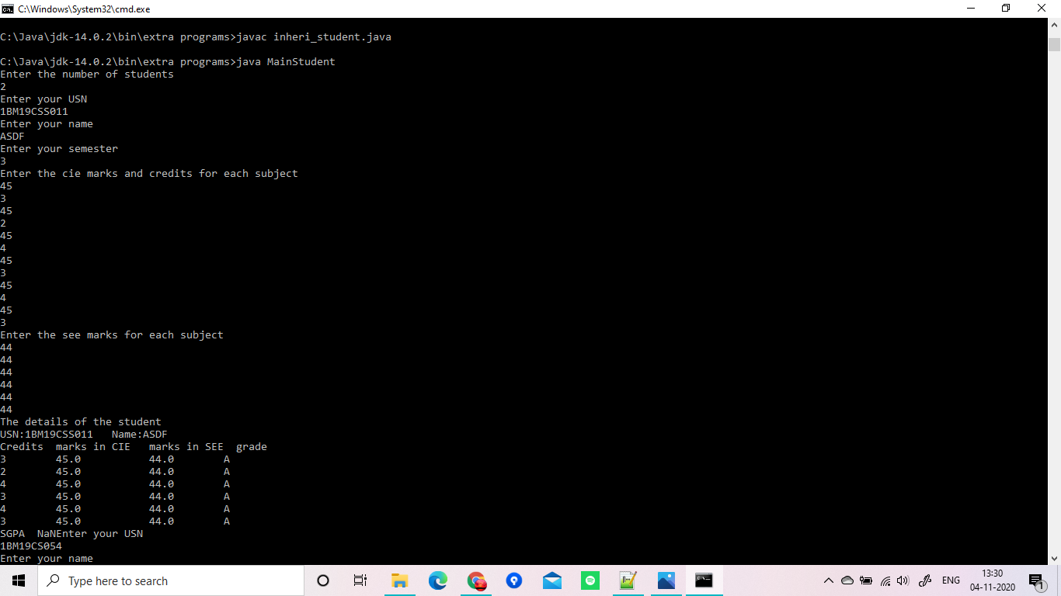

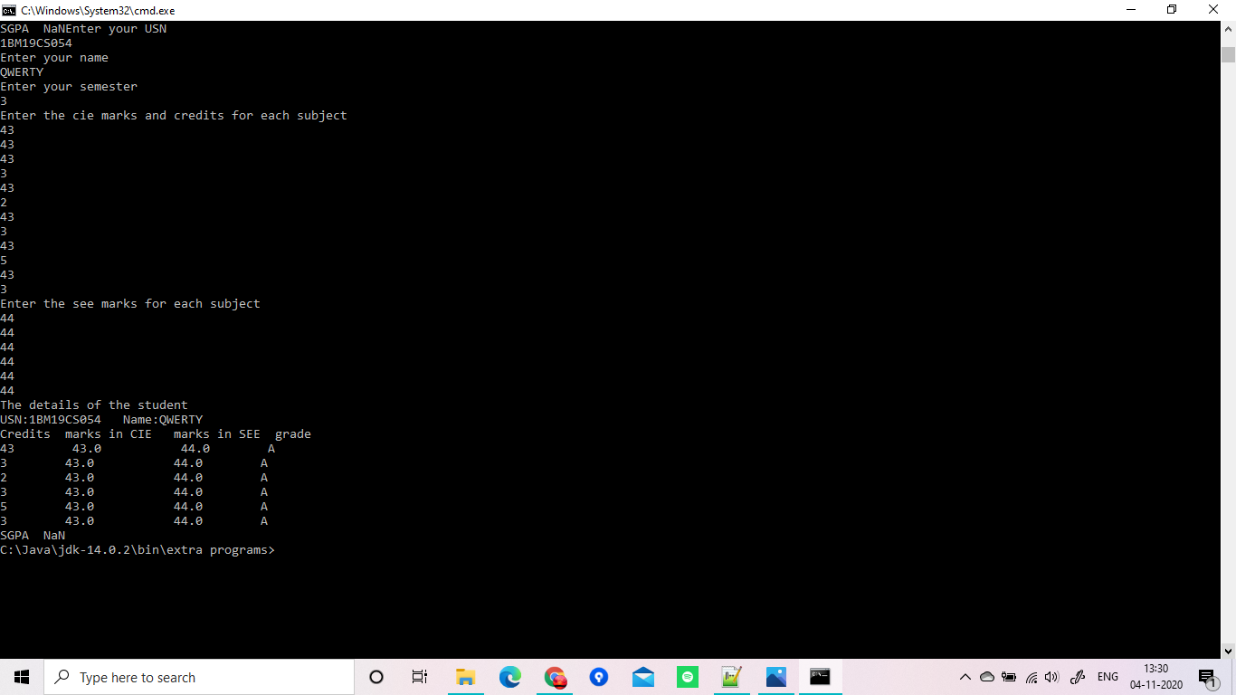

import java.util.*;

abstract class Player

{

String name;

int matches;

float average;

abstract void Average(String a,int b,int c);

}

class Batsman extends Player

{

void Average(String name,int matches,int runs_scored)

{

average=runs_scored/matches;

System.out.println("Details:\nName: "+name+"\nMatches: "+matches+"\nRuns scored: "+runs_scored+"\nAverage:"+average);

}

}

class Bowler extends Player

{

void Average(String name,int matches,int runs_given)

{

average=runs_given/matches;

System.out.println("Details:\nName: "+name+"\nMatches: "+matches+"\nRuns given: "+runs_given+"\nAverage:"+average);

}

}

class MainPlayer

{

public static void main(String args[])

{

Scanner sc=new Scanner(System.in);

System.out.println("Enter the number of batsman and bowlers");

int n=sc.nextInt();

int o=sc.nextInt();

sc.nextLine();

Batsman b1[]=new Batsman[n];

Bowler b2[]=new Bowler[o];

System.out.println("Batsman details");

for(int i=0;i<n;i++)

{

sc.nextLine();

System.out.println("Enter your name");

String name=sc.nextLine();

System.out.println("Enter the number of matches played");

int matches=sc.nextInt();

System.out.println("Enter the total number of runs scored");

int runs_scored=sc.nextInt();

b1[i]=new Batsman();

b1[i].Average(name,matches,runs_scored);

}

System.out.println("Bowler details");

for(int i=0;i<o;i++)

{

sc.nextLine();

System.out.println("Enter your name");

String name=sc.nextLine();

System.out.println("Enter the number of matches played");

int matches=sc.nextInt();

System.out.println("Enter the total number of runs given");

int runs_given=sc.nextInt();

b2[i]=new Bowler();

b2[i].Average(name,matches,runs_given);

}

}

}

