import java.util.Scanner;

class Oddeven

{

public static void main(String args[])

{

Scanner sc=new Scanner(System.in);

int n,s1=0,s2=0;

System.out.println("Enter the size of the array");

n=sc.nextInt();

int a[]=new int[n];

for(int i=0;i<n;i++)

{

System.out.println("Enter the element" +(i+1)+ "of the array");

a[i]=sc.nextInt();

if(i%2==0)

s1=s1+a[i];

else

s2=s2+a[i]:

}

System.out.println("The sum of the numbers in the even indicies of the array is:"+s1);

System.out.println("The sum of the numbers in the odd indicies of the array is:"+s2);

}

}

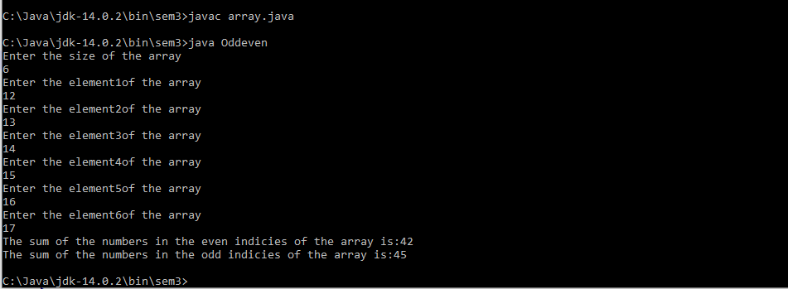

import java.util.Scanner;

class posneg

{

public static void main(String args[])

{

Scanner sc=new Scanner(System.in);

int n,c1=0,c2=0;

System.out.println("Enter the size of the array");

n=sc.nextInt();

int a[]=new int[n];

for(int i=0;i<n;i++)

{

System.out.println("Enter the element " +(i+1)+ " of the array");

a[i]=sc.nextInt();

if(a[i]>=0)

c1=c1+1;

else

c2=c2+1;

}

System.out.println("The count of the positive numbers in the array is:"+c1);

System.out.println("The count of the negative numbers in the array is:"+c2);

}

}

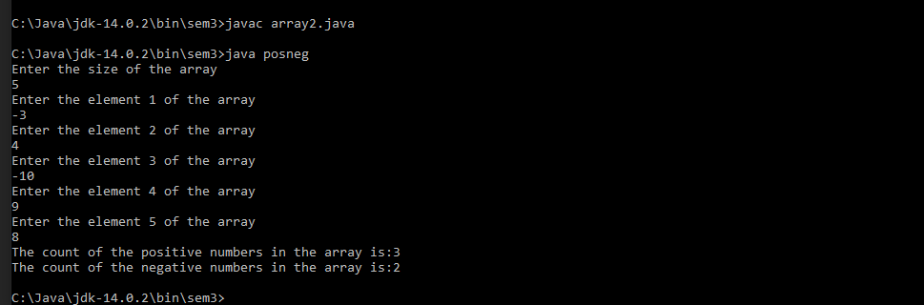

import java.util.Scanner;

class bill

{

public static void main(String args[])

{

Scanner sc=new Scanner(System.in);

int n,c1=0,c2=0;

double tb=0,fb=0;

System.out.println("Enter the total number of items bought");

n=sc.nextInt();

int a[]=new int[n];

double b[]=new double[n];

for(int i=0;i<n;i++)

{

System.out.println("Enter the rate per item and the quantity of item "+(i+1));

b[i]=sc.nextDouble();

a[i]=sc.nextInt();

tb=tb+a[i]\*b[i];

}

if(tb>=10000)

fb=tb-(5/100\*tb);

else if(tb>=7500 && tb<10000)

fb=tb-(3/100\*tb);

else

fb=tb-(2/100\*tb);

System.out.printf("The final bill after discount is %.4f",fb);

}

}

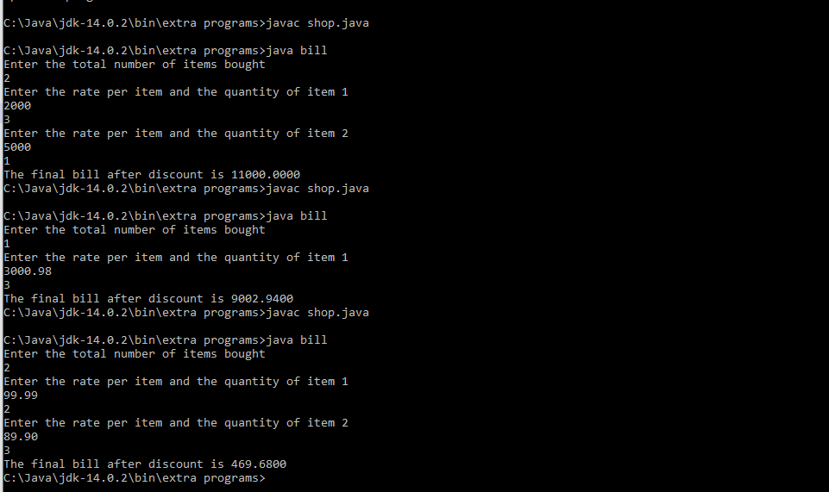

import java.util.Scanner;

class number

{

public static void main(String args[])

{

Scanner sc=new Scanner(System.in);

int n,k=0,j=0,s=0,avg=0;

System.out.println("Enter the size of the array");

n=sc.nextInt();

int a[]=new int[n];

int b[]=new int[n];

int c[]=new int[n];

for(int i=0;i<n;i++)

{

System.out.println("Enter the element" +(i+1)+ "of the array");

a[i]=sc.nextInt();

if(a[i]%2==0)

{

c[k]=a[i];

k++;

}

else

{

b[j]=a[i];

j++;

}

}

int min=c[0],max=c[0];

for(int i=0;i<k;i++)

{

s=s+c[i];

if(c[i]>=max)

max=c[i];

}

for(int i=0;i<k;i++)

{

if(c[i]<=min)

min=c[i];

}

avg=s/k;

System.out.println("Sum is "+s+" average is "+avg+" maximum number is "+max+" minimum number is "+min+"of array C");

}

}

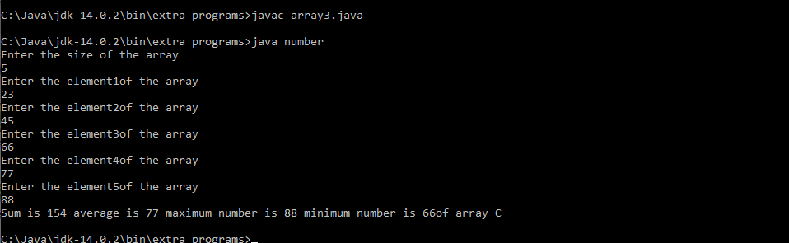

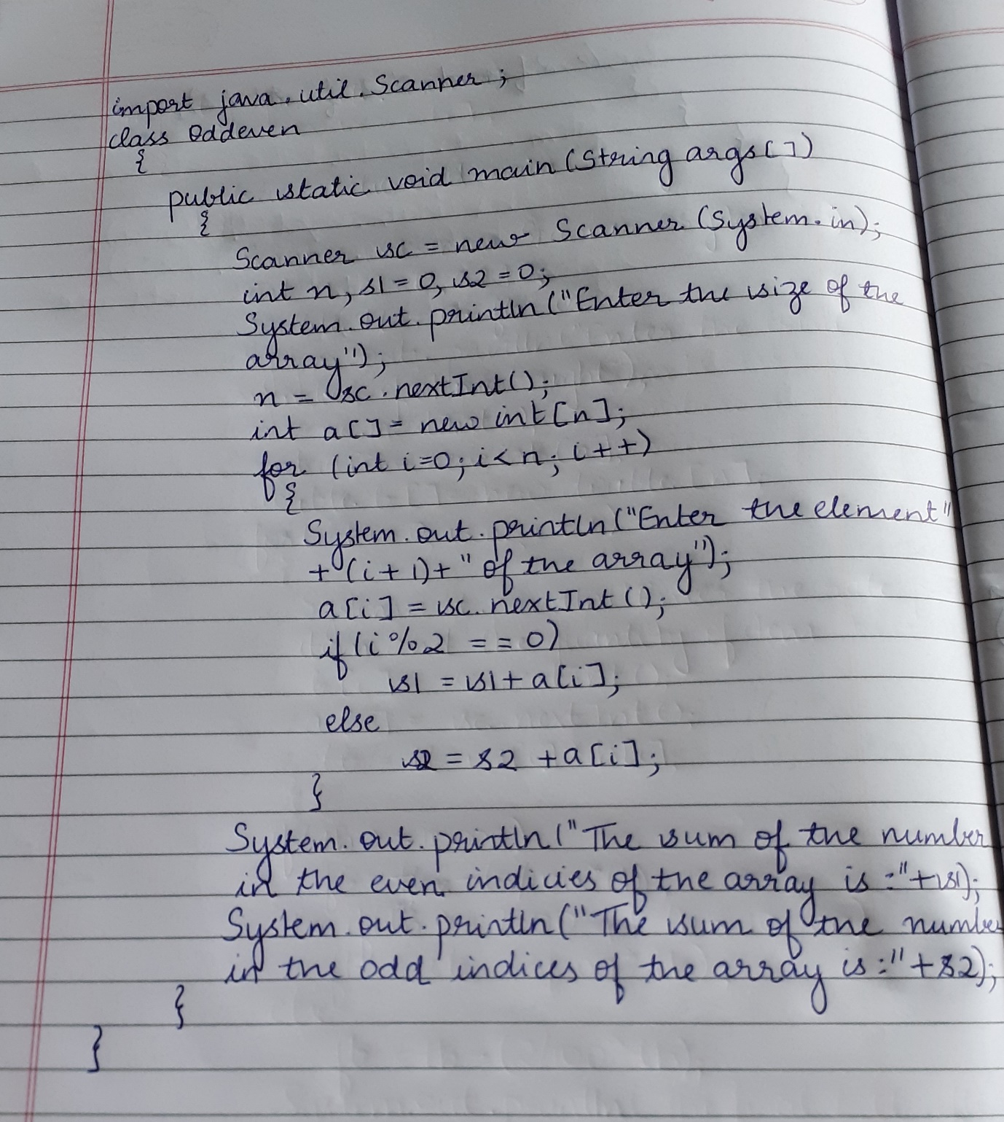

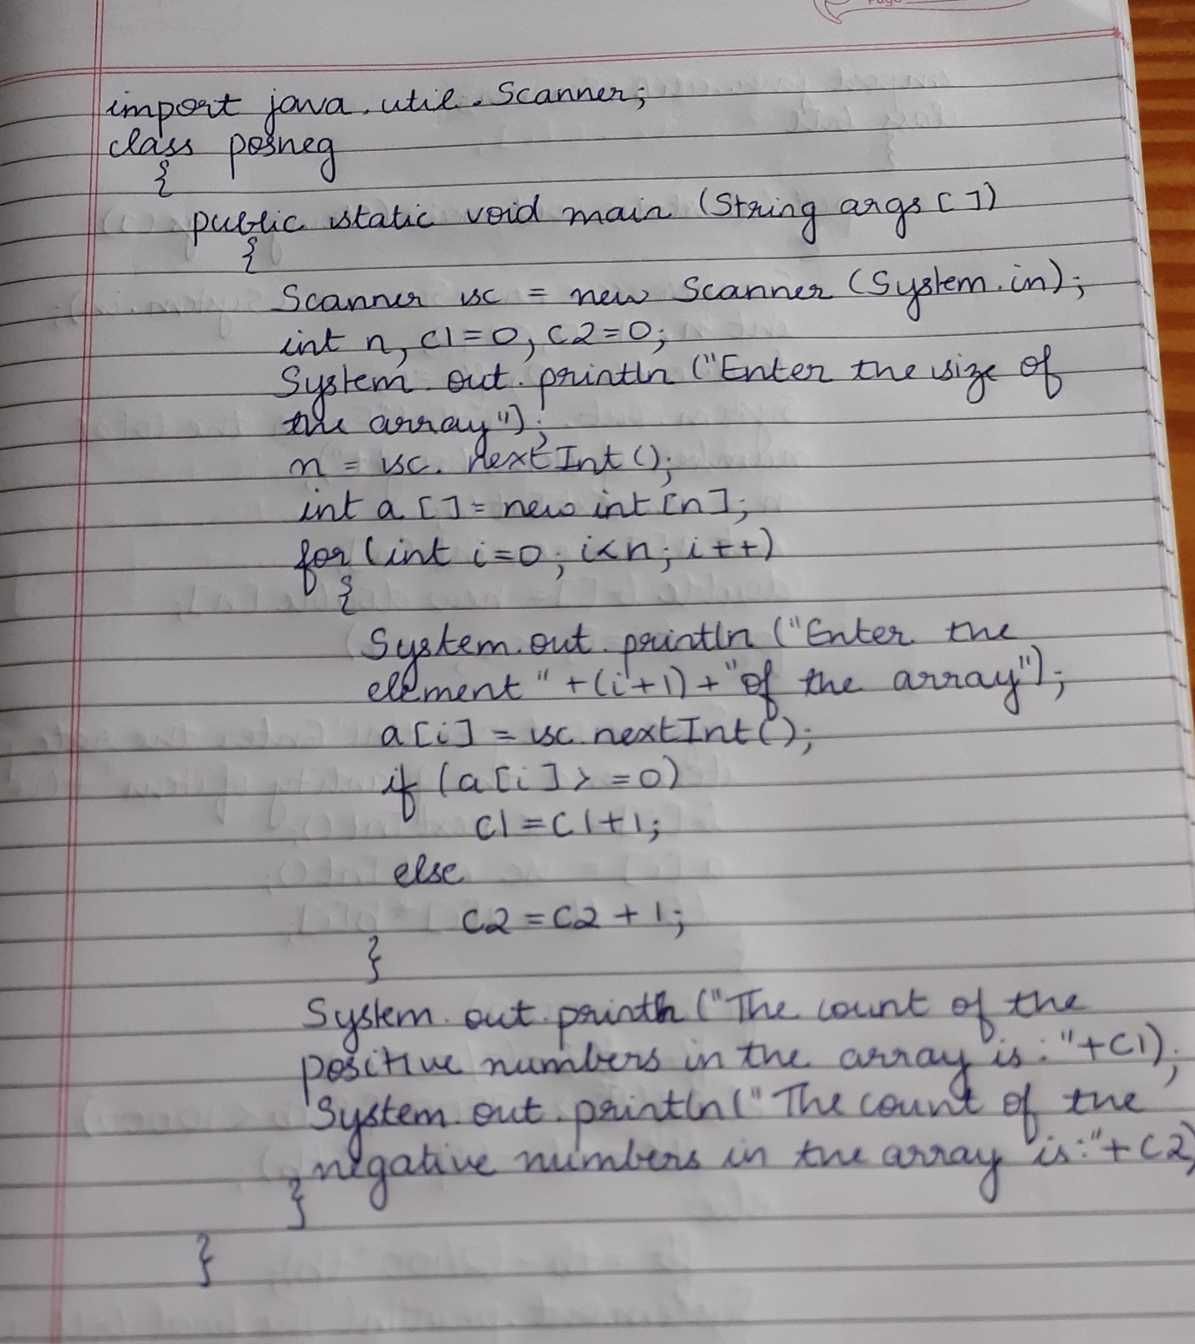

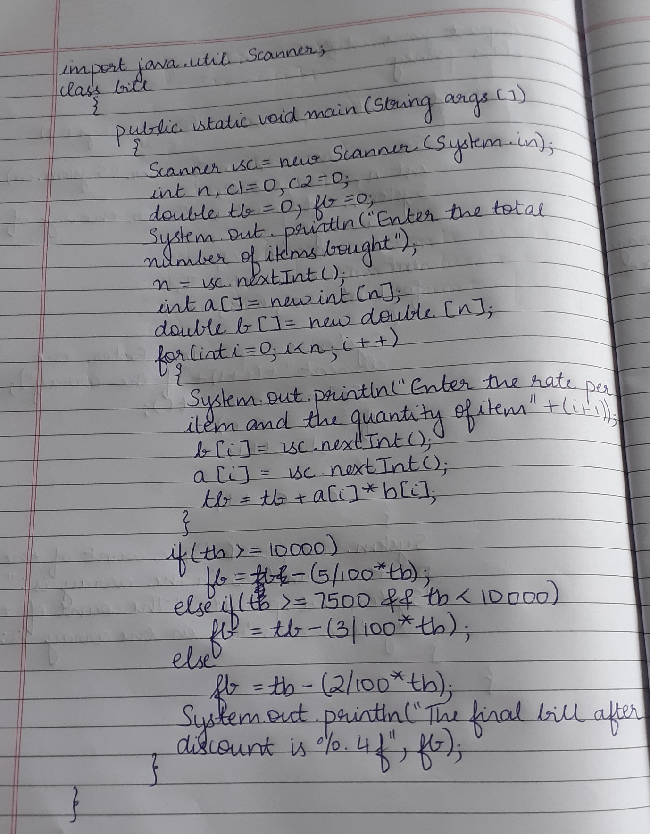

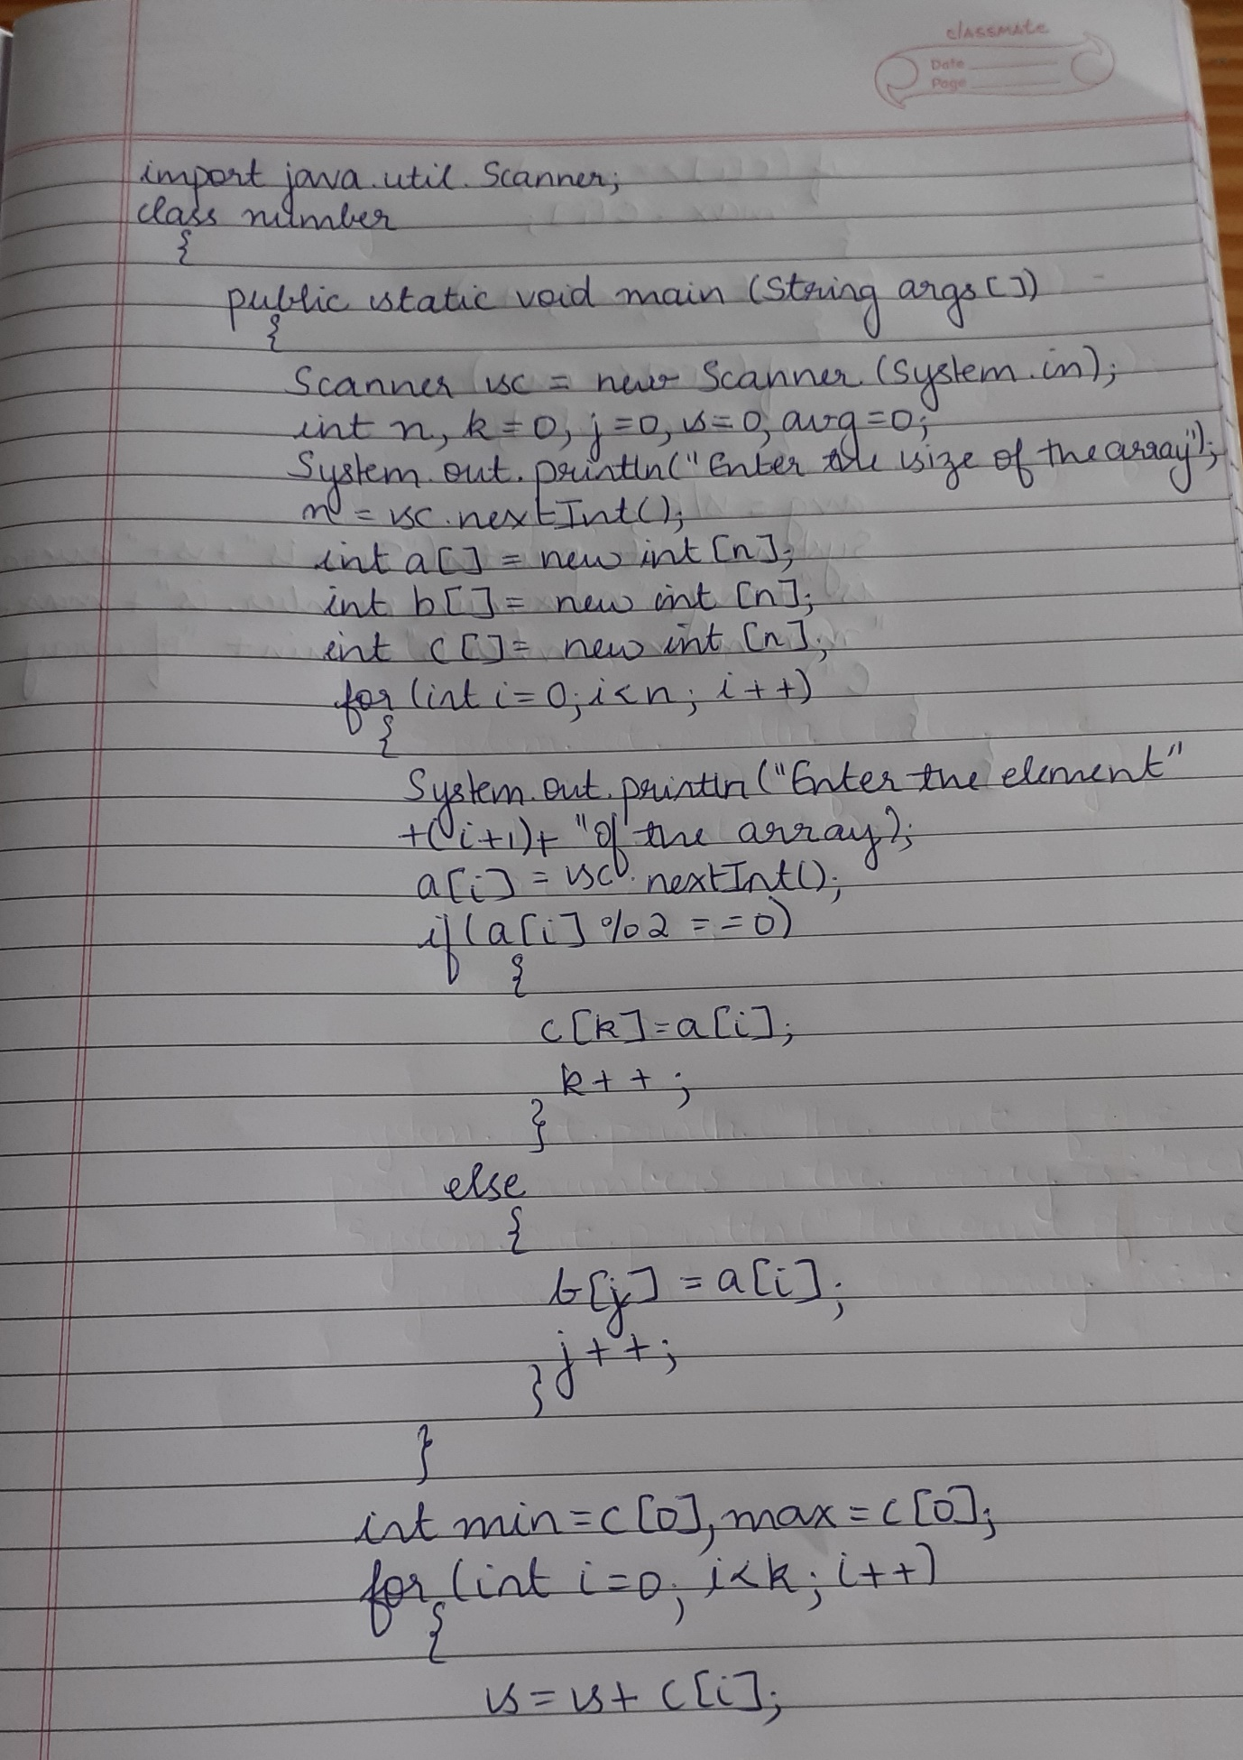

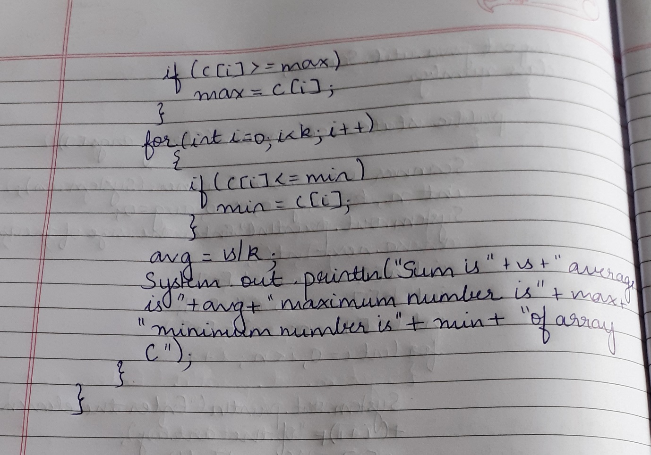s