import java.util.Scanner;

class Book

{

int bookid,year,pages,publish_year;

String booktitle;

String author;

float price;

void Accept()

{

Scanner sc=new Scanner(System.in);

System.out.println("Enter the author of the book");

author=sc.nextLine();

System.out.println("Enter the name of the book");

booktitle=sc.nextLine();

System.out.println("Enter the book id");

bookid=sc.nextInt();

System.out.println("Enter the year of publishing the book");

publish_year=sc.nextInt();

System.out.println("Enter the total number of pages of the book");

pages=sc.nextInt();

System.out.println("Enter the price");

price=sc.nextFloat();

}

void Display()

{

System.out.println("The book id"+bookid);

System.out.println("Name of the book"+booktitle);

System.out.println("Author of the book"+author);

System.out.println("Year of publishing the book"+publish_year);

System.out.println("Total number of pages of the book"+pages);

System.out.println("Price of the book"+price);

}

float bookPrice()

{

return price;

}

}

class BookMain

{

public static void main(String args[])

{

int c=0;

String a;

Scanner sc=new Scanner(System.in);

Book b1=new Book();

Book b2=new Book();

Book b3=new Book();

b1.Accept();

b2.Accept();

b3.Accept();

System.out.println("Enter the author of the book you want details of");

a=sc.nextLine();

if(b1.author==a)

b1.Display();

else if(b2.author==a)

b2.Display();

else

b3.Display();

if(b1.bookPrice()>b2.bookPrice() && b1.bookPrice()>b3.bookPrice())

System.out.println(b1.booktitle+" is the most expensive book");

else if(b2.bookPrice()>b1.bookPrice() && b2.bookPrice()>b3.bookPrice())

System.out.println(b2.booktitle+" is the most expensive book");

else

System.out.println(b3.booktitle+" is the most expensive book");

if(b1.publish_year==2020 && b2.publish_year==2020 && b3.publish_year==2020)

c=3;

else if(b1.publish_year==2020 && b2.publish_year==2020 && b3.publish_year!=2020)

c=2;

else if(b1.publish_year!=2020 && b2.publish_year==2020 && b3.publish_year!=2020)

c=2;

else if(b1.publish_year==2020 && b2.publish_year!=2020 && b3.publish_year!=2020)

c=2;

else if(b1.publish_year==2020 || b2.publish_year==2020 || b3.publish_year!=2020)

c=1;

else

c=0;

System.out.println("Number of book published in 2020 :"+c);

if(b1.pages<b2.pages && b1.pages<b3.pages)

b1.Display();

else if(b2.pages<b1.pages && b2.pages<b3.pages)

b2.Display();

else

b3.Display();

}

}

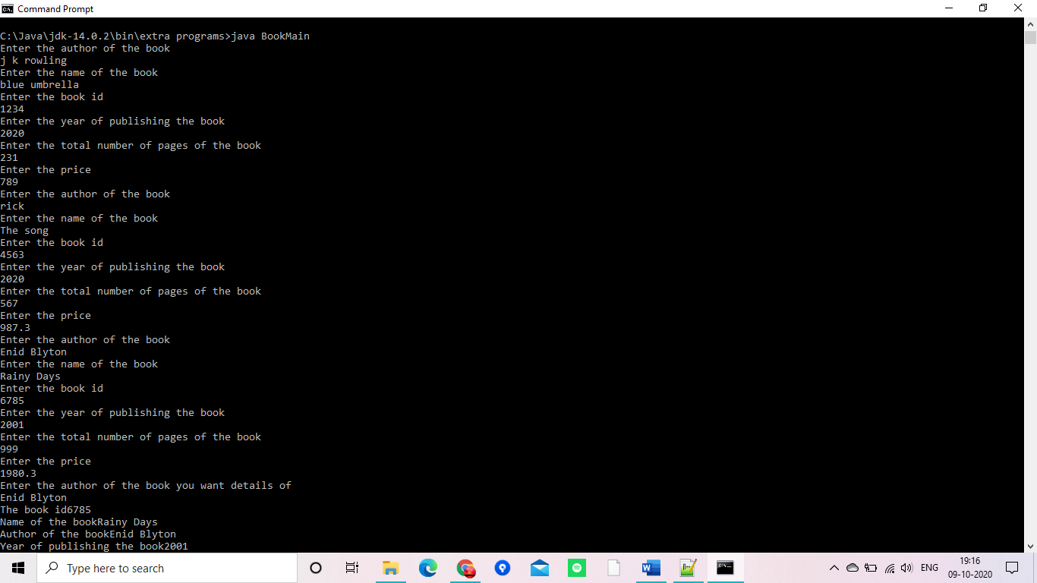

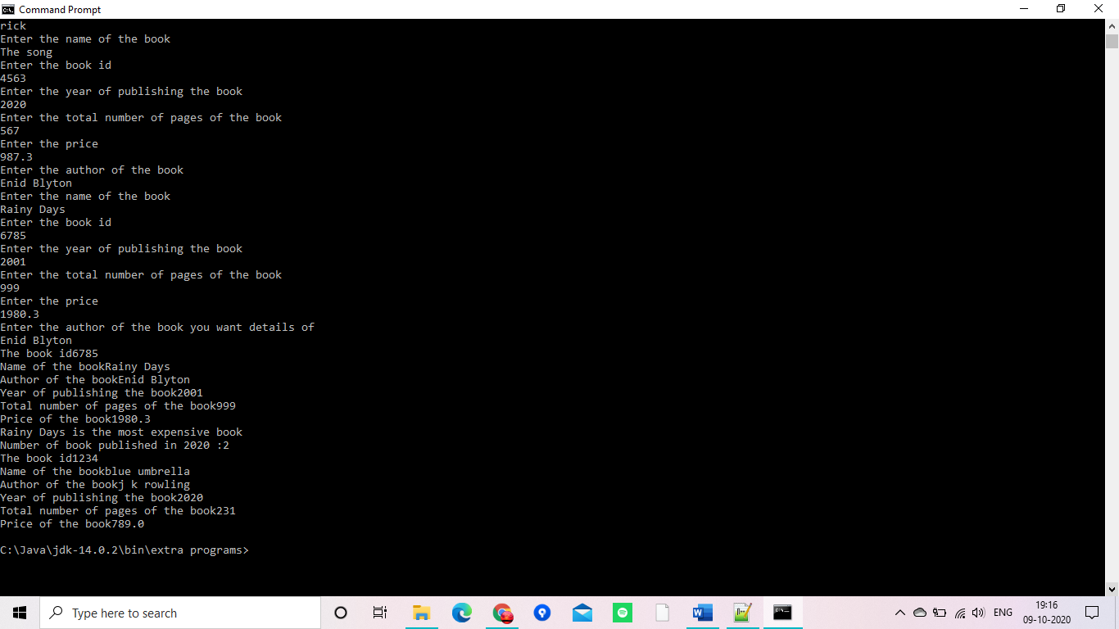

import java.util.Scanner;

class player

{

int id,scores,no_matches_played;

String name;

float avg=0;

player()

{

id=0;

scores=0;

no_matches_played=0;

name="";

}

void Accept()

{

Scanner sc=new Scanner(System.in);

System.out.println("Enter your name");

name=sc.nextLine();

System.out.println("Enter your id");

id=sc.nextInt();

System.out.println("Enter your total score");

scores=sc.nextInt();

System.out.println("Enter the total number of matches played");

no_matches_played=sc.nextInt();

}

float Calculate()

{

avg=(float)scores/no_matches_played;

return avg;

}

void Display()

{

System.out.println("Id "+id);

System.out.println("Name "+name);

System.out.println("Total score "+scores);

System.out.println("Number of matches played "+no_matches_played);

System.out.println("Average score "+avg);

}

}

class MainPlayer

{

public static void main(String args[])

{

player p1=new player();

p1.Accept();

p1.Calculate();

player p2=new player();

p2.Accept();

p2.Calculate();

if(p1.Calculate()>p2.Calculate())

p1.Display();

else

p2.Display();

}

}

