import java.util.Scanner;

class Employee

{

int id,hrs;

String name;

float basic,hra,da,it,gross;

Employee()

{

id=hrs=0;

name="";

basic=hra=da=it=gross=0.0f;

}

void Accept()

{

Scanner sc=new Scanner(System.in);

System.out.println("Enter your name");

name=sc.nextLine();

System.out.println("Enter your id");

id=sc.nextInt();

System.out.println("Enter number of hours");

hrs=sc.nextInt();

System.out.println("Enter your basic salary");

basic=sc.nextFloat();

System.out.println("Enter your DA");

da=sc.nextFloat();

System.out.println("Enter your IT");

it=sc.nextFloat();

System.out.println("Enter your HRA");

hra=sc.nextFloat();

}

void Calculate()

{

da=(da/100)\*basic;

it=(it/100)\*basic;

hra=(hra/100)\*basic;

gross= basic + (basic\*hra) + (basic\*da) - (basic\*it);

}

void Update()

{

if(hrs>=200)

gross=gross+(100\*hrs);

else

gross=gross-(100\*hrs);

System.out.println("Final employee salary is: "+gross);

}

}

class EmployeeMain

{

public static void main(String args[])

{

Employee e1=new Employee();

e1.Accept();

e1.Calculate();

e1.Update();

}

}

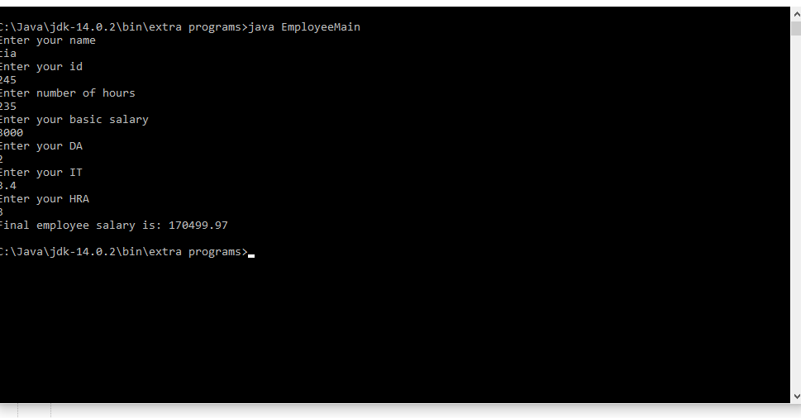

import java.util.Scanner;

class Age

{

int m,y;

Age()

{

m=0;

y=0;

}

void Accept()

{

Scanner sc=new Scanner(System.in);

System.out.println("Enter your age in months and years");

m=sc.nextInt();

y=sc.nextInt();

}

}

class AgeMain

{

public static void main(String args[])

{

Age a1=new Age();

Age a2=new Age();

a1.Accept();

a2.Accept();

if(a1.y!=a2.y)

{

if(a1.y>a2.y)

System.out.println("rita(age "+a1.y+"years and "+a1.m+" months) is older than gita age("+a2.y+"years and "+a2.m+" months)");

else

System.out.println("gita(age "+a2.y+"years and "+a2.m+" months) is older than rita age("+a1.y+"years and "+a1.m+"months)");

}

else

{

if(a1.m>a2.m)

System.out.println("rita(age "+a1.y+"years and "+a1.m+" months) is older than gita age("+a2.y+"years and "+a2.m+"months)");

else

System.out.println("gita(age "+a2.y+"years and "+a2.m+" months) is older than rita age("+a1.y+"years and "+a1.m+"monthsA)");

}

}

}

