class Gen<I,S,F>

{

I ob1;

S ob2;

F ob3;

Gen(I o1, S o2,F o3)

{

ob1=o1;

ob2=o2;

ob3=o3;

}

void showTypes()

{

System.out.println("Type of I is " +ob1.getClass().getName());

System.out.println("Type of S is " +ob2.getClass().getName());

System.out.println("Type of F is " +ob3.getClass().getName());

}

I getob1()

{

return ob1;

}

S getob2()

{

return ob2;

}

F getob3()

{

return ob3;

}

}

class MainGen

{

public static void main(String args[])

{

Gen<Integer, String,Float> tgObj = new Gen<Integer, String,Float>(123, "Generics",0.987f);

tgObj.showTypes();

int a=tgObj.getob1();

System.out.println("Integer value is: " +a);

String b=tgObj.getob2();

System.out.println("String value is: " +b);

Float c=tgObj.getob3();

System.out.println("Float value is: "+c);

}

}

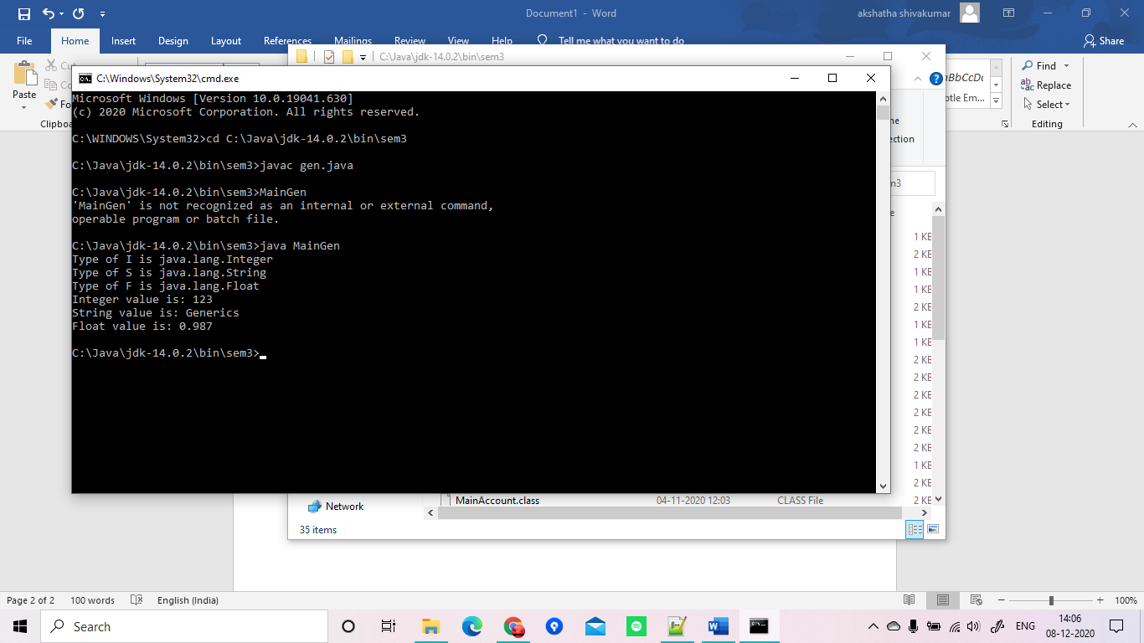

import java.util.Scanner;

class WrongAge extends Exception {

int age;

WrongAge(int x) {

age = x;

}

public String toString() {

return "Age entered is incorrect";

}

}

class father {

int a;

father(int x) {

a = x;

}

}

class son extends father {

int age;

son(int fage, int sage) {

super(fage);

age = sage;

}

void check() throws WrongAge {

if (age >= a || age<0 || a<0) {

throw new WrongAge(age);

}

else {

System.out.println("Correct ages entered");

System.out.println("Father's age:" + a + "\n" + "Son's age:" + age);

}

}

}

class ExceptionsMain {

public static void main(String args[]) {

Scanner sc = new Scanner(System.in);

System.out.println("Enter father's age:");

int f = sc.nextInt();

System.out.println("Enter son's age:");

int s = sc.nextInt();

son ss = new son(f, s);

try {

ss.check();

}

catch (WrongAge e) {

System.out.println(" "+e);

}

}

}

