import java.util.Scanner;

class Matrix

{

int a[][];

int r,c;

void Accept()

{

Scanner sc=new Scanner(System.in);

System.out.println("Enter the number of rows and columns of the matrix");

r=sc.nextInt();

c=sc.nextInt();

a=new int[r][c];

System.out.println("Enter valuse into the matrix");

for(int i=0;i<r;i++)

{

for(int j=0;j<c;j++)

a[i][j]=sc.nextInt();

}

}

void Transpose()

{

System.out.println("The entered matrix ");

for(int i=0;i<r;i++)

{

for(int j=0;j<c;j++)

{

System.out.print(a[i][j]+" ");

}

System.out.println("");

}

System.out.println("The matrix after transpose ");

for(int i=0;i<c;i++)

{

for(int j=0;j<r;j++)

{

System.out.print(a[j][i]+" ");

}

System.out.println("");

}

}

}

class MainMatrix

{

public static void main(String args[])

{

Matrix m=new Matrix();

m.Accept();

m.Transpose();

}

}

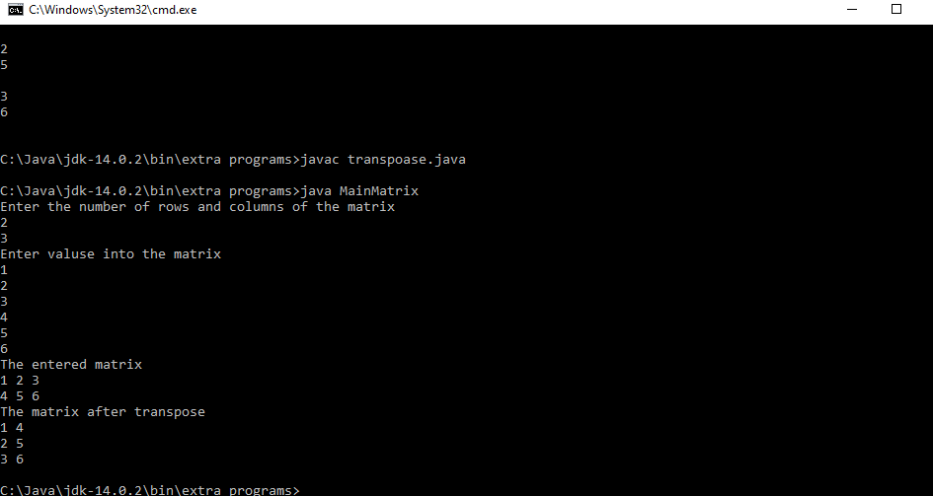

import java.util.\*;

class CircleDemo

{

double area=0.0f,r=0.0f,peri=0.0f;

void Accept()

{

Scanner sc=new Scanner(System.in);

System.out.println("Enter the radius of the circle");

r=sc.nextDouble();

}

void Area()

{

area=3.14\*r\*r;

}

void Perimeter()

{

peri=2\*3.14\*r;

}

void Display()

{

System.out.println("Radius "+r+"\nArea "+area+"\nPerimeter "+peri+"\n");

}

public static void main(String args[])

{

CircleDemo c=new CircleDemo();

c.Accept();

c.Area();

c.Perimeter();

c.Display();

}

}

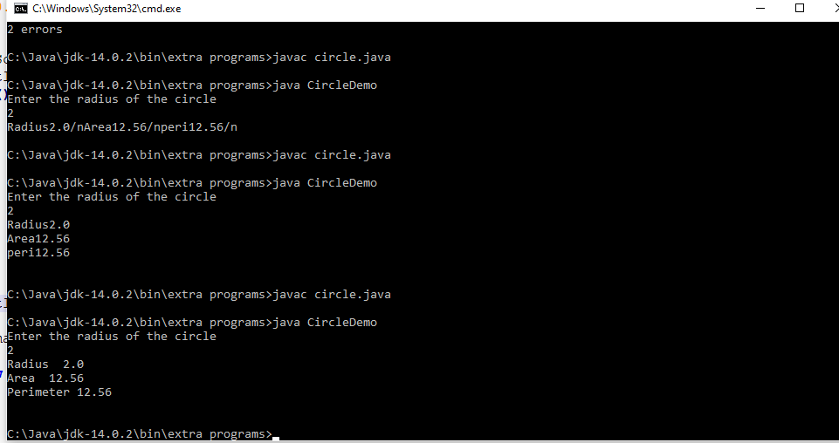

import java.util.Scanner;

class Actor

{

int id,nom,years;

float avg=0;

String name;

void Accept()

{

Scanner sc=new Scanner(System.in);

System.out.println("Enter your name");

name=sc.nextLine();

System.out.println("Enter your id");

id=sc.nextInt();

System.out.println("Enter the number of movies");

nom=sc.nextInt();

System.out.println("Enter number of years of experience");

years=sc.nextInt();

}

float calculate()

{

avg=nom/years;

return avg;

}

void Display()

{

System.out.println("Id: "+id+"\nNumber of movies: "+nom+"\nYeras of experience: "+years+"\n Average performance: "+avg);

}

void Display1()

{

System.out.println("Actor with the highest average performance is"+name);

}

}

class MainActor

{

public static void main(String args[])

{

int n,j=0;

Scanner sc=new Scanner(System.in);

System.out.println("Enter the number of actors");

n=sc.nextInt();

Actor a[]=new Actor[n];

for(int i=0;i<n;i++)

{

a[i]=new Actor();

a[i].Accept();

a[i].calculate();

}

for(int i=0;i<n;i++)

{System.out.println("Actor "+(i+1));

a[i].Display();

}

float h=a[0].calculate();

for(int i=0;i<n;i++)

{

if(a[i].calculate()>h)

{

System.out.println("Actor with higher average performance");

a[i].Display();

}

}

}

}

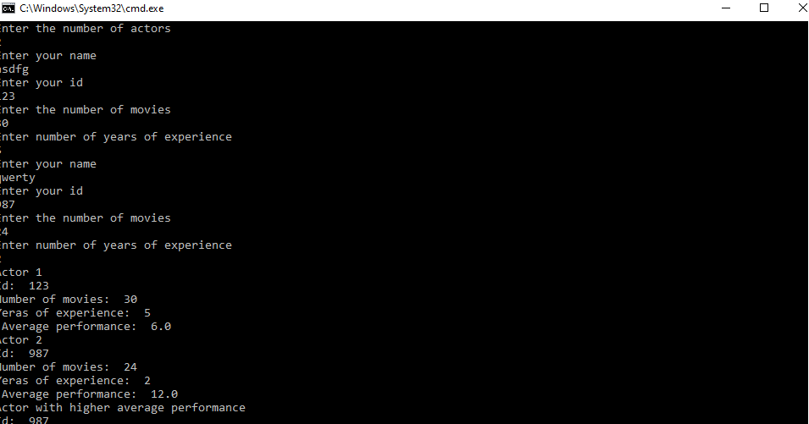

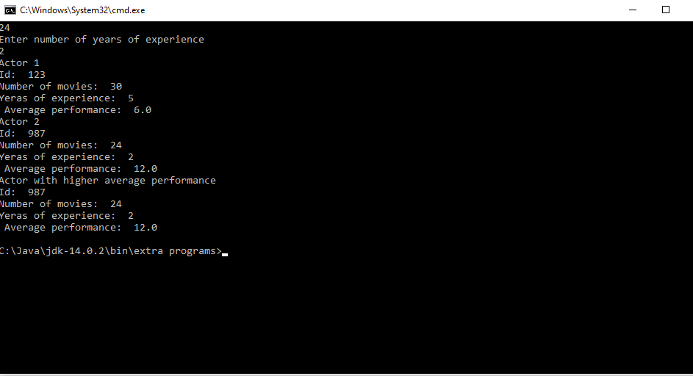

class Array

{

public static void main(String args[])

{

int a[]=new int [args.length];

int temp;

for(int i=0;i<args.length;i++)

{

a[i]=Integer.parseInt(args[i]);

}

for(int i=0; i < args.length; i++)

{

for(int j=1; j < (args.length-i); j++)

{

if(a[j-1] > a[j])

{

temp = a[j-1];

a[j-1] = a[j];

a[j] = temp;

}

}

}

System.out.println("The sorted array :");

for(int i=0;i<args.length;i++)

{

System.out.print(a[i]+" ");

}

}

}

