import java.util.Scanner;

abstract class Shape

{

int a1,a2;

Scanner sc = new Scanner(System.in);

abstract void printArea();

}

class Rectangle extends Shape

{

void printArea()

{

System.out.println("Enter length and breadth of Rectangle: ");

a1 = sc.nextInt();

a2 = sc.nextInt();

System.out.println("The area of Rectangle is: "+a1\*a2);

}

}

class Triangle extends Shape

{

void printArea()

{

System.out.println("Enter base and height of Triangle: ");

a1 = sc.nextInt();

a2= sc.nextInt();

System.out.println("The area of Triangle is: "+(a1\*a2)/2f);

}

}

class Circle extends Shape

{

void printArea()

{

System.out.println("Enter radius of Circle: ");

a1 = sc.nextInt();

System.out.println("The area of Circle is: " +a1\*a1\*3.14f);

}

}

class MainShape

{

public static void main(String args[])

{

Rectangle r = new Rectangle();

r.printArea();

Triangle t = new Triangle();

t.printArea();

Circle c = new Circle();

c.printArea();

}

}

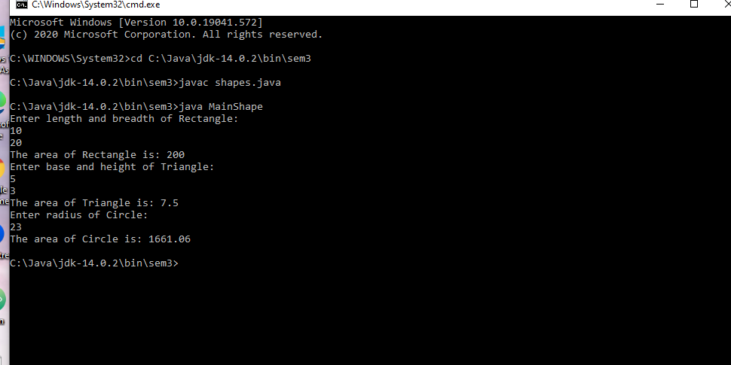

import java.util.Scanner;

class Account

{

String name,type;

long acno;

double bal;

double minbal=1000.0;

double w=0;

Account(String name,String type,long acno,double bal)

{

this.name=name;

this.type=type;

this.acno=acno;

this.bal=bal;

}

Scanner sc=new Scanner(System.in);

}

class Current extends Account

{

Current (String name,long acno,double bal)

{

super(name,"Current",acno,bal);

}

void Withdraw()

{

System.out.println("Enter the amount you want to withdraw");

w=sc.nextDouble();

bal=bal-w;

Balance();

}

void Deposit()

{

System.out.println("Enter the amount you want to deposit");

w=sc.nextDouble();

bal=bal+w;

}

void Balance()

{

if (bal<minbal)

{

System.out.println("Insufficient balance ,penalty will be imposed");

bal=bal\*0.3;

}

}

void Display()

{

System.out.println("Name"+name+"\n Account number"+acno+"\n Type of account"+type+"\nBalance"+bal);

}

}

class Savings extends Account

{

Savings (String name,long acno,double bal)

{

super(name,"Savings",acno,bal);

}

void Withdraw()

{

System.out.println("Enter the amount you want to withdraw");

w=sc.nextDouble();

bal=bal-w;

}

void Deposit()

{

System.out.println("Enter the amount you want to deposit");

w=sc.nextDouble();

bal=bal+w;

Calculate();

}

void Calculate()

{

int t=2, R=55;

bal=bal+bal\*(Math.pow((1+(R/100)), t));

}

void Display()

{

System.out.println("Name"+name+"\n Account number"+acno+"\n Type of account"+type+"\nBalance"+bal);

}

}

class MainAccount

{

public static void main(String args[])

{

Scanner sc=new Scanner(System.in);

System.out.println("Enter your name");

String name=sc.nextLine();

System.out.println("Enter your account number");

long acno=sc.nextLong();

System.out.println("Enter your account balance");

float bal=sc.nextFloat();

System.out.println("Type of account:\n 1.Current account\n 2.Savings account\n 3.Exit");

int o=sc.nextInt();

if(o==1)

{

Current c = new Current(name,acno,bal);

while(true)

{

System.out.println("1.Deposit\n2.Withdraw Amount\n3.Display\n4.Exit");

int ch = sc.nextInt();

switch (ch)

{

case 1:

c.Deposit();

break;

case 2:

c.Withdraw();

break;

case 3:

c.Display();

case 4:

System.exit(0);

default:

System.out.println("Invalid choice");

}

}

}

else if(o==2)

{

Savings s = new Savings(name,acno,bal);

while(true)

{

System.out.println("1.Deposit\n2.Withdraw Amount\n3.Display\n4.Exit");

int ch = sc.nextInt();

switch (ch)

{

case 1:

s.Deposit();

break;

case 2:

s.Withdraw();

break;

case 3:

s.Display();

case 4:

System.exit(0);

default:

System.out.println("Invalid choice");

}

}

}

else if(o==3)

System.exit(0);

else

System.out.println("Invalid choice");

}

}

