import java.util.Scanner;

abstract class Solid

{

double r,h;

Scanner sc=new Scanner(System.in);

}

class Sphere extends Solid

{

void print(double r)

{

System.out.println("The surface area is " +4\*3.14\*r\*r+"\nThe volume is "+(4/3)\*3.14\*Math.pow(r,3));

}

}

class Cone extends Solid

{

void print(double r,double h)

{

System.out.println("The surface area is " +3.14\*r\*(r+(h\*h)+(r\*r))+"\nThe volume is "+3.14\*r\*r\*(h/3));

}

}

class Cylinder extends Solid

{

void print(double r,double h)

{

System.out.println("The surface area is " +((2\*3.14\*r\*h)+(2\*3.14\*r\*r))+"\nThe volume is "+3.14\*r\*r\*h);

}

}

class MainSolid

{

public static void main(String args[])

{

Scanner sc=new Scanner(System.in);

while(true)

{

System.out.println("Enter your choice\n1.Cylinder\n2.Sphere\n3.Cone\n4.Exit");

int ch=sc.nextInt();

switch(ch)

{

case 1:

System.out.println("Enter the radius and height of the cylinder");

double r=sc.nextDouble();

double h=sc.nextDouble();

Cylinder c=new Cylinder();

c.print(r,h);

break;

case 2:

System.out.println("Enter the radius of the sphere");

double r1=sc.nextDouble();

Sphere s=new Sphere();

s.print(r1);

break;

case 3:

System.out.println("Enter the radius and height of the cone");

double r3=sc.nextDouble();

double h3=sc.nextDouble();

Cone co=new Cone();

co.print(r3,h3);

break;

case 4:System.exit(0);

default:System.out.println("Invalid input");

}

}

}

}

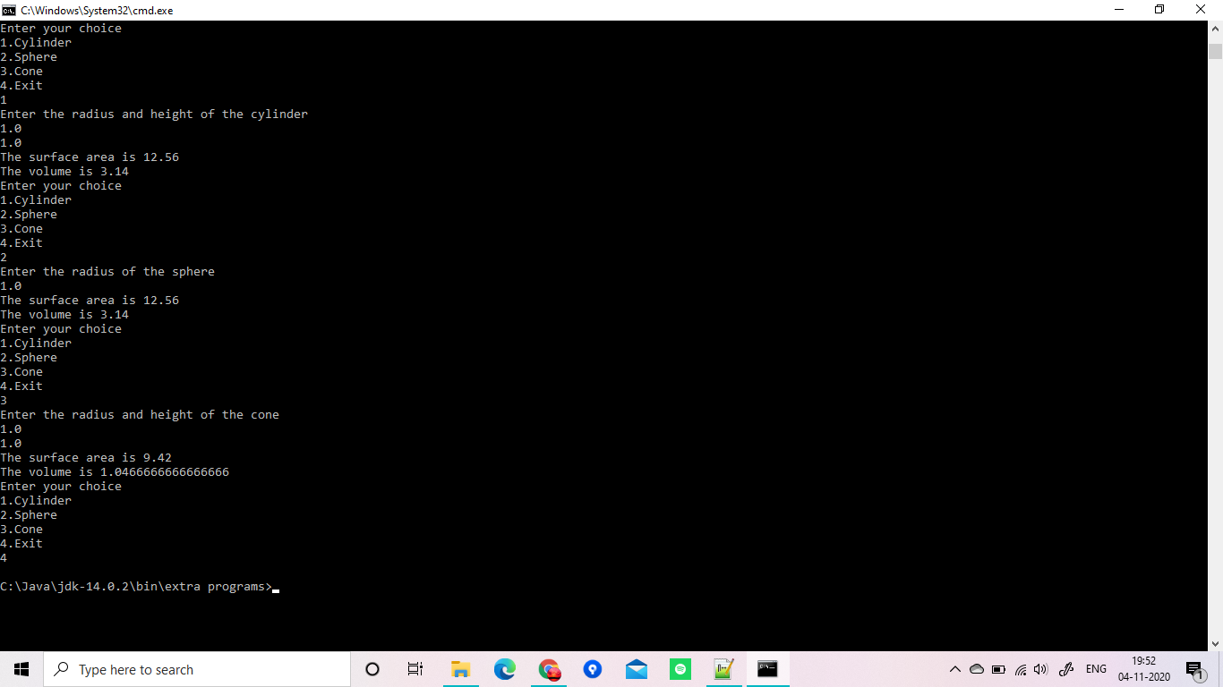

import java.util.Scanner;

class Person

{

int age;

String s1,s2,s3;

Person(int age,String s1,String s2,String s3)

{

this.age=age;

this.s1=s1;

this.s2=s2;

this.s3=s3;

}

}

class Employee extends Person

{

Employee(int age,String s1,String s2,String s3)

{

super(age,s1,s2,s3);

}

}

class Student extends Person

{

Student(int age,String s1,String s2,String s3)

{

super(age,s1,s2,s3);

}

}

class Teaching extends Employee

{

Teaching(int age,String s1,String s2,String s3)

{

super(age,s1,s2,s3);

}

void Display()

{

System.out.println("Details\n Age:"+age+"\n Name:"+s1+"\nIs a teaching employee ");

}

}

class Nonteaching extends Employee

{

Nonteaching(int age,String s1,String s2,String s3)

{

super(age,s1,s2,s3);

}

void Display()

{

System.out.println("Details\nAge:"+age+"\nName:"+s1+"\nIs a non teaching employee ");

}

}

class Ug extends Student

{

Ug(int age,String s1,String s2,String s3)

{

super(age,s1,s2,s3);

}

void Display()

{

System.out.println("Details\nAge:"+age+"\nName:"+s1+"\nIs a UG Student");

}

}

class Pg extends Student

{

Pg(int age,String s1,String s2,String s3)

{

super(age,s1,s2,s3);

}

void Display()

{

System.out.println("Details\nAge:"+age+"\nName:"+s1+"\nIs a PG Student");

}

}

class MainPerson

{

public static void main(String args[])

{

Scanner sc=new Scanner(System.in);

while(true)

{

System.out.println("Choose\n1.Teaching\n2.Non-teaching\n3.UG Student\n4. PG Student\n5.Exit");

int ch=sc.nextInt();

sc.nextLine();

System.out.println("Enter your name");

String name=sc.nextLine();

System.out.println("Enter your age");

int age=sc.nextInt();

switch(ch)

{

case 1:

Teaching t=new Teaching(age,name,"Employee","Teaching");

t.Display();

break;

case 2:

Nonteaching n=new Nonteaching(age,name,"Employee","Non teaching");

n.Display();

break;

case 3:

Ug u=new Ug(age,name,"Student","Ug");

u.Display();

break;

case 4:

Pg p=new Pg(age,name,"Student","Pg");

p.Display();

break;

case 5:

System.exit(0);

break;

default:

System.out.println("Wrong choice");

}

}

}

}

