AKSHATHA.R
Movie Ticket Booking App
FOR UI/UX

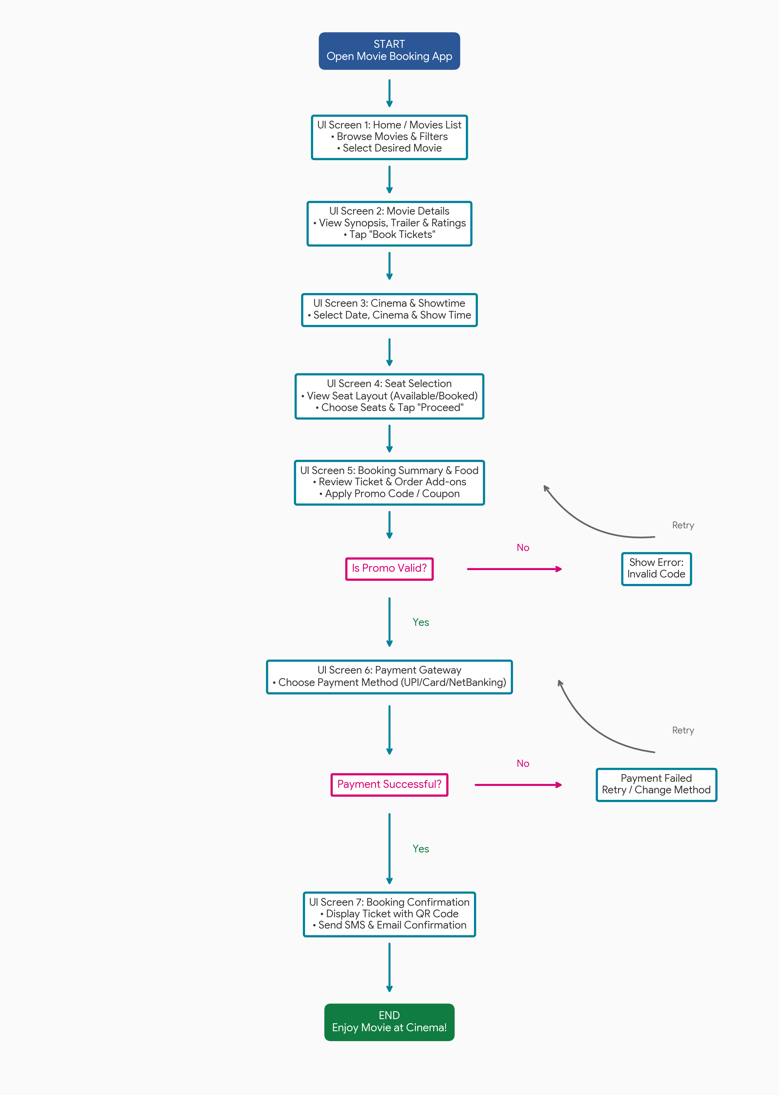

DISCOVERY & MOVIE SELECTION PHASE

Phase 1: Finding and Choosing a Movie:
This phase guides the user from opening the application to viewing details and choosing an ideal showtime.
• Step 1: Open the App (Home Screen)
• What happens: The user opens the app on their phone.
• UI Elements: Banner offers, trending movies, city/location selector, search bar, and category filters (Action, Comedy, IMAX, 2D/3D).
• User Action: The user sets their location, browses the movie list, or searches for a specific movie.
• Step 2: Movie Details Screen
• What happens: The user taps on a movie poster to view full information.
• UI Elements: Movie trailer, synopsis, cast & crew, user ratings, reviews, language, and genre tags.
• User Action: Taps the primary CTA button: 'Book Tickets'.
• Step 3: Select Date, Cinema & Show Time
• What happens: The app presents available theaters and timings.
• UI Elements: Date selector ribbon (e.g., Today, Tomorrow), theater list sorted by distance/popularity, and showtime pills (color-coded for availability like Almost Full or Available).
• User Action: Picks preferred date, theater, and time slot.
.

SLIDE 2: SEAT SELECTION & CUSTOMIZATION PHASE

Phase 2: Choosing Seats and Reviewing Order:
This phase allows the user to select their preferred seating arrangement and add extra snacks or discounts.
• Step 4: Interactive Seat Matrix
• What happens: An interactive screen map opens showing screen direction and seat layout.
• UI Elements: Color-coded seats (Gray = Available, White/Blue = Selected, Dark Gray = Sold, Gold = Recliner/VIP).
• User Action: Selects desired seats. Total ticket price updates live at the bottom bar. Taps 'Proceed'.
• Step 5: Food & Beverage Add-ons (Optional)
• What happens: User is offered snack combos (Popcorn, Drinks) to save time at the cinema counter.
• UI Elements: Simple cards with 'Add' buttons, quantity selectors (+/-), and a 'Skip' button.
• User Action: Adds snacks or skips directly to order review.
• Step 6: Order Summary & Coupon Validation
• What happens: Displays total itemized bill breakdown (Tickets + F&B + Taxes/Convenience Fee).
• UI Elements: Promo code input box, offer list, and final payable amount.
• User Action & Flow Decision: User applies a promo code. If valid, discount is applied immediately. If invalid, an error message shows prompting retry.

SLIDE 3: PAYMENT & TICKET CONFIRMATION PHASE

Phase 3: Secure Checkout and Digital Ticket Generation:
This final phase ensures secure transaction processing and delivers immediate booking confirmation to the user.
• Step 7: Payment Screen
• What happens: The user selects their preferred method to pay securely.
• UI Elements: Payment options list including UPI (GPay, PhonePe, Paytm), Credit/Debit Cards, Net Banking, and Mobile Wallets. Countdown timer (e.g., 8-10 mins) to hold selected seats.
• User Action: Chooses payment mode and enters details.
• Step 8: Payment Processing & Error Handling
• What happens: Secure payment gateway validates transaction with bank.
• Decision Logic: If payment succeeds, proceed to confirmation. If payment fails (bank timeout, insufficient funds), system shows error popup with 'Try Again' or 'Change Payment Method'.
• Step 9: Confirmation & Digital M-Ticket Screen
• What happens: Instant confirmation of booked tickets.
• UI Elements: QR Code / Barcode for seamless theater entry, booking ID, seat numbers, theater name, date, time, and 'Add to Calendar' / 'Share Ticket' buttons.
• Additional Action: Automated confirmation email and SMS/WhatsApp message sent to user.
.

3. UI Screen & Functionality Summary Matrix
Screen Name | Key UI Elements | User Goal
1. Home Screen | Search, City Picker, Banners, Movie Grid | Discover and select a movie
2. Movie Details | Poster, Trailer, Synopsis, Ratings, Book Button | Check movie info & start booking
3. Cinema & Showtimes | Date Picker, Theater List, Showtime Buttons | Choose convenient time & location
4. Seat Map | Screen direction, Color-coded seats, Live Total | Pick preferred seats
5. Order Summary | Bill breakdown, F&B Add-ons, Promo box | Review order & apply discounts
6. Payment Screen | UPI, Cards, Wallets, Payment Timer | Complete transaction securely
7. Ticket Screen | QR Code, Seat details, Share/Download button | Get entry pass for theater

