Exercise 1: Implementing the Singleton Pattern
public class SingletonPatternExample{
public static void main(String[] args){
Logger login1 = Logger.getInstance();
Logger login2 = Logger.getInstance();
System.out.println(login1 == login2);
}
}
class Logger{
private static Logger login;
private Logger(){
System.out.println("Login Successfull");
}
public static Logger getInstance(){
if(login == null){
synchronized(Logger.class){
if(login == null){
login = new Logger();
}
}
}
return login;
}
}

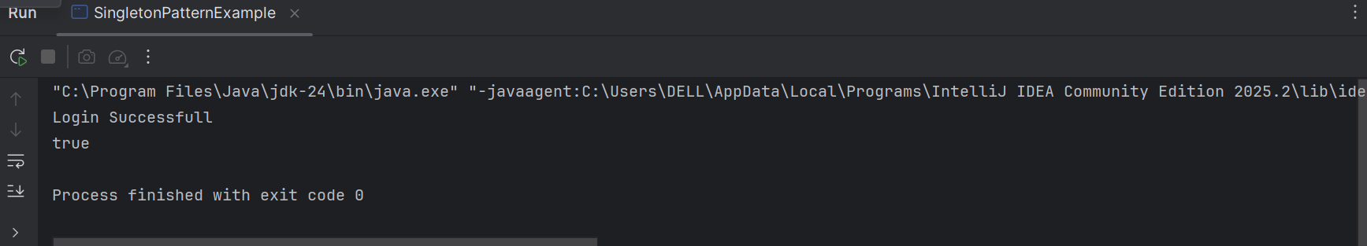
In this program, I implemented the Singleton Design Pattern using a Logger class. The main purpose of Singleton is to make sure that only one object of a class is created and used throughout the program. To achieve this, I made the constructor private so that no other class can create objects directly. I used a static variable to store the single object and a getInstance() method to return that object whenever needed. I also used synchronized double-checking to make the code thread-safe, so even if multiple threads access it at the same time, only one object will be created. When I tested the program, both login1 and login2 referred to the same Logger object, proving that the Singleton pattern was implemented successfully.
Exercise 2: Implementing the Factory Method Pattern
interface Document {
void open();
}
class WordDocument implements Document {
public void open() {
System.out.println("Opening Word Document");
}
}
class PdfDocument implements Document {
public void open() {
System.out.println("Opening PDF Document");
}
}
class ExcelDocument implements Document {
public void open() {
System.out.println("Opening Excel Document");
}
}
abstract class DocumentFactory {
public abstract Document createDocument();
}
class WordFactory extends DocumentFactory {
public Document createDocument() {
return new WordDocument();
}
}
class PdfFactory extends DocumentFactory {
public Document createDocument() {
return new PdfDocument();
}
}
class ExcelFactory extends DocumentFactory {
public Document createDocument() {
return new ExcelDocument();
}
}
public class FactoryMethodPatternExample {
public static void main(String[] args) {
DocumentFactory wordFactory = new WordFactory();
Document word = wordFactory.createDocument();
word.open();
DocumentFactory pdfFactory = new PdfFactory();
Document pdf = pdfFactory.createDocument();
pdf.open();
DocumentFactory excelFactory = new ExcelFactory();
Document excel = excelFactory.createDocument();
excel.open();
}
}

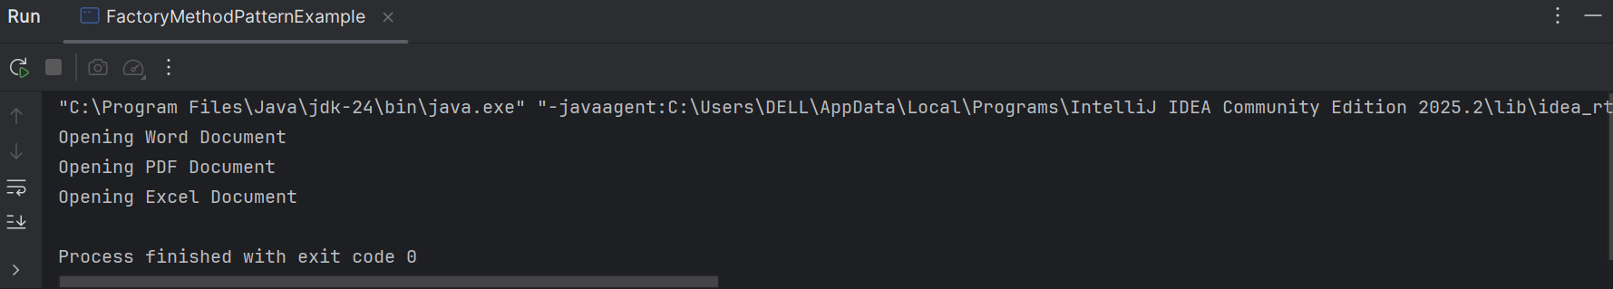

Exercise 2: E-commerce Platform Search Function
import java.util.Scanner;
class Product {
int productId;
String productName;
String category;
Product(int productId, String productName, String category) {
this.productId = productId;
this.productName = productName;
this.category = category;
}
}
class LinearSearch {
public static Product search(Product[] products, int id) {
for (int i = 0; i < products.length; i++) {
if (products[i].productId == id) {
return products[i];
}
}
return null;
}
}
class BinarySearch {
public static Product search(Product[] products, int id) {
int low = 0;
int high = products.length - 1;
while (low <= high) {
int mid = (low + high) / 2;
if (products[mid].productId == id) {
return products[mid];
} else if (products[mid].productId < id) {
low = mid + 1;
} else {
high = mid - 1;
}
}
return null;
}
}
public class EcommerceSearch {
public static void main(String[] args) {
Scanner sc = new Scanner(System.in);
Product[] productsLinear = {
new Product(103, "Shoes", "Fashion"),
new Product(101, "Laptop", "Electronics"),
new Product(105, "Bag", "Fashion"),
new Product(102, "Phone", "Electronics"),
new Product(104, "Watch", "Accessories")
};
Product[] productsBinary = {
new Product(101, "Laptop", "Electronics"),
new Product(102, "Phone", "Electronics"),
new Product(103, "Shoes", "Fashion"),
new Product(104, "Watch", "Accessories"),
new Product(105, "Bag", "Fashion")
};
System.out.print("Enter Product ID to search: ");
int searchId = sc.nextInt();
Product linearResult = LinearSearch.search(productsLinear, searchId);
if (linearResult != null) {
System.out.println("\nLinear Search Result:");
System.out.println("Product ID: " + linearResult.productId);
System.out.println("Product Name: " + linearResult.productName);
System.out.println("Category: " + linearResult.category);
} else {
System.out.println("\nProduct not found using Linear Search");
}
Product binaryResult = BinarySearch.search(productsBinary, searchId);
if (binaryResult != null) {
System.out.println("\nBinary Search Result:");
System.out.println("Product ID: " + binaryResult.productId);
System.out.println("Product Name: " + binaryResult.productName);
System.out.println("Category: " + binaryResult.category);
} else {
System.out.println("\nProduct not found using Binary Search");
}
sc.close();
}
}

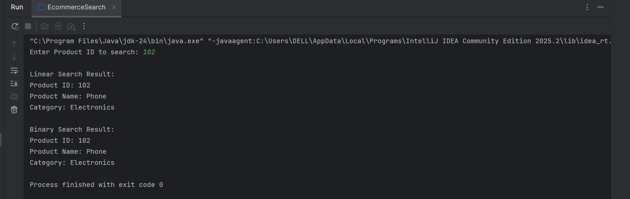
Big O Notation
Big O notation is used to measure the efficiency of an algorithm by describing how its execution time grows as the input size increases.
Linear Search:
- Best Case: O(1)
- Average Case: O(n)
- Worst Case: O(n)
Binary Search:
- Best Case: O(1)
- Average Case: O(log n)
- Worst Case: O(log n)
Binary Search is more suitable for an e-commerce platform because it searches much faster by repeatedly dividing the search space into halves. However, the product array must be sorted before using Binary Search. For large product databases, Binary Search provides better performance than Linear Search.

