VISVESVARAYA TECHNOLOGICAL UNIVERSITY
“JnanaSangama”, Belgaum -590014, Karnataka.



MOBILE APPLICATION DEVELOPMENT REPORT
on

PROJECT TITLE

Submitted by

NAME1 (1BM24CS )
NAME2 (1BM24CS )
NAME3 (1BM24CS )
NAME4 (1BM24CS )

Under the Guidance of
Guide Name
Assistant Professor, BMSCE
in partial fulfillment for the award of the degree of
BACHELOR OF ENGINEERING
in
COMPUTER SCIENCE AND ENGINEERING



B.M.S. COLLEGE OF ENGINEERING
(Autonomous Institution under VTU)
BENGALURU-560019
Feb-2026 to June-2026

B. M. S. College of Engineering,
Bull Temple Road, Bangalore 560019
(Affiliated To Visvesvaraya Technological University, Belgaum)
Department of Computer Science and Engineering

CERTIFICATE
This is to certify that the project work entitled “PROJECT TITLE” carried out by NAME1 (usn), NAME2 (usn), NAME3 (Usn) AND NAME4 (usn) who are bonafide students of B. M. S. College of Engineering. It is in partial fulfillment for the award of Bachelor of Engineering in Computer Science and Engineering of the Visveswaraiah Technological University, Belgaum during the year 2024-2025. The project report has been approved as it satisfies the academic requirements in respect of Mobile Application Development (23CS4AEMAD) work prescribed for the said degree.

Signature of the Guide Signature of the HOD
Dr. Kavitha Sooda
Assistant Professor, Dept. of CSE Prof.& Head, Dept. of CSE
BMSCE, Bengaluru BMSCE, Bengaluru
External Viva
Name of the Examiner Signature with date

1._____________________________ ________________________

2. _____________________________ _________________________

B.M.S. COLLEGE OF ENGINEERING
DEPARTMENT OF COMPUTER SCIENCE AND ENGINEERING



DECALARATION

We, name(USN), name(USN), name(USN), name(USN), students of 4th Semester, B.E, Department of Computer Science and Engineering, B. M. S. College of Engineering, Bangalore, hereby declare that, this Mobile Application Development entitled "Project Title" has been carried out by us under the guidance of Name of the faculty, Assistant Professor, Department of CSE, B. M. S. College of Engineering, Bangalore during the academic semester Feb-2026 to June-2026

We also declare that to the best of our knowledge and belief, the development reported here is not from part of any other report by any other students.

Signature
name(USN)
name(USN)
name(USN)
name(USN)

Abstract

(Describe your project in minimum 100 words)

Table of Contents
Sl No | Topics | Page Nos
1 | Abstract
2 | Introduction
3 | Hardware and Software Requirements
4 | Design Layouts: Screen Shots of Mobile App / Webpages
5 | Database Table screen shots
6 | Testing  Unit Testcases  (module wise)
7 | Conclusion and Future Work
8 | Appendix  (All teammates Infosys springboard certificate  Compulsory:(TechA Git Foundation Certification)  Optional: And another if they have done on their own interest and that certificate should be relevant to their project

Chapter 1
Introduction

Website development for “Online Course Registration”
This online submission system supports following users
a. Student
b. CS Office staff
Functionalities under Student login
i. Can register for 3rd semester subjects through online application form
ii. Display of the list of subjects registered
Functionalities under CS office staff login
i. Addition of students for registration
ii. Deletion of students
iii.Display of the list of students registered

Chapter 2
Hardware and Software Requirements

2.1 Hardware Requirements

2.2 Software Requirements
( List and Describe )

Chapter 3
Design Layouts: Screen Shots of Mobile App / Webpages
2.1: Login Webpage

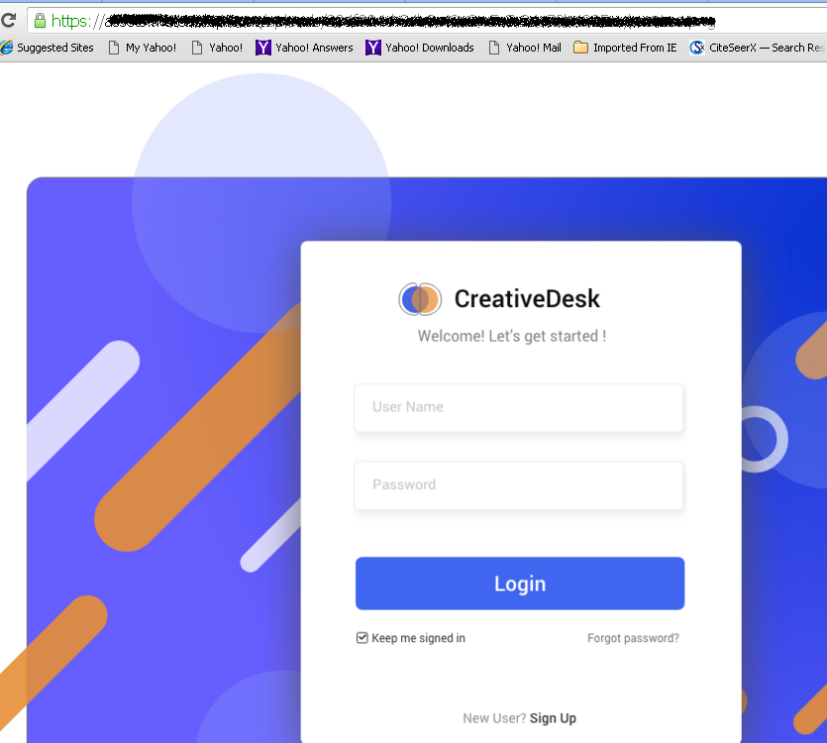
Fig.1 Login Screen
2.2: Home Webpage
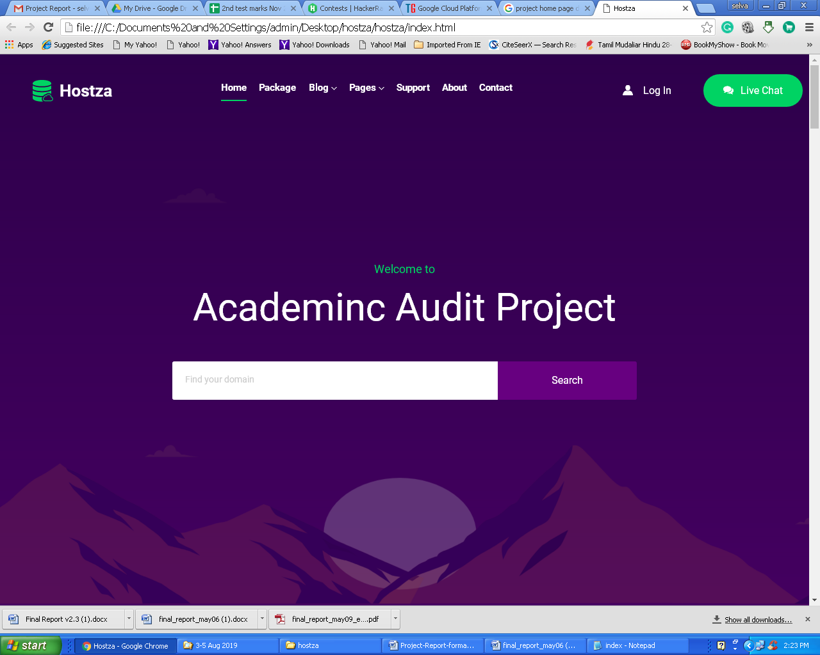
Fig 2. Home Page

Chapter 4
Database Table Screen shots

4.1.1. Course Registration Database Table: Description
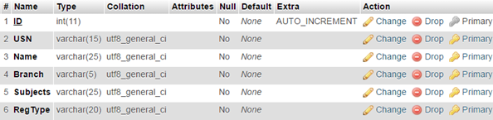
4.1.2 Course Registration Database Table: Data
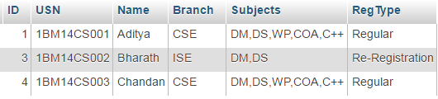
4.2.1. Login Users Database Table: Description
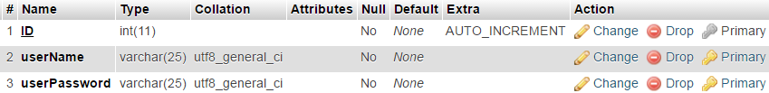
4.2.2 Login Users Database Table: Data

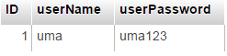

4.3.1 ER Diagram

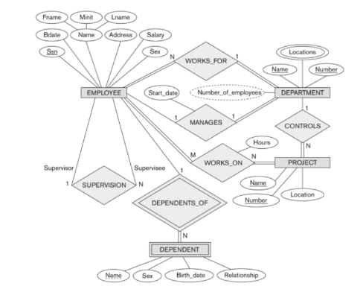
Fig 4.1: ER diagram of Employee Database

Chapter 5
Testing
Module name:
TC ID | Test Scenario | Input Data | Expected Result | Actual Result | Status
TC_011 | Login with valid credentials | Email: test@hosp.com, Pass: Test@123 | Dashboard screen loads successfully | Result that you have got in your project | Yes: if the expected result is matching with the actual result  No: if the expected result is not matching with the actual result
TC_012 | Login with wrong password | Email: test@hosp.com, Pass: wrong123 | Error: 'Invalid credentials'
TC_013 | Login with unregistered email | Email: notexist@hosp.com | Error: 'Account not found'
TC_014 | Login with both fields empty | Email: (blank), Password: (blank) | Error: 'Please fill in all fields'
TC_015 | Session token expiry handling | Use an expired JWT token | Redirect to login; show 'Session expired'

Chapter 6
Conclusion and Future Work

References

[1] https://en.wikipedia.org/wiki/Flutter_(software)
[2]
[3]

Appendix
Certificate
What Topics have been learnt from it and how it helped in the project.

