Problem 2.1

Problem Definition & Methodology:
In this task, we trained a Fully Connected Neural Network (FCNN), on MNIST dataset using pytorch and analysed the learned representations by visualizing the weights of neurons in the first hidden layer.
Each image in MNIST, is an image of handwritten digits (0-9), and of dimension 28x28 pixels.
Before passing the images into FCNN, the images are flattened into a 784-dimensional vector.
The architecture of the FCNN consist of:
- An input layer of size 784.
- Two hidden layers of size 128 each with relu activations.
- An output layer of size 10 corresponding to the digit classes.
Since, this is a multi-class classification problem, Cross Entropy Loss is used as the suitable loss function, and Adam is used as the optimizer, with learning rate set to 0.001.
The model was trained for 10 epochs.
During training, the loss decreased from 0.3809 in the first epoch to 0.0061 in the final epoch.
The final accuracy achieved was 98.32% on the training set and 96.95% on the test set, indicating good generalization.

Weight Visualization:
After the model was trained, and weights of first hidden layer were extracted, the weights were of dimension 128x784, i.e., the first hidden layer contains 128 neurons, each neuron is connected to 784 input pixels.
According to our task, we have to select 10 different neurons, and then reshape them back into 28x28 grids, and plot them as heatmaps.
Positive weights will indicate regions of the image that excite the neuron, while negative weights suppress activation.
Here are the heatmaps of 10 neurons (additionally, 10 more Neurons are visualized to capture more variety if neurons):
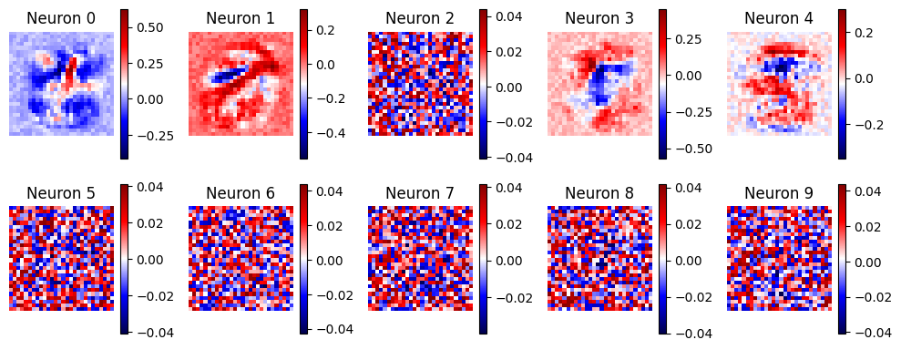
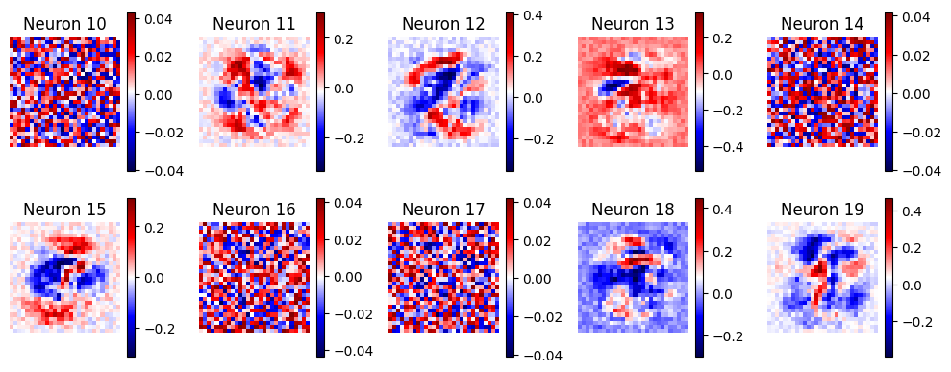

Observations and Interpretation:
From the heatmaps, several distinct patterns emerged:
- Some neurons are concentrating on some specific regions (for eg. Neuron 0, 1), trying to capture simple shape like a line, or dot, like Neuron 1 is looking for a diagonal line in the upper middle region of the image,
- Some neurons which are giving positive on multiple specific regions, while also giving negative weights to multiple specific regions (for eg. Neuron 11, 18), suggesting they are trying to capture some complex shapes,
- There are neurons, that appears like noise (for eg. Neuron 5, 6, 7),
- Interestingly, certain Neurons resembles some of the digit from 0-9, for example, Neuron 4 is resembling ‘5’, Neuron 12 is resembling ‘2’ and Neuron 15 is resembling ‘3’.
Here, we observe that many types of neurons are present in the first hidden layer, some focuses on simple shape in the image (maybe a dot, or line), some focuses on multiple specific regions of the images, while giving negative weights to other (like multiple blobs), capturing complex shapes, but not directly resembling any digit, whereas some resembles some of the digits present in MNIST, while other appear as noise, which cannot be visually interpreted, but encode fine-grained variations in the representation.
Overall, the visualization shows that the FCNN learns a diverse set of features, ranging from basic lines to more complex digit-like patterns to fine-grained noise, forming a meaningful latent representation of the input data.

