Question 4.1: The Depth vs. Normalization Duel

Problem definition & methodology:
The goal of this experiment is to quantitatively demonstrate how Batch Normalization reduces Internal Covariate Shift by analyzing the stability of layer activations during training.
We use the Tiny-ImageNet-10 dataset, which consists of:
- Training set: 3,500 images (350 images per class)
- Test set: 1,000 images (100 images per class)
- Number of classes: 10
- Image dimensions: 64×64×3 (RGB)
We train two identical deep CNNs under different conditions:
- Model A (Baseline): Deep CNN without Batch Normalization
- Model B (With BatchNorm): Same architecture with BatchNorm2d layers after every convolution
Both models are trained for 100 epochs using identical hyperparameters to isolate the effect of Batch Normalization.

Architecture designs:
Model A: CNN without Batch Normalization
The network consists of 7 convolutional layers followed by 2 fully connected layers:
Convolutional Blocks:
- Block 1: Conv(3, 32) -> ReLU -> Conv(32, 32) -> ReLU -> MaxPool(2×2)
- Block 2: Conv(32, 64) -> ReLU -> Conv(64, 64) -> ReLU -> MaxPool(2×2)
- Block 3: Conv(64, 128) -> ReLU -> Conv(128, 128) -> ReLU -> MaxPool(2×2)
- Block 4: Conv(128, 256, kernel=8×8, padding=0) -> ReLU
Classification Head:
- Flatten -> FC(256, 64) -> ReLU -> FC(64, 10)

First 6 convolutions use 3×3 kernels with padding=1 to preserve spatial dimensions
Channel depth doubles after every 2 layers (32, 64, 128, 256)
The final 8×8 convolution reduces spatial dimensions to 1×1, simplifying the transition to fully connected layers
MaxPooling (2×2, stride=2) progressively reduces spatial resolution after each block

Model B: CNN with Batch Normalization
Model B uses an identical architecture to Model A, with the addition of BatchNorm2d layers:
- A BatchNorm2d layer is inserted after every convolutional layer, before the ReLU activation
- This results in the pattern: Conv -> BatchNorm -> ReLU

Both of these models were trained with Adam optimizer, learning rate = 0.001, and Cross Entropy Loss was used as the loss function, both models were trained for 100 epochs, with batch size was set to 512.

Results, visualizations, and interpretations:
Model A (No BatchNorm):
- Initial Loss (Epoch 1): 2.2366
- Final Loss (Epoch 100): 0.000178
- Observation: Loss stabilizes around epoch 80 with noticeable oscillations throughout training
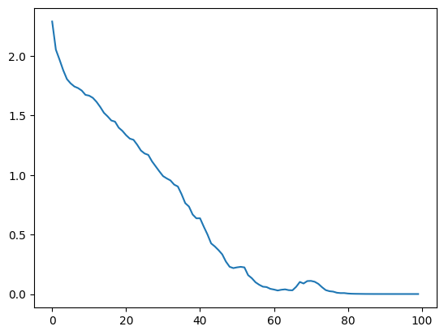
Model B (With BatchNorm):
- Initial Loss (Epoch 1): 1.6074
- Final Loss (Epoch 100): 0.000131
- Observation: Smooth, monotonic loss reduction with stabilization by epoch 20
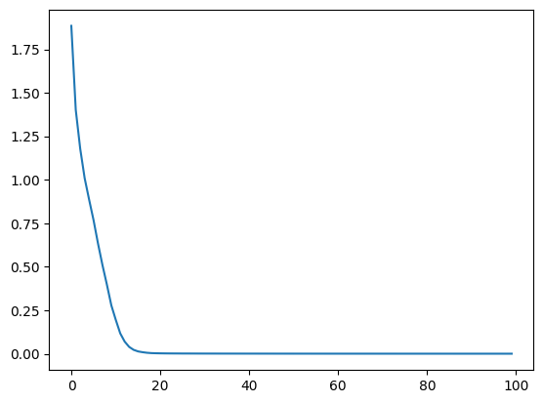
Accuracy Comparison:
Model | Train Accuracy | Test Accuracy
Model A (No BN) | 100.00% | 51.50%
Model B (With BN) | 100.00% | 63.40%

Observations:
- BatchNorm improves test accuracy by 11.9 percentage points (23% relative improvement)
- Both models achieve perfect training accuracy, indicating sufficient model capacity
- Model B shows reduced overfitting despite identical architecture and training epochs

To quantify Internal Covariate Shift, we collected activation statistics from the 5th convolutional layer (conv5) across 500 randomly sampled training batches.
Mean of Activations Across Batches
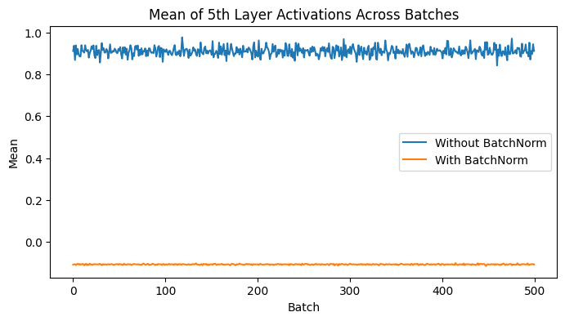
Statistics:
- Model A: Mean = 0.9109, Std = 0.0212
- Model B: Mean = -0.1090, Std = 0.0018
Interpretation:
- The near-zero mean in Model B indicates successful normalization
- Model A shows significant drift in activation distributions across batches
Variance of Activations Across Batches
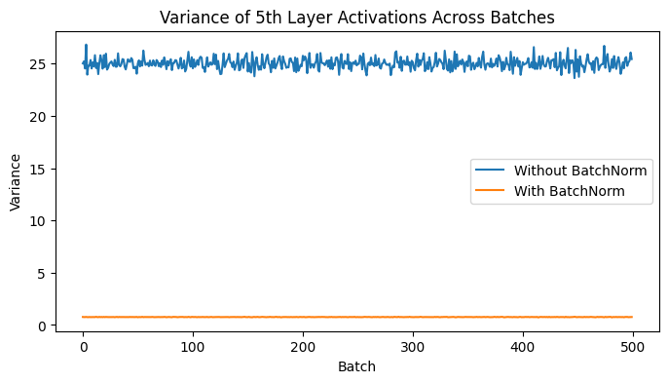
Statistics:
- Model A: Mean = 25.0316, Std = 0.5255
- Model B: Mean = 0.7597, Std = 0.0097
Interpretation:
- Model B maintains activation variance close to 1, as expected from normalization
- The unstable variance in Model A indicates severe Internal Covariate Shift

The key findings and explanations:
Model B converged 4× faster (20 epochs vs 80 epochs), demonstrating that Batch Normalization accelerates training by stabilizing the distribution of inputs to each layer.
The loss curve for Model B is significantly smoother, with fewer oscillations. This occurs because BatchNorm reduces the sensitivity of gradients to parameter scale, allowing for more stable gradient descent.
Our quantitative analysis clearly shows that Batch Normalization dramatically reduces Internal Covariate Shift, across activation means and variances:
By normalizing activations to have mean ≈ 0 and variance ≈ 1 at each layer, BatchNorm ensures that:
- The distribution of inputs to each layer remains stable during training
- Gradients flow more consistently through the network
- The network can use higher learning rates without diverging
Despite identical capacity, Model B achieved 11.9% higher test accuracy. This suggests that BatchNorm acts as a regularizer, reducing overfitting by adding noise through batch statistics during training.
This experiment provides empirical evidence that Batch Normalization significantly improves deep network training by reducing Internal Covariate Shift.
These findings confirm that Batch Normalization is essential for training deep convolutional networks effectively, particularly when working with limited data and complex architectures.

