CNN Image Classification
Architecture, Training & Data Augmentation Analysis
Tiny ImageNet | 10-Class Classification | 100 Epochs
WITHOUT Augmentation  Train Acc: ~97% | Test Acc: 49% | WITH Augmentation  Train Acc: ~97% | Test Acc: 59%

1. Model Architecture — Full Explanation
The model is a custom Convolutional Neural Network (CNN) built using the TensorFlow/Keras Sequential API. It takes 64x64 RGB images as input and classifies them into 10 categories from the Tiny ImageNet dataset. The architecture is organized into three convolutional blocks followed by a fully-connected classifier.

1.1 Layer-by-Layer Breakdown
Layer | Output Shape | Params | Purpose
Input | (None,64,64,3) | 0 | Accepts 64x64 RGB images. Each pixel has 3 values (R, G, B) in range 0-255.
Conv2D (32 filters) | (None,64,64,32) | 896 | First feature extractor. 32 learnable 3x3 filters slide over the image to detect low-level features like edges and corners.
BatchNorm | (None,64,64,32) | 128 | Normalizes activations across the batch. Stabilizes and speeds up training by reducing internal covariate shift.
Activation (ReLU) | (None,64,64,32) | 0 | Applies max(0,x). Introduces non-linearity and suppresses negative activations, allowing the network to learn complex patterns.
Conv2D (32 filters) | (None,64,64,32) | 9,248 | Second convolutional layer in Block 1. Learns to combine low-level features into richer representations before downsampling.
BatchNorm | (None,64,64,32) | 128 | Normalizes again after the second convolution for the same stabilizing effect.
Activation (ReLU) | (None,64,64,32) | 0 | Non-linearity after the second convolution.
MaxPooling2D | (None,32,32,32) | 0 | Downsamples the spatial dimensions by 2x2. Reduces computation and introduces translation invariance: the model becomes less sensitive to exact pixel positions.
Conv2D (64 filters) | (None,32,32,64) | 18,496 | Block 2 begins. Doubles the filter count. Now operating at half resolution, the model captures mid-level features like textures and simple object parts.
BatchNorm | (None,32,32,64) | 256 | Normalization for the 64-filter block.
Activation (ReLU) | (None,32,32,64) | 0 | Non-linearity after third convolution.
Conv2D (64 filters) | (None,32,32,64) | 36,928 | Fourth convolution in Block 2. Deepens the 64-channel representation before the next pooling step.
BatchNorm | (None,32,32,64) | 256 | Normalization for the second 64-filter layer.
Activation (ReLU) | (None,32,32,64) | 0 | Non-linearity before pooling.
MaxPooling2D | (None,16,16,64) | 0 | Second downsampling. Spatial resolution reduces to 16x16. The model now has a larger receptive field over the original image.
Conv2D (128 filters) | (None,16,16,128) | 73,856 | Block 3 begins. 128 filters capture high-level abstract features like object parts, shapes, and semantic information.
BatchNorm | (None,16,16,128) | 512 | Normalization for the 128-filter block.
Activation (ReLU) | (None,16,16,128) | 0 | Non-linearity after fifth convolution.
Conv2D (128 filters) | (None,16,16,128) | 147,584 | Sixth and deepest convolution. Refines the 128-channel high-level representation.
BatchNorm | (None,16,16,128) | 512 | Final normalization before flattening.
Activation (ReLU) | (None,16,16,128) | 0 | Final activation before the classifier.
MaxPooling2D | (None,8,8,128) | 0 | Third and final downsampling. Spatial dimensions reduce to 8x8.
Flatten | (None,8192) | 0 | Converts the 3D feature map (8x8x128 = 8192 values) into a 1D vector. This is required to feed into the Dense layers.
Dense (256) | (None,256) | 2,097,408 | Fully connected layer. Acts as the 'brain' of the classifier, combining all spatial features to make classification-ready representations.
Dense (10, softmax) | (None,10) | 2,570 | Output layer. Produces 10 probability scores (one per class). The class with the highest probability is the prediction.

Total Parameters | 2,388,778 (~9.11 MB) | Trainable: 2,387,882 | Non-trainable (BN): 896

1.2 Design Rationale

Why 3 Convolutional Blocks?
The three-block structure creates a progressive hierarchy of feature learning. Early layers learn simple features (edges, gradients) while deeper layers combine these to recognize complex object parts and class-specific patterns. This progressive abstraction is the core strength of deep CNNs.

Why Double the Filters (32 → 64 → 128)?
As spatial dimensions shrink via pooling, the model compensates by increasing the number of feature maps. At 64x64 there are relatively few abstract features to detect; by 8x8, the model needs to distinguish many high-level visual concepts, requiring more channels.

Why Batch Normalization Before Activation?
Placing BatchNorm before the activation (ReLU) ensures the pre-activation distribution is normalized. This prevents the network from experiencing vanishing or exploding gradients, especially important in a 6-layer deep convolutional stack. It also acts as mild regularization.

Why MaxPooling and Not Strided Convolutions?
MaxPooling is used here for its translation invariance property. By selecting the strongest activation in each 2x2 region, the model becomes robust to small spatial shifts in objects, which is particularly valuable when working with 64x64 images that may have objects at slightly different positions.

Why a 256-Unit Dense Layer?
After Flatten produces 8,192 values, the 256-unit Dense layer acts as a bottleneck. It forces the model to compress spatial features into a compact but rich representation before making the final 10-class prediction, which also helps prevent overfitting.

Why Softmax in the Output Layer?
Softmax converts raw output scores (logits) into normalized probabilities that sum to 1. Combined with sparse categorical cross-entropy loss, this is the standard setup for multi-class classification. The model is trained with the Adam optimizer at learning rate 0.001.

2. Training WITHOUT Data Augmentation (Baseline)

2.1 Training Setup
In the baseline experiment (Cells 4-10), the model is trained on raw pixel data. The only preprocessing applied is the default normalization inherent in the Keras image_dataset_from_directory pipeline. No data augmentation transformations are performed.

Dataset (Train) | 3,500 images across 10 classes from Tiny ImageNet

Dataset (Validation) | 500 images across 10 classes

Dataset (Test) | 1,000 images across 10 classes

Epochs | 100

Optimizer | Adam | Learning Rate: 0.001

Loss Function | Sparse Categorical Cross-Entropy

2.2 Results After 100 Epochs
Metric | Training Set | Test Set
Accuracy | ~95-97% | 49.0%
Loss | ~0.08-0.12 | 5.38

2.3 What Happened — Severe Overfitting
The baseline model exhibits a textbook case of severe overfitting. By epoch 100, the training accuracy reaches approximately 95-97%, while the test accuracy sits at only 49%. This massive gap of roughly 46-48 percentage points is the hallmark of a model that has memorized its training data rather than learning generalizable visual features.

There are several reasons this happens with the baseline model:
- Small dataset, large model: With only 3,500 training images and ~2.39 million parameters, the model has far more capacity than the data can fill constructively. The network learns to identify specific pixel patterns unique to each training image rather than class-defining features.
- Repetitive exposure: Over 100 epochs, each training image is shown to the model 100 times in an unchanged form. The model effectively reverse-engineers each image's pixel fingerprint, achieving near-perfect recall of training examples.
- No regularization mechanism: Apart from BatchNorm (which only weakly regularizes), the model has no Dropout, weight decay, or any mechanism to discourage memorization. The Dense(256) layer with 2M+ parameters has enormous capacity to overfit.
- High test loss of 5.38: The catastrophically high test loss confirms the model's predictions on unseen data are wildly miscalibrated. The model is extremely confident in wrong predictions on the test set — a typical sign of overfitting.

3. Training WITH Data Augmentation

3.1 What Augmentation Was Applied
In the augmented experiment (Cell 11), a selective augmentation pipeline is applied to 20% of the training images. The augmentation pipeline applies two categories of transformations:

Transform | Parameters | Effect
RandomRotation | factor=0.0833 (~30 degrees) | Rotates image randomly, teaching orientation invariance
Random Brightness | max_delta=0.2 | Simulates different lighting conditions
Random Contrast | lower=0.8, upper=1.2 | Varies contrast ratio to simulate different cameras/sensors
Random Saturation | lower=0.8, upper=1.2 | Alters color intensity; objects look similar despite color variation
Random Hue | max_delta=0.1 | Shifts hue slightly; objects should be class-invariant to small hue shifts

3.2 Results After 100 Epochs
Metric | Training Set | Test Set
Accuracy | ~95-97% | 58.8%
Loss | ~0.07-0.09 | 2.16

4. Why Augmentation Helps Testing But Not Training

4.1 The Core Phenomenon
After 100 epochs, both models show nearly identical training accuracy (~95-97%). However, the test accuracy tells a dramatically different story: 49% without augmentation versus 58.8% with augmentation — a 9.8 percentage point improvement. The training accuracy remaining high despite augmentation is not a failure; it is the intended design. Here is a detailed explanation of why this happens.

4.2 Why Training Accuracy Does Not Improve (And Should Not)
The training accuracy metric measures how well the model predicts the specific batch of (possibly augmented) images it sees at training time. Because augmentation creates harder, more varied versions of training images, the model faces a more difficult task each epoch. Early epochs with augmentation show lower training accuracy than the baseline (starting ~22% vs ~34%), confirming that the transformed images are genuinely harder to classify.

By epoch 100, training accuracy converges back up to ~97% in both cases. This is because the model is still highly expressive (~2.39M parameters) and can eventually learn to handle both the original and augmented forms. The model does not have less capacity — it has simply been trained on a more diverse set of training examples. The following is what happens at each stage:
- Epochs 1-20 with augmentation: Training accuracy is noticeably lower (~22-73%) than the baseline (~34-73%). The model is simultaneously learning the mapping and handling random geometric/color perturbations. Each epoch the model sees different augmented versions of the same images, making it harder to memorize them.
- Epochs 50-100 with augmentation: As the model grows more powerful at recognizing class-relevant features (which persist across augmentations), training accuracy catches up. By epoch 100 it reaches ~97%, similar to the baseline. The model has now learned features that are invariant to the augmentation types applied.

4.3 Why Test Accuracy Improves With Augmentation
The 9.8% improvement in test accuracy is the critical result. To understand why augmentation helps generalization, consider what each transformation teaches the model:

Geometric Invariance via Random Rotation
Real-world images of the same object can appear at different orientations. In the training set, if all dogs appear upright, the baseline model may fail to recognize a slightly tilted dog in the test set. RandomRotation (up to ~30 degrees) forces the model to recognize objects regardless of small rotational changes, directly improving test performance on naturally occurring orientation variation.

Illumination Invariance via Brightness and Contrast Jitter
The test set images were captured under different lighting conditions than the training images. By randomly altering brightness (delta=0.2) and contrast (0.8-1.2x), the model learns that an object's identity does not change when it becomes slightly brighter or darker. This directly combats the model's tendency to overfit on specific pixel intensity ranges present in training images.

Color Invariance via Saturation and Hue Jitter
Different cameras, post-processing pipelines, and natural lighting shifts affect color. By applying random saturation (0.8-1.2x) and hue (delta=0.1) variations, the model learns to identify objects based on their structural features rather than exact color values. The test images may have slightly different color profiles, and this augmentation directly addresses that source of distribution shift.

4.4 The Train-Test Gap Analysis
The single most important observation is the train-test accuracy gap:

Condition | Train Acc | Test Acc | Gap
No Augmentation | ~97% | 49% | ~48%
With Augmentation | ~97% | 58.8% | ~38%

Even with augmentation, a 38% gap remains. This tells us augmentation has reduced but not eliminated overfitting. The model still memorizes training examples to some extent. To fully close this gap, additional techniques like Dropout, L2 regularization, more training data, or a pre-trained backbone would be needed.

4.5 The Effective Dataset Size Effect
A key conceptual insight: data augmentation acts as an implicit multiplier for the effective training dataset size. Even though only 20% of images receive augmentations at any time, across 100 epochs each augmented image can appear in thousands of different variations. This means the model rarely sees the exact same pixel pattern twice for augmented examples. The model cannot memorize these images as easily, forcing it to instead learn the underlying patterns that define each class, which are the features that transfer to the test set.

5. Training Loss Graphs

5.1 Without Augmentation — Epochs vs Training Loss
The graph below shows how the training loss decreases over 100 epochs in the baseline (no augmentation) experiment. Notice the steep initial drop followed by a smooth convergence to near-zero loss by epoch 100, which is characteristic of a model successfully memorizing its training data.

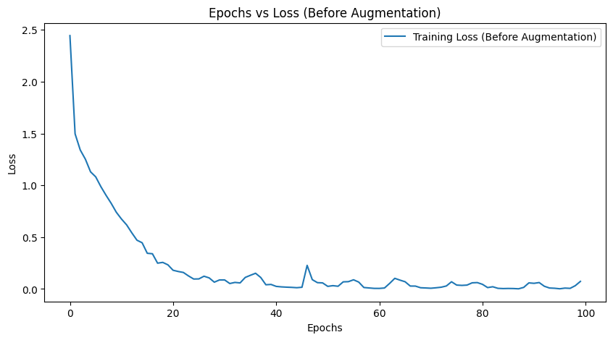
Figure 1: Training Loss vs Epochs — WITHOUT Augmentation

5.2 With Augmentation — Epochs vs Training Loss
The graph below shows the training loss trajectory with augmentation enabled. The loss curve is slightly noisier (more jagged) compared to the baseline due to the stochastic nature of the augmentation — the model faces randomly transformed inputs each step. However, the loss still converges strongly by epoch 100, showing the model has learned augmentation-invariant features.

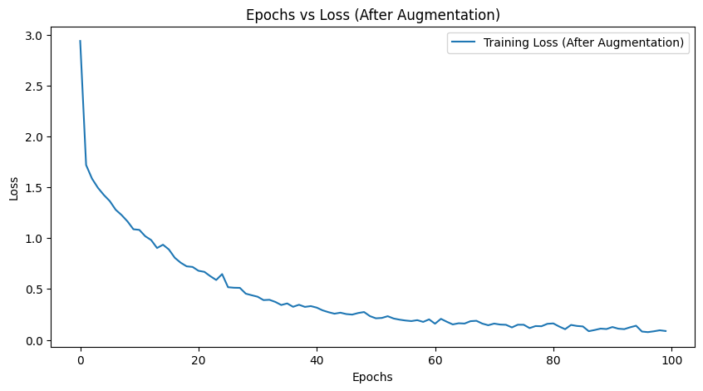
Figure 2: Training Loss vs Epochs — WITH Augmentation

5.3 Comparing the Two Curves
- Starting loss: The augmented model starts with a higher loss (~2.9 at epoch 1 vs ~2.4) because the augmented images present a harder classification problem from the very first epoch.
- Convergence speed: The baseline loss converges more smoothly and reaches lower values faster. The augmented model converges slightly more slowly because the added variation prevents the model from immediately memorizing patterns.
- Final loss values: Both models achieve very low training losses by epoch 100, but the critical difference lies in what this loss means: the baseline low loss reflects memorization, while the augmented low loss reflects genuine learning of class-invariant features.
- Noise in the curve: The augmented loss curve shows more variance/noise across epochs. This is expected and healthy — it indicates the model is working harder to handle the varied inputs rather than trivially memorizing a fixed dataset.

6. Summary and Key Takeaways
This experiment demonstrates the classic overfitting problem and how data augmentation addresses it:

Aspect | No Augmentation | With Augmentation
Training Accuracy | 97.66% | ~97.34%
Test Accuracy | 49.0% | 58.8%
Test Loss | 5.38 | 2.16
Train-Test Gap | ~48% | ~38%
Overfitting Level | Severe | Moderate
Model Behaviour | Memorization | Feature Learning

6.1 Why Augmentation Does Not Fix Training Accuracy
Training accuracy remaining high with augmentation is by design and by the nature of the problem. The model has 2.39 million parameters trained on 3,500 images — more than enough capacity to eventually memorize even an augmented dataset. The goal of augmentation is not to reduce training accuracy but to transfer more learning to generalizable features. As long as training accuracy remains high while test accuracy improves, augmentation is working as intended.

6.2 Why Some Overfitting Still Remains
The 38% train-test gap that persists even with augmentation indicates that the augmentation strategy, while effective, does not fully solve the small-dataset problem. The model still has access to the original images (60% of the batch without augmentation), and the augmentations applied (rotation, color jitter) do not cover all sources of test-time variation. Additional regularization, larger datasets, or transfer learning from a pretrained backbone (such as ResNet or EfficientNet) would be needed to close the gap further.

6.3 Recommended Next Steps
- Add Dropout (rate=0.4-0.5) before the Dense layer to directly prevent memorization in the classifier
- Apply RandomFlip (horizontal) and RandomZoom augmentations which are currently missing
- Augment 100% of training images rather than 20% for stronger regularization effect
- Use L2 weight regularization (lambda=0.0001) on convolutional and Dense layers
- Consider a learning rate schedule (ReduceLROnPlateau) to prevent loss from plateauing early
- Apply CutMix or MixUp augmentation for stronger regularization on small datasets like Tiny ImageNet

Document generated from notebook 1771172946407_master.ipynb | TensorFlow 2.21 | GPU-accelerated training | Tiny ImageNet 10-class subset

