Akshat Agarwal  
RA1911003010646

**Compiler Design**

**Lab – 13**

**Simple code generation**

**Code :**

#include<stdio.h>

#include<conio.h>

#include<string.h>

#include<ctype.h>

#include<graphics.h>

typedef struct{

char var[10];

int alive;}

regist;

regist preg[10];

void substring(char exp[],int st,int end)

{ int i,j=0;

char dup[10]="";

for(i=st;i<end;i++)

dup[j++]=exp[i];

dup[j]='0';

strcpy(exp,dup);

} int getregister(char var[])

{ int i;

for(i=0;i<10;i++)

{

if(preg[i].alive==0)

{

strcpy(preg[i].var,var);

break;

}}

return(i);

}

void getvar(char exp[],char v[])

{ int i,j=0;

char var[10]="";

for(i=0;exp[i]!='\0';i++)

if(isalpha(exp[i]))

var[j++]=exp[i];

else

break;

strcpy(v,var);

}

void main()

{ char basic[10][10],var[10][10],fstr[10],op;

int i,j,k,reg,vc,flag=0;

clrscr();

printf("\nEnter the Three Address Code:\n");

for(i=0;;i++)

{

gets(basic[i]);

if(strcmp(basic[i],"exit")==0)

break;

}

printf("\nThe Equivalent Assembly Code is:\n");

for(j=0;j<i;j++)

{

getvar(basic[j],var[vc++]);

strcpy(fstr,var[vc-1]);

substring(basic[j],strlen(var[vc-1])+1,strlen(basic[j]));

getvar(basic[j],var[vc++]);

reg=getregister(var[vc-1]);

if(preg[reg].alive==0)

{

printf("\nMov R%d,%s",reg,var[vc-1]);

preg[reg].alive=1;

}

op=basic[j][strlen(var[vc-1])];

substring(basic[j],strlen(var[vc-1])+1,strlen(basic[j]));

getvar(basic[j],var[vc++]);

switch(op)

{ case '+': printf("\nAdd"); break;

case '-': printf("\nSub"); break;

case '*': printf("\nMul"); break;

case '/': printf("\nDiv"); break;

}

flag=1;

for(k=0;k<=reg;k++)

{ if(strcmp(preg[k].var,var[vc-1])==0)

{

printf("R%d, R%d",k,reg);

preg[k].alive=0;

flag=0;

break;

}} if(flag)

{

printf(" %s,R%d",var[vc-1],reg);

printf("\nMov %s,R%d",fstr,reg);

}strcpy(preg[reg].var,var[vc-3]);

getch();

}}

|  |
| --- |
|  |
|  |
|  |
|  |
|  |
|  |
|  |
|  |
|  |
|  |
|  |
|  |
|  |
|  |
|  |
|  |
|  |
|  |
|  |
|  |
|  |
|  |
|  |
|  |
|  |
|  |
|  |
|  |
|  |
|  |
|  |
|  |
|  |
|  |
|  |
|  |
|  |
|  |
|  |
|  |
|  |
|  |
|  |
|  |
|  |
|  |
|  |
|  |
|  |
|  |
|  |
|  |
|  |
|  |
|  |
|  |
|  |
|  |
|  |
|  |
|  |
|  |
|  |
|  |
|  |
|  |
|  |
|  |
|  |
|  |
|  |
|  |
|  |
|  |
|  |
|  |
|  |
|  |
|  |
|  |
|  |
|  |
|  |
|  |
|  |
|  |
|  |
|  |
|  |
|  |
|  |
|  |
|  |
|  |
|  |
|  |
|  |
|  |
|  |
|  |
|  |
|  |
|  |
|  |
|  |
|  |
|  |
|  |
|  |
|  |
|  |
|  |
|  |
|  |
|  |
|  |
|  |
|  |
|  |
|  |
|  |
|  |
|  |
|  |
|  |
|  |
|  |
|  |
|  |
|  |
|  |
|  |
|  |
|  |
|  |
|  |
|  |
|  |
|  |
|  |
|  |
|  |
|  |
|  |
|  |
|  |
|  |
|  |
|  |
|  |
|  |
|  |
|  |
|  |
|  |
|  |
|  |
|  |
|  |
|  |
|  |
|  |
|  |
|  |
|  |
|  |
|  |
|  |
|  |
|  |
|  |
|  |
|  |
|  |
|  |
|  |
|  |
|  |
|  |
|  |
|  |
|  |
|  |
|  |
|  |
|  |
|  |
|  |
|  |
|  |
|  |
|  |
|  |
|  |
|  |
|  |
|  |
|  |
|  |
|  |
|  |
|  |
|  |
|  |

**OUTPUT :**

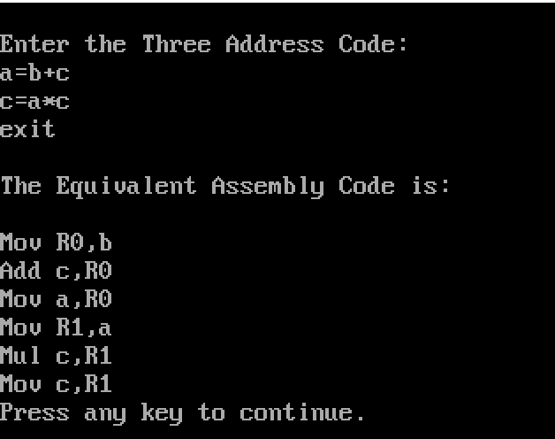

**RESULT:** Hence, the Simple Code Generator was successfully done.