Akshat Agarwal  
RA1911003010646

**Compiler Design**

**Lab - 3**

1. **Write a C program to identify whether a given line is comment or not**

#include<stdio.h>

void main() {

char com[4095];

int i=2,a=0;

scanf("%s", com);

if(com[0]=='/') {

if(com[1]=='/')

printf("\n It is a comment");

else if(com[1]=='*') {

for(i=2;i<=4095;i++)

{

if(com[i]=='*'&&com[i+1]=='/')

{

printf("It is a comment");

a=1;

break; }

else

continue; }

if(a==0)

printf("It is not a comment");

}

else

printf("It is not a comment");

}

else

printf("It is not a comment");

}

**Output:**

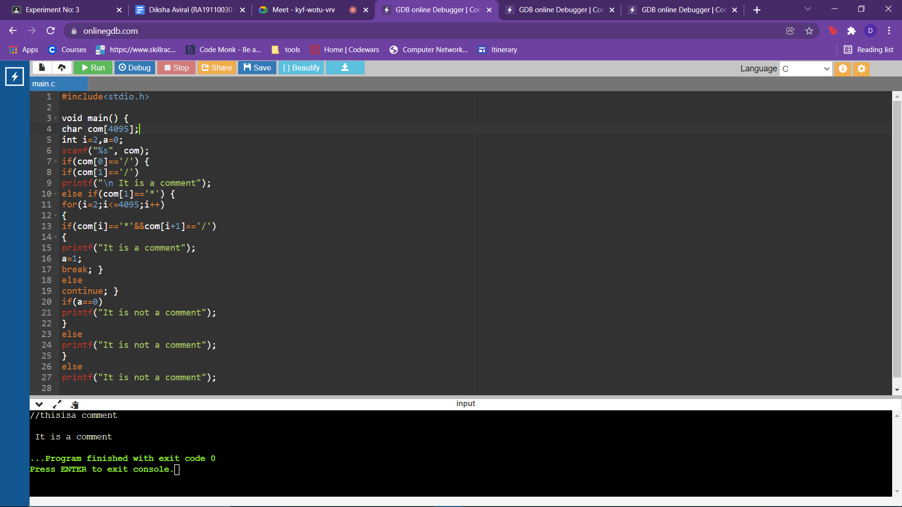

1. **Write a C program to simulate lexical analyzer for validating operators**

#include<stdio.h>

void main()

{

char s[5];

scanf("%s",s);

switch(s[0])

{

case'>':

if(s[1]=='=')

printf("Greater than or equal");

else

printf("Greater than");

break;

case'<':

if(s[1]=='=')

printf("Less than or equal");

else

printf("Less than");

break;

case'=':

if(s[1]=='=')

printf("Equal to");

else

printf("Assignment");

break;

case'!':

if(s[1]=='=')

printf("Not Equal");

else

printf("Bit Not");

break;

case'&':

if(s[1]=='&')

printf("Logical AND");

else

printf("Bitwise AND");

break;

case'|':

if(s[1]=='|')

printf("Logical OR");

else

printf("Bitwise OR");

break;

case'+':

printf("Addition");

break;

case'-':

printf("Substraction");

break;

case'*':

printf("Multiplication");

break;

case'/':

printf("Division");

break;

case'%':

printf("Modulus");

break;

default:

printf("Not a operator");

}}

**Output :**

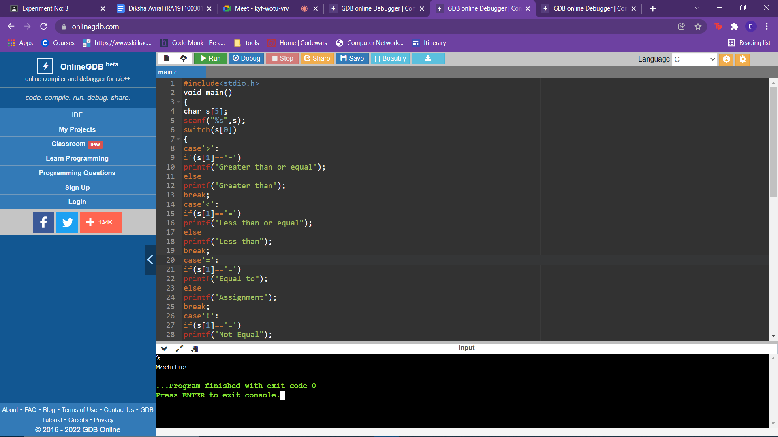

1. **Write a C program to recognize strings under 'a', 'a*b+', 'abb**

#include<stdio.h>

#include<string.h>

#include<stdlib.h>

void main()

{

char s[20],c;

int state=0,i=0;

scanf("%s",s);

while(s[i]!='\0')

{

switch(state)

{

case 0:

c=s[i++];

if(c=='a')

state=1;

else if(c=='b')

state=2;

else

state=6;

break;

case 1:

c=s[i++];

if(c=='a')

state=3;

else if(c=='b')

state=4;

else

state=6;

break;

case 2:

c=s[i++];

if(c=='a')

state=6;

else if(c=='b')

state=2;

else

state=6;

break;

case 3:

c=s[i++];

if(c=='a')

state=3;

else if(c=='b')

state=2;

else

state=6;

break;

case 4:

c=s[i++];

if(c=='a')

state=6;

else if(c=='b')

state=5;

else state=6;

break;

case 5:

c=s[i++];

if(c=='a')

state=6;

else if(c=='b')

state=2;

else

state=6;

break;

case 6:

printf("not recognised");

exit(0);

} }

if(state==1)

printf("accepted");

else if((state==2)||(state==4))

printf("accepted");

else if(state==5)

printf("accepted");

}

**Output :**

