Akshat Agarwal  
RA1911003010646

**Compiler Design**

**Lab – 5**

**NFA to DFA Conversion**

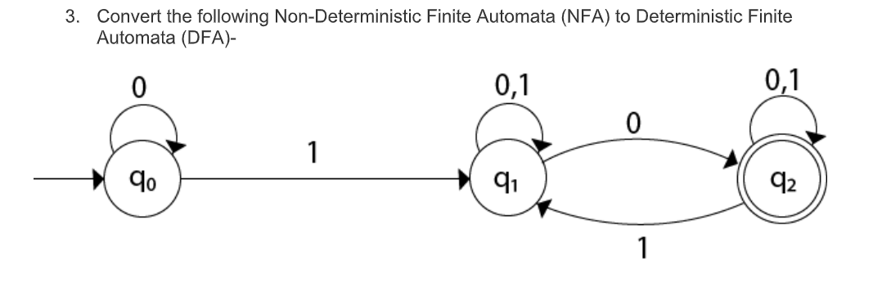

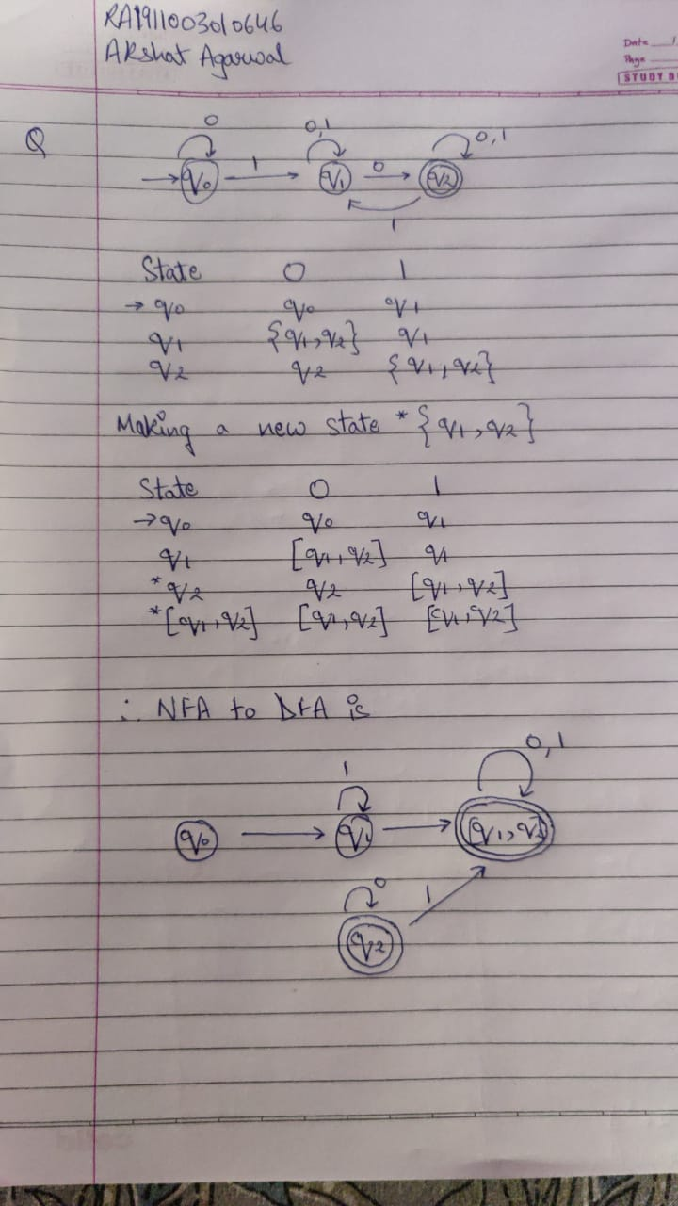

**Code :**

#include<stdio.h>

#include<string.h>

#include<math.h>

int ninputs;

int dfa[100][2][100] = {0};

int state[10000] = {0};

char ch[10], str[1000];

int go[10000][2] = {0};

int arr[10000] = {0};

int main()

{

int st, fin, in;

int f[10];

int i,j=3,s=0,final=0,flag=0,curr1,curr2,k,l;

int c;

printf("\nFollow the one based indexing\n");

printf("\nEnter the number of states::");

scanf("%d",&st);

printf("\nGive state numbers from 0 to %d",st-1);

for(i=0;i<st;i++)

state[(int)(pow(2,i))] = 1;

printf("\nEnter number of final states\t");

scanf("%d",&fin);

printf("\nEnter final states::");

for(i=0;i<fin;i++)

{

scanf("%d",&f[i]);

}

int p,q,r,rel;

printf("\nEnter the number of rules according to NFA::");

scanf("%d",&rel);

printf("\n\nDefine transition rule as \"initial state input symbol final state\"\n");

for(i=0; i<rel; i++)

{

scanf("%d%d%d",&p,&q,&r);

if (q==0)

dfa[p][0][r] = 1;

else

dfa[p][1][r] = 1;

}

printf("\nEnter initial state::");

scanf("%d",&in);

in = pow(2,in);

i=0;

printf("\nSolving according to DFA");

int x=0;

for(i=0;i<st;i++)

{

for(j=0;j<2;j++)

{

int stf=0;

for(k=0;k<st;k++)

{

if(dfa[i][j][k]==1)

stf = stf + pow(2,k);

}

go[(int)(pow(2,i))][j] = stf;

printf("%d-%d-->%d\n",(int)(pow(2,i)),j,stf);

if(state[stf]==0)

arr[x++] = stf;

state[stf] = 1;

}

}

for(i=0;i<x;i++)

{

printf("for %d ---- ",arr[x]);

for(j=0;j<2;j++)

{

int new=0;

for(k=0;k<st;k++)

{

if(arr[i] & (1<<k))

{

int h = pow(2,k);

if(new==0)

new = go[h][j];

new = new | (go[h][j]);

}

}

if(state[new]==0)

{

arr[x++] = new;

state[new] = 1;

}

}

}

printf("\nThe total number of distinct states are::\n");

printf("STATE 0 1\n");

for(i=0;i<10000;i++)

{

if(state[i]==1)

{

int y=0;

if(i==0)

printf("q0 ");

else

for(j=0;j<st;j++)

{

int x = 1<<j;

if(x&i)

{

printf("q%d ",j);

y = y+pow(2,j);

}

}

printf(" %d %d",go[y][0],go[y][1]);

printf("\n");

}

}

return 0;

}

**OUTPUT :**

