PROJECT REPORT
ON
ONLINE
VOTING SYSTEM

By: Shri Akshat Jain
Guide: Shri Mridul Chetia
Institute: Aptech Computer Education, Doomdooma, Tinsukia, Assam

ACKNOWLEDGEMENT
I owe a great many thanks to a great many people who helped and supported me in successful completion of this project.
First and foremost, I would like to thank APTECH Doomdooma for giving me this opportunity to make the project.
I would like to express my deep sense of gratitude to Mridul Chetia for his guidance, constructive comments, valuable suggestions and inspirations without whom this project would not have been possible.
All the work done in coming up with this system is dedicated to my family for being with/part of me in the whole process especially my dear sister who stood by me in all situations.
Finally, I wish to say thanks to all Faculties of APTECH for helping me a lot.

Akshat Jain

INDEX
- Abstract
- Introduction To Online Voting System
- Background Of Study
- Scope Of Study
- Problems with Existing Voting Registration System
- Project Justification
- Limitations of online voting system
- Software and Hardware Required
- Data Flow Diagram
- ER Diagram
- Conclusion
- Appendix(Snapshots)

1. ABSTRACT

The word “vote” means to choose from a list, to elect or to determine. The main goal of voting (in a scenario involving the citizens of a given country) is to come up with leaders of the people’s choice.
Most countries, exception have problems when it comes to voting. Some of the problems involved include ridging votes during election, insecure or inaccessible polling stations, inadequate polling materials and also inexperienced personnel.
This online voting/polling system seeks to address the above issues. It should be noted that with this system in place, the users, citizens in this case shall be given ample time during the voting period. They shall also be trained on how to vote online before the election time.

2. INTRODUCTION TO ONLINE VOTING SYSTEM

“ONLINE VOTING SYSTEM” is an online voting technique. In this system people who have citizenship of India and whose age is above 18 years of age and any sex can give his\her vote online without going to any physical polling station. There is a database which is maintained in which all the names of voters with complete information is stored.
In “ONLINE VOTING SYSTEM” a voter can use his/her voting right online without any difficulty. He/She has to be registered first for him/her to vote. Registration is mainly done by the system administrator for security reasons. The system Administrator registers the voters on a special site of the system visited by him only by simply filling a registration form to register voter. Citizens seeking registration are expected to contact the system administrator to submit their details. After the validity of them being citizens of India has been confirmed by the system administrator by comparing their details submitted with those in existing databases such as those as the Registrar of Persons, the citizen is then registered as a voter.
After registration, the voter is assigned a secret User ID and a PIN with which he/she can use to log into the system and enjoy services provided by the system such as voting. If invalid/wrong details are submitted, then the citizen is not registered to vote.

3. BACKGROUND OF STUDY
Online voting is an electronic way of choosing leaders via a desktop application. The advantage of online voting over the common “queue method” is that the voters have the choice of voting at their own free time and there is reduced congestion. It also minimizes on errors of vote counting. The individual votes are submitted in a database which can be queried to find out who of the aspirants for a given post has the highest number of votes.
This system is geared towards increasing the voting percentage since it has been noted that with the old voting method {the Queue System}, the voter turnout has been a wanting case. With system in place also, if high security is applied, cases of false votes shall be reduced.
With the “ONLINE VOTING SYSTEM”, a voter can use his/her voting right online without any difficulty. He/She has to register as a voter first before being authorized to vote. The registration should be done prior to the voting date to enable data update in the database.
However, not just anybody can vote. For one to participate in the elections, he/she must have the requirements. For instance, he/she must be a registered citizen i.e. must be 18 and above years old. As already stated, the project ‘Online Voting' provides means for fast and convenient voting and access to this system is limited only to registered voters.
Internet voting systems are appealing for several reasons which include; People are getting more used to work with computers to do all sorts of things, namely sensitive operations such as shopping and home banking and they allow people to vote far from where they usually live, helping to reduce absenteeism rate.
4. SCOPE OF STUDY
The main purpose of Online Voting System includes:
- Provision of improved voting services to the voters through fast, timely and convenient voting.
- Reduction of the costs incurred by the Indian Electoral Commission during voting time in paying the very many clerks employed for the sake of the success of the manual system.
- Ensuring that the members who are registered are the only ones to vote. Cases of “False Votes” are also minimized.
- Being very precise online voting system will ensure cost cutting to produce an effective election management system.
Therefore crucial points that this system emphasizes on are listed below.
- Require less number of staff during the election.
- This system is a lot easier to independently moderate the elections and subsequently reinforce its transparency and fairness.
- Less capital, less effort, and less labor intensive, as the primary cost and effort will focus primarily on creating, managing, and running a secure online portal.
- Increased number of voters as individual will find it easier and more convenient to vote, especially those abroad.

- PROBLEMS WITH THE EXISTING VOTING SYSTEM
The problems of the existing manual system of voting include among others the following:
- Lower turnout of voters: As the voter need to be physically appear in the polling stations, many a times the voter finds it difficult to vote, especially those abroad.
- Expensive and Time consuming: The process of collecting data and entering this data into the database takes too much time and is expensive to conduct, for example, time and money is spent in printing data capture forms, in preparing registration stations together with human resources.
- Too much paper work: The process involves too much paper work and paper storage which is difficult as papers become bulky with the population size.
- Errors during data entry: Errors are part of all human beings; it is very unlikely for humans to be 100 percent efficient in data entry.
- Loss of registration forms: Some times, registration forms get lost after being filled in with voters’ details, in most cases these are difficult to follow-up and therefore many remain unregistered even though they are voting age nationals and interested in exercising their right to vote.
- Short time provided to view the voter register: This is a very big problem since not all people have free time during the given short period of time to check and update the voter register.
- Above all, a number of voters end up being locked out from voting.
- PROJECT JUSTIFICATION
The ONLINE VOTING SYSTEM in India shall reduce the time spend making long queues at the polling stations during voting. It shall also enable the voters to vote from any part of the globe as explained since this is an online application available on the internet. Cases of vote miscounts shall also be solved since at the backend of this system resides a well developed database that can provide the correct data. Since the voting process shall be open as early as possible, the voters shall have ample time to decide when and whom to vote for.
Registering as a Voter:
- Registration of the voter is done by ELECTION COMMISION OF INDIA.
- ELECTION COMMISION OF INDIA can change the information any time if required.
- Registration of the Voter depends upon the information filled by the user.
- Voter is given a unique ID and PASSWORD.
- In the DATABASE information of every voter is stored.
- Database shows the information of every user.

- LIMITATIONS OF ONLINE VOTING SYSTEM
This project has a few limitations as well. Some of these are cited below:
- Security issues:
Foreign experience revealed that they are often confronted by security issues while the online voting system is running. The origin of the security issues was due to not only outsider (such as voters and attackers) but also insider (such as system developers and administrators), even just because the inheritance of some objects in the source code are unsuitable. These errors caused the voting system to crash.
- Lack of computer literacy:
As majority of the people in India resides in villages and lack computer knowledge, they need to be trained on how to vote online before election time.

- SOFTWARE REQUIREMENTS:

OS: Microsoft Windows 7 Ultimate(Service Pack 1)
Application Software: DevC++ Version 5.1.

HARDWARE REQUIREMENTS:
Processor: Intel Pentium 2.10 GHz or above
Memory: 2 GB
System type: 32 bit operating system
Disk space: 200mb of free disk space

BLOCK DIAGRAM:
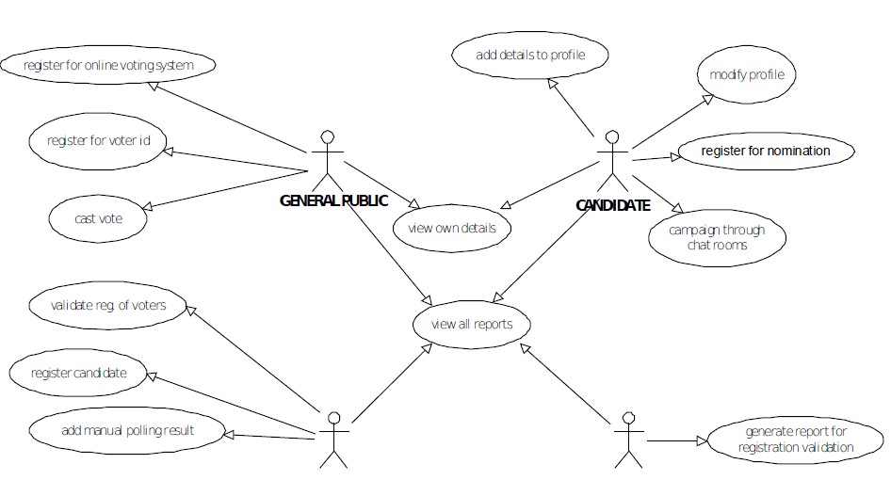

- Data Flow Diagram
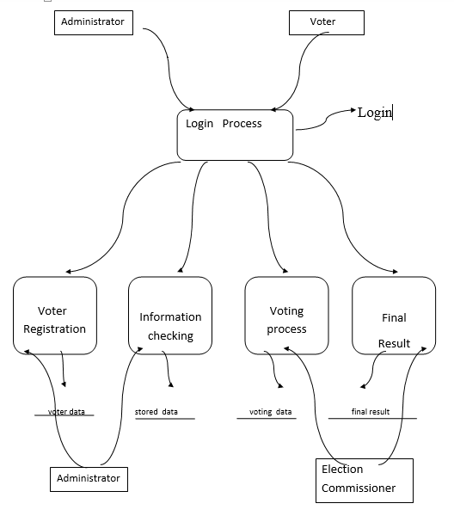

10. ER Diagram:
Registration
Process
Candidates
Voter

Registered Voter
Database
Registered Candidate
Voting
ADMIN

Add Candidates
Update Candidate

Add Voters
Update Voter Details
Check Results

Sample of Admin login and voter Login
UserName Password
Admin Page
Administrator ******

User Id PIN
Sample Voter Login
Voter Id
100001 ****

11. CONCLUSION
This Online Voting system will manage the Voter’s information by which voter can login and use his voting rights. The system will incorporate all features of voting system. It provides the tools for maintaining voter’s vote to every party and it count total no. of votes of every party. There is a DATABASE which is maintained by the ELECTION COMMISION OF INDIA in which all the names of voter with complete information is stored.
In this user who is above 18 year’s register his/her information on the database and when he/she want to vote he/she has to login by his id and password and can vote to any party only single time. Voting detail store in database and the result is displayed by calculation. By online voting system percentage of voting is increases. It decreases the cost and time of voting process. It is very easy to use and It is vary less time consuming. It is very easy to debug.

SCREENSHOTS
Administrator login:
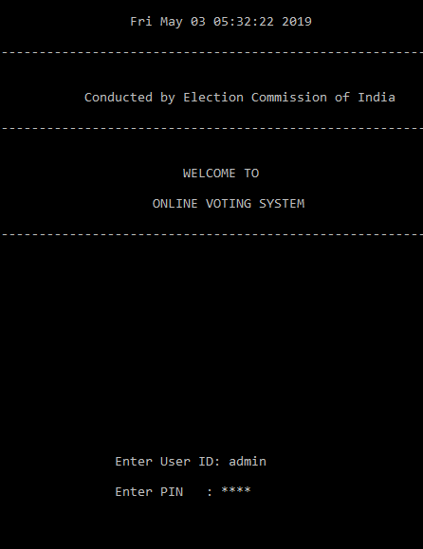

Administrator Menu:
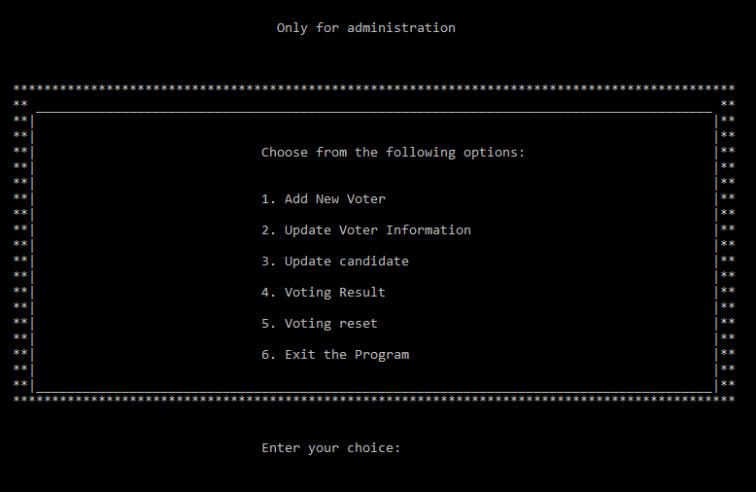

Voter login:
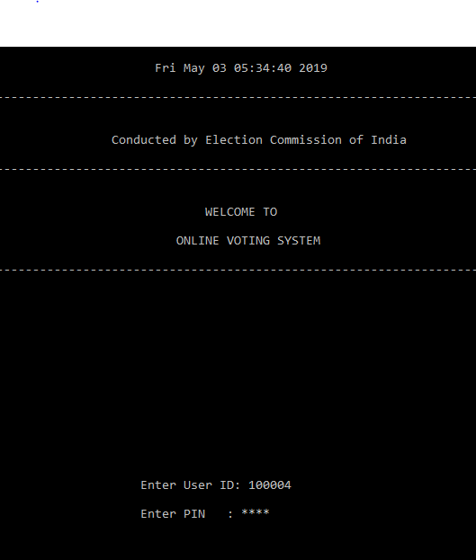

Voter’s details and casting vote:

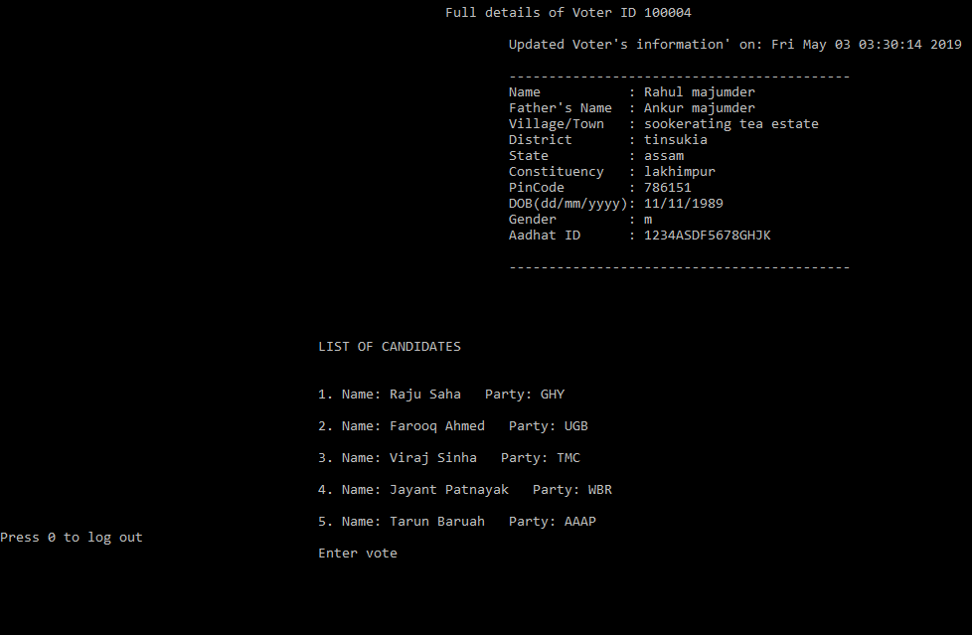

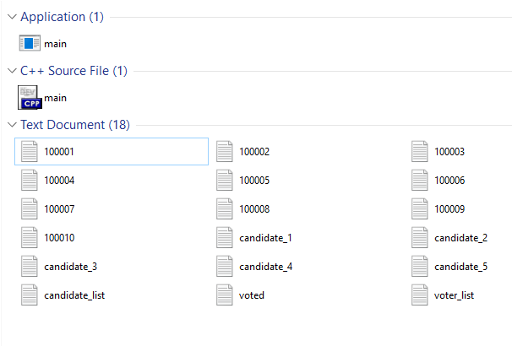
File Structure & Source Codes
Executable File

C++ Source File

Program Resource Files

Source Codes:
#include<iostream>
#include<fstream>
#include<conio.h>
#include<time.h>
#include<cstring>
#include<windows.h>
#include <sstream>
#include<stdio.h>
using namespace std;
int admin();
int addVoter();
int updateVoter();
int updateCandidate();
int votingResult();
int reset();
int exit();
int LoginCheck(string, string);
void displaycandidatedata();
void deletecandidatedata();
void displaycandidatedata();
int main() //main login page
{
time_t rawtime; //System time define
struct tm * timeinfo; //predefined structure in time.h
time ( &rawtime );
timeinfo = localtime ( &rawtime );
cout << "\n\n\t\t\t\t\t\t " << asctime (timeinfo); //display time and date
cout<<"\n-------------------------------------------------------------------------------------------------\n";
int vote; //voter's input to vote
char ch;
string fname; //input user id
string fend = ".txt"; //for creating text file
string voted_user; //users who have given their vote
string username, password; //saved user id and password
fstream voter_account; //file streaming
voter_account.open("voter_list.txt", ios::out | ios::app); //reading registered voter id and password
voter_account >> username >> password;
cout << "\n\t\t\t Conducted by Election Commission of India \n";
cout<<"\n----------------------------------------------------------------------------------------\n";
cout << "\t\t\t \n";
cout << "\t\t\t WELCOME TO \n";
cout << "\t\t\t \n";
cout << "\t\t\t ONLINE VOTING SYSTEM \n";
cout<<"\n-----------------------------------------------------------------------------------------------\n";
cout << "\n\n\n\n\n\n\n\n\n\n\n\n\n\t\t\t\t\t\tEnter User ID: ";
cin>>fname; //get id from user
cout << "\n\t\t\t\t\t\tEnter PIN : ";
char pass[32];//to store password.
int i = 0;
char a;//a Temp char
for(i=0;;)//infinite loop
{
a=getch();//stores char typed in a
if((a>='a'&&a<='z')||(a>='A'&&a<='Z')||(a>='0'&&a<='9'))
//check if a is numeric or alphabet
{
pass[i]=a;//stores a in pass
++i;
cout<<"*";
}
if(a=='\b'&&i>=1)//if user typed backspace
//i should be greater than 1.
{
cout<<"\b \b";//rub the character behind the cursor.
--i;
}
if(a=='\r')//if enter is pressed
{
pass[i]='\0';//null means end of string.
break;//break the loop
}
}
if((fname=="admin") && (strcmp(pass, "1234") == 0)) //admin id and password
{
cout << "\n\n\t\t\t\t\t\tAdmin login Successful\n\t\t\t\t\t\t";
cout<<"\n------------------------------------------------------------------------------------------------------\n";
Sleep(1500); //pause for 1.5 sec
system("cls"); //clearing screen
admin(); // admin page
}
else if (LoginCheck(fname, pass)!=0) //checking voter-id and password
{
cout<<"\n\n\t\t\t\t\t\tVoter login Successful\n\t\t\t\t\t\t";
cout<<"\n------------------------------------------------------------------------\n";

Sleep(2000); //pause for 2 sec
system("cls");
string filename = fname + fend; //creating a text file named as username
fstream file;
file.open(filename.c_str(), ios::in); // reading voter file with full details of the voter
cout << "\n\t\t\t\t\t\t\tFull details of Voter ID " << fname << " \n";
string info;
while(!file.eof())
{
getline(file,info);
cout << "\t\t\t\t\t" << info << "\n";//display details of voter
}
fstream voter;
voter.open("voted.txt"); //opening the file where the user has already voted
int m=0;
int k=0;
while (voter >> voted_user) //checking if the user has voted
{
m++;
if (fname != voted_user)
k++;
}
if (m != k)
{
cout << "\n\t\tYou have already voted" << endl; //the user has already voted
system("pause");
system("cls");
exit();
}
else
{
y: //jump statement incase of invalid choice
int p;
int a;
int b;
int c;
int d;
int total;
int i=0;

fstream candidate;
string name1, name2, party;
candidate.open("candidate_list.txt");

cout<<"\n\n\t\t\t\t\tLIST OF CANDIDATES\n\n";

while(candidate >> name1 >> name2 >> party)
{
cout <<"\n\t\t\t\t\t" << ++i << ". " << "Name: "<<name1 << " " << name2 <<" Party: "<< party <<"\n";

}
candidate.close();
cout<<"Press 0 to log out";
cout << "\n\t\t\t\t\tEnter vote "; // casting vote

cin >> vote;
if(vote==0)
{
Sleep(1000);
system("cls");
main();
}
else if(vote>0 && vote<=i)
{
ostringstream os; //converting integer to string
os << "candidate_" << vote << ".txt"; //concatenation strings
string s = os.str();
ifstream file;
file.open(s.c_str(), ios::app); //opening the file of the candidate
int count;
file >> count; //reading the vote count of the candidate
ofstream newfile;
newfile.open(s.c_str());
count++; //incrementing the vote count of the candidate by 1
newfile << count; // writing back the vote count of the candidate
file.close();
newfile.close();
fstream createdaccount;
createdaccount.open("voted.txt",ios::app); //opening the file containing list of voters who have given vote
createdaccount << fname<< endl; // adding the id of voter to the list so he cannot vote again
createdaccount.close();
system("cls");
exit();
}
else
{
cout << "invalid choice. please try again";
Sleep(1500);
system("CLS");
goto y; //jump statement to the begining
}
}

}

else
{
cout << "Invalid username/password combination" << endl;
Sleep(1500);
system("CLS");
main();
}
}

int LoginCheck (string fname, string pass ) //User Login Fuction
{
ifstream file;
string username, password;
int n=0;
file.open("voter_list.txt"); //opening the file containing list of user id and password
if (file.is_open())
{
while (!file.eof())
{
file >> username >> password; //reading the file
n++;
if ((fname==username) && (pass==password)) //login successful if id and password matches in the list
return n;
}
}
else
{
cout << "file not open" << endl;
}
return 0;
}

int admin() //Admin fuction
{
cout << "\n\n\n\n\t\t\t\t\t\t Only for administration ";
cout << "\n\n\n\n\t\t*******************************************************\n";
cout << "\t\t** ____________________________________________________________________ **\n";
cout << "\t\t**| |**\n";
cout << "\t\t**| |**\n";
cout << "\t\t**| Choose from the following options: |**\n";
cout << "\t\t**| |**\n";
cout << "\t\t**| |**\n";
cout << "\t\t**| 1. Add New Voter |**\n";
cout << "\t\t**| |**\n";
cout << "\t\t**| 2. Update Voter Information |**\n";
cout << "\t\t**| |**\n";
cout << "\t\t**| 3. Update candidate |**\n";
cout << "\t\t**| |**\n";
cout << "\t\t**| 4. Voting Result |**\n";
cout << "\t\t**| |**\n";
cout << "\t\t**| 5. Voting reset |**\n";
cout << "\t\t**| |**\n";
cout << "\t\t**| 6. Exit the Program |**\n";
cout << "\t\t**| |**\n";
cout << "\t\t**|_____________________________________________________________|**\n";
cout << "\t\t*****************************************************************\n\n\n\t\t\t\t";

char i;
cout << "\t\tEnter your choice: ";
cin >> i; // taking input from the user
system("cls");
switch(i)
{
case '1':
addVoter(); //function for adding new voter
break;
case '2':
updateVoter(); //function for updating details of the voter
break;
case '3':
updateCandidate(); //function for adding and deleting candidate
break;
case '4':
votingResult(); // function for displaying voting result
break;
case '5':
reset(); //function for resetting result and candidate list
break;
case '6':
exit(); // exit function
break;
default:
{
cout << "\n\n\t\t\t\t\t\tInvalid Choice\n";
cout << "\t\t\t\t\t\tTry again...........\n\n";
Sleep(1500);
system("cls");
admin();
}
}
}

int addVoter() //Create new voter aacount
{
time_t rawtime;
struct tm * timeinfo;
time ( &rawtime );
timeinfo = localtime ( &rawtime );
cout << "\n\n\t\t\t\t\t\t\t" << asctime (timeinfo); //display date and time in screen
ifstream file;
ofstream newuser;
string user, pass;
string fname;
string end = ".txt";
string username, password, passwordconfirm;
file.open("voter_list.txt", ios::app); //opening the file containing the list of voters
newuser.open("voter_list.txt", ios::app);
int age;
cout<<"\n------------------------------------------------------------------------------------------------\n";
cout<<"\n\t\t\t(Press 0 to go back)";
cout<< "\n\n\t\t\tEnter Voter's age: ";
cin>>age; //get input age from the user
if(age==0)
{
Sleep(1000);
system("cls");
admin();

}
else if(age>0 && age<18) //checking whether the user is eligible to vote
{
cout<<"\n\t\t\tYou are not eligible for voting\n\t\t\t";
cout<<"\n------------------------------------------------------------------------------\n";
system("pause");
system("cls");
addVoter();
}
else
{
cout<<"\n\t\t\tYou are eligible for voting";
cout<<"\n--------------------------------------------------------------------------\n";

Sleep(1000);
system("cls");
cout<<"\n\t\t\t(Press 0 to go back)";
cout<<"\n\n\t\t\tCreate the 6 digit User ID: ";
cin >> fname;
if(fname=="0")
{
Sleep(1000);
system("cls");
addVoter();
}
char ch1;
char ch2;
string pass1 = "";
string pass2 = "";
int m=0;
int k=0;
while (file >> user >> pass)
{
m++;
if (fname!=user)
k++;
}
if (m!=k)
{
cout << "\n\t\t\tThere is already a user with this ID." << endl;
cout<< "\n\t\t\tPress 1 to try again, 0 to go back: ";
int x;
cin>>x;
switch(x)
{
case 1:
system("cls");
addVoter();
break;
case 0:
system("cls");
admin();
break;
default:
cout<<"Invalid choice, try again.";
main();
}
}
else
{

cout << "\n\t\t\tPlease create a 4 digit PIN: ";
ch1=_getch();
while(ch1 != 13 && ch1!=4)
{//character 13 is enter
pass1.push_back(ch1);
cout << '*';
ch1 = _getch();
}
cout<<"\n\t\t\tRe-enter PIN: ";
ch2=_getch();
while(ch2 != 13 && ch2!=4)
{//character 13 is enter
pass2.push_back(ch2);
cout << '*';
ch2 = _getch();
}
}

if (m==k && pass1==pass2)
{
newuser << fname << " " << pass1 <<endl; //saving the user id and password to the voter list
string filename=fname + end;
cout << "\n\t\t\tAccount created!" << endl;
cout<<"\n---------------------------------------------------------------------------\n";
file.close();
newuser.close();
fstream file;
file.open(filename.c_str(), ios::out); //creating a file for getting details about the voter
time_t rawtime;
struct tm * timeinfo;
time ( &rawtime );
timeinfo = localtime ( &rawtime );
cout << "\n\t\t\tUpdating Voter's information on : "<<asctime (timeinfo);file<<"\n\t\t\tUpdated Voter's information' on: "<<asctime (timeinfo)<<"\n";
struct voter_info
{
char name[20];
char fathers_name[20];
char address[100];
char district[20];
char state[20];
char pincode[20];
char constituency[20];
char contact[10];
char age[20];
char sex[10];
char aadhar_id[15];
};
voter_info ak;
cout << "\t\t\t------------------------------------------- ";file<<"\t\t\t-----------------------------------------";
cout << "\n\t\t\tEnter details in block letters";
cout << "\n ";file<<" ";gets(ak.name) ;file<<ak.name<<"\n";
cout << "\n\t\t\tName : ";file << "\t\t\tName : ";gets(ak.name) ;file << ak.name<<"\n";
cout << "\n\t\t\tFather's Name : ";file << "\t\t\tFather's Name : ";gets(ak.fathers_name);file << ak.fathers_name<<"\n";
cout << "\n\t\t\tVillage/Town : ";file << "\t\t\tVillage/Town : ";gets(ak.address) ;file << ak.address<<"\n";
cout << "\n\t\t\tDistrict : ";file << "\t\t\tDistrict : ";gets(ak.district) ;file << ak.district<<"\n";
cout << "\n\t\t\tState : ";file << "\t\t\tState : ";gets(ak.state) ;file << ak.state<<"\n";
cout << "\n\t\t\tConstituency : ";file << "\t\t\tConstituency : ";gets(ak.constituency);file << ak.constituency<<"\n";
cout << "\n\t\t\tPinCode : ";file << "\t\t\tPinCode : ";gets(ak.pincode) ;file << ak.pincode<<"\n";
cout << "\n\t\t\tDOB(dd/mm/yyyy): ";file << "\t\t\tDOB(dd/mm/yyyy): ";gets(ak.age) ;file << ak.age<<"\n";
cout << "\n\t\t\tGender(M/F) : ";file << "\t\t\tGender : ";gets(ak.sex) ;file << ak.sex<<"\n";
cout << "\n\t\t\tAadhar ID : ";file << "\t\t\tAadhat ID : ";gets(ak.aadhar_id) ;file << ak.aadhar_id<<"\n";
cout << "\n\t\t\t-------------------------------------\n";file << "\n\t\t\t-----------------------------------------\n\n";
cout << "\t\t\tInformation Saved Successfully\n";
file.close();
system("pause");
system("cls");
admin();
}
else
{
cout << "\n\t\tThe passwords given do not match." << endl;
Sleep(1500);
system("cls");
addVoter();
}
}
}

int updateVoter() //Voter details Update function
{
string fname;
ifstream file;
cout<<"\n\nEnter the Voter ID to be opened : ";
cin>>fname;
system("cls");
string filename = fname + ".txt";
file.open(filename.c_str());
if(!file)
{
cout << "\nError while opening the file\n";
updateVoter();
}
else
{
cout << "\n\n\t\t\t\t Information about Voter ID "<<fname<<"\n\n";
string info;
while(file.good())
{
getline(file,info);
cout<<info<<"\n";
}
ofstream newfile;
newfile.open(filename.c_str());
cout << "\n";
time_t rawtime;
struct tm * timeinfo;
time ( &rawtime );
timeinfo = localtime ( &rawtime );
cout<<"\n\t\t\tEnter details in block letters\n";
newfile<<"\n\t\t\tVoter's information' on: "<<asctime (timeinfo);

struct voter_info
{
char name[20];
char fathers_name[20];
char address[100];
char district[20];
char state[20];
char pincode[20];
char constituency[20];
char contact[10];
char age[20];
char sex[10];
char aadhar_id[15];
};
voter_info ak;
cout << "\n\t-------------------------------------------\n";
newfile<<"\n\t-------------------------------------------\n";
cout << "\n ";newfile<<" ";gets(ak.name) ;newfile<<ak.name<<"\n";
cout << "\n\t\t\tName : ";newfile << "Name : ";gets(ak.name) ;newfile << ak.name<<"\n";
cout << "\n\t\t\tFather's Name : ";newfile << "Father's Name : ";gets(ak.fathers_name);newfile << ak.fathers_name<<"\n";
cout << "\n\t\t\tVillage/Town : ";newfile << "Village/Town : ";gets(ak.address) ;newfile << ak.address<<"\n";
cout << "\n\t\t\tDistrict : ";newfile << "District : ";gets(ak.district) ;newfile << ak.district<<"\n";
cout << "\n\t\t\tState : ";newfile << "State : ";gets(ak.state) ;newfile << ak.state<<"\n";
cout << "\n\t\t\tConstituency : ";newfile << "Constituency : ";gets(ak.constituency);newfile << ak.constituency<<"\n";
cout << "\n\t\t\tPinCode : ";newfile << "PinCode : ";gets(ak.pincode) ;newfile << ak.pincode<<"\n";
cout << "\n\t\t\tDate of birth : ";newfile << "Date of birth : ";gets(ak.age) ;newfile << ak.age<<"\n";
cout << "\n\t\t\tGender(M/F) : ";newfile << "Gender(M/F) : ";gets(ak.sex) ;newfile << ak.sex<<"\n";
cout << "\n\t\t\tAadhar ID : ";newfile << "Aadhat ID : ";gets(ak.aadhar_id) ;newfile << ak.aadhar_id<<"\n";
cout << "\n\t-------------------------------------------\n";newfile << "\n\t-------------------------------------------";
cout << "\t\t\tInformation Saved Successfully\n";

file.close();
newfile.close();
cout << "\n\n";
system("pause");
system("cls");
admin();
}
}
int updateCandidate() // function for Updating candidate list
{
b:
char a;
string info;
int i = 0;
int count=0;
fstream candidate;
string name1, name2, party;
candidate.open("candidate_list.txt");
cout<<"\n\n\t\t\t\t\tLIST OF CANDIDATES\n\n";
while(candidate >> name1 >> name2 >> party)
{
cout <<"\n\t\t\t\t\t" << ++i << ". " << "Name: "<<name1 << " " << name2 <<" Party: "<< party <<"\n";
}
candidate.close();
cout<<"\n--------------------------------------------------------------------------------------------------------------";

cout<<"\n\n\t\t\t\t\tpress 1 to add candidate";
cout<<"\n\n\t\t\t\t\tpress 2 to delete candidate ";
cout<<"\n\n\t\t\t\t\tpress 0 to go back: ";
cin>>a;
switch(a)
{
case '0':
system("cls");
admin();
break;
case '1':
{
string name1, name2;
string party;
fstream newcandidate;
newcandidate.open("candidate_list.txt", ios::app);
cout<<"\n-----------------------------------------------------------------------------------------------------------\n\n";

cout << "\t\t\t\t\tEnter Candidate First name" <<": ";
cin>>name1;
cout<< "\n\t\t\t\t\tEnter Candidate Last name" <<": ";
cin>>name2;
cout << "\n\t\t\t\t\tEnter party name" <<": ";
cin>>party;
cout<<"\n----------------------------------------------------------------------------------------------\n";
cout<<"\n\t\t\t\t\tNew candidate added to the list, please wait....";
newcandidate << name1 << " " << name2 << " " << party << endl;
ostringstream os;
os << "candidate_" << ++i << ".txt";
string s = os.str();
fstream file;
file.open(s.c_str(), ios::out);
int count =0;
file << count;
Sleep(2500);
system("cls");
file.close();
updateCandidate();
break;
}
case '2':
{
deletecandidatedata();
Sleep(2500);
system("cls");
updateCandidate();
break;
}
default:
{
system("cls");
cout<<"incorrect choice, try again";
Sleep(100);
updateCandidate();
}
}
}

void deletecandidatedata()
{
string name1, name2, party, tname1, tname2;
int age, x=0; // x - "counter" to check if user entered wrong name

ifstream candidate("candidate_list.txt");
ofstream temp("temp.txt"); // temp file for input of every student except the one user wants to delete
cout<<"\n---------------------------------------------------------------------------------------------------------------\n";
cout << "\n\t\t\t\t\tEnter the candidate name you want to erase from database ";
cout << "\n\n\t\t\t\t\tFirst name: ";
cin>>tname1;
cout << " \n\t\t\t\t\tLast name: ";
cin>>tname2;
//ifstream students("students.txt");
//ofstream temp("temp.txt"); // temp file for input of every student except the one user wants to delete
while(candidate >> name1 >> name2 >> party )
{
if((tname1!=name1) && (tname2 != name2)){ // if there are students with different name, input their data into temp file
temp << name1 << ' ' << name2 << ' ' << party << ' ' << endl;
}
else if((tname1==name1) && (tname2 == name2)){ // if user entered correct name, x=1 for later output message that the user data has been deleted
x=1;
}
}
cout<<"\n---------------------------------------------------------------------------------------------------------------\n";
candidate.close();
temp.close();
remove("candidate_list.txt");
rename("temp.txt", "candidate_list.txt");
if(x==0){ // x was set to 0 at start, so if it didn't change, it means user entered the wrong name
cout << "\n\n\t\t\t\t\tThere is no candidate with name you entered." << endl;
}
else{ // x is not 0, it means user entered the correct name, print message that students data has been deleted
cout << "\n\n\t\t\t\t\tcandidate data deleted from the list, please wait....";
}
}
int votingResult() //displaying Voting Result function
{
int vote;
string candidate;
fstream file;
fstream vote_file;
vote_file.open("candidate_list.txt");
int i=0;
while(!vote_file.eof()) //displaying candidate list
{
getline(vote_file,candidate);
++i;
}
vote_file.close();
int j;
for(j=1;j<=i;j++)
{
ostringstream os;
os << "candidate_" << j << ".txt";
string s = os.str();
fstream file;
file.open(s.c_str()); // opening all the candidate vote count
file >> vote;
cout<<"\n\t\t\t\tCandidate_"<<j<<":"<<vote<<"votes"<<endl; // displaying the vote count of the candidate
}
system("pause");
system("cls");
admin();
}
int reset() //Voting Result Reset function
{
int vote;
string candidate;
fstream file;
file.open("candidate_list.txt");
int i=0;
while(!file.eof())
{
getline(file,candidate);
cout<<"\n\t\t\t\t " <<++i <<". "<< candidate <<endl; //displaying candidate list
}
int j;
for(j=1;j<=i;j++)
{
ostringstream os;
os << "candidate_" << j << ".txt";
string s = os.str();
remove(s.c_str()); //deleting the all the candidate's file
}
ofstream ofs;
ofs.open("candidate_list.txt", std::ofstream::out | std::ofstream::trunc); //deleting the contents of the file
ofs.close();
ofstream fs;
fs.open("voted.txt", std::ofstream::out | std::ofstream::trunc); //deleting the contents of the file
fs.close();
Sleep(1500);
system("cls");
admin();

}
int exit() //Main Exit function
{
cout<<"\n\n\n\n\n\n\n";
cout<<"\t\t\t************************************************************\n";
cout<<"\t\t\t** _________________________________________________ **\n";
cout<<"\t\t\t**| |**\n";
cout<<"\t\t\t**| |**\n";
cout<<"\t\t\t**| |**\n";
cout<<"\t\t\t**| |**\n";
cout<<"\t\t\t**| |**\n";
cout<<"\t\t\t**| THANK YOU FOR USING |**\n";
cout<<"\t\t\t**| |**\n";
cout<<"\t\t\t**| ONLINE VOTING SYSTEM |**\n";
cout<<"\t\t\t**| |**\n";
cout<<"\t\t\t**| |**\n";
cout<<"\t\t\t**| |**\n";
cout<<"\t\t\t**| |**\n";
cout<<"\t\t\t**| |**\n";
cout<<"\t\t\t**| |**\n";
cout<<"\t\t\t**|_________________________________________________________|**\n";
cout<<"\t\t\t***********************************************************\n";

Sleep(1500);
system("cls");
main();
}

--------------------End of File--------------------

