Pipeline Execution Procedure
1) Open the Pipeline tool
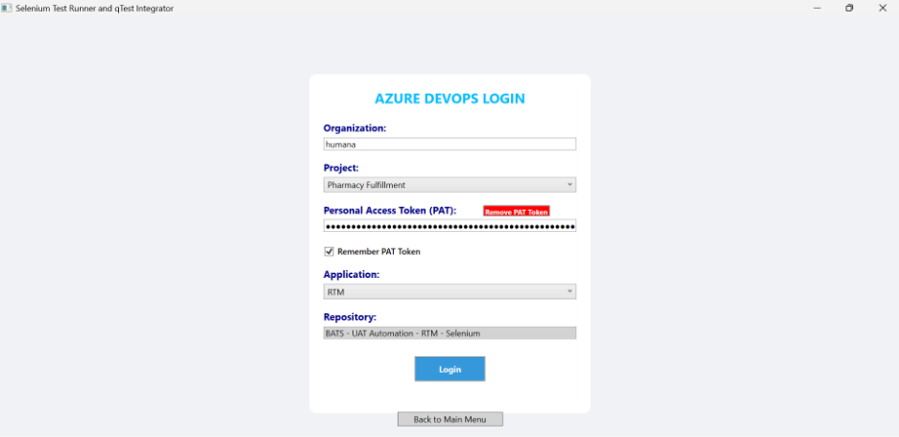

2) Select the correct project where you are maintaining the solution in repo, enter the PAT token and select the Application.
Steps to follow to create a new PAT token if you do not have an existing token
- Go to your Azure Devops repo and click on user settings (beside your profile) and click on personal access token

- Click New token

- Enter token name
- Change the expiration date for 1 year
- Under scopes , select full access

- Click on create

A token will be generated for your use. Please copy the token immediately and store it in a secure location, as it can only be generated once and cannot be retrieved again after you close this screen.
3) Paste the token in pipeline tool (PAT field) and click on login

4) Click on OK

5) Select the project name where the testcases are maintained in Qtest and you can get the parent ID , API token from Qtest

6) Click on Next

7) Click on OK
8) You can view all the test cases on this screen. Please review each test case carefully, select the testcases which you want to execute and click Next to proceed.

9) Select the branch, browser and upload the datasheet

10) Click on Run Pipeline
11) Click on OK
Job run Status in Tool

Job run Status in Azure Devops Pipeline

Once the execution is completed you will receive a mail, click on view results.
Once you click, it will take you to the below page.

Click on 2 published, you can find the HTML reports for the executed test cases.

- Prerequisites Installation
- Install latest .NET SDK from appshop
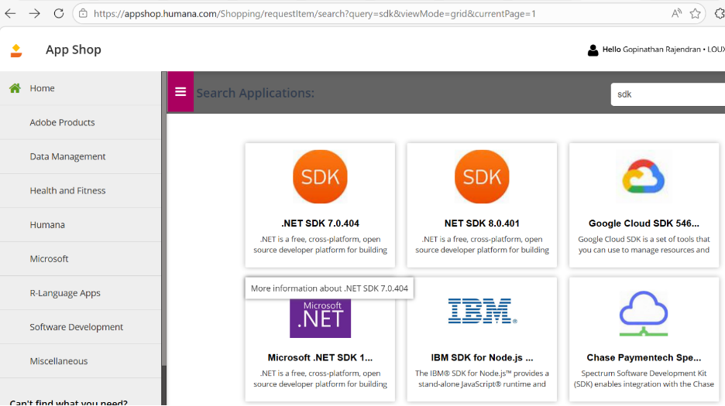
- dotnet –version
- SDK = Software Development Kit
- SDK is a collection of tools, libraries, and commands that help developers build and run applications

- Install Visual Studio Code
- Install VS code from appshop

- VS Code (Visual Studio Code) is a lightweight code editor developed by Microsoft
- VS Code is a lightweight editor that becomes a full-featured IDE(Integrated Development Environment)ssswhen we install extensions like C# and Test Explorer.”

3. Install VS Code Extensions
Open VS Code → Extensions → Install:
- ✅ C# (by Microsoft)
- ✅ NuGet Package Manager
4. Install Edge Browser + WebDriver
✅ Edge Browser
Ensure Microsoft Edge is installed.
✅ Edge WebDriver
5.Create Selenium C# Project in VS Code
✅ 1. Set Up VS Code
- Open Visual Studio Code.
- Install required extensions:
- C# → Enables coding support
- C# Dev Kit → Adds debugging and project features
✅ 2. Create Workspace and Project Folder
- Use terminal:
mkdir ePost_Auto
cd ePost_Auto
- This creates and navigates to your working project directory.

✅ 3. Create Solution and Project
- Initialize solution:
dotnet new sln
- Create class library:
dotnet new classlib -o selenium_tests
- Add project to solution:
dotnet sln add .\selenium_tests\
- This structures your automation framework.

✅ 4. Install Required Packages
- Add Selenium and testing dependencies:
dotnet add package Selenium.WebDriver --version 4.20.0
dotnet add package Selenium.Support --version 4.20.0
dotnet add package NUnit --version 4.0.1
dotnet add package NUnit3TestAdapter --version 4.5.0
dotnet add package Microsoft.NET.Test.Sdk --version 17.10.0-preview-24801.1
dotnet add package Selenium.WebDriver.MSEdgeDriver --version 147

dotnet add package Selenium.WebDriver.MSEdgeDriver

- These packages enable browser automation and test execution.

✅ 5. Build the Project
- Run:
dotnet build
- Compiles the code and verifies setup is correct.

✅ 6. Write Automation Code
- Create Selenium test scripts using C# and NUnit.
- Save and rebuild to ensure no errors.
6.Basic Selenium Test Setup
using NUnit.Framework;
using OpenQA.Selenium;
using OpenQA.Selenium.Edge;

namespace SeleniumDemo
{
public class Tests
{
IWebDriver driver;

[SetUp]
public void Setup()
{
// Initialize Edge Driver
driver = new EdgeDriver();
driver.Manage().Window.Maximize();
}

[Test]
public void OpenGoogleTest()
{
driver.Navigate().GoToUrl("https://www.google.com");

// Simple validation
Assert.That(driver.Title, Does.Contain("Google"));
}

[TearDown]
public void CloseBrowser()sssss
{
driver.Quit();
}
}
}

7. How to Create XPath

How to Inspect Elements
- Open browser
- Right-click → Inspect
- Click element icon (arrow tool)
- Click target element

Types of locators:
- Absolute XPath (❌ not recommended) - //input[@name='q']
- By Text - //button[text()='Search']
- Contains - //input[contains(@class,'search')]
- Starts-with - //input[starts-with(@id,'user')]

Example in Selenium Code
[Test]
public void SearchTest()
{
driver.Navigate().GoToUrl("https://www.google.com");

IWebElement searchBox = driver.FindElement(By.XPath("//textarea[@name='q']"));
searchBox.SendKeys("Selenium C#");

searchBox.Submit();

Assert.That(driver.Title, Does.Contain("Selenium"));
}
Running Tests in VS Code
Option 1: Terminal
dotnet test
Option 2: Test Explorer (if installed extension)
- Install: .NET Core Test Explorer
- Run tests from UI
8. Sample Complete Test Flow
[Test]
public void LoginExample()
{
driver.Navigate().GoToUrl("https://example.com");

driver.FindElement(By.XPath("//input[@id='username']")).SendKeys("admin");
driver.FindElement(By.XPath("//input[@id='password']")).SendKeys("password");
driver.FindElement(By.XPath("//button[@type='submit']")).Click();

Assert.That(driver.Title, Does.Contain("Dashboard"));
}

9. Topics covered

- Introduction to Selenium + C#
- Install .NET + VS Code
- Create project
- Add Selenium packages
- Write basic test
- WebDriver lifecycle
- XPath fundamentals
- Inspect elements demo
- Run test in Edge

✅ 10. Run Tests via Terminal
- Execute tests using:
dotnet test .\bin\Debug\net8.0\selenium_tests.dll
- Runs all automation tests from command line.

✅ 11ss. Run Tests via VS Code UI
- Install extension:
- .NET Core Test Explorer
- Go to View → Testing
- Run tests from the graphical interface.

🎯 Overall Flow
Install → Setup → Create Project → Add Packages → Build → Write Code → Run Tests ✅

