ER Diagram
Data Exploration & Schema Inference in Databricks

I used Databricks Community Edition to read and analyse a GZIP-compressed file efficiently. Databricks provided a seamless way to process compressed data while enabling me to examine table structures, including column names and data types.
It has built-in schema capabilities, so that I can easily determine its structure without defining any manual schema.
Below Details of all Fact and Dimension Table along with their Data Type
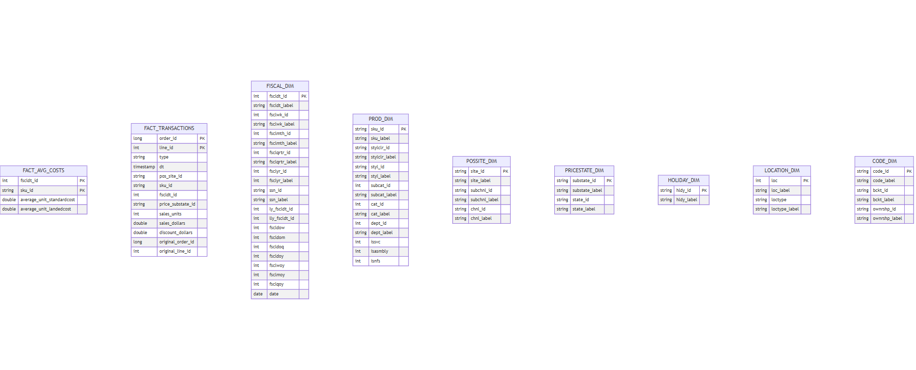
After analysing the dataset structure and its contents, I observed that a referential integrity relationship exists between the fact_avg_cost table and the following dimension tables:
- Fiscal Dimension Table
- Product Dimension Table

Primary Key – Foreign Key Relation
Fscldt_id in the fact_avg_cost table serves as a foreign key referencing the fiscal dimension table.
sku_id in the fact_avg_cost table serves as a foreign key referencing the product dimension table.
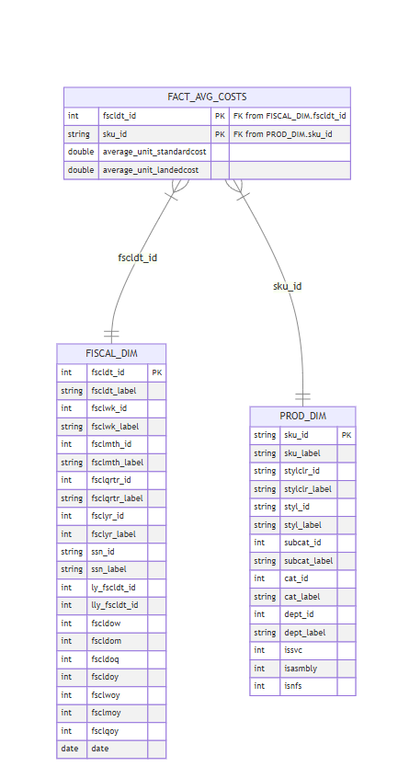

The ER diagram below illustrates the primary key – foreign key relationships between the fact_txns fact table and various dimension tables.
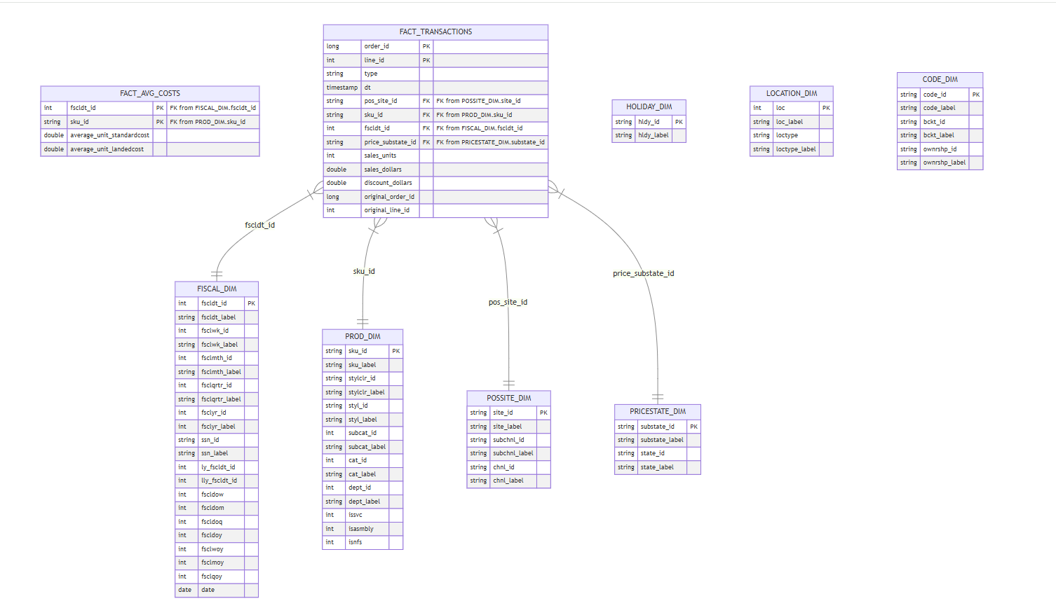

Fiscal Dimension Table: - Drilling down (Normalizing)
Now further normalizing fiscal_dim table, here also referential integrity relationship exists.
for example, Fiscal month id is coming from fiscal month table.
This normalization follows the Snowflake Schema approach, where dimension tables are further decomposed into smaller, related tables to improve data integrity and reduce duplication.