Architecture
Living Application Knowledge Platform
Knowledge Transfer Document
29 September 2026
Table of Contents
Layers and components
Target system architecture
Forge concepts as used here
asUser versus asApp
Target data flow
External services
Design decisions
Constraints and limits

Layers and components
Layer | Components | Runs where
Presentation | UI Kit panels and macro, two Custom UI apps | Browser (Atlassian iframe)
API (resolvers) | resolver.define(...) in src/index.js | Forge function
Event handlers | onConfluencePage in src/triggers.js | Forge function
Domain libraries | src/lib/* (Confluence, Jira, ADF, sessions, insights) | Forge function
Agent seam | src/lib/agentClient.js | Forge function
Persistence | Forge KVS through @forge/kvs | Forge platform
External services | Agent server, local-context-service, local-flow-service | Outside Atlassian
Atlassian APIs | Confluence REST v2 and search, Jira REST v3 | Atlassian Cloud

Target system architecture
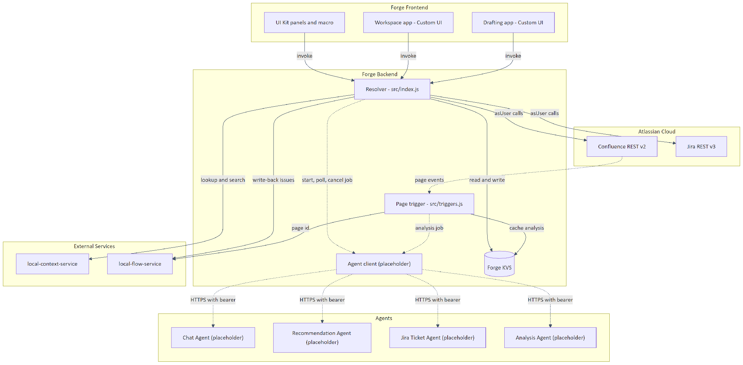
Figure 1: Flux-Spine target system architecture
Solid edges are live today. Dashed edges are planned or not yet live: the agent client currently answers locally instead of opening a connection, and the chat agent has no caller yet.

Forge concepts as used here
Concept | How this app uses it
Modules | Issue panel, byline item, admin page, global settings, macro, content action, two global pages, one trigger (see Manifest)
Function | Two: resolver (all UI calls) and confluenceTrigger
Resolver | One Resolver instance in src/index.js with 32 named definitions. export const handler = resolver.getDefinitions()
Bridge | UI calls invoke to reach resolvers; router.open opens the drafting app in a new tab; view.getContext and view.resize
Storage | KVS only (kvs.get, kvs.set, kvs.delete). No Forge SQL, no custom entities, no queries or indexes
Events | Product events avi:confluence:created:page and avi:confluence:updated:page
Egress | fetch from @forge/api to hosts in permissions.external.fetch.backend
Auth | Atlassian APIs are called asUser() almost everywhere; see below

asUser versus asApp
api.asUser() sends the request with the current user's permissions and attributes changes to them. api.asApp() uses the app's identity. This code base uses asUser() for every Confluence and Jira call. The reasons recorded in comments: a user who cannot see or edit something cannot do so through the app, and page history and Jira history show the real person. asApp() is not used anywhere.

Target data flow
- A PM opens the workspace or drafting app (Custom UI) or a panel (UI Kit).
- The UI calls a resolver with invoke.
- The resolver reads Atlassian data as the user, assembles a payload, and asks the agent client to start a job. It returns a job id immediately.
- The UI polls a resolver (getJobResult) which asks the agent client for one status check.
- When the agent returns a proposal, the UI shows a diff. The PM edits and approves.
- Resolvers save a draft page, publish it, then create Jira issues, all as the user.
- The created issues are posted to local-flow-service so the knowledge bundle stays current.
- Confluence page events fire the trigger, which forwards to the flow service and requests analysis, caching the result for the macro.
See Application flow for sequence diagrams.

External services
Service | Direction | Purpose | Status
Agent server | Forge to agent | Four job-based agent endpoints | Status: Placeholder (planned)
local-context-service | Forge to service | Lookup, search, recommend, health | Status: Implemented (client side)
local-flow-service | Forge to service | Bundle write from Confluence and Jira events | Status: Implemented (client side)

The two local-* services sit behind one gateway host that splits by path prefix (/context, /flow). deriveFlowBaseUrl in src/lib/bundleWriteBack.js derives the flow URL from the configured context URL.

Design decisions
Decision | Reason (from code comments)
Job and poll, polling in the browser | A resolver that waits for an agent would be capped by the function time limit
One agent seam file | Switching from local stand-in to live server should be a one-line change with no manifest edit
Payload assembled in the resolver | Page text is already server-side; avoids sending large text to the browser and back
Text capped from the middle | Keeps a page's opening and closing (capText in src/lib/confluence.js)
Draft is a real Confluence page | Renders exactly like a page; macros, comments, sharing all work
Publish edits by re-applying changes to the live page | Avoids reverting someone else's edit to a different section
Section hash (expectedHash) before overwrite | A changed section is reported as blocked, not overwritten
Create Jira issues one phase per call | Each call must finish inside the resolver time limit; progress is saved after each phase
Macro never calls an agent | Macro renders on every page view; analysis is done at write time and cached
Two apps, handover through KVS | Reading query parameters in a global page is not documented; a KVS key is used instead
Bookkeeping in a separate finishTicketRun call | Keeps the creation response inside the time limit

Constraints and limits
Figures in the first table come from this repo's code and comments. Platform limits in the second table are general Forge facts to verify against current Atlassian documentation before relying on them.
Constraint | Value | Where
Resolver time budget assumed by code | 25 seconds | comments in src/index.js, src/lib/jiraCreate.js
One Jira creation phase budget | 16 seconds | PHASE_BUDGET_MS in src/lib/jiraCreate.js
Jira bulk create chunk | 10 issues | BULK_LIMIT in src/lib/jiraCreate.js
Agent request timeout | 20 seconds per call | REQUEST_TIMEOUT_MS in src/lib/agentClient.js
Context service request timeout | 10 seconds | src/lib/contextService.js
Flow service write-back | 4 seconds per call, 12 seconds total | src/lib/bundleWriteBack.js
Trigger forward timeout | 15 seconds | src/triggers.js
Page text sent to agent | 24,000 characters; parent 8,000 | src/index.js
Sessions kept per account | 25 | MAX_SESSIONS in src/lib/sessions.js
Fan-out re-analysis | 5 pages per edit | fanOutTargets in src/lib/insights.js
Client wait for drafting job | 16 minutes | draft/App.jsx
Client wait for ticket job | 5 minutes | draft/jira/JiraStep.jsx

Platform limit (verify) | Relevance
Function invocation timeout | Trigger work (flow call plus analysis plus fan-out) may exceed the default; see Open questions
Payload size limits for invoke and fetch | Large pages and reports travel in payloads
KVS value size limit | insights:<pageId> stores full page text
Confluence and Jira API rate limits | Fan-out, bulk create and per-issue reads

Continue with Manifest and modules.

