04 — Agents
  - Living Application Knowledge Platform
Knowledge Transfer Document
29 September 2026
Table of Contents
1. Inventory
2. Model configuration (shared by every agent)
3. Common middleware stack
4. Agent details
4.1 PM / manager agent
4.2 Automation intake manager (automation_intake_manager)
4.3 Automation delivery manager (automation_delivery_manager)
4.4 Wiki agent (specialist)
4.5 Confluence agent (specialist)
4.6 Jira agent (specialist)
4.7 Developer agent (specialist)
4.8 Knowledge-stage agents (pipeline)
5. Agent orchestration and hand-offs
5.1 Hand-off rules (implemented in core/middlewares/subagents_middleware.py and prompts)
6. Agent interaction over time (chat turn)
7. Knowledge-pipeline agents
8. Capability matrix
9. Adding or changing an agent — checklist

All agents are built with langchain.agents.create_agent(...) (LangChain 1.x) on top of LangGraph. Every agent is created with tools=[]; all tools arrive through middlewares (core/middlewares/). Prompts live in core/agents/prompts/ and are documented by core/agents/prompts/README.md.

1. Inventory
# | Agent | Factory (file) | Prompt | Runs when | Memory
1 | PM / manager agent (business_requirements_agent) | create_business_requirements_agent — core/agents/business_requirements_agent.py | manager_chat.md | A user sends a chat message; also the legacy webhook path | LangGraph checkpointer (Redis or in-memory), thread = AgentThread.id
2 | Automation intake manager | create_automation_intake_agent — core/agents/automation_agent.py | manager_automation_intake.md | Confluence page published/updated | Checkpointer, thread = automation:<run_id>
3 | Automation delivery manager | create_automation_delivery_agent — same file | manager_automation_delivery.md (byte-identical to the intake prompt — see R-4 in 11) | Jira issue moved into an "in progress" status | Checkpointer, thread = automation:<run_id>
4 | Wiki agent (wiki_agent, class name wiki_sync_subagent) | create_wiki_sync_subagent — core/agents/wiki_sync_agent.py | specialist_wiki_chat.md / specialist_wiki_automation.md | Delegated by a manager via task | Own checkpointed namespace under the manager's thread
5 | Confluence agent | create_confluence_subagent — core/agents/confluence_agent.py | specialist_confluence_chat.md / _automation.md (identical files) | Delegated | same
6 | Jira agent | create_jira_subagent — core/agents/jira_agent.py | specialist_jira_chat.md / specialist_jira_automation.md | Delegated | same
7 | Developer agent | create_developer_subagent — core/agents/developer_agent.py | specialist_developer_chat.md / _automation.md (identical files) + generated toolchain section | Delegated; only if an application checkout exists | same
8 | Knowledge-stage agents ×4 (feature extraction, requirements, Jira, test cases) | create_custom_agent — core/agents/wiki_agent.py | step1..4_*_system_prompt.md + human_messages/step1..4_*_human_message.md | Knowledge job stages (backend/app/knowledge_runner.py) | InMemorySaver created inside the factory
9 | Knowledge-stage coding sub-agent | built inside create_custom_agent (name="developer_agent") | knowledge_pipeline_coding_subagent.md | Delegated by a stage agent | same in-memory saver
10 | Standalone coding agent | create_coding_agent — core/agents/coding_agent.py | none (system_prompt = "") | Not wired to the API | InMemorySaver

2. Model configuration (shared by every agent)
core/utils/llms.py::LLMModels.get_llm() reads core/config/llm-config.yaml:
Key | Value in repo
llm_model.default_service_provider | OpenAI
llm_model.default_model | gpt-5.3-codex (commented alternatives in the file)
temperature / max_tokens / max_retries | 0.7 / 30000 / 2
use_responses_api | true
Reasoning | hard-coded in llms.py: {"effort": "medium", "summary": "auto"}

AgentChatService.model() builds one shared model per process (on a worker thread) and passes it to the manager, the automation service and every specialist. The manager and specialists receive the same model object (model= argument). get_llm() returns None on any failure; callers turn that into AGENT_MODEL_UNAVAILABLE (503). There is no environment override for the model name — change the YAML.

3. Common middleware stack
Every production agent adds, in this order (order matters):
- TodoListMiddleware (LangChain) — write_todos tool (not on Confluence agent).
- ScratchpadMiddleware(agent_name=...) — tools write_note, update_note, rewrite_notes; per-agent notes that survive compaction; injects reminders into the freshest tool result; excluded from sub-agent state sharing ("scratchpad" is in _EXCLUDED_STATE_KEYS) and returned to the delegator inside the task result (_handover_notes).
- Domain middlewares (below).
- ContextCompactionMiddleware(model, config=SCRATCHPAD_COMPACTION_CONFIG, agent_name=...) — microcompaction (clears old tool output) and full LLM-summary compaction. Config = FOUR_HUNDRED_K_CONFIG (trigger at 80 % of the resolved window, microcompact at 50 %, keeps 8 messages / 20 k tokens, output reserve 30 k) with the scratchpad tool names excluded from clearing. Context windows come from core/config/openai_model_context_windows.json via core/utils/model_context_windows.py.
- Optional logging hook (@before_model) that logs an invocation line without prompts or content.

4. Agent details

4.1 PM / manager agent
- Purpose: the only agent the user talks to. Coordinates BRD drafting, Jira backlog creation and code implementation by delegating; holds no domain tools.
- Inputs: a HumanMessage (chat text up to 50 000 chars) with configurable.thread_id, recursion_limit=2000.
- Outputs: final assistant text; streaming events (thread, step, tool, result, reasoning, delta, final, error) are derived by AgentChatService (see 09).
- Prompt (manager_chat.md, ~22 KB): sections "The one rule…", ADA-compliant content rules, Stateful-agent handoff rule (same-agent vs cross-agent, no payload duplication), "Your team", "Your three responsibilities" (1 draft/publish BRD, 2 create Jira work, 3 implement a Jira item), "How you communicate", "Approval requests", "Hard rules", worked examples.
- Tools: write_todos, write_note/update_note/rewrite_notes, and task (delegation; SubAgentMiddleware with general_purpose_agent=False). The system prompt gets an auto-generated roster of the specialists actually registered (_delegation_prompt), so a project without an application checkout does not advertise the developer agent.
- Approvals: create_business_requirements_agent defaults approvals=AgentApprovalContext(confluence_reference=..., jira_reference=...) with fixed placeholder strings. The chat service does not override it, so chat specialists have mutation enabled and rely on the prompt's conversational approval protocol (see S-2 in 11).
- Invoked by: AgentChatService.chat() / stream_chat() (backend/app/agent_chat_service.py), and run_atlassian_webhook() for the legacy webhook path. The agent is rebuilt for every turn; specialists are compiled lazily (_LazySubAgent).

4.2 Automation intake manager (automation_intake_manager)
- Purpose: turn a published Confluence page into Jira work, unattended. Reads the authoritative page, decides if it is a specification, researches the backlog, creates/reconciles issues, then has the wiki agent reconcile the bundle.
- Approvals: AgentApprovalContext(jira_reference="automation:<run_id>") — no Confluence approval, so its Confluence agent cannot write.
- Specialist prompts: AUTOMATION_SPECIALIST_PROMPTS.
- Invoked by: AutomationService._build_agent() when trigger == "confluence_published"; instruction text from _build_instruction().

4.3 Automation delivery manager (automation_delivery_manager)
- Purpose: for a Jira issue moved into progress — have the developer implement + test the change and, only if tests pass, commit/push/open a PR; record the verified outcome in Jira (comment + remote link), update Confluence only if made wrong, reconcile the bundle. Never merges, never transitions to done.
- Approvals: both Jira and Confluence references = automation:<run_id>.
- Delivery: BusinessRequirementsAgentSettings.delivery (a DeliverySettings) is set only for this trigger (AutomationService._agent_settings(with_delivery=True)), which adds GitDeliveryMiddleware to the developer agent.
- Invoked by: AutomationService._build_agent() when trigger == "jira_in_progress".

4.4 Wiki agent (specialist)
- Purpose: owns the local OKF bundle (<project>/wiki). Answers "what does the product already do / which features, requirements, issues, tests relate to X" and is the only writer of bundle files; reconciles the bundle after verified Confluence/Jira changes. Has no Confluence/Jira tools by design (avoids ~25 extra tool schemas).
- Tools: write_todos, scratchpad tools, BackgroundPowerShellMiddleware(root=knowledge_root) → execute, check_status, cancel_job; ApplyPatchMiddleware(root=knowledge_root) → apply_patch. ConceptPageMiddleware is commented out in the factory.
- Prompt caveat: specialist_wiki_automation.md currently begins "You are the Jira agent…" (see R-3 in 11).

4.5 Confluence agent (specialist)
- Tools (ConfluenceMiddleware): confluence_get_configuration, confluence_list_pages, confluence_search_pages, confluence_get_page, confluence_create_page, confluence_update_page, plus scratchpad tools.
- Guardrails: scoped to one space; create/update return APPROVAL_REQUIRED unless approval_reference supplied; update requires last-read version; body cap max_body_characters=100_000; retries on reads.
- Prompt: template for BRDs (## The BRD template — required structure), "agent-note convention", revision and publish handling.

4.6 Jira agent (specialist)
- Tools (JiraManagementMiddleware, exported as JiraMiddleware): read — jira_get_configuration, jira_get_project, jira_get_create_metadata, jira_search_issues, jira_get_issue, jira_get_edit_metadata, jira_get_comments, jira_get_transitions, jira_get_issue_link_types, jira_find_assignable_users, jira_get_remote_links; write — jira_create_issue, jira_update_issue, jira_assign_issue, jira_add_comment, jira_transition_issue, jira_create_issue_link, jira_add_remote_link; plus todos and scratchpad.
- Guardrails: JQL is auto-restricted to the configured project; write tools return APPROVAL_REQUIRED without an approval reference; updates check the last-read updated timestamp; ADF, not Markdown, for rich text.

4.7 Developer agent (specialist)
- Tools: read_file (FileReaderMiddleware), apply_patch, execute / check_status / cancel_job (background PowerShell), load_skill (SkillsMiddleware, read-only, confined to core/agents/skills/), todos and scratchpad. All rooted at source/codebase. When settings.delivery is set: delivery_repository_status, delivery_create_branch, delivery_commit, delivery_push, delivery_open_pull_request (GitDeliveryMiddleware).
- System prompt = chosen prompt + _toolchain_prompt() which probes shutil.which() for python3, pip, virtualenv, pytest, node, npm, npx, git, rg, pwsh, make, java, mvn, gradle, dotnet, go, cargo, docker and states what is available (and whether PIP_REQUIRE_VIRTUALENV blocks global pip).
- Skill: core/agents/skills/raise-pull-request/SKILL.md — PR body format.
- Delivery safety: refuses to push to the base branch or to main/master/develop/trunk/release; token only through a temporary GIT_ASKPASS helper; PR opened via provider API; returns existing PR if one is open for the branch.
- Known gap: the docstring says listing/glob/ripgrep tools precede reading, but the middleware list contains only reader, patch, shell (and delivery). See R-5 in 11.

4.8 Knowledge-stage agents (pipeline)
KnowledgeStageExecutor.run_agent() (backend/app/knowledge_runner.py) maps stage → prompts:
Stage | System prompt | Human message
feature_extraction | step1_feature_extractor_system_prompt.md | human_messages/step1_feature_extractor_human_message.md
requirements_ingestion | step2_requirement_ingestion_system_prompt.md | human_messages/step2_...
jira_ingestion | step3_jira_ingestion_system_prompt.md | human_messages/step3_...
test_case_ingestion | step4_test_case_ingestion_system_prompt.md | human_messages/step4_...

Each call builds a fresh stage agent with create_custom_agent(root_path=<project_root>, system_prompt_path=...): TodoList, Scratchpad, BackgroundPowerShell, ApplyPatch, Compaction, and a SubAgentMiddleware exposing one sub-agent developer_agent (prompt knowledge_pipeline_coding_subagent.md, same tool set). Input message = human prompt + "Project root: <path>". Output = last message text (truncated to 50 000 chars) stored in JobStage.result.

5. Agent orchestration and hand-offs

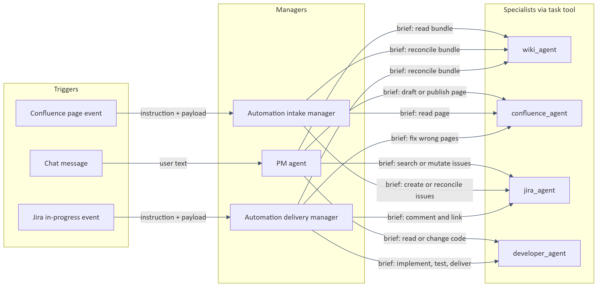
Figure 1: 5. Agent orchestration and hand-offs

Explanation: the same specialist factories serve all three managers; what differs is the manager prompt, the specialist prompt set, and which approvals/delivery settings are issued. Arrows are task(subagent_type=..., description=...) calls. Reports flow back as the task tool result; a specialist's scratchpad notes are appended to that report.

5.1 Hand-off rules (implemented in core/middlewares/subagents_middleware.py and prompts)
- A specialist cannot see the conversation and cannot ask follow-ups; the brief must carry goal, identifiers (page IDs+versions, issue keys+timestamps, paths), approval reference, and desired answer shape. Never credentials.
- A specialist remembers its own earlier delegations in the same conversation/run (checkpointed namespace derived by subagent_namespace()); later briefs should be incremental.
- Two delegations to the same specialist run sequentially; to different specialists, in parallel.
- After verified Confluence/Jira changes the manager must delegate bundle reconciliation to the wiki agent (even for no-change outcomes); the brief must carry the verified content, because the wiki agent has no Atlassian tools.
- Delegation announcements are emitted as custom stream events so the UI can label concurrent sub-agents correctly (DelegationTracker in backend/app/agent_activity.py).

6. Agent interaction over time (chat turn)

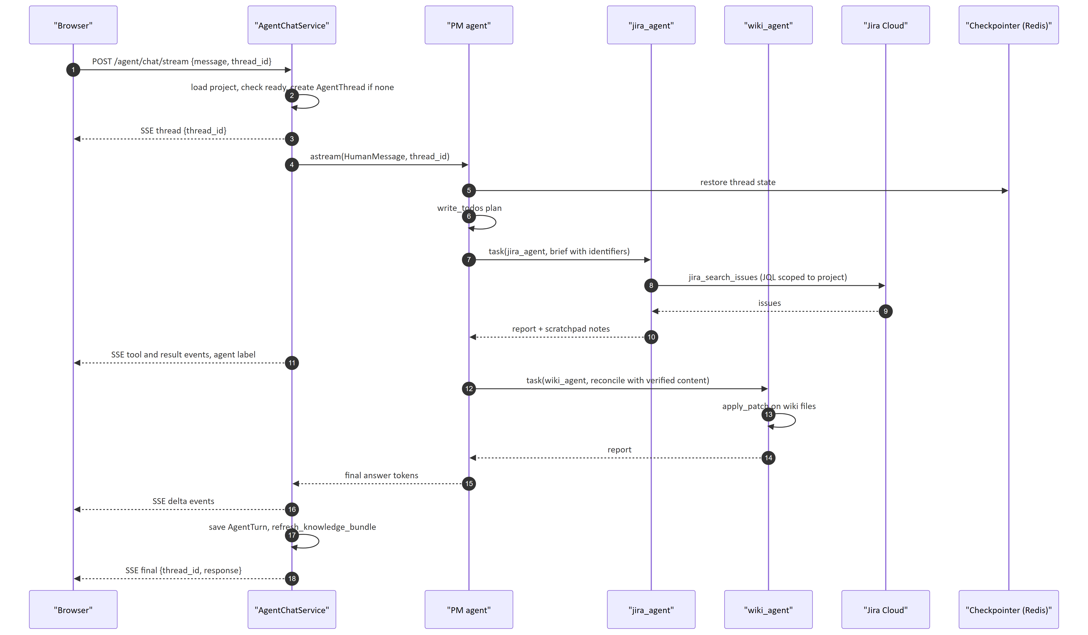
Figure 2: 6. Agent interaction over time (chat turn)

Explanation: the service filters stream chunks so only the manager's own tokens become the visible answer; sub-agent tokens are treated as working transcript. After the turn the bundle is re-rendered and committed because the wiki agent may have written to it.

7. Knowledge-pipeline agents

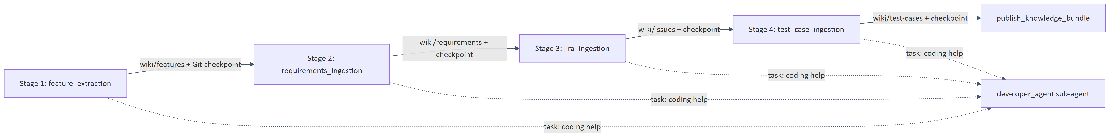
Figure 3: 7. Knowledge-pipeline agents

Explanation: stages run strictly in order inside one job; each later stage reads what earlier stages wrote to wiki/ (there is no other hand-off channel). A later stage can be re-run alone (knowledge_stage job) after the prerequisites check in ProjectService._validate_stage_prerequisites.

8. Capability matrix
Capability | PM chat | Intake | Delivery | How enforced
Read Confluence / Jira | yes | yes | yes | specialist tools
Write Jira | yes (default approvals) | yes (automation:<run_id>) | yes | allow_mutations + approval_reference
Write Confluence | yes (default approvals) | no | yes | same
Edit application code | yes | n/a in practice | yes | developer agent apply_patch (always present)
Branch / commit / push / PR | no | no | yes (if repo publishable) | GitDeliveryMiddleware only added when settings.delivery set
Write wiki bundle | via wiki agent | via wiki agent | via wiki agent | wiki agent rooted at wiki/

9. Adding or changing an agent — checklist
- Add/modify the factory in core/agents/; keep tools=[] and add tools via middleware.
- Register the specialist in _build_specialist_specs() and in SUBAGENT_DESCRIPTIONS, and add its prompt to both CHAT_SPECIALIST_PROMPTS and AUTOMATION_SPECIALIST_PROMPTS in business_requirements_agent.py.
- Place ScratchpadMiddleware before ContextCompactionMiddleware.
- Prompt filenames must be bare filenames inside core/agents/prompts/ (enforced by load_business_requirements_system_prompt).
- If the agent can mutate an external system, gate it on an approval reference, not on prompt text alone.
- Update tests such as tests/test_specialist_agents.py, tests/test_subagent_memory.py, tests/test_subagent_labelling.py.

