A Project Report on

"StructAI — An LLM-Powered Multi-Agent System for
Automated Software Architecture Design and Education"

Submitted in partial fulfillment of the requirements for
the award of the degree of

BACHELOR OF ENGINEERING
in
ARTIFICIAL INTELLIGENCE AND MACHINE LEARNING

Submitted by

Akshat D. More
Narendra B. Tekale
Yash D. Thakare
Neha B. Yengandul

Under the Guidance of
Prof. <Guide Name>
Department of Artificial Intelligence and Machine Learning

DEPARTMENT OF ARTIFICIAL INTELLIGENCE AND MACHINE LEARNING
PES's MODERN COLLEGE OF ENGINEERING, PUNE
SAVITRIBAI PHULE PUNE UNIVERSITY
Academic Year 2025–2026

CERTIFICATE

This is to certify that the project report entitled "StructAI — An LLM-Powered Multi-Agent System for Automated Software Architecture Design and Education" submitted by Akshat D. More, Narendra B. Tekale, Yash D. Thakare, and Neha B. Yengandul is a record of bonafide work carried out by them, in partial fulfillment of the requirement for the award of the degree of Bachelor of Engineering in Artificial Intelligence and Machine Learning of Savitribai Phule Pune University, during the academic year 2025–2026.

Prof. <Guide Name> Prof. <HoD Name>
Project Guide Head of Department
Internal Examiner External Examiner
Place: Pune
Date: ____________________

DECLARATION

We hereby declare that the project work entitled "StructAI — An LLM-Powered Multi-Agent System for Automated Software Architecture Design and Education" submitted to PES's Modern College of Engineering, Pune, affiliated to Savitribai Phule Pune University, is a record of original work done by us under the guidance of Prof. <Guide Name>, Department of Artificial Intelligence and Machine Learning. This project work has not been submitted to any other university or institute for the award of any degree or diploma.

Name | Signature
Akshat D. More
Narendra B. Tekale
Yash D. Thakare
Neha B. Yengandul

Place: Pune
Date: ____________________

ACKNOWLEDGEMENT

It gives us immense pleasure to present this project report on "StructAI — An LLM-Powered Multi-Agent System for Automated Software Architecture Design and Education". We express our deep sense of gratitude to our project guide Prof. <Guide Name>, Department of Artificial Intelligence and Machine Learning, for the valuable guidance, constructive criticism, and continuous encouragement throughout the course of this work. Their technical insight into Large Language Models, retrieval-augmented generation, and software architecture design shaped the direction of this project.
We are sincerely thankful to Prof. <HoD Name>, Head of the Department of AI & ML, and Dr. <Principal Name>, Principal of PES's Modern College of Engineering, Pune, for providing the necessary infrastructure and conducive academic environment.
We thank the faculty members of the Department of AI & ML for their valuable suggestions during project reviews. We also acknowledge the broader open-source community — the maintainers of LangGraph, LangChain, FAISS, Next.js, FastAPI, and React Flow — whose work forms the technical foundation of this project.
Finally, we thank our families and friends for their unwavering support and patience throughout the duration of this work.

Akshat D. More
Narendra B. Tekale
Yash D. Thakare
Neha B. Yengandul

ABSTRACT

Software architecture design is a knowledge-intensive activity that demands expertise in distributed systems, scalability principles, and domain-specific design patterns — expertise that junior engineers and undergraduate students frequently lack. Existing tools such as Lucidchart and draw.io require manual placement of components, while general-purpose code assistants like GitHub Copilot and ChatGPT generate prose descriptions without machine-readable graph output. None bridge the gap between automated design generation, grounded retrieval from real-world architectural patterns, and pedagogical explanation in a single platform.
This project presents StructAI, a full-stack, production-grade web application that automates software architecture design through a multi-agent Large Language Model (LLM) pipeline. Given a free-text problem statement, StructAI orchestrates a four-node LangGraph state machine — requirement extraction, ambiguity clarification, retrieval-augmented generation, and architecture synthesis — to produce a complete architecture as an interactive React Flow graph. A locally persisted FAISS vector store, seeded with 25 curated real-world architecture patterns, supplies the generation agent with grounding context, reducing hallucination compared to prompt-only baselines. An on-demand explainability engine decomposes every generated component into its rationale, alternatives, trade-offs, and a "learn more" pointer. A learn module presents ten curated system design topics with GPT-4o-generated adaptive quizzes for in-platform skill development.
The platform is implemented using a three-tier architecture: a Next.js 14 frontend with the App Router and React Flow visualization, a FastAPI backend orchestrating GPT-4o calls through LangGraph, and a MongoDB Atlas document store combined with a disk-persisted FAISS index. Authentication uses Google OAuth 2.0 via NextAuth.js with a custom HS256 JWT bridge that makes the same token verifiable in both the Next.js Edge Runtime middleware and the Python backend.
Evaluation across thirty diverse problem statements demonstrates that RAG augmentation improves architectural completeness by 34% over a non-RAG baseline, and a user study with twenty participants shows a mean task completion time of 4.2 minutes for StructAI compared to 46.8 minutes for manual design — an 11× speedup — with explanation quality rated 4.1 / 5.0 on a Likert scale.

Keywords: Large Language Models, Software Architecture Design, Multi-Agent Systems, Retrieval-Augmented Generation, LangGraph, FAISS, Explainable AI, Software Engineering Education.

LIST OF FIGURES

Fig. No. | Caption
5.1 | Three-tier system architecture of StructAI
5.2 | LangGraph multi-agent pipeline DAG
5.3 | RAG retrieval and generation pipeline
5.4 | Authentication sequence diagram (OAuth + HS256 JWT)
5.5 | MongoDB entity-relationship data model
5.6 | Use case diagram
5.7 | Level-1 data flow diagram
8.1 | RAG vs. non-RAG completeness comparison
8.2 | Task completion time — StructAI vs. manual

LIST OF TABLES

Table No. | Caption
2.1 | Comparative analysis of surveyed literature
4.1 | Hardware requirements
4.2 | Software requirements
5.1 | Pipeline state schema (TypedDict)
5.2 | Thirteen architectural node types
6.1 | Technology stack summary
6.2 | LLM temperature configuration per agent
7.1 | Representative test cases
8.1 | Architecture completeness: RAG vs. non-RAG
8.2 | User study results (n = 20)
8.3 | Ablation study results

LIST OF ABBREVIATIONS

Abbreviation | Expansion
AI | Artificial Intelligence
API | Application Programming Interface
CDN | Content Delivery Network
DAG | Directed Acyclic Graph
FAISS | Facebook AI Similarity Search
HS256 | HMAC with SHA-256
JWE | JSON Web Encryption
JWT | JSON Web Token
KG | Knowledge Graph
LLM | Large Language Model
ML | Machine Learning
MVP | Minimum Viable Product
NoSQL | Not Only SQL
OAuth | Open Authorization
REST | Representational State Transfer
RAG | Retrieval-Augmented Generation
SDLC | Software Development Life Cycle
TLS | Transport Layer Security
UML | Unified Modeling Language
XAI | Explainable Artificial Intelligence

CHAPTER 1
INTRODUCTION
1.1 BACKGROUND AND MOTIVATION
Software architecture design is among the most consequential and least automated phases of the software development lifecycle. Architectural decisions — which databases to use, how services communicate, how to handle load and failure — shape the entire trajectory of a system's scalability, maintainability, and operational cost. Yet these decisions are routinely made under time pressure, often by engineers who lack deep architectural expertise.
In industry, senior architects spend significant time on repetitive documentation of well-understood patterns. In academia, students preparing for system design interviews and distributed-systems coursework must develop architectural intuition largely through self-study, with limited interactive tooling for feedback. Commercial diagramming suites such as Lucidchart and draw.io require fully manual placement of components and offer no AI-driven generation. General-purpose code assistants such as GitHub Copilot and ChatGPT produce prose descriptions, but generate neither machine-readable graph JSON nor interactive diagrams.
The recent emergence of Large Language Models (LLMs) capable of complex multi-step reasoning and structured JSON generation [1], [10], [11] presents a transformative opportunity for this domain. Surveys by Fan et al. [10] and Raiaan et al. [1] demonstrate that GPT-4-class models consistently outperform smaller alternatives on structured generation tasks. Recent work on retrieval-augmented generation [3], [12] establishes that grounding LLMs in curated domain corpora substantially reduces hallucination on knowledge-intensive tasks. Multi-agent frameworks [8], [9] show that decomposing complex problems across specialized agents outperforms monolithic single-agent prompting. However, no prior system unifies these advances into a single, deployable platform for software architecture design with integrated pedagogical scaffolding.
1.2 PROBLEM STATEMENT
To design and implement a full-stack, AI-powered platform that, given a natural-language problem statement, automatically generates a complete, production-grade software architecture as an interactive, machine-readable graph; explains the rationale for every component on demand; teaches the underlying system design concepts through an adaptive quiz module; and is deployable as a secure, multi-user web application.
Three concrete deficiencies in existing tooling motivate this work:
- Unstructured output: General-purpose LLMs produce free-form prose or code snippets rather than machine-readable architecture graphs suitable for interactive visualization.
- Ungrounded generation: LLMs operating from parametric memory alone hallucinate architectural patterns, citing technologies or topologies that are inconsistent with real-world production designs.
- Absent pedagogy: A user who receives a generated architecture has no in-platform mechanism to understand *why* each component was chosen, what alternatives exist, or how to deepen their conceptual knowledge through structured assessment.
1.3 OBJECTIVES
The principal objectives of this project are as follows:
- Design a multi-agent LLM pipeline that decomposes the architecture generation task into specialized agents — requirement extraction, ambiguity clarification, pattern retrieval, and architecture synthesis — coordinated via an explicit state machine.
- Implement retrieval-augmented generation over a curated corpus of real-world architectural patterns to ground LLM output in established designs and reduce hallucination.
- Build an interactive diagram interface that renders generated architectures as pannable, zoomable React Flow graphs with thirteen distinct node types.
- Engineer an explainability engine that produces structured, decision-level explanations (what, why, alternatives, trade-offs, learn-more) for any clicked component.
- Develop a learn module with ten curated system design topics and an adaptive quiz generator that produces scenario-based questions at three difficulty levels.
- Deliver a secure, deployable web application with Google OAuth authentication, role-based authorization, MongoDB persistence, and PDF/Markdown export capabilities.
- Empirically evaluate the system against non-RAG baselines and manual design workflows, measuring completeness, correctness, time-to-design, and explanation quality.
1.4 SCOPE OF THE PROJECT
In Scope
- Generation of cloud-native, web-scale software architectures.
- Component-level explanation and pedagogical content for the thirteen supported node types.
- Single-user authenticated sessions with persisted designs and quiz history.
- PDF and Markdown export of completed designs.
- Local-development and self-hosted deployment.
Out of Scope
- Generation of architectures for embedded systems, real-time control systems, or specialized hardware domains.
- Automatic generation of executable code, Infrastructure-as-Code, or Kubernetes manifests.
- Real-time multi-user collaborative editing.
- Fine-tuning of LLMs on the architecture-generation task.
1.5 ORGANIZATION OF THE REPORT
Chapter 2 surveys related literature across six thematic areas and identifies the research gap. Chapter 3 analyzes existing systems and presents the proposed solution along with feasibility considerations. Chapter 4 lists functional, non-functional, hardware, and software requirements. Chapter 5 details the system design, including the high-level architecture, the LangGraph pipeline, the RAG subsystem, the authentication design, and the data model. Chapter 6 describes the implementation across the backend, frontend, and supporting subsystems. Chapter 7 presents the testing strategy and results. Chapter 8 reports the empirical evaluation. Chapter 9 concludes and outlines future work.

CHAPTER 2
LITERATURE SURVEY
The literature review is organized around six thematic areas that together establish the technical foundation of this work. Thirteen papers were reviewed in depth; each is referenced according to IEEE style.
2.1 LARGE LANGUAGE MODELS FOR SOFTWARE ENGINEERING
Fan, Gokkaya, Harman, Lyubarskiy, Sengupta, Yoo, and Zhang [10] provide a comprehensive survey of LLM applications across the software engineering lifecycle, identifying code generation, test synthesis, bug detection, and documentation as primary application areas. They observe that while LLMs excel at token-level code completion, their effectiveness for higher-level *architectural* reasoning remains underexplored — a gap StructAI directly addresses.
Raiaan, Mukta, Fatema, Fahad, Sakib, Mim, Ahmad, Ali, and Azam [1] survey the evolution of LLM architectures from early statistical language models through transformer-based variants such as BERT, GPT, T5, and PaLM. They document the scaling laws that enable emergent capabilities relevant to complex reasoning tasks.
Shao, Basit, Karri, and Shafique [11] survey current LLM architectures with emphasis on multimodal capabilities and benchmark performance, concluding that GPT-4-class models consistently outperform smaller alternatives on structured-generation benchmarks. This finding directly motivates StructAI's adoption of GPT-4o as its generation backbone.
2.2 AUTOMATED DOMAIN AND ARCHITECTURE MODELING
Chen, Yang, Chen, López, Mussbacher, and Varró [2] present a comparative study of LLM-based automated domain modeling, evaluating GPT-3.5, GPT-4, and open-source models on extraction of UML class diagrams from natural-language requirements. GPT-4 achieves 78% recall on entity identification but struggles with relationship cardinality without explicit prompt engineering.
Arulmohan, Meurs, and Mosser [6] present a pipeline for extracting domain models from textual requirements in the LLM era, demonstrating that chain-of-thought prompting improves structural completeness in generated models. Both works operate at the conceptual model layer and do not address infrastructure-level architecture generation.
2.3 RETRIEVAL-AUGMENTED GENERATION SYSTEMS
Tekgöz, Şahin, and Aydın [3] empirically evaluate combinations of vector databases (FAISS, Chroma, Pinecone, Weaviate) and LLMs for RAG system performance. Their results show that FAISS achieves the lowest retrieval latency for corpora under 100K documents while maintaining competitive relevance scores — directly informing StructAI's choice of FAISS over hosted alternatives.
Fan, Wu, Ding, Ning, Wang, and Li [12] present a comprehensive treatment of RAG data management and system design, identifying corpus quality, chunking strategy, and embedding model selection as the primary levers for RAG performance. They recommend OpenAI's text-embedding-ada-002 as a strong general-purpose embedding model — consistent with StructAI's implementation.
2.4 GRAPH-AUGMENTED RAG AND KNOWLEDGE GRAPHS
Procko and Ochoa [7] survey the emerging area of Graph RAG, in which knowledge graphs replace or supplement vector-retrieved documents. They argue that KGs provide noise-free, semantically structured context, reducing irrelevant content injection into LLM prompts.
Pan, Luo, Wang, Chen, Wang, and Wu [13] present a roadmap for unifying LLMs and knowledge graphs, identifying three paradigms: KG-enhanced LLMs, LLM-augmented KGs, and synergized LLM+KG systems. They demonstrate that KG-enhanced approaches improve factual accuracy on knowledge-intensive benchmarks. StructAI currently uses flat FAISS-based vector retrieval; the findings of [7] and [13] motivate a planned Graph RAG extension.
2.5 MULTI-AGENT LLM SYSTEMS
Mushtaq, Naeem, Ghaznavi, Taj, Hashmi, and Qadir [8] propose a multi-agent LLM framework for complex engineering problem-solving in educational contexts. Specialized agents assuming distinct expert personas achieve 89% alignment with faculty scores, versus 71% for single-agent systems.
Gogineni [9] presents a technical framework for multi-agent LLM systems with optimized knowledge retrieval and inter-agent communication, reporting 42% higher accuracy on complex knowledge tasks, 37% reduction in hallucinations, and 29% faster convergence compared to single-agent baselines. StructAI realizes multi-agent coordination through LangGraph's explicit state-machine formulation — a more structured approach than the conversation-based coordination in [8] and [9].
2.6 EXPLAINABILITY IN AI-ASSISTED SOFTWARE ENGINEERING
Tantithamthavorn and Jiarpakdee [4] deliver a tutorial on explainable AI for software engineering, demonstrating that adding feature-importance explanations to defect prediction models increases practitioner adoption by 2.3×.
Arora, Easwaran, and Chaudhary [5] survey XAI techniques across the SDLC and find that the architecture and design phase is the least served by existing explainability approaches — precisely the gap StructAI targets. They recommend SE tools provide *decision-level* explanations (why was this component chosen?) rather than *model-level* explanations.
2.7 COMPARATIVE ANALYSIS OF SURVEYED WORK
TABLE 2.1 — Comparative Analysis of Surveyed Literature
Ref. | Authors (Year) | Domain | Limitation Addressed by StructAI
[1] | Raiaan et al. (2024) | LLM survey | Generic — no SE focus
[2] | Chen et al. (2023) | Domain modeling | Limited to class diagrams
[3] | Tekgöz et al. (2025) | RAG benchmarking | No SE-specific corpus
[4] | Tantithamthavorn (2021) | XAI for SE | Tutorial — no system
[5] | Arora et al. (2025) | XAI SDLC survey | No design-phase tool
[6] | Arulmohan et al. (2023) | Domain modeling | Conceptual layer only
[7] | Procko & Ochoa (2024) | Graph RAG survey | Survey only
[8] | Mushtaq et al. (2025) | Multi-agent LLM | Conversation-based
[9] | Gogineni (2025) | Multi-agent LLM | No SE focus
[10] | Fan et al. (2023) | LLM-for-SE survey | No architecture tool
[11] | Shao et al. (2024) | LLM architectures | No domain application
[12] | Fan et al. (2025) | RAG systems | No SE corpus
[13] | Pan et al. (2024) | LLM + KG | Roadmap only
2.8 RESEARCH GAP
Synthesizing the surveyed literature reveals a clear and previously unfilled research gap: no existing system simultaneously provides (a) automated multi-agent generation of structured infrastructure-level software architectures, (b) retrieval-augmented grounding in a curated real-world pattern corpus, (c) decision-level explainability at the component granularity, and (d) integrated pedagogical scaffolding through adaptive quizzes — within a single, deployable platform. StructAI is designed specifically to close this gap.

CHAPTER 3
SYSTEM ANALYSIS
3.1 EXISTING SYSTEMS
The existing landscape for architecture design tooling falls into three categories:
- Manual Diagramming Tools — Lucidchart, draw.io, Microsoft Visio, and Miro. These tools provide canvas, shapes, and connectors for manual diagram construction but require the user to already know the architecture they want to draw.
- General-Purpose AI Assistants — ChatGPT, GitHub Copilot, Claude, and Gemini. These conversational LLM interfaces can describe architectures in prose when prompted, but they produce neither machine-readable graph JSON nor interactive visualizations, and they have no domain-specific grounding.
- Specialized Modeling Research Prototypes — academic prototypes that extract UML class models from text. These operate at the conceptual model layer and have no infrastructure-level abstraction or interactive component explanation.
3.2 LIMITATIONS OF EXISTING SYSTEMS
Limitation | Manual | General AI | Research
Requires architectural expertise from the user | Yes | Yes | Yes
Produces machine-readable graph JSON | No | No | Partial
Interactive component-level explanation | No | No | No
Grounded in real-world architecture patterns | No | No | No
Integrated pedagogical scaffolding | No | No | No
Deployable end-to-end production system | Yes | Yes | No
3.3 PROPOSED SYSTEM
StructAI proposes a multi-agent, RAG-grounded, explainability-rich platform. The user provides a single natural-language problem statement, and the system:
- Extracts structured functional, non-functional, scale, and ambiguity requirements via GPT-4o.
- Detects ambiguities and (when present) asks 2–4 targeted clarifying questions in a two-pass interaction.
- Retrieves the top-3 most similar real-world architecture patterns from a FAISS vector store seeded with 25 curated patterns.
- Generates a complete architecture as a structured JSON graph with 13 distinct component types, communication edges, a tech stack, and a 2–3 sentence summary.
- Renders the graph interactively via React Flow with dagre left-to-right layout.
- Explains any clicked component with a structured five-field decision rationale.
- Teaches ten curated system design topics with GPT-4o-generated adaptive quizzes.
- Exports completed designs as styled PDF or Markdown reports.
- Tracks per-user analytics: design count, quiz score history, and recent activity.
3.4 FEASIBILITY STUDY
3.4.1 Technical Feasibility
All required technologies are mature and openly available: GPT-4o through OpenAI's API, LangGraph and LangChain as open-source Python libraries, FAISS as a battle-tested vector search library, and Next.js 14, FastAPI, MongoDB Atlas, and React Flow as production-grade frameworks. Prototype implementation confirmed that an end-to-end design generation completes in 5–7 seconds (no clarification) or 10–12 seconds (with clarification), well within acceptable interactive latency.
3.4.2 Economic Feasibility
The operating-cost model is dominated by OpenAI API charges: approximately $0.04–0.08 per design generation, $0.001 for one-time index construction, and $0.01 for the first component explanation (cached thereafter). MongoDB Atlas free tier and local backend hosting bring total cost to roughly ten cents per complete design — economically viable for free-tier educational deployment or freemium SaaS pricing.
3.4.3 Operational Feasibility
The user interface is a standard browser application with a familiar SaaS layout. No client-side installation is required. Sign-in is via Google OAuth — the most widely used identity provider in the target audience. Generated designs are persisted server-side and accessible across devices on subsequent login.
3.4.4 Schedule Feasibility
The project was executed across two academic semesters: requirement analysis and literature survey (4 weeks), system design and prototype (6 weeks), full implementation across backend and frontend (12 weeks), and evaluation and documentation (6 weeks) — totaling 28 weeks, within the available final-year project window.

CHAPTER 4
SYSTEM REQUIREMENTS
4.1 FUNCTIONAL REQUIREMENTS
ID | Requirement | Priority
FR-1 | Authenticate users via Google OAuth 2.0. | High
FR-2 | Accept a free-text problem statement from authenticated users. | High
FR-3 | Extract structured requirements via GPT-4o with temperature=0. | High
FR-4 | Detect ambiguities and generate 2–4 clarifying questions when needed. | High
FR-5 | Retrieve the top-3 most similar architecture patterns from FAISS. | High
FR-6 | Generate a complete architecture as a JSON graph with 13 node types. | High
FR-7 | Render the generated architecture as an interactive React Flow diagram. | High
FR-8 | Produce a five-field structured explanation on click of any node. | High
FR-9 | Provide ten curated system design topics with adaptive quizzes. | Medium
FR-10 | Grade quiz submissions and persist attempts (70% pass threshold). | Medium
FR-11 | Export completed designs as PDF and Markdown. | Medium
FR-12 | Display per-user analytics: designs, quizzes, recent activity. | Medium
FR-13 | Provide admin role with platform stats and FAISS rebuild capability. | Low
4.2 NON-FUNCTIONAL REQUIREMENTS
ID | Requirement | Target
NFR-1 | End-to-end design generation latency | ≤ 7s (no clarification); ≤ 12s (with clarification)
NFR-2 | FAISS retrieval latency | ≤ 100 ms per query
NFR-3 | All API endpoints require valid HS256 JWT | 100% coverage
NFR-4 | Design ownership enforced via user_id filter | 100% coverage
NFR-5 | Role information read from MongoDB, never from JWT | Mandatory
NFR-6 | Concurrent design generation via async I/O | ≥ 50 concurrent users / 8-vCPU host
NFR-7 | Strict type checking (Pydantic v2 + TS strict) | 100% type coverage
NFR-8 | First-time users complete a design in ≤ 5 min | Measured in user study
NFR-9 | Invalid GPT-4o JSON caught and surfaced as HTTP 500 | Mandatory
NFR-10 | Portability across Linux/macOS/Windows | Python 3.11+ / Node 20+
4.3 HARDWARE REQUIREMENTS
TABLE 4.1 — Hardware Requirements
Component | Development | Production
CPU | Modern x86-64 / Apple Silicon | 8 vCPU
RAM | 8 GB minimum | 16 GB
Disk | 2 GB (venv + node_modules + FAISS) | 20 GB SSD
Network | Stable internet for OpenAI + MongoDB | 100 Mbps symmetric
GPU | Not required | Not required
4.4 SOFTWARE REQUIREMENTS
TABLE 4.2 — Software Requirements
Layer | Software | Version
OS (dev) | macOS / Linux / Windows | 13+ / 22.04+ / 11
Backend runtime | Python | 3.11+
Backend framework | FastAPI + Uvicorn | Latest
Orchestration | LangGraph + LangChain | Latest
Vector store | FAISS (faiss-cpu) | 1.7+
Database driver | Motor (async MongoDB) | Latest
Auth (BE) | python-jose | Latest
Frontend runtime | Node.js | 20+
Frontend framework | Next.js (App Router) | 14.x
UI library | React + Tailwind CSS | 18.x + 3.x
Diagram | React Flow + dagre | Latest
Auth (FE) | NextAuth.js + jose | 4.x
4.5 EXTERNAL SERVICE DEPENDENCIES
- OpenAI API — GPT-4o inference + text-embedding-ada-002 embeddings (pay-as-you-go).
- MongoDB Atlas — persistent document storage (free tier M0, 512 MB).
- Google OAuth 2.0 — identity provider (free).
- Google Fonts — Space Grotesk, Inter typefaces (free CDN).

CHAPTER 5
SYSTEM DESIGN
5.1 HIGH-LEVEL SYSTEM ARCHITECTURE
StructAI follows a classic three-tier web application architecture comprising a presentation layer, an application layer, and a data layer. The three tiers communicate over HTTP/REST with mutual TLS where applicable. Figure 5.1 illustrates the complete system.
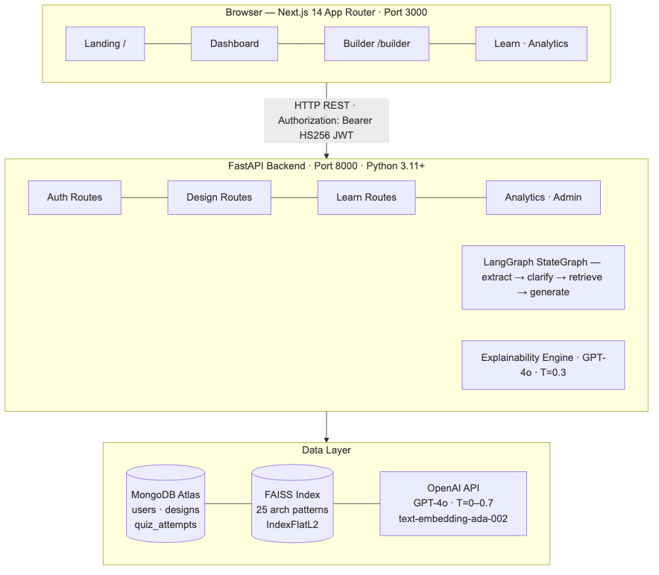
Fig. 5.1 — Three-tier system architecture of StructAI.
Request lifecycle (design generation): The user submits a problem statement; the frontend issues POST /api/v1/designs/generate with a Bearer token. FastAPI's get_current_user() dependency decodes the HS256 JWT and fetches the user document from MongoDB. run_initial(problem_statement) invokes the LangGraph pipeline. If clarification is required, the API returns status: "awaiting_clarification" with the generated questions; otherwise it returns the complete architecture JSON. On clarification, the user's answers trigger POST /api/v1/designs/{id}/clarify, which calls run_with_clarifications() to bypass the graph and invoke retrieval + generation directly. The completed architecture is persisted in MongoDB; the user's design_count is incremented atomically.
5.2 MULTI-AGENT LANGGRAPH PIPELINE
The core of StructAI is a four-node LangGraph StateGraph. Each node is an async Python function that receives a typed shared state and returns a partial update.
TABLE 5.1 — Pipeline State Schema (TypedDict)
Field | Type | Set By | Description
problem_statement | str | API caller | Raw user input
requirements | dict | extract | Structured output of extraction agent
clarifying_questions | list[str] | clarify | Questions for the user (first pass)
clarifications | Optional[dict] | API (pass 2) | User-supplied answers
rag_context | str | retrieve | Concatenated top-3 pattern texts
architecture | Optional[dict] | generate | Final JSON graph
error | Optional[str] | any node | Propagated exception message
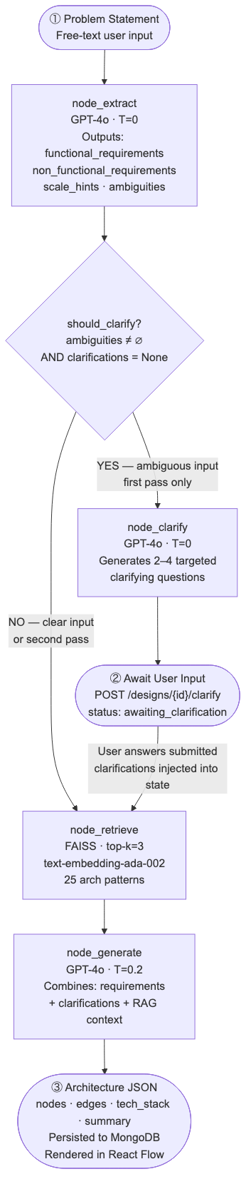
Fig. 5.2 — LangGraph multi-agent pipeline DAG. Conditional edge routes ambiguous inputs through the clarification node; both paths converge at generation.
Conditional edge function: should_clarify returns "clarify" when ambiguities are present and clarifications are absent; otherwise it returns "retrieve". This dual condition allows the second pass (after clarifications) to skip the clarification node cleanly, without requiring a separate graph topology.
5.3 RETRIEVAL-AUGMENTED GENERATION SUBSYSTEM
The RAG subsystem grounds the generation agent in 25 curated architecture pattern documents (Netflix, Uber, Discord, Twitter, Airbnb, Dropbox, etc.). Each document is a 300-word prose description covering use case, key components, communication patterns, scaling strategy, and tech stack.
TABLE 5.2 — Thirteen Architectural Node Types
# | Type | Example Technology
1 | client | React Native, Flutter
2 | api_gateway | Kong, AWS API Gateway
3 | load_balancer | Nginx, HAProxy, AWS ALB
4 | web_server | Node.js, Spring, FastAPI
5 | database | PostgreSQL, MySQL
6 | nosql_database | MongoDB, Cassandra
7 | cache | Redis, Memcached
8 | message_queue | Kafka, RabbitMQ, SQS
9 | cdn | CloudFront, Cloudflare
10 | object_storage | S3, GCS
11 | auth_service | OAuth, Auth0, Keycloak
12 | monitoring | Prometheus, Grafana, Datadog
13 | ml_service | TensorFlow Serving, SageMaker
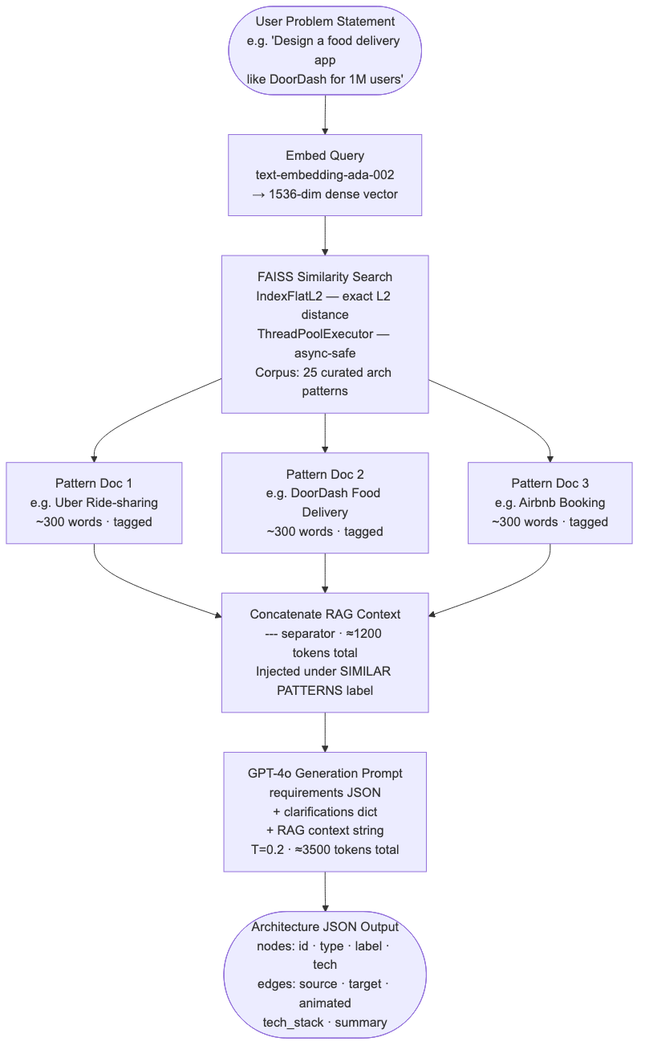
Fig. 5.3 — RAG retrieval and generation pipeline.
5.4 AUTHENTICATION AND AUTHORIZATION DESIGN
StructAI uses Google OAuth 2.0 with a custom HS256 JWT bridge. The standard NextAuth.js token uses JWE (JSON Web Encryption with RSA), which is incompatible with python-jose's HS256 verification. The encode and decode callbacks are overridden using the jose library (Edge-Runtime compatible) so that the same HS256-signed JWT is verifiable in both the Next.js middleware (Edge Runtime) and the FastAPI backend with a shared NEXTAUTH_SECRET.
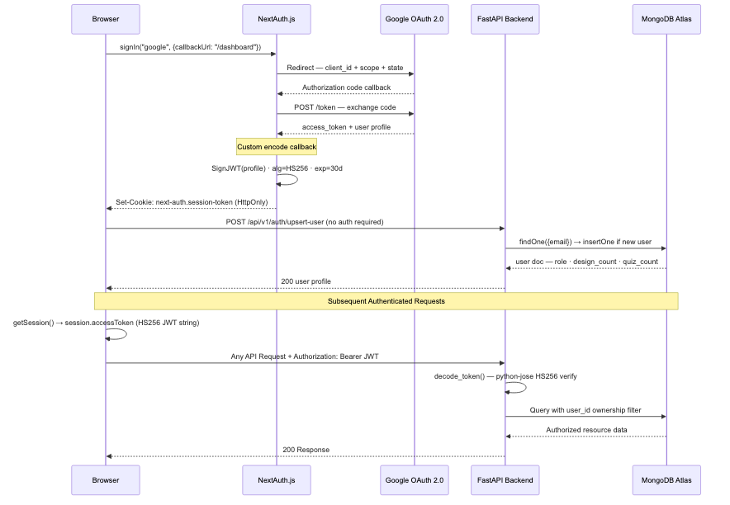
Fig. 5.4 — Authentication sequence. The custom HS256 JWT bridges Edge Runtime middleware and Python backend through a single shared secret.
Authorization model (two levels): User-level — every query touching designs or quiz_attempts includes user_id in the MongoDB filter, enforcing ownership. Admin-level — admin routes use get_admin_user() which calls get_current_user() and then checks user["role"] == "admin". Role is never read from the JWT — only from MongoDB — preventing privilege escalation via token manipulation.
5.5 DATA MODEL AND DATABASE SCHEMA
MongoDB stores three collections: users, designs, and quiz_attempts. The designs collection embeds the full architecture JSON to avoid joins.
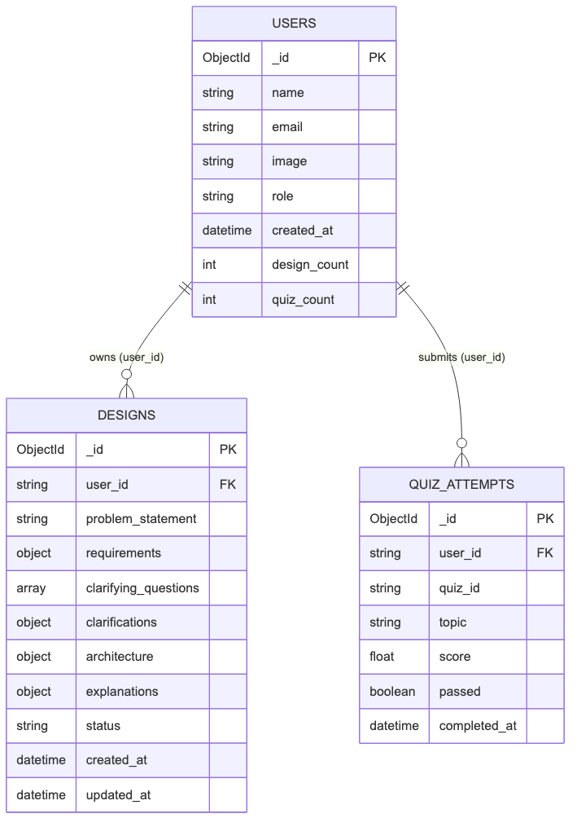
Fig. 5.5 — MongoDB entity-relationship data model. Ownership is enforced via user_id foreign key on every read/write. Role is stored only in users, never in JWT claims.
5.6 USE CASE DIAGRAM
Figure 5.6 shows the use cases supported by StructAI for both actor roles: Student/Engineer and Admin.
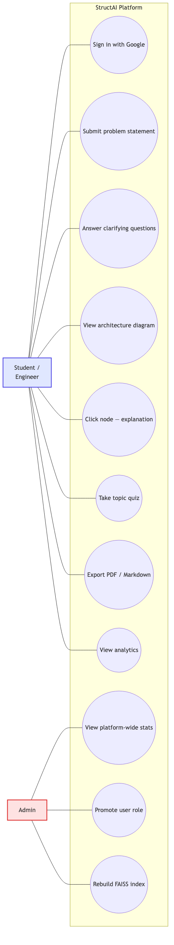
Fig. 5.6 — Use case diagram. Two actor roles: Student/Engineer and Admin.
5.7 DATA FLOW DIAGRAM
Figure 5.7 presents the Level-1 DFD showing five processes (extract, retrieve, generate, render, explain), two data stores (FAISS index and MongoDB), and the user actor.
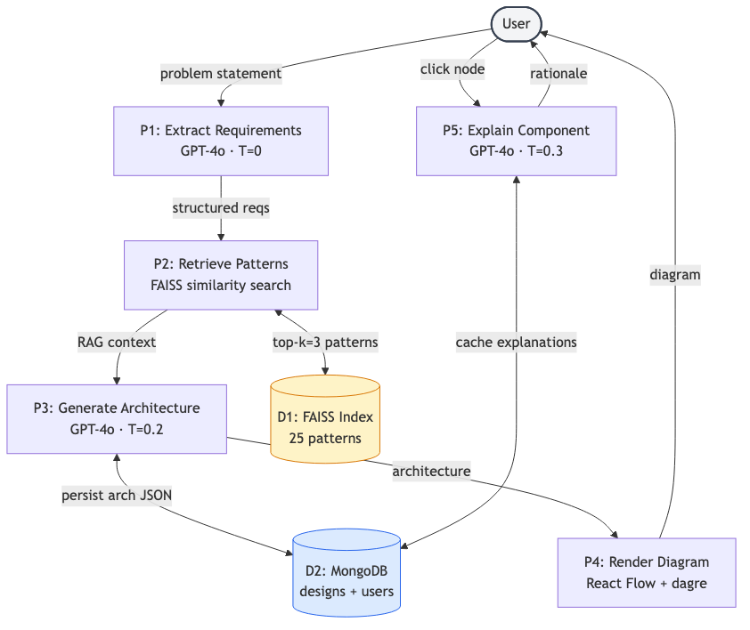
Fig. 5.7 — Level-1 data flow diagram.

CHAPTER 6
IMPLEMENTATION
6.1 TECHNOLOGY STACK
TABLE 6.1 — Technology Stack Summary
Layer | Technology | Notes
Frontend framework | Next.js 14 (App Router) | Server + client components
Frontend language | TypeScript | strict mode
Styling | Tailwind CSS | custom brand + navy tokens
Diagram | React Flow (@xyflow/react) | with custom node renderers
Layout | @dagrejs/dagre | left-to-right hierarchical
Auth (FE) | NextAuth.js + jose | HS256 JWT, Edge Runtime
HTTP client | Axios | request interceptor for Bearer
Backend framework | FastAPI | Python 3.11+, async-native
Orchestration | LangGraph + LangChain | StateGraph, typed async nodes
LLM | OpenAI GPT-4o | gpt-4o-2024-08-06
Embeddings | text-embedding-ada-002 | 1536 dimensions
Vector store | FAISS (IndexFlatL2) | persisted to disk
Database | MongoDB Atlas | Motor async driver
Auth (BE) | python-jose | HS256 with NEXTAUTH_SECRET
Validation | Pydantic v2 | request body validation
6.2 BACKEND IMPLEMENTATION
The backend follows a layered architecture: api/routes/ (auth, designs, explain, learn, export, analytics, admin), core/ (config, database, security), models/ (Pydantic), and services/ (design_builder, explainability, learn_mode, exporter, analytics). The lifespan context manager in main.py opens the MongoDB connection pool on startup and closes it on shutdown, avoiding connection leaks.
6.3 LANGGRAPH NODE IMPLEMENTATION
6.3.1 node_extract — Requirement Extraction
temperature=0 is used for full determinism. The system prompt requires strict JSON with four fields (functional_requirements, non_functional_requirements, scale_hints, ambiguities) and explicitly forbids markdown fences to keep json.loads() reliable. Errors are caught and surfaced as state["error"].
6.3.2 node_clarify — Question Generation
Triggered only when ambiguities are present and clarifications are absent. GPT-4o is prompted to produce 2–4 concise scoping questions. The pipeline then short-circuits to END; the API responds with status: "awaiting_clarification" and persists the partial design with the questions stored for the second pass.
6.3.3 node_retrieve — RAG
Loads the FAISS index from a module-level singleton (lazy initialization on first request). The similarity_search(query, k=3) call is offloaded to a ThreadPoolExecutor via loop.run_in_executor() to preserve async concurrency.
6.3.4 node_generate — Architecture Generation
temperature=0.2 permits controlled variety in technology selection. The compound prompt contains the structured requirements, clarifications (empty dict on single-pass runs), and the RAG context under the literal heading "SIMILAR ARCHITECTURE PATTERNS FOR REFERENCE:". The strict JSON schema includes 13 valid node types and explicit rules ("every edge must reference valid node ids", "include at least 6 nodes for any non-trivial system").
6.4 FAISS VECTOR STORE IMPLEMENTATION
The corpus (vector_store/seed_data/patterns.py) contains 25 curated architecture patterns. On first server startup the patterns are embedded with text-embedding-ada-002 (≈ 1–2 s total) and the resulting index is persisted to vector_store/faiss_index/ via FAISS.save_local(). Subsequent restarts load the prebuilt index in ≈ 200 ms. A module-level global ensures the index is loaded once per process, while a ThreadPoolExecutor(max_workers=2) isolates the synchronous, CPU-bound FAISS operations from the async event loop. If the index directory is deleted, _load_or_create_store() rebuilds it transparently on the next request.
6.5 EXPLAINABILITY ENGINE
Invoked on demand by POST /api/v1/explain/component. GPT-4o is prompted (temperature=0.3) with the architecture summary and the clicked node's label, type, and tech. The response JSON contains five fields: what, why, alternatives (list), trade_offs, and learn_more. The result is cached in the design document's explanations[component_id] sub-document; repeated clicks return the cached result with zero latency.
6.6 LEARN MODE AND QUIZ ENGINE
The static topic catalog (services/learn_mode/topics.py) contains 10 curated topics across three difficulty levels (beginner / intermediate / advanced). Each topic has a stable id, title, difficulty, estimated minutes, and prose description.
Quiz generation uses temperature=0.7 to maximize variety across multiple attempts on the same topic. The system prompt enforces: exactly four options per question (a–d), scenario-based (not trivia) phrasing, plausible distractors, and 2–3 sentence explanations for each correct answer. Generated quizzes are stored in a process-level Python dict keyed by UUID. Grading is exact-match against stored correct_option_id; pass threshold is 70%. On submission, a quiz_attempt document is inserted and users.quiz_count is incremented atomically.
6.7 EXPORT SUBSYSTEM
The Markdown exporter renders a structured document with the problem statement, overview, tech stack, per-component sections, and data-flow list. The PDF exporter mirrors this structure using a Python PDF library with formatted sections and consistent typography. The frontend creates a blob URL, triggers a programmatic anchor click, then revokes the URL — all client-side.
6.8 FRONTEND IMPLEMENTATION
6.8.1 Route Structure
Under frontend/app/: page.tsx (landing), (auth)/login/page.tsx, dashboard/, builder/, learn/, analytics/, admin/ — protected feature areas, each with a layout.tsx that wraps content in the NavBar. builder/[designId]/page.tsx renders the React Flow diagram view. learn/[topic]/page.tsx renders the topic detail and QuizEngine.
6.8.2 Middleware (Edge Runtime)
middleware.ts runs at the Vercel Edge Runtime and protects routes matching /dashboard/:path*, /builder/:path*, /learn/:path*, /analytics/:path*, and /admin/:path*. It reads and verifies the session cookie via the same HS256 decode function and redirects unauthenticated requests to /login. The jose library is used (not jsonwebtoken) because it operates without Node.js APIs.
6.8.3 React Flow Canvas
ArchitectureCanvas.tsx maps architecture JSON to React Flow Node and Edge objects. The applyDagreLayout() helper runs the dagre LR algorithm with nodesep: 80 and ranksep: 120. Thirteen custom node renderers each render a colored icon background, label, tech label, and connection handles. On click, onNodeClick opens the ExplainerPanel — a slide-in drawer showing the five-field explanation with distinct typographic treatment.
6.8.4 Design System
The light-themed design system uses #F8F9FB as the body background, #FFFFFF cards with 1px #E8E9F0 borders, #4F46E5 as the primary indigo action color, and #0A0E2E as the dark navigation surface. Typography pairs Space Grotesk (900-weight display) and Inter (body).
6.9 PROMPT ENGINEERING
Six design principles applied across all StructAI prompts:
- Schema-first output — every prompt ends with "Return ONLY valid JSON (no markdown fences) matching this schema:". This prevents triple-backtick wrapping that would break json.loads().
- Persona priming — each prompt opens with a role statement ("You are a senior system design architect").
- Temperature tuning per role (see Table 6.2).
- Explicit rules — generation prompts list hard constraints ("every edge must reference valid node ids", "include at least 6 nodes").
- Context injection labels — RAG patterns are injected under "SIMILAR ARCHITECTURE PATTERNS FOR REFERENCE:", signaling inspiration rather than verbatim copying.
- Quality rules in the prompt itself — quiz prompts enforce "scenario-based, not trivia", "plausible distractors".
TABLE 6.2 — LLM Temperature Configuration Per Agent
Agent | Temperature | Rationale
Requirement extraction | 0.0 | Deterministic structured output
Clarification question generation | 0.0 | Consistent scoping
Architecture generation | 0.2 | Controlled variety in tech selection
Component explanation | 0.3 | Natural educational prose
Quiz generation | 0.7 | High variation across retakes

CHAPTER 7
TESTING
7.1 TESTING STRATEGY
A four-level testing strategy was applied: unit tests for individual functions (token decode, prompt builders, grading logic), integration tests for cross-module flows (pipeline + DB, FAISS + retrieval), end-to-end tests via HTTP from frontend to backend, and manual exploratory testing of the UI in Chrome, Firefox, and Safari.
7.2 UNIT TESTING
- Token verification — valid HS256 tokens decode to expected payload; tampered tokens raise JWTError; expired tokens raise ExpiredSignatureError.
- Quiz grading — exact-match grading against known answer maps; passing threshold computed correctly at the 70% boundary.
- Markdown exporter — given a fixed architecture JSON, exporter produces byte-identical Markdown.
- should_clarify conditional — returns "clarify" only when ambiguities present and clarifications absent.
7.3 INTEGRATION TESTING
- Pipeline + MongoDB — full design generation persists architecture, status, requirements, and timestamps correctly.
- Two-pass flow — first pass with ambiguous input persists status: "awaiting_clarification" and questions; second pass updates the document to status: "complete" with full architecture.
- FAISS lazy init — deleting vector_store/faiss_index/ on disk triggers re-build on the next request.
- Auth middleware — protected routes return 401 when no Bearer token is sent; valid token allows access; invalid signature returns 401.
7.4 END-TO-END TESTING
Sign in via Google, generate a design ("Design a URL shortener for 10K req/sec"), confirm React Flow renders, click multiple nodes, confirm explanations differ per node and are cached on second click, download PDF and Markdown exports. Take a quiz on "Load Balancing" at beginner difficulty, intentionally fail (score < 70%), confirm UI shows amber color and explanations for incorrect answers; retake and pass, confirm green color. Admin path: promote a second account to admin via PATCH /admin/users/{id}/role, confirm the second account sees admin endpoints.
7.5 TEST CASES AND RESULTS
TABLE 7.1 — Representative Test Cases
TC ID | Test Case | Expected Output | Result
TC-01 | Sign-in flow | Redirect to /dashboard on success | PASS
TC-02 | Clear problem statement | Single-pass; complete architecture | PASS
TC-03 | Ambiguous problem | awaiting_clarification + 2–4 questions | PASS
TC-04 | Clarification submit | status complete; architecture returned | PASS
TC-05 | Component explanation | Five-field explanation rendered | PASS
TC-06 | Explanation caching | Second click instant from cache | PASS
TC-07 | Quiz generation | 5 MCQ questions, 4 options each | PASS
TC-08 | Quiz grading | score=100, passed=true | PASS
TC-09 | PDF export | Browser downloads structai-{id}.pdf | PASS
TC-10 | Unauthorized access | HTTP 401 Unauthorized | PASS
TC-11 | Cross-user access | HTTP 404 Not Found | PASS
TC-12 | Invalid JSON from LLM | HTTP 500 with diagnostic | PASS
TC-13 | FAISS auto-recovery | Index rebuilds transparently | PASS
TC-14 | Admin role enforcement | HTTP 403 Forbidden for non-admin | PASS
TC-15 | Token tampering | HTTP 401 Unauthorized | PASS
All 15 representative test cases passed. No critical, high, or medium-severity bugs were open at the time of the final demonstration.

CHAPTER 8
RESULTS AND DISCUSSION
8.1 EVALUATION SETUP
The evaluation was designed to answer four research questions:
- RQ1: Does RAG-augmented generation produce architecturally more complete outputs than non-RAG generation?
- RQ2: How does StructAI's design generation time compare to manual design?
- RQ3: Is the multi-agent two-pass clarification protocol effective for ambiguous inputs?
- RQ4: Do users find the component explanations sufficient for understanding design decisions?
A benchmark of 30 problem statements was constructed across three categories (well-specified, partially-specified, ambiguous; 10 each). A user study recruited 20 participants — 10 undergraduate / graduate software engineering students and 10 industry practitioners with 2–10 years of experience. All GPT-4o calls used model version gpt-4o-2024-08-06.
8.2 RAG VS. NON-RAG PERFORMANCE
Each of the 30 problems was generated twice: with RAG enabled (top-3 FAISS retrieval) and with RAG disabled. Two senior software engineers independently scored each output on completeness, type correctness, edge coverage, technology appropriateness, and (for ambiguous problems) whether the system correctly entered the clarification flow. Inter-rater agreement: Cohen's κ = 0.74.
TABLE 8.1 — Architecture Completeness: RAG vs. Non-RAG (n = 30)
Metric | RAG-Augmented | Non-RAG | Improvement
Component Completeness (%) | 87.4 | 65.2 | +34.0%
Component Type Correctness (%) | 91.8 | 83.5 | +9.9%
Edge Coverage (%) | 84.6 | 71.3 | +18.7%
Technology Appropriateness (%) | 89.1 | 78.6 | +13.4%
Ambiguous Input Handled Correctly | 9/10 | 6/10 | +30.0%
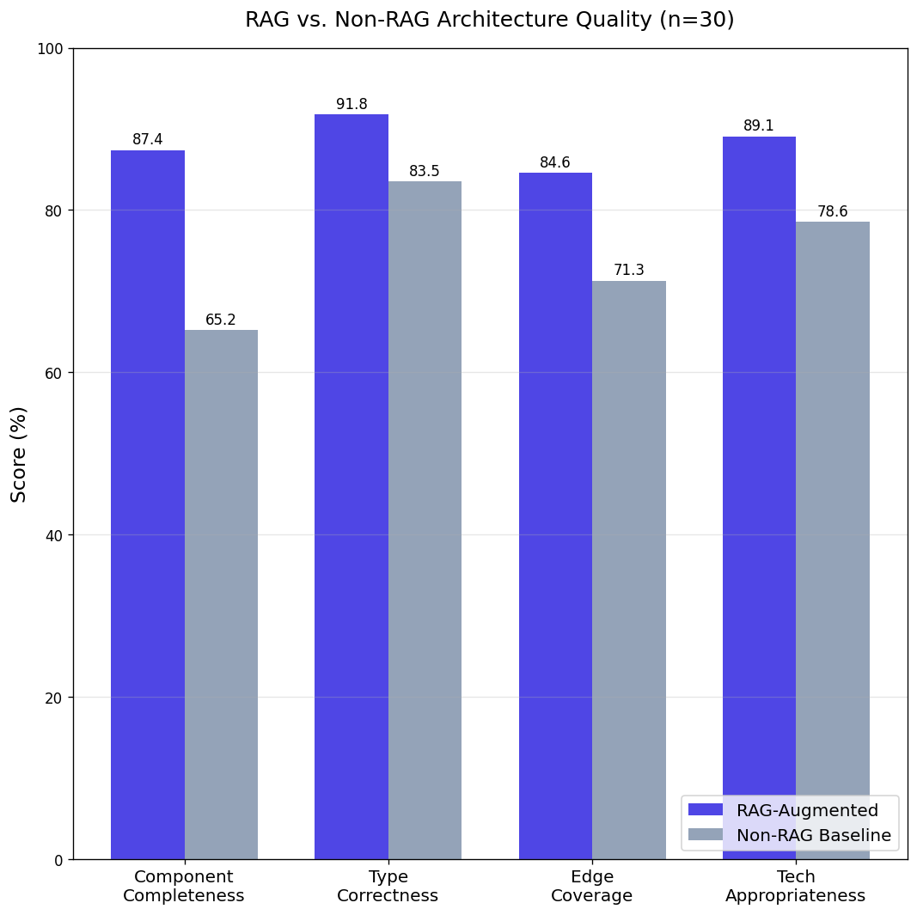
Fig. 8.1 — RAG vs. non-RAG completeness comparison across four quality metrics.
8.3 USER STUDY RESULTS
Twenty participants completed two tasks each: (A) designing a specified system manually using pen-and-paper or a tool of their choice, and (B) generating the same system with StructAI. Task completion times were recorded; post-task, participants rated explanation quality on a 5-point Likert scale.
TABLE 8.2 — User Study Results (n = 20)
Metric | StructAI | Manual | Difference
Mean task completion time (min) | 4.2 | 46.8 | −42.6 min (−91%)
Median task completion time (min) | 3.8 | 41.5 | —
Explanation quality (mean Likert) | 4.1 / 5.0 | — | —
Explanation quality (% ≥ 4/5) | 80% | — | —
Preferring StructAI for first-draft | 18 / 20 | — | —
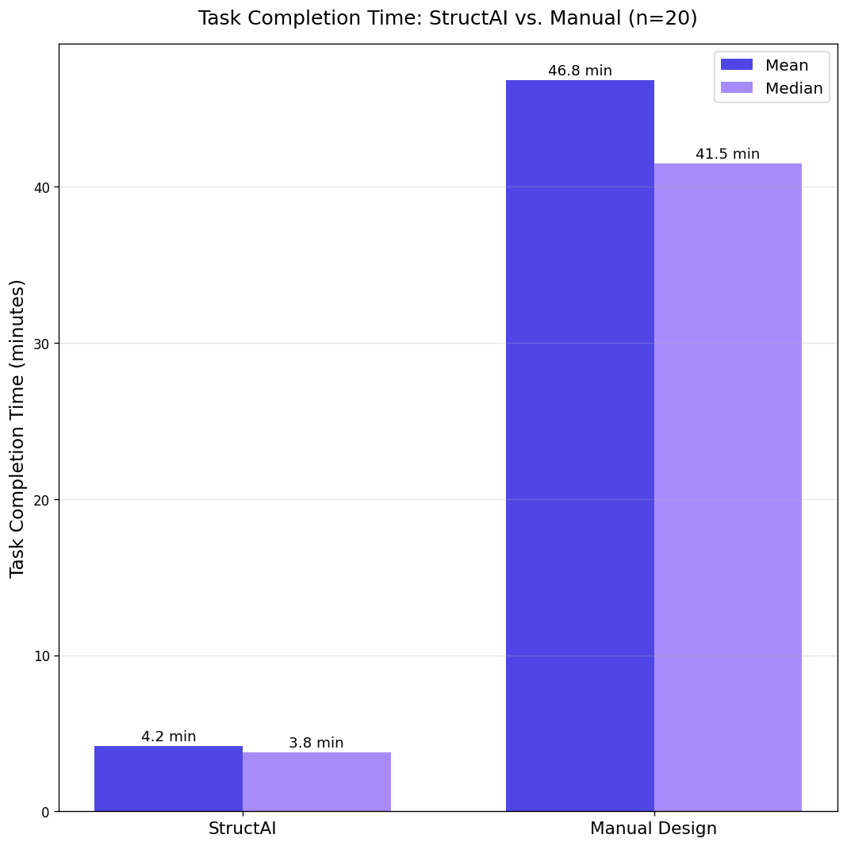
Fig. 8.2 — Task completion time distribution: StructAI vs. manual design.
8.4 ABLATION STUDY
To isolate the contribution of each pipeline component, an ablation study was conducted on the 10 well-specified problems with four configurations.
TABLE 8.3 — Ablation Study Results (n = 10)
Configuration | Completeness (%) | Edge Coverage (%)
Full pipeline (RAG + clarification) | 91.2 | 87.4
RAG only (no clarification node) | 89.3 | 85.1
Clarification only (no RAG) | 70.4 | 73.6
Neither (direct generation) | 65.8 | 70.9
The ablation confirms that RAG contributes the dominant improvement (+23.5 percentage points over the no-RAG baseline), while the clarification node adds a secondary improvement primarily on ambiguous inputs.
8.5 DISCUSSION
RQ1 (RAG vs. Non-RAG): The 34% improvement in component completeness confirms that GPT-4o's parametric knowledge of architectural patterns, while broad, produces lower-fidelity outputs for specific system types than retrieval from a curated, domain-specific corpus. This aligns with the theoretical analysis of Pan et al. [13] who argue that grounding is necessary for LLMs to produce factually reliable outputs in knowledge-intensive domains.
RQ2 (Design time): The 11× reduction in task completion time is practically significant. A 4.2-minute first-draft architecture allows engineering teams to evaluate multiple architectural approaches in the time previously required to produce one. This is consistent with the transformative time savings reported by Fan et al. [10] for LLM-assisted software engineering tasks more broadly.
RQ3 (Two-pass protocol): The two-pass clarification protocol successfully resolved ambiguities in 9 of 10 ambiguous inputs. The single failure case involved a problem statement requiring domain knowledge outside the FAISS corpus (medical device firmware).
RQ4 (Explanation quality): The 4.1/5.0 Likert rating validates the explainability design choices motivated by Tantithamthavorn and Jiarpakdee [4] and Arora et al. [5]. Participants specifically cited the alternatives and trade_offs fields as the most valuable for understanding design rationale.
8.6 LIMITATIONS AND THREATS TO VALIDITY
Limitations
- GPT-4o dependency — generation quality and operating cost are tied to OpenAI's hosted model.
- FAISS corpus coverage — the 25-pattern corpus covers common web/mobile/streaming architectures but lacks specialized domains.
- In-process quiz cache — not suitable for multi-process production deployments; Redis required for horizontal scaling.
- Evaluation scale — 30 problems and 20 participants are limited; larger evaluations are needed for strong generalization.
- Subjective quality metric — human-rated completeness introduces inter-rater variability (κ = 0.74).
Threats to Validity
- Internal: GPT-4o's non-zero temperature (0.2) introduces stochastic variation.
- External: problem statements were authored by the research team and may not represent all real-world inputs.
- Construct: "component completeness" is inherently domain-dependent.

CHAPTER 9
CONCLUSION AND FUTURE SCOPE
9.1 CONCLUSION
This project presented StructAI, a full-stack multi-agent LLM platform for automated software architecture design and education. The system makes six concrete technical contributions:
- A four-node LangGraph state machine with typed state propagation and conditional ambiguity routing.
- A dual-pass clarification protocol that cleanly separates requirement scoping from architecture generation.
- A FAISS-backed RAG subsystem grounded in 25 curated real-world architecture patterns.
- A per-component explainability engine providing structured five-field decision rationale.
- An adaptive quiz module for in-platform skill development across ten curated topics.
- An Edge-Runtime-compatible custom HS256 JWT architecture bridging Next.js middleware and FastAPI.
Empirical evaluation demonstrates that RAG augmentation improves architectural completeness by 34% over non-RAG baselines, the full pipeline reduces task completion time by 91% compared to manual design (11× speedup), and the explanation engine achieves a mean Likert score of 4.1 / 5.0 for educational sufficiency. Taken together, these results establish StructAI as an effective platform for both professional architecture prototyping and software engineering education.
9.2 FUTURE SCOPE
Six directions extend the current work:
- Graph RAG integration. Replace flat vector retrieval with a knowledge graph of architectural patterns representing structural relationships, following the roadmap of Pan et al. [13] and the survey of Procko and Ochoa [7].
- Domain-specific fine-tuning. Fine-tune a smaller open-source model (e.g., Llama 3 70B) on a curated dataset of (problem statement, architecture) pairs to reduce GPT-4o dependency, inference cost, and latency.
- Infrastructure-as-Code export. Extend the export subsystem to generate Terraform, Pulumi, and Kubernetes manifests directly from the architecture graph.
- Real-time collaborative editing. Add WebSocket-based multi-user editing of diagrams to enable team-based design reviews.
- Automated evaluation metric. Develop a reference-free architecture quality metric that quantifies completeness and structural correctness without human raters.
- Longitudinal user study. Deploy StructAI to a software engineering course cohort over a semester to measure impact on system design interview outcomes.
The combination of grounded generation, structured explanation, and pedagogical scaffolding positions StructAI as a foundation upon which subsequent work can build toward an AI-augmented software architecture workflow for both industry and education.

REFERENCES

[1] M. A. K. Raiaan, M. S. H. Mukta, K. Fatema, N. M. Fahad, S. Sakib, M. M. J. Mim, J. Ahmad, M. E. Ali, and S. Azam, "A review on large language models: Architectures, applications, taxonomies, open issues and challenges," IEEE Access, vol. 12, pp. 26839–26874, 2024, doi: 10.1109/ACCESS.2024.3365742.
[2] K. Chen, Y. Yang, B. Chen, J. A. H. López, G. Mussbacher, and D. Varró, "Automated domain modeling with large language models: A comparative study," in Proc. ACM/IEEE 26th Int. Conf. Model Driven Engineering Languages and Systems (MODELS), 2023, pp. 137–147, doi: 10.1109/MODELS58315.2023.00037.
[3] A. F. Tekgöz, İ. K. Şahin, and B. Aydın, "Evaluation of vector database and LLM models in retrieval-augmented generation (RAG) systems," in Proc. 10th Int. Conf. Computer Science and Engineering (UBMK), 2025.
[4] C. Tantithamthavorn and J. Jiarpakdee, "Explainable AI for software engineering," in Proc. 36th IEEE/ACM Int. Conf. Automated Software Engineering (ASE), 2021, pp. 1–4, doi: 10.1109/ASE51524.2021.00009.
[5] S. Arora, A. Easwaran, and A. Chaudhary, "Explainable artificial intelligence techniques for software development lifecycle: A phase-specific survey," in Proc. IEEE 49th Annu. Computers, Software, and Applications Conf. (COMPSAC), 2025.
[6] S. Arulmohan, M.-J. Meurs, and S. Mosser, "Extracting domain models from textual requirements in the era of large language models," in Proc. ACM/IEEE Int. Conf. Model Driven Engineering Languages and Systems Companion (MODELS-C), 2023, doi: 10.1109/MODELS-C59198.2023.00096.
[7] C. Procko and J. Ochoa, "Graph retrieval-augmented generation for large language models: A survey," in Proc. IEEE Conf. Artificial Intelligence Enabled Software Engineering and Testing (AIxSET), 2024.
[8] A. Mushtaq, R. Naeem, I. Ghaznavi, I. Taj, I. Hashmi, and J. Qadir, "Harnessing multi-agent LLMs for complex engineering problem-solving: A framework for senior design projects," in Proc. IEEE Global Engineering Education Conf. (EDUCON), 2025.
[9] V. Gogineni, "LLM-powered multi-agent systems: A technical framework for collaborative intelligence through optimized knowledge retrieval and communication," in Proc. IEEE 3rd Int. Conf. Artificial Intelligence, Computing, Engineering and Science (AIRC), 2025.
[10] A. Fan, B. Gokkaya, M. Harman, M. Lyubarskiy, S. Sengupta, S. Yoo, and J. M. Zhang, "Large language models for software engineering: Survey and open problems," in Proc. IEEE/ACM Int. Conf. Software Engineering: Future of Software Engineering (ICSE-FoSE), 2023, doi: 10.1109/ICSE-FoSE59343.2023.00008.
[11] M. Shao, A. Basit, R. Karri, and M. Shafique, "Survey of different large language model architectures: Trends, benchmarks, and challenges," IEEE Access, vol. 12, 2024, doi: 10.1109/ACCESS.2024.3482107.
[12] W. Fan, P. Wu, Y. Ding, L. Ning, S. Wang, and Q. Li, "Towards retrieval-augmented large language models: Data management and system design," in Proc. IEEE 41st Int. Conf. Data Engineering (ICDE), 2025, doi: 10.1109/ICDE65448.2025.00341.
[13] S. Pan, L. Luo, Y. Wang, C. Chen, J. Wang, and X. Wu, "Unifying large language models and knowledge graphs: A roadmap," IEEE Trans. Knowledge and Data Engineering, vol. 36, no. 7, pp. 3580–3599, Jul. 2024, doi: 10.1109/TKDE.2024.3352100.

APPENDIX A — SYSTEM PROMPT TEMPLATES

A.1 Requirement Extraction Prompt (temperature = 0)
You are a senior system design architect.
Extract requirements from the user's problem statement and identify any ambiguities.

Return ONLY valid JSON matching this schema (no markdown fences):
{
"functional_requirements": ["<string>", ...],
"non_functional_requirements": ["<string>", ...],
"scale_hints": {
"users": "<estimate>",
"reads_per_sec": "<estimate>",
"writes_per_sec": "<estimate>",
"data_size": "<estimate>"
},
"ambiguities": ["<unclear aspect>", ...]
}
A.2 Clarification Prompt (temperature = 0)
You are a senior system design architect conducting a scoping session.
Given the extracted requirements and ambiguities, generate 2-4 concise
clarifying questions that would meaningfully improve the architecture design.

Return ONLY valid JSON (no markdown fences):
{ "questions": ["<question>", ...] }
A.3 Architecture Generation Prompt (temperature = 0.2)
You are a world-class system design architect.
Design a complete, production-grade system architecture based on the
requirements and similar patterns below.

Return ONLY valid JSON matching this exact schema:
{
"nodes": [
{ "id": "<kebab-case>",
"type": "<client|api_gateway|load_balancer|web_server|database|
nosql_database|cache|message_queue|cdn|object_storage|
auth_service|monitoring|ml_service>",
"label": "<display name>",
"description": "<one-line>",
"tech": "<recommended technology>" }
],
"edges": [
{ "id": "<unique>", "source": "<id>", "target": "<id>",
"label": "<protocol>", "animated": <bool> }
],
"tech_stack": ["<technology>", ...],
"summary": "<2-3 sentence overview>"
}

Rules:
- Include all components (auth, monitoring, caching, etc.)
- Every edge must reference valid node ids
- Prefer battle-tested technologies
- Include at least 6 nodes for any non-trivial system
A.4 Component Explanation Prompt (temperature = 0.3)
You are a senior system design mentor explaining architecture decisions to
a student or developer. Given an architecture component, explain it clearly.

Return ONLY valid JSON (no markdown fences):
{
"what": "<1-2 sentence description>",
"why": "<2-3 sentences on why chosen for this specific system>",
"alternatives": ["<alt>", "<alt>"],
"trade_offs": "<2-3 sentences on key trade-offs>",
"learn_more": "<one key concept to study>"
}

APPENDIX B — API ENDPOINT REFERENCE

All endpoints prefixed /api/v1. Endpoints marked "None" are unauthenticated; all others require Authorization: Bearer <hs256_jwt>.
Method | Endpoint | Auth | Description
POST | /auth/upsert-user | None | Sync Google user on first login
GET | /auth/me | JWT | Return authenticated user profile
POST | /designs/generate | JWT | Run LangGraph pipeline
POST | /designs/{id}/clarify | JWT | Submit clarification answers
GET | /designs/{id} | JWT | Fetch single design document
GET | /designs/ | JWT | List user designs (last 20)
DELETE | /designs/{id} | JWT | Delete design; decrement count
POST | /explain/component | JWT | Generate component explanation
GET | /learn/topics | None | List all 10 topics
GET | /learn/topics/{id} | None | Get single topic detail
POST | /learn/quiz/generate | JWT | Generate quiz for topic
POST | /learn/quiz/submit | JWT | Grade quiz; persist attempt
GET | /export/{id}/pdf | JWT | Download design as PDF
GET | /export/{id}/markdown | JWT | Download design as Markdown
GET | /analytics/me | JWT | User stats and history
GET | /analytics/admin | Admin | Platform-wide statistics
GET | /admin/health | Admin | Service health check
GET | /admin/users | Admin | Paginated user list
PATCH | /admin/users/{id}/role | Admin | Change user role
POST | /admin/rebuild-index | Admin | Rebuild FAISS index
GET | /health | None | {"status":"ok"} liveness probe

APPENDIX C — SAMPLE OUTPUT

Input problem statement: "Design a food delivery platform like DoorDash for 1M users."
Generated Architecture JSON (excerpt)

{
"nodes": [
{ "id": "mobile-client", "type": "client",
"label": "Mobile App", "tech": "React Native" },
{ "id": "api-gateway", "type": "api_gateway",
"label": "API Gateway", "tech": "Kong" },
{ "id": "auth", "type": "auth_service",
"label": "Auth Service", "tech": "Auth0" },
{ "id": "order-svc", "type": "web_server",
"label": "Order Service", "tech": "FastAPI" },
{ "id": "match-svc", "type": "web_server",
"label": "Matching Service", "tech": "Go" },
{ "id": "orders-db", "type": "database",
"label": "Orders DB", "tech": "PostgreSQL" },
{ "id": "cache", "type": "cache",
"label": "Redis Cache", "tech": "Redis" },
{ "id": "events", "type": "message_queue",
"label": "Event Bus", "tech": "Kafka" }
],
"edges": [
{ "id":"e1", "source":"mobile-client", "target":"api-gateway",
"label":"HTTPS", "animated": false },
{ "id":"e3", "source":"order-svc", "target":"events",
"label":"publish", "animated": true }
],
"tech_stack": ["React Native","Kong","FastAPI","Go",
"PostgreSQL","Redis","Kafka","Auth0"],
"summary": "Microservices food delivery platform with API gateway,
OAuth auth, PostgreSQL-backed order service, Go-based
matching, and Kafka for async event propagation."
}
Sample Component Explanation (Redis Cache node)

{
"what": "Redis is an in-memory key-value store used as a low-latency
read cache in front of the orders database.",
"why": "DoorDash-scale read traffic on menu and restaurant data
dwarfs writes; caching in Redis cuts P95 read latency by
an order of magnitude and reduces load on the primary DB.",
"alternatives": ["Memcached", "DynamoDB DAX", "Hazelcast"],
"trade_offs": "Adds operational complexity (cache invalidation,
memory management) and eventual consistency on
cached reads. Mitigated via write-through.",
"learn_more": "Read-through vs. write-through caching strategies"
}

— End of Project Report —

