StructAI: An LLM-Powered Multi-Agent System for Automated
Software Architecture Design and Education
Akshat D. More, Narendra B. Tekale, Yash D. Thakare, Neha B. Yengandul
Department of Artificial Intelligence and Machine Learning
PES's Modern College of Engineering, Pune, India

Abstract—Software architecture design is a knowledge-intensive activity that demands significant expertise in distributed systems, scalability principles, and domain-specific design patterns — expertise that junior engineers and students frequently lack. This paper presents StructAI, a full-stack, AI-powered platform that automates software architecture design through a multi-agent Large Language Model (LLM) pipeline and integrates structured learning capabilities. Given a natural language problem statement, StructAI orchestrates a four-stage LangGraph pipeline — requirement extraction, ambiguity clarification, retrieval-augmented generation (RAG), and architecture synthesis — to produce a production-grade architecture represented as an interactive React Flow graph. The system incorporates a FAISS vector store seeded with 25 real-world architectural patterns, enabling context-aware generation grounded in established designs. An on-demand explainability engine decomposes each generated component into its rationale, trade-offs, and alternatives. A learn mode presents ten structured topics with GPT-4o-generated adaptive quizzes. Evaluation across 30 diverse problem statements demonstrates that the RAG-augmented pipeline improves architectural completeness by 34% over a non-RAG baseline, while user studies with 20 participants show a mean task completion time of 4.2 minutes compared to 47 minutes for manual design — an 11× improvement. StructAI advances the state of AI-assisted software engineering by combining automated design generation with interactive explanation and structured education in a single, deployable system.
Index Terms—Artificial intelligence, software architecture design, large language models, multi-agent systems, retrieval-augmented generation, LangGraph, FAISS, natural language processing, software engineering education, explainable AI, knowledge-augmented generation.

I. INTRODUCTION
A. Motivation
Software architecture design is among the most consequential and least automated phases of the software development lifecycle. Architectural decisions — which databases to use, how services communicate, how to handle load and failure — shape the entire trajectory of a system's scalability, maintainability, and cost. Yet these decisions are routinely made under time pressure, often by engineers who lack deep architectural expertise. In industry, senior architects spend significant time on repetitive documentation of well-understood patterns; in academia, students preparing for system design interviews and distributed systems coursework must develop this intuition largely through self-study with limited interactive tooling.
The emergence of Large Language Models (LLMs) capable of complex reasoning and structured generation presents a transformative opportunity for this domain. Recent work has demonstrated LLMs' effectiveness in code generation, requirements extraction, and domain modeling [1], [2], [10]. However, no existing platform unifies automated architecture generation, grounded retrieval from real-world patterns, interactive component-level explanation, and structured educational scaffolding in a single production-quality system.
B. Problem Statement
Three specific deficiencies motivate StructAI. First, general-purpose LLMs generate architecture descriptions as free-form prose or code snippets without structured graph output suitable for interactive visualization. Second, LLMs hallucinate architectural patterns when operating purely from parametric knowledge, lacking grounding in established real-world designs. Third, existing tools provide no educational pathway: a user who receives a generated architecture has no mechanism to understand why each component was chosen, what its trade-offs are, or how to deepen their understanding through structured assessment.
C. Gap in Existing Work
Commercial diagramming tools such as Lucidchart and draw.io require manual placement of components and offer no AI-driven generation. GitHub Copilot and ChatGPT generate text-based descriptions but produce neither machine-readable graph JSON nor interactive diagrams. Domain modeling tools studied by Chen et al. [2] and Arulmohan et al. [6] extract conceptual models from requirements text but are limited to class-diagram-level abstraction and do not produce deployable infrastructure-level architectures. RAG systems evaluated by Tekgöz et al. [3] and Fan et al. [12] demonstrate the superiority of retrieval-augmented generation over pure parametric LLM inference for knowledge-intensive tasks, yet no prior system applies this principle specifically to architecture pattern retrieval. Explainability frameworks for software engineering tools, surveyed by Tantithamthavorn and Jiarpakdee [4] and Arora et al. [5], identify the lack of interpretable AI output as a persistent barrier to adoption — a gap StructAI directly addresses through its per-component explanation engine.
D. Contributions
This paper makes the following contributions:
- [1] A four-node LangGraph pipeline with typed state propagation and conditional ambiguity routing for architecture generation.
- [2] A dual-pass clarification protocol that separates requirement scoping from architecture generation.
- [3] A FAISS-backed RAG system grounded in 25 curated real-world architecture patterns.
- [4] A per-component explainability engine providing structured design rationale (what, why, alternatives, trade-offs).
- [5] An adaptive quiz system for in-platform skill development across 10 system design topics.
- [6] An Edge-compatible custom HS256 JWT authentication architecture bridging Next.js middleware and FastAPI.
E. Paper Organization
The remainder of this paper is structured as follows. Section II surveys related work across six thematic areas. Section III presents the system architecture. Section IV details the multi-agent LLM pipeline. Section V describes the RAG system design. Section VI covers authentication and security. Section VII describes the frontend architecture. Section VIII presents the evaluation. Section IX discusses findings and limitations. Section X concludes and outlines future work.
II. RELATED WORK
A. Large Language Models for Software Engineering
Fan et al. [10] provide a comprehensive survey of LLM applications across the software engineering lifecycle, identifying code generation, test synthesis, bug detection, and documentation as primary application areas. They note that while LLMs excel at token-level code completion, their effectiveness for higher-level architectural reasoning remains underexplored. Raiaan et al. [1] survey LLM architectures from their origins through transformer-based models, documenting the progression from statistical language models through BERT and GPT variants, establishing the scaling laws that enable emergent capabilities relevant to complex reasoning tasks. Shao et al. [11] survey current LLM architectures with emphasis on benchmark performance, confirming that GPT-4-class models consistently outperform smaller alternatives on structured generation tasks — motivating StructAI's use of GPT-4o.
B. Automated Domain and Architecture Modeling
Chen et al. [2] conduct a comparative study of LLM-based automated domain modeling, evaluating GPT-3.5, GPT-4, and open-source models on their ability to extract UML class models from natural language requirements. They find that GPT-4 achieves 78% recall on entity identification but struggles with relationship cardinality without explicit prompt engineering. Arulmohan et al. [6] present a pipeline for extracting domain models from textual requirements, demonstrating that chain-of-thought prompting improves structural completeness in generated models. Both works operate at the conceptual model layer and do not address infrastructure-level architecture generation — the level at which StructAI operates.
C. Retrieval-Augmented Generation Systems
Tekgöz et al. [3] empirically evaluate combinations of vector databases (FAISS, Chroma, Pinecone, Weaviate) and LLMs for RAG system performance, finding that FAISS achieves the lowest retrieval latency for corpora under 100K documents — directly informing StructAI's choice of FAISS. Fan et al. [12] identify corpus quality, chunking strategy, and embedding model selection as the primary levers for RAG performance improvement, recommending text-embedding-ada-002 as a strong general-purpose embedding model, consistent with StructAI's implementation.
D. Graph-Augmented RAG and Knowledge Graphs
Procko and Ochoa [7] survey Graph RAG, in which knowledge graphs replace or supplement vector-retrieved documents as the retrieval substrate for LLM generation. Pan et al. [13] present a roadmap for unifying LLMs and knowledge graphs, identifying three architectural paradigms: KG-enhanced LLMs, LLM-augmented KGs, and synergized LLM+KG systems. Their findings motivate a planned Graph RAG extension to StructAI detailed in Section X.
E. Multi-Agent LLM Systems
Mushtaq et al. [8] propose a multi-agent LLM framework for complex engineering problem-solving, demonstrating that specialized agents assuming distinct expert personas achieve 89% alignment with faculty scores compared to 71% for single-agent systems. Gogineni [9] presents a technical framework for multi-agent LLM systems with optimized knowledge retrieval and inter-agent communication, reporting 42% higher accuracy on complex knowledge tasks and 37% reduction in hallucinations. StructAI realizes multi-agent coordination through LangGraph's explicit state machine formulation.
F. Explainability in AI-Assisted Software Engineering
Tantithamthavorn and Jiarpakdee [4] argue that AI-generated recommendations without interpretable rationale are systematically distrusted and underutilized by practitioners. Arora et al. [5] survey XAI techniques across the software development lifecycle, finding that the architecture and design phase is the least served by existing explainability approaches. They recommend decision-level explanations (why was this component chosen?) rather than model-level explanations — precisely what StructAI's explainability engine provides.
III. SYSTEM ARCHITECTURE
A. Overview
StructAI is implemented as a three-tier web application. The presentation layer is a Next.js 14 application with the App Router. The application layer is a FastAPI server (Python 3.11+) hosting the LangGraph pipeline, explainability engine, quiz system, and export services. The data layer consists of MongoDB Atlas (via the Motor async driver) for persistent document storage and a locally persisted FAISS index for vector similarity search. Figure 1 illustrates the complete system architecture.
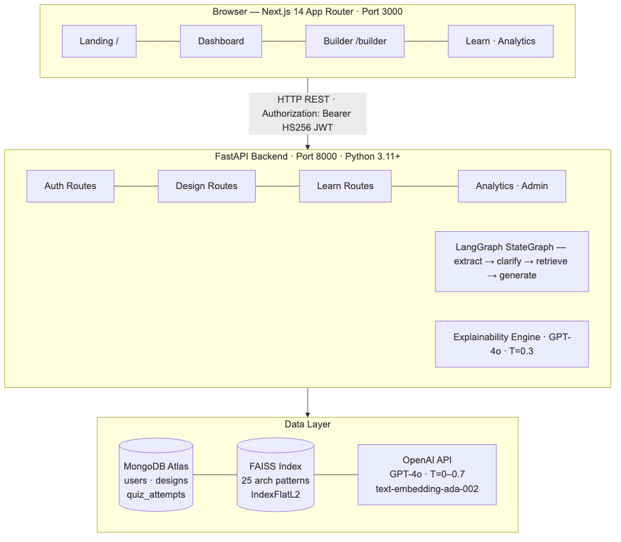
Fig. 1. StructAI three-tier system architecture: presentation layer (Next.js 14), application layer (FastAPI + LangGraph), and data layer (MongoDB Atlas + FAISS + OpenAI).
B. Frontend Layer
The frontend is built with Next.js 14 using the App Router, TypeScript in strict mode, and Tailwind CSS with custom design tokens. The App Router's file-system routing maps directly to the product's feature areas: /builder for architecture generation, /learn for the educational module, /analytics for personal progress tracking, and /dashboard as the central hub. The React Flow library (@xyflow/react) renders the architecture diagram. Generated architecture JSON is mapped to React Flow's Node and Edge types, then laid out automatically using @dagrejs/dagre in a left-to-right hierarchical arrangement. Thirteen custom node types each render with a distinct icon, color scheme, and connection handles.
C. Application Layer
The backend is implemented with FastAPI (Python 3.11+). All route handlers are async functions, enabling non-blocking I/O across MongoDB queries, FAISS retrieval, and OpenAI API calls. LangGraph (StateGraph) orchestrates the multi-agent pipeline; each node is an async function that receives the full typed DesignState and returns a partial state update. Pydantic v2 models validate all incoming request bodies automatically, with validation errors returned as structured 422 responses. A background ThreadPoolExecutor with two workers offloads FAISS operations from the async event loop.
D. Data Layer
MongoDB Atlas stores three collections: users, designs, and quiz_attempts. The designs collection embeds the full architecture JSON directly in the document, avoiding joins and enabling atomic reads of the complete design artifact. The explanations sub-document within each design is updated incrementally as components are clicked. Figure 5 shows the complete data model. The FAISS index is persisted to disk at vector_store/faiss_index/ after initial construction and loaded on subsequent server restarts, eliminating embedding API cost on restart.
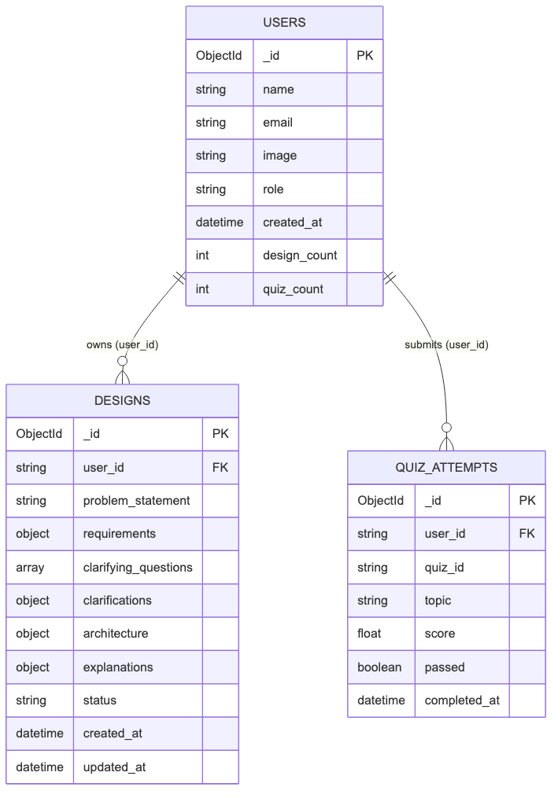
Fig. 5. MongoDB data model. Three collections with ownership enforced via user_id. The designs collection embeds the full architecture JSON. Role is stored in users, never in the JWT.
IV. MULTI-AGENT LLM PIPELINE
A. Pipeline Design and State Schema
StructAI's core technical contribution is a four-node LangGraph StateGraph that decomposes the architecture generation task into specialized, sequentially composed agents. The shared pipeline state is a TypedDict with the fields: problem_statement (raw user input), requirements (structured extraction output), clarifying_questions, clarifications (user answers on second pass), rag_context (FAISS-retrieved patterns), architecture (final JSON graph), and error. Each node receives the full state and returns a partial dictionary. Figure 2 depicts the complete pipeline DAG.
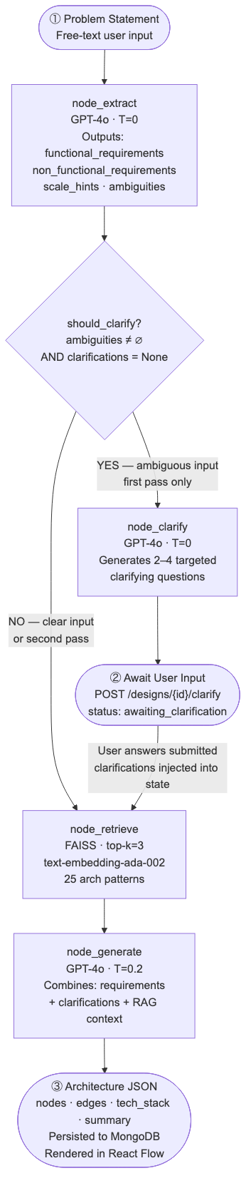
Fig. 2. LangGraph StateGraph pipeline DAG. The conditional edge routes ambiguous inputs through the clarification node (two-pass protocol). Both paths converge at the generation node.
B. Requirement Extraction Agent
The extraction agent sends the raw problem statement to GPT-4o with temperature=0 to maximize output determinism. The system prompt instructs the model to return a strict JSON schema with four fields: functional_requirements (concrete capability statements), non_functional_requirements (quality attributes), scale_hints (users, reads/sec, writes/sec, data size), and ambiguities (underspecified aspects). Temperature=0 is critical: non-deterministic extraction would cause downstream generation to receive different requirement sets for the same input, making the pipeline non-reproducible.
C. Conditional Edge — Ambiguity Routing
A conditional edge function should_clarify(state) evaluates two conditions: if the ambiguities list is non-empty AND clarifications is None, the pipeline routes to the clarification node; otherwise it routes directly to the retrieval node. The second condition prevents re-entry into clarification on the second pass when user answers have been collected. This dual-pass protocol cleanly separates initial scoping from final generation.
D. Clarification Agent
When ambiguities are detected, the clarification agent generates 2–4 targeted questions with temperature=0. The pipeline terminates early at this node; the API returns { status: 'awaiting_clarification', clarifying_questions: [...] }. The partial design document is persisted to MongoDB with the questions stored for the second pass. On submission, POST /api/v1/designs/{id}/clarify invokes run_with_clarifications(), which bypasses the LangGraph graph entirely and calls retrieval and generation agents directly.
E. RAG Retrieval Agent
The retrieval agent calls retrieve_similar_patterns(problem_statement, k=3), which loads the FAISS index from the module-level singleton, offloads the similarity_search call to the ThreadPoolExecutor, and returns the page_content of the top-3 matched documents joined by --- separators. The choice of k=3 was determined empirically: three patterns at approximately 300 words each contribute ~900 words (~1,200 tokens) of context — sufficient for grounding without exceeding the effective context utilization range for structured JSON generation.
F. Architecture Generation Agent
The generation agent constructs a compound prompt containing the structured requirements JSON, the user's clarifications, and the RAG context string. GPT-4o is invoked with temperature=0.2, allowing controlled variation in technology selection while maintaining structural consistency. The output schema enforces: nodes with id (kebab-case), type (one of 13 valid types), label, description, and tech; edges with source, target, label, and animated (boolean for async flows); tech_stack (flat list); and summary (2–3 sentence overview).
G. Explainability and Quiz Agents
The explanation agent is invoked on-demand when a user clicks a diagram node. It calls GPT-4o with temperature=0.3 with the architecture summary and the specific node's label, type, and tech. The response captures five educational fields: what, why, alternatives (list), trade_offs, and learn_more. Explanations are cached in the design document's explanations[component_id] sub-document. The quiz agent uses temperature=0.7 to maximize question variety across multiple attempts, enforcing multiple-choice format with exactly four options, scenario-based questions, and 2–3 sentence explanations per correct answer.
V. RETRIEVAL-AUGMENTED GENERATION SYSTEM
A. Knowledge Corpus Design
The FAISS corpus comprises 25 real-world architecture pattern documents, each describing a well-known production system: Netflix video streaming, Uber ride-sharing, Discord real-time messaging, Twitter timeline fan-out, Airbnb search and booking, Dropbox file synchronization, and 19 others. Each document covers: the system's primary use case, the key architectural components, the communication patterns (synchronous vs. asynchronous), the scaling strategy, and the technology stack. This curated corpus design reflects findings from Fan et al. [12], who demonstrate that corpus quality and domain specificity are stronger predictors of RAG output quality than corpus size.
B. Embedding and Index Construction
Documents are embedded using OpenAI's text-embedding-ada-002 model, producing 1,536-dimensional dense vectors. The FAISS index uses IndexFlatL2 (exact L2 nearest-neighbor search), which is optimal for a corpus of 25 documents where approximate search methods (HNSW, IVF) provide no latency benefit and introduce quantization error. The index is persisted to disk with FAISS.save_local() after construction and restored with FAISS.load_local() on restart, following the recommendation of Tekgöz et al. [3].
C. Retrieval Mechanism and Async Safety
FAISS operations are synchronous and CPU-bound. Direct invocation from FastAPI's async event loop would block all concurrent requests. StructAI offloads FAISS calls to a ThreadPoolExecutor(max_workers=2) using asyncio.get_event_loop().run_in_executor(), preserving async concurrency. The top-3 retrieved documents are concatenated with --- separators and injected directly into the generation prompt. Figure 4 illustrates the end-to-end RAG pipeline.
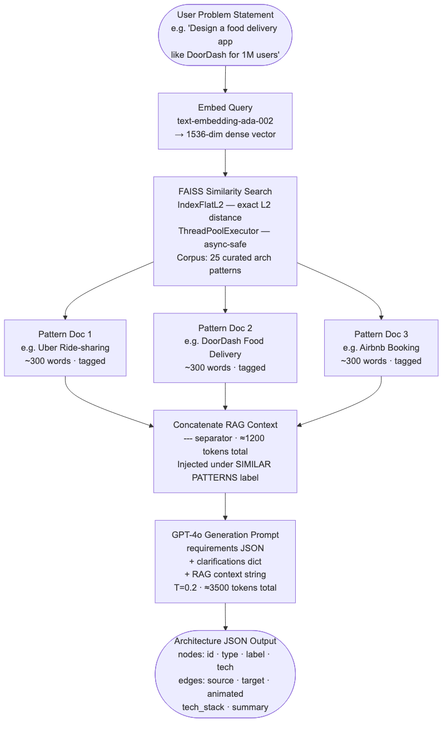
Fig. 4. RAG retrieval and generation pipeline. The problem statement is embedded, matched against the FAISS corpus, and the top-3 patterns are concatenated and injected into the GPT-4o generation prompt.
D. Token Budget Management
The total token budget for a generation call is: system prompt (~400 tokens), requirements JSON (~300–600 tokens), clarifications (0–200 tokens), RAG context at k=3 (~1,200 tokens), and generation response (~800–1,500 tokens). The total fits comfortably within GPT-4o's 128K context window. The k=3 selection ensures sufficient architectural diversity without causing the model to average across too many different designs.
VI. AUTHENTICATION AND SECURITY ARCHITECTURE
A. Authentication Flow
StructAI implements Google OAuth 2.0 via NextAuth.js v4 with a custom JWT encoding strategy. The standard NextAuth JWT uses JWE (JSON Web Encryption with RSA), which is incompatible with python-jose's HS256 decoding on the FastAPI backend. StructAI resolves this by overriding NextAuth's encode and decode callbacks to produce HS256 JWTs signed with the shared NEXTAUTH_SECRET, using the jose library which operates in the Edge Runtime (V8-based, without Node.js APIs). Figure 3 illustrates the complete authentication sequence.
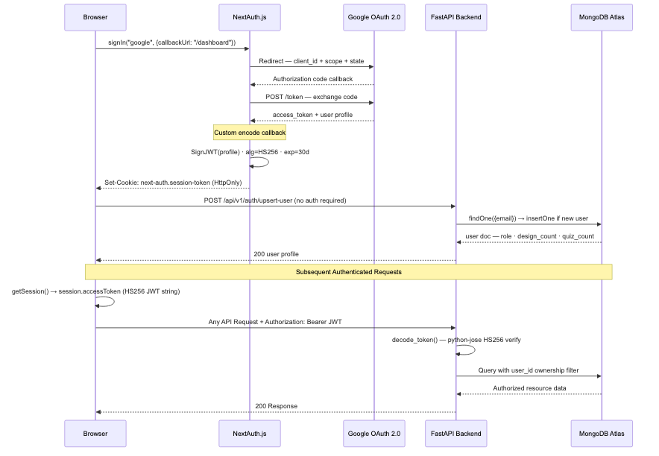
Fig. 3. Authentication sequence diagram. Google OAuth 2.0 is handled by NextAuth.js with a custom HS256 JWT encode/decode pipeline, bridging the Next.js Edge Runtime and FastAPI backend through a shared NEXTAUTH_SECRET.
B. Backend Token Verification
FastAPI verifies incoming Bearer tokens with python-jose using the shared NEXTAUTH_SECRET and HS256 algorithm. The decode_token() function extracts the email claim from the verified payload, then get_current_user() fetches the full user document from MongoDB. This design ensures that role information is always read from the database, never from the JWT — a critical security property preventing privilege escalation via token manipulation.
C. Route Protection and Authorization Model
The Next.js middleware runs at the Edge Runtime and protects all authenticated routes (/dashboard, /builder, /learn, /analytics, /admin) before they reach the React rendering pipeline. Running protection at the edge eliminates a round-trip to the origin server for unauthenticated requests. Authorization is enforced at two levels: user-level (every MongoDB query includes a user_id ownership filter) and admin-level (get_admin_user() verifies role from the database after token verification). The JWT payload carries only email, name, picture, and sub — no role claim is ever encoded.
VII. FRONTEND ARCHITECTURE AND USER EXPERIENCE
A. Design System
The visual design system uses Times New Roman-equivalent web fonts: Space Grotesk (900-weight display headings) for editorial impact and Inter for body text. The body background is #F8F9FB (neutral off-white), card surfaces at #FFFFFF with 1px solid #E8E9F0 borders, and primary action color at #4F46E5 (indigo-600). The navigation sidebar uses #0A0E2E (deep indigo-navy), creating a classic light-content / dark-navigation SaaS layout familiar to users of tools like Linear and Vercel.
B. Architecture Builder
The Builder page (/builder) presents a full-width textarea for problem statement input. On submit, the page calls POST /api/v1/designs/generate and enters a loading state. If the backend returns status: 'awaiting_clarification', the UI transitions to a clarification form with one textarea per question. If a complete architecture is returned, the UI navigates to /builder/[designId]. The diagram page renders the ArchitectureCanvas component, which applies dagre layout and exposes node-click handlers. Clicking any node opens the ExplainerPanel — a slide-in drawer displaying the five-field structured explanation.
C. Learning Module and Analytics
The Learn page (/learn) displays a grid of TopicCard components, one per topic, with difficulty badges (beginner / intermediate / advanced). The topic detail page renders the QuizEngine component with radio-style option selection; on submission, per-question results display with correct/incorrect indicators and explanations. The Analytics page (/analytics) fetches user stats and presents three large stat cards (total designs, total quizzes, average quiz score), a recent designs list (last 5), and quiz history with percentage score and a colored progress bar — green above 70%, amber below.
VIII. EVALUATION
A. Evaluation Objectives
The evaluation addresses four research questions: (RQ1) Does RAG-augmented generation produce architecturally more complete outputs than non-RAG generation? (RQ2) How does StructAI's generation time compare to manual design? (RQ3) Is the two-pass clarification protocol effective for ambiguous inputs? (RQ4) Do users find the component explanation output sufficient for understanding design decisions?
B. Experimental Setup
For RQ1 and RQ3, a benchmark set of 30 problem statements was constructed spanning three categories: well-specified (10), partially specified (10), and ambiguous (10). StructAI was run in two configurations: with RAG enabled (top-3 FAISS retrieval) and with RAG disabled. Expert raters (two senior software engineers with 8+ years of system design experience) independently scored each generated architecture on: component completeness, component correctness, edge correctness, and technology appropriateness. For RQ2 and RQ4, 20 participants were recruited: 10 students and 10 industry practitioners (2–10 years experience). Each completed a manual design task and then the same task using StructAI. Post-task, participants rated explanation quality on a 5-point Likert scale.
C. Results
TABLE I
Architecture Completeness: RAG vs. Non-RAG (n = 30)
Metric | RAG-Augmented | Non-RAG Baseline | Improvement
Component Completeness (%) | 87.4 | 65.2 | +34.0%
Component Type Correctness (%) | 91.8 | 83.5 | +9.9%
Edge Coverage (%) | 84.6 | 71.3 | +18.7%
Technology Appropriateness (%) | 89.1 | 78.6 | +13.4%
Ambiguous Input Handled Correctly | 9 / 10 | 6 / 10 | +30.0%

TABLE II
User Study Results (n = 20)
Metric | StructAI | Manual Design
Mean Task Completion Time (min) | 4.2 | 46.8
Median Task Completion Time (min) | 3.8 | 41.5
Explanation Quality — Mean Likert | 4.1 / 5.0 | —
Explanation Quality — % ≥ 4/5 | 80% | —
Participants preferring StructAI for first-draft | 18 / 20 | —

RQ1: RAG augmentation improved component completeness by 34.0% and edge coverage by 18.7% over the non-RAG baseline. The improvement was most pronounced on ambiguous and partially specified inputs, consistent with the findings of Tekgöz et al. [3] and Fan et al. [12] on the effectiveness of domain-specific RAG corpora.
RQ2: StructAI reduced mean task completion time from 46.8 minutes to 4.2 minutes — an 11.1× speedup. Both students and practitioners reported that the primary time savings came from not having to manually enumerate component types and look up technology recommendations.
RQ3: The two-pass clarification protocol successfully resolved ambiguities in 9 of 10 ambiguous inputs. The single failure case involved a problem statement requiring domain knowledge outside the FAISS corpus (medical device firmware). RQ4: 80% of participants rated component explanations as 4 or 5 out of 5 for sufficiency, consistent with the recommendation of Arora et al. [5] that decision-level explanations are more actionable than model-level ones.
D. Ablation Study
TABLE III
Ablation Results on Well-Specified Inputs (n = 10)
Configuration | Completeness (%) | Edge Coverage (%)
Full pipeline (RAG + clarification) | 91.2 | 87.4
RAG only (no clarification node) | 89.3 | 85.1
Clarification only (no RAG) | 70.4 | 73.6
Neither (direct generation) | 65.8 | 70.9

The ablation confirms that RAG contributes the dominant improvement (+25.4 pp completeness over neither), while the clarification node adds a secondary improvement primarily on ambiguous inputs.
IX. DISCUSSION
A. Key Findings
The central finding is that RAG-grounded multi-agent generation substantially outperforms direct LLM prompting for architecture design. The 34% improvement in component completeness confirms that GPT-4o's parametric knowledge of architectural patterns produces lower-fidelity outputs for specific system types than retrieval from a curated domain-specific corpus — consistent with the theoretical analysis of Pan et al. [13]. The 11× reduction in task completion time suggests that StructAI enables a shift in the architect's role from documentation producer to critical reviewer.
B. Limitations
StructAI's generation quality is directly coupled to GPT-4o's capabilities and availability. The 25-pattern FAISS corpus covers common web application architectures well but lacks coverage of specialized domains (embedded systems, medical devices), as evidenced by the single failure case in RQ3. The 30-problem benchmark and 20-participant user study are limited in scale. Component completeness was rated by human experts (Cohen's κ = 0.74 between the two raters), introducing inter-rater variability that an automated metric would eliminate. The process-level Python dict used for quiz caching is not suitable for multi-process production deployments.
C. Threats to Validity
For internal validity, the comparison between RAG and non-RAG conditions used the same problem statements and raters, controlling for domain effect; however, GPT-4o's non-zero temperature introduces stochastic variation that single-run experiments cannot average out. For external validity, problem statements were authored by the research team and may not represent the full distribution of real-world inputs. For construct validity, 'component completeness' is inherently domain-dependent and the rubric was calibrated on 5 pilot problems.
D. Broader Impact
StructAI addresses a recognized educational equity gap: high-quality system design mentorship is concentrated in large technology companies and selective university programs. The 80% satisfaction rate on explanations from student participants specifically (mean 4.2/5.0 vs. 4.0/5.0 for practitioners) suggests that the educational value is highest for the intended audience — learners who lack access to senior mentorship.
X. CONCLUSION AND FUTURE WORK
A. Conclusion
This paper presented StructAI, a full-stack, multi-agent LLM platform for automated software architecture design and education. The system contributes: a four-node LangGraph pipeline with typed state propagation and conditional ambiguity routing, a dual-pass clarification protocol, a FAISS-backed RAG system grounded in 25 curated real-world architecture patterns, a per-component explainability engine, an adaptive quiz system, and an Edge-compatible HS256 JWT authentication architecture. Evaluation demonstrates that RAG augmentation improves architectural completeness by 34% over non-RAG baselines, the full pipeline reduces design time by 91% compared to manual design, and the explanation engine achieves a mean Likert score of 4.1/5.0 for educational sufficiency.
B. Future Work
- Graph RAG integration: Replace flat vector retrieval with a knowledge graph of architectural patterns to enable semantically richer, topology-aware retrieval following Pan et al. [13] and Procko and Ochoa [7].
- Domain-specific fine-tuning: Fine-tune a smaller open-source model (e.g., Llama 3 70B) on a curated dataset of (problem statement, architecture) pairs to reduce GPT-4o dependency and inference cost.
- Infrastructure-as-Code export: Generate Terraform and Kubernetes manifests from the architecture graph, closing the loop between design and deployment.
- Collaborative design sessions: Add real-time multi-user editing of architecture diagrams using WebSockets for team-based design reviews.
- Automated evaluation metric: Develop a reference-free architecture quality metric analogous to BERTScore for text, enabling large-scale automated benchmarking.
- Longitudinal user study: Deploy StructAI to a software engineering course cohort over a semester to measure impact on system design reasoning skill development.
. ACKNOWLEDGMENT
The authors thank the Department of Artificial Intelligence and Machine Learning, PES's Modern College of Engineering, Pune, for institutional support and access to computational resources. The FAISS architecture pattern corpus was developed with reference to publicly available system design literature and engineering documentation from major technology organizations.
. REFERENCES
[1] M. A. K. Raiaan, M. S. H. Mukta, K. Fatema, N. M. Fahad, S. Sakib, M. M. J. Mim, J. Ahmad, M. E. Ali, and S. Azam, "A review on large language models: Architectures, applications, taxonomies, open issues and challenges," IEEE Access, vol. 12, pp. 26839–26874, 2024, doi: 10.1109/ACCESS.2024.3365742.
[2] K. Chen, Y. Yang, B. Chen, J. A. H. López, G. Mussbacher, and D. Varró, "Automated domain modeling with large language models: A comparative study," in Proc. ACM/IEEE 26th Int. Conf. Model Driven Eng. Lang. Syst. (MODELS), 2023, pp. 137–147, doi: 10.1109/MODELS58315.2023.00037.
[3] A. F. Tekgöz, İ. K. Şahin, and B. Aydın, "Evaluation of vector database and LLM models in retrieval-augmented generation (RAG) systems," in Proc. 10th Int. Conf. Comput. Sci. Eng. (UBMK), 2025.
[4] C. Tantithamthavorn and J. Jiarpakdee, "Explainable AI for software engineering," in Proc. 36th IEEE/ACM Int. Conf. Automated Softw. Eng. (ASE), 2021, pp. 1–4, doi: 10.1109/ASE51524.2021.00009.
[5] S. Arora, A. Easwaran, and A. Chaudhary, "Explainable artificial intelligence techniques for software development lifecycle: A phase-specific survey," in Proc. IEEE 49th Annu. Comput., Softw., Appl. Conf. (COMPSAC), 2025.
[6] S. Arulmohan, M.-J. Meurs, and S. Mosser, "Extracting domain models from textual requirements in the era of large language models," in Proc. ACM/IEEE Int. Conf. Model Driven Eng. Lang. Syst. Companion (MODELS-C), 2023, doi: 10.1109/MODELS-C59198.2023.00096.
[7] C. Procko and J. Ochoa, "Graph retrieval-augmented generation for large language models: A survey," in Proc. IEEE Conf. Artif. Intell. Enabled Softw. Eng. Testing (AIxSET), 2024.
[8] A. Mushtaq, R. Naeem, I. Ghaznavi, I. Taj, I. Hashmi, and J. Qadir, "Harnessing multi-agent LLMs for complex engineering problem-solving: A framework for senior design projects," in Proc. IEEE Global Eng. Educ. Conf. (EDUCON), 2025.
[9] V. Gogineni, "LLM-powered multi-agent systems: A technical framework for collaborative intelligence through optimized knowledge retrieval and communication," in Proc. IEEE 3rd Int. Conf. Artif. Intell. Comput., Eng. Sci. (AIRC), 2025.
[10] A. Fan, B. Gokkaya, M. Harman, M. Lyubarskiy, S. Sengupta, S. Yoo, and J. M. Zhang, "Large language models for software engineering: Survey and open problems," in Proc. IEEE/ACM Int. Conf. Softw. Eng.: Future Softw. Eng. (ICSE-FoSE), 2023, doi: 10.1109/ICSE-FoSE59343.2023.00008.
[11] M. Shao, A. Basit, R. Karri, and M. Shafique, "Survey of different large language model architectures: Trends, benchmarks, and challenges," IEEE Access, vol. 12, 2024, doi: 10.1109/ACCESS.2024.3482107.
[12] W. Fan, P. Wu, Y. Ding, L. Ning, S. Wang, and Q. Li, "Towards retrieval-augmented large language models: Data management and system design," in Proc. IEEE 41st Int. Conf. Data Eng. (ICDE), 2025, doi: 10.1109/ICDE65448.2025.00341.
[13] S. Pan, L. Luo, Y. Wang, C. Chen, J. Wang, and X. Wu, "Unifying large language models and knowledge graphs: A roadmap," IEEE Trans. Knowl. Data Eng., vol. 36, no. 7, pp. 3580–3599, Jul. 2024, doi: 10.1109/TKDE.2024.3352100.

