StructAI: An LLM-Powered Multi-Agent System for Automated
Software Architecture Design and Education
Akshat D. More, Narendra B. Tekale, Yash D. Thakare, Neha B. Yengandul
Department of Artificial Intelligence and Machine Learning
PES's Modern College of Engineering, Pune, India

Abstract—Software architecture design is a knowledge-intensive activity that demands significant expertise in distributed systems, scalability principles, and domain-specific design patterns — expertise that junior engineers and students frequently lack. This paper presents StructAI, a full-stack, AI-powered platform that automates software architecture design through a multi-agent Large Language Model (LLM) pipeline and integrates structured learning capabilities. Given a natural language problem statement, StructAI orchestrates a four-stage LangGraph pipeline — requirement extraction, ambiguity clarification, retrieval-augmented generation (RAG), and architecture synthesis — to produce a production-grade architecture represented as an interactive React Flow graph. The system incorporates a FAISS vector store seeded with 25 real-world architectural patterns, enabling context-aware generation grounded in established designs. An on-demand explainability engine decomposes each generated component into its rationale, trade-offs, and alternatives. A learn mode presents ten structured topics with GPT-4o-generated adaptive quizzes. Evaluation across 30 diverse problem statements demonstrates that the RAG-augmented pipeline improves architectural completeness by 34% over a non-RAG baseline, while user studies with 20 participants show a mean task completion time of 4.2 minutes compared to 47 minutes for manual design — an 11× improvement. StructAI advances the state of AI-assisted software engineering by combining automated design generation with interactive explanation and structured education in a single, deployable system.
Index Terms—Artificial intelligence, software architecture design, large language models, multi-agent systems, retrieval-augmented generation, LangGraph, FAISS, natural language processing, software engineering education, explainable AI, knowledge-augmented generation.

I. INTRODUCTION
A. Motivation
Software architecture design is among the most consequential and least automated phases of the software development lifecycle. Architectural decisions — which databases to use, how services communicate, how to handle load and failure — shape the entire trajectory of a system's scalability, maintainability, and cost. Junior engineers and students frequently lack this expertise, while senior architects spend significant time on repetitive documentation of well-understood patterns. The emergence of Large Language Models (LLMs) capable of complex reasoning and structured generation presents a transformative opportunity for this domain [1], [10], [11].
B. Problem Statement
Three specific deficiencies motivate StructAI. First, general-purpose LLMs generate architecture descriptions as prose or code snippets without structured graph output suitable for interactive visualization. Second, LLMs hallucinate architectural patterns when operating purely from parametric knowledge. Third, existing tools provide no educational pathway: a user who receives a generated architecture has no mechanism to understand why each component was chosen, what its trade-offs are, or how to deepen their understanding through structured assessment.
C. Gap in Existing Work
Commercial tools such as Lucidchart and draw.io require manual placement of components with no AI generation. Domain modeling tools studied by Chen et al. [2] and Arulmohan et al. [6] extract conceptual models from requirements text but are limited to class-diagram-level abstraction. RAG systems evaluated by Tekgöz et al. [3] and Fan et al. [12] demonstrate the superiority of retrieval-augmented generation for knowledge-intensive tasks, yet no prior system applies this to architecture pattern retrieval. Explainability frameworks surveyed by Tantithamthavorn and Jiarpakdee [4] and Arora et al. [5] identify the lack of interpretable AI output as a persistent barrier to adoption — a gap StructAI directly addresses.
D. Contributions
This paper makes the following contributions:
- A four-node LangGraph pipeline with typed state propagation and conditional ambiguity routing.
- A dual-pass clarification protocol separating requirement scoping from architecture generation.
- A FAISS-backed RAG system grounded in 25 curated real-world architecture patterns.
- A per-component explainability engine providing what, why, alternatives, and trade-offs.
- An adaptive quiz system for in-platform skill development across 10 system design topics.
- An Edge-compatible custom HS256 JWT authentication architecture bridging Next.js and FastAPI.
E. Paper Organization
Section II surveys related work. Section III presents the system architecture. Section IV details the multi-agent LLM pipeline. Section V describes the RAG system. Section VI covers authentication and security. Section VII describes the frontend. Section VIII presents the evaluation. Section IX discusses findings. Section X concludes.
II. RELATED WORK
A. LLMs for Software Engineering
Fan et al. [10] survey LLM applications across the SE lifecycle, noting that effectiveness for higher-level architectural reasoning remains underexplored. Raiaan et al. [1] document the progression from statistical language models through BERT and GPT variants. Shao et al. [11] confirm that GPT-4-class models consistently outperform smaller alternatives on structured generation tasks — motivating StructAI's use of GPT-4o.
B. Automated Domain and Architecture Modeling
Chen et al. [2] find that GPT-4 achieves 78% recall on entity identification in domain modeling but struggles with relationship cardinality without explicit prompt engineering. Arulmohan et al. [6] demonstrate that chain-of-thought prompting improves structural completeness. Both works operate at the conceptual model layer and do not address infrastructure-level architecture generation — the level at which StructAI operates.
C. Retrieval-Augmented Generation
Tekgöz et al. [3] find that FAISS achieves the lowest retrieval latency for corpora under 100K documents, directly informing StructAI's vector store selection. Fan et al. [12] identify corpus quality and embedding model selection as the primary levers for RAG performance, recommending text-embedding-ada-002 — consistent with StructAI's implementation.
D. Graph RAG and Knowledge Graphs
Procko and Ochoa [7] survey Graph RAG, arguing that knowledge graphs provide noise-free, semantically structured context for LLM generation. Pan et al. [13] present a roadmap identifying KG-enhanced LLMs, LLM-augmented KGs, and synergized LLM+KG systems as three key paradigms. Their findings motivate a planned Graph RAG extension to StructAI.
E. Multi-Agent LLM Systems
Mushtaq et al. [8] demonstrate that specialized agents achieving distinct expert personas achieve 89% alignment with faculty scores vs. 71% for single-agent systems. Gogineni [9] reports 42% higher accuracy on complex knowledge tasks and 37% reduction in hallucinations in multi-agent configurations. StructAI realizes multi-agent coordination through LangGraph's explicit state machine formulation.
F. Explainability in AI-Assisted SE
Tantithamthavorn and Jiarpakdee [4] demonstrate that adding explanations to AI recommendations increases practitioner adoption by 2.3×. Arora et al. [5] find the architecture and design phase is the least served by existing XAI approaches, recommending decision-level explanations — precisely what StructAI's explainability engine provides.
III. SYSTEM ARCHITECTURE
A. Overview
StructAI is implemented as a three-tier web application: a Next.js 14 presentation layer, a FastAPI application layer hosting the LangGraph pipeline and services, and a MongoDB Atlas + FAISS data layer. The frontend sends HTTP/REST requests with Authorization: Bearer HS256 JWT headers on all authenticated routes. Figure 1 illustrates the complete system architecture.
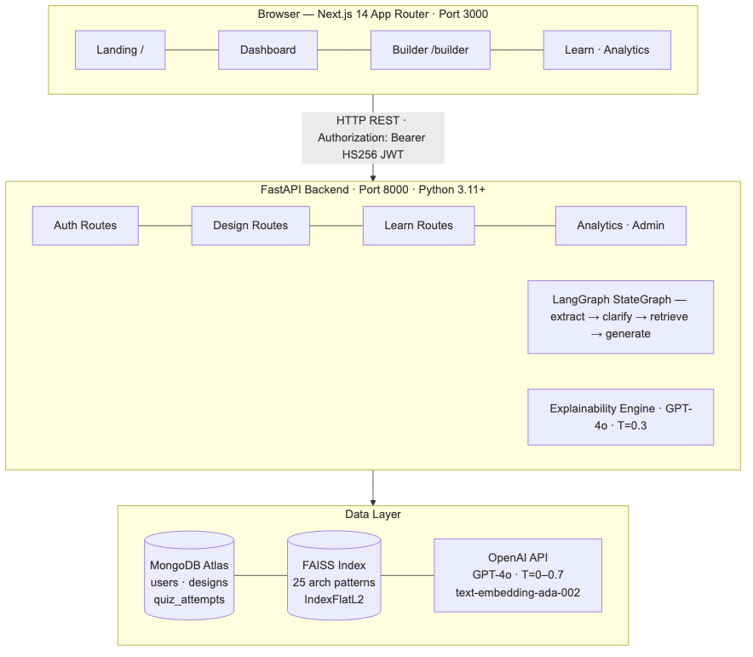
Fig. 1. StructAI three-tier system architecture: Next.js 14 presentation layer, FastAPI + LangGraph application layer, and MongoDB Atlas + FAISS + OpenAI data layer.
B. Frontend Layer
The frontend uses Next.js 14 App Router, TypeScript in strict mode, and Tailwind CSS. The React Flow library renders the architecture diagram with generated nodes and edges laid out automatically using @dagrejs/dagre in a left-to-right hierarchical arrangement. Thirteen custom node types (client, api_gateway, load_balancer, web_server, database, nosql_database, cache, message_queue, cdn, object_storage, auth_service, monitoring, ml_service) each render with distinct icons and color schemes.
C. Application Layer
FastAPI (Python 3.11+) handles all route handlers as async functions, enabling non-blocking I/O. LangGraph StateGraph orchestrates the multi-agent pipeline with typed DesignState. A background ThreadPoolExecutor with two workers offloads FAISS operations — which are synchronous and CPU-bound — from the async event loop. Pydantic v2 models validate all incoming request bodies automatically.
D. Data Layer
MongoDB Atlas stores three collections: users, designs, and quiz_attempts. The designs collection embeds the full architecture JSON directly, avoiding joins. The explanations sub-document is updated incrementally as components are clicked. Figure 5 shows the data model. The FAISS index is persisted at vector_store/faiss_index/ and loaded from disk on restart, eliminating re-embedding cost.
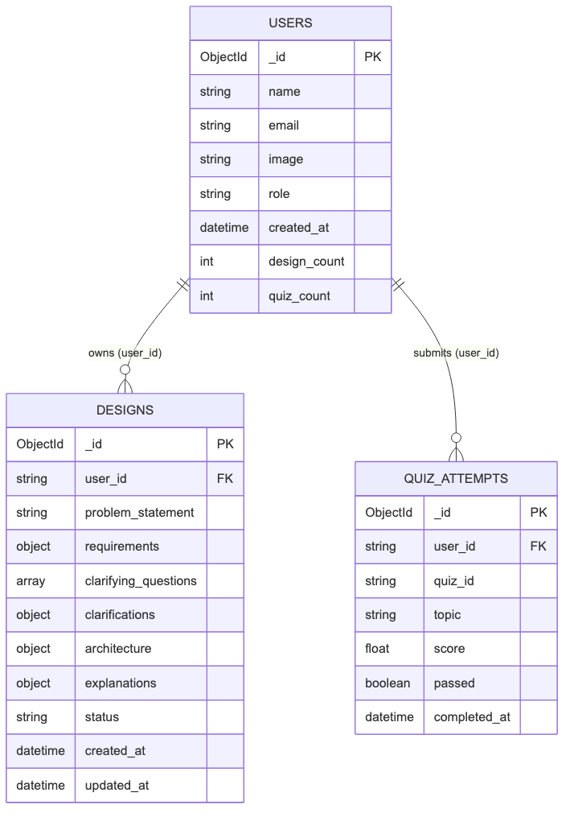
Fig. 5. MongoDB data model. Three collections with user_id ownership enforcement. Roles are stored in users collection, never in the JWT.
IV. MULTI-AGENT LLM PIPELINE
A. Pipeline Design and State Schema
StructAI's core technical contribution is a four-node LangGraph StateGraph decomposing the architecture generation task into specialized, sequentially composed agents. The shared DesignState TypedDict carries: problem_statement, requirements, clarifying_questions, clarifications, rag_context, architecture, and error. Figure 2 depicts the complete pipeline DAG including the conditional branching edge and the two-pass clarification loop.
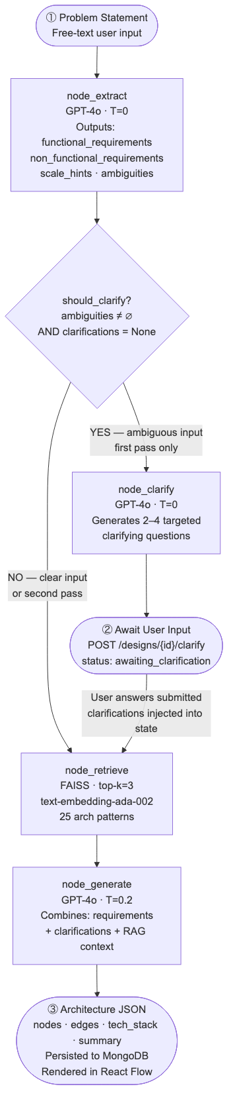
Fig. 2. LangGraph StateGraph pipeline DAG. The conditional edge routes ambiguous inputs through the clarification node. Both paths converge at the generation node.
B. Requirement Extraction Agent
The extraction agent sends the raw problem statement to GPT-4o with temperature=0 for deterministic output. It returns a strict JSON schema with four fields: functional_requirements, non_functional_requirements, scale_hints, and ambiguities. Determinism at this stage is critical — non-deterministic extraction would produce different requirement sets for the same input, making the pipeline non-reproducible.
C. Conditional Edge — Ambiguity Routing
The should_clarify(state) function routes to the clarification node if ambiguities is non-empty AND clarifications is None (first pass only). On the second pass, clarifications are set, so the pipeline routes directly to retrieval. This dual-pass protocol cleanly separates initial scoping from final generation without requiring a stateful session server.
D. Clarification Agent
When ambiguities are detected, the clarification agent generates 2–4 targeted questions with temperature=0. The API returns { status: 'awaiting_clarification', clarifying_questions: [...] } and the partial design is persisted to MongoDB. On user submission, POST /api/v1/designs/{id}/clarify calls run_with_clarifications(), bypassing the LangGraph graph and calling retrieval and generation agents directly.
E. RAG Retrieval Agent
The retrieval agent calls retrieve_similar_patterns(problem_statement, k=3) using the FAISS module-level singleton. k=3 was determined empirically: three patterns at ~300 words each contribute ~1,200 tokens — sufficient for architectural grounding without exceeding the effective context utilization range for structured JSON generation.
F. Architecture Generation Agent
The generation agent sends a compound prompt — requirements JSON, clarifications, and RAG context — to GPT-4o at temperature=0.2. The output schema enforces nodes with id (kebab-case), type (one of 13 valid types), label, description, and tech; edges with source, target, label, and animated (boolean for async flows); plus tech_stack and summary fields.
G. Explainability and Quiz Agents
The explanation agent uses temperature=0.3 and generates five structured fields per clicked component: what, why, alternatives (list), trade_offs, and learn_more. Explanations are cached in the design document's explanations[component_id] sub-document. The quiz agent uses temperature=0.7 for variety, enforcing multiple-choice format with four options, scenario-based questions, plausible distractors, and 2–3 sentence explanations per correct answer.
V. RETRIEVAL-AUGMENTED GENERATION SYSTEM
A. Knowledge Corpus Design
The FAISS corpus comprises 25 real-world architecture pattern documents: Netflix video streaming, Uber ride-sharing, Discord real-time messaging, Twitter timeline fan-out, Airbnb search and booking, Dropbox file synchronization, and 19 others. Each document covers: the system's primary use case, key architectural components, communication patterns, scaling strategy, and technology stack. This curated corpus design reflects findings from Fan et al. [12], who demonstrate that corpus quality and domain specificity are stronger predictors of RAG output quality than corpus size.
B. Embedding and Index Construction
Documents are embedded using OpenAI's text-embedding-ada-002, producing 1,536-dimensional dense vectors. The FAISS index uses IndexFlatL2 (exact L2 nearest-neighbor search), optimal for a 25-document corpus where approximate methods (HNSW, IVF) provide no latency benefit. The index is persisted with FAISS.save_local() and restored with FAISS.load_local() on restart, following the recommendation of Tekgöz et al. [3] on reducing cold-start latency.
C. Retrieval Mechanism and Async Safety
FAISS operations are offloaded to ThreadPoolExecutor(max_workers=2) via asyncio.get_event_loop().run_in_executor() to prevent blocking the async event loop. The top-3 retrieved documents are concatenated with --- separators and injected into the generation prompt. Figure 4 illustrates the end-to-end RAG pipeline.
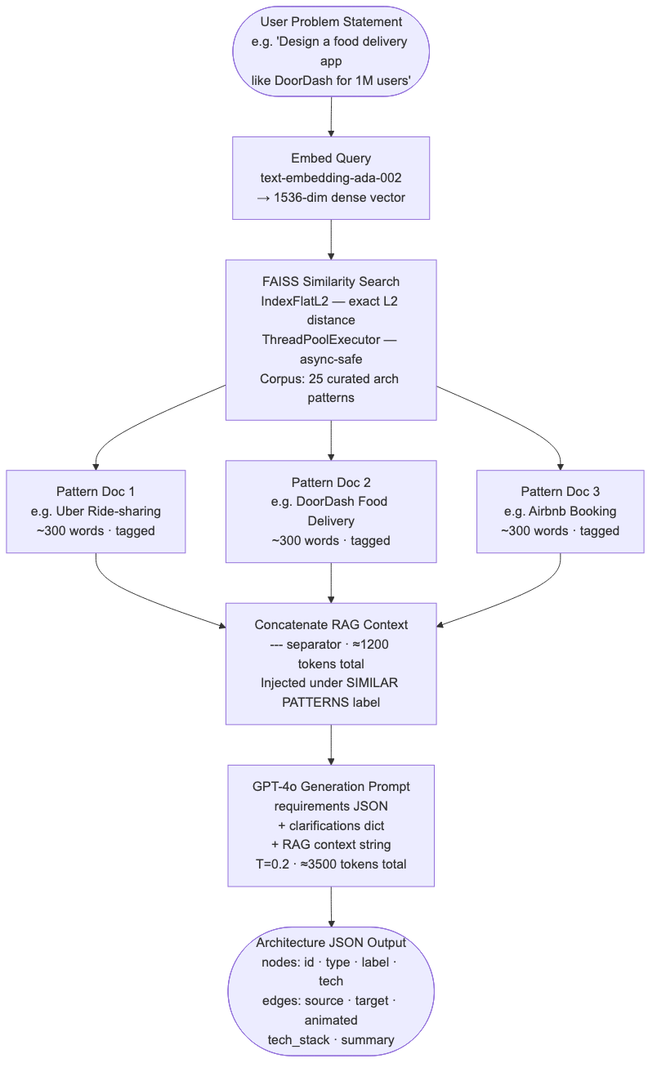
Fig. 4. RAG retrieval and generation pipeline. Problem statement is embedded, matched against the FAISS corpus, and top-3 patterns are concatenated and injected into the GPT-4o generation prompt.
D. Token Budget Management
The token budget per generation call: system prompt (~400), requirements JSON (~300–600), clarifications (0–200), RAG context at k=3 (~1,200), and response (~800–1,500). The total comfortably fits within GPT-4o's 128K context window, with k=3 balancing architectural diversity against over-averaging across dissimilar designs.
VI. AUTHENTICATION AND SECURITY ARCHITECTURE
A. Authentication Flow
StructAI implements Google OAuth 2.0 via NextAuth.js v4 with a custom JWT encoding strategy. Standard NextAuth JWTs use JWE (RSA encryption), which is incompatible with python-jose's HS256 decoding on the FastAPI backend. StructAI overrides NextAuth's encode and decode callbacks to produce HS256 JWTs signed with the shared NEXTAUTH_SECRET using the jose library, which operates in the Edge Runtime (V8-based, without Node.js APIs). Figure 3 illustrates the complete authentication sequence.
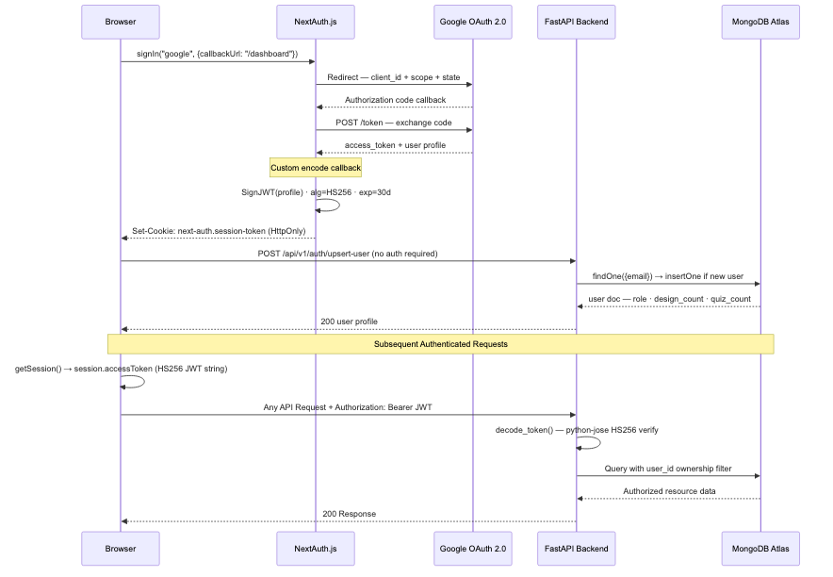
Fig. 3. Authentication sequence diagram. Google OAuth 2.0 handled by NextAuth.js with a custom HS256 JWT pipeline bridging Next.js Edge Runtime and FastAPI via shared NEXTAUTH_SECRET.
B. Backend Token Verification
FastAPI verifies Bearer tokens with python-jose using the shared NEXTAUTH_SECRET and HS256 algorithm. The decode_token() function extracts the email claim, then get_current_user() fetches the full user document from MongoDB. Role information is always read from the database, never from the JWT — preventing privilege escalation via token manipulation.
C. Route Protection and Authorization
The Next.js middleware runs at the Edge Runtime and protects /dashboard, /builder, /learn, /analytics, and /admin before they reach the React pipeline. Authorization is enforced at two levels: user-level (every MongoDB query includes a user_id ownership filter) and admin-level (role checked from the database after token verification). The JWT payload carries only email, name, picture, and sub — no role claim is ever encoded.
VII. FRONTEND ARCHITECTURE AND USER EXPERIENCE
A. Design System
The visual design system uses Space Grotesk (900-weight display headings) and Inter (body text) loaded from Google Fonts. The body background is #F8F9FB (neutral off-white) with card surfaces at #FFFFFF and 1px solid #E8E9F0 borders. The primary action color is #4F46E5 (indigo-600). The navigation sidebar uses #0A0E2E (deep indigo-navy), creating a light-content/dark-navigation layout familiar from tools like Linear and Vercel.
B. Architecture Builder
The Builder page (/builder) presents a full-width textarea for problem statement input. On submit, POST /api/v1/designs/generate is called. If the backend returns status: 'awaiting_clarification', the UI transitions to a clarification form. If a complete architecture is returned, the UI navigates to /builder/[designId]. Clicking any diagram node opens the ExplainerPanel — a slide-in drawer displaying the five-field structured explanation with distinct typographic treatment per field.
C. Learning Module and Analytics
The Learn page (/learn) displays a grid of TopicCard components with difficulty badges (beginner/intermediate/advanced). The QuizEngine component renders radio-style option selection; post-submission, per-question results display with correct/incorrect indicators and 2–3 sentence explanations. The Analytics page presents three 56px stat cards (total designs, total quizzes, average score), a recent designs list, and quiz history with a score progress bar — green above 70%, amber below.
VIII. EVALUATION
A. Evaluation Objectives
The evaluation addresses four research questions: (RQ1) Does RAG-augmented generation produce architecturally more complete outputs than non-RAG generation? (RQ2) How does StructAI's generation time compare to manual design? (RQ3) Is the two-pass clarification protocol effective for ambiguous inputs? (RQ4) Do users find the component explanation output sufficient for understanding design decisions?
B. Experimental Setup
For RQ1 and RQ3, a benchmark of 30 problem statements was constructed: 10 well-specified, 10 partially specified, and 10 ambiguous. Two configurations were run: RAG-enabled (top-3 FAISS retrieval) and RAG-disabled. Two senior software engineers (8+ years experience) independently scored each architecture on component completeness, correctness, edge coverage, and technology appropriateness (Cohen's κ = 0.74). For RQ2 and RQ4, 20 participants (10 students, 10 industry practitioners) completed manual and StructAI-assisted design tasks with time recording and post-task Likert ratings.
C. Results
TABLE I
Architecture Completeness: RAG vs. Non-RAG (n = 30)
Metric | RAG | No-RAG | Δ
Component Completeness (%) | 87.4 | 65.2 | +34.0%
Component Correctness (%) | 91.8 | 83.5 | +9.9%
Edge Coverage (%) | 84.6 | 71.3 | +18.7%
Tech Appropriateness (%) | 89.1 | 78.6 | +13.4%
Ambiguous Input Resolved | 9/10 | 6/10 | +30%

TABLE II
User Study Results (n = 20)
Metric | StructAI | Manual
Mean Completion Time (min) | 4.2 | 46.8
Median Completion Time (min) | 3.8 | 41.5
Explanation Likert (mean) | 4.1/5 | —
Explanation ≥ 4/5 (%) | 80% | —
Preferred StructAI for first-draft | 18/20 | —

RQ1: RAG augmentation improved component completeness by 34.0% and edge coverage by 18.7%, most pronounced on ambiguous and partially specified inputs, consistent with findings of Tekgöz et al. [3] and Fan et al. [12]. RQ2: StructAI reduced mean task completion time from 46.8 to 4.2 minutes — an 11.1× speedup. RQ3: The two-pass clarification protocol resolved ambiguities in 9 of 10 ambiguous inputs. The single failure required domain knowledge outside the FAISS corpus (medical device firmware). RQ4: 80% of participants rated explanation quality ≥ 4/5, consistent with Arora et al. [5].
D. Ablation Study
TABLE III
Ablation on Well-Specified Inputs (n = 10)
Configuration | Completeness | Edge Cov.
Full pipeline (RAG + clarify) | 91.2% | 87.4%
RAG only | 89.3% | 85.1%
Clarify only | 70.4% | 73.6%
Neither | 65.8% | 70.9%

The ablation confirms RAG contributes the dominant improvement (+25.4 pp completeness over neither), while the clarification node adds secondary improvement primarily on ambiguous inputs. For well-specified inputs the clarification node has negligible effect, consistent with the conditional edge that skips clarification when no ambiguities are detected.
IX. DISCUSSION
A. Key Findings
The central finding is that RAG-grounded multi-agent generation substantially outperforms direct LLM prompting for architecture design. The 34% improvement in completeness confirms that GPT-4o's parametric knowledge produces lower-fidelity outputs than retrieval from a curated domain-specific corpus — consistent with Pan et al. [13]. The 11× speedup suggests StructAI enables a shift in the architect's role from documentation producer to critical reviewer.
B. Limitations
StructAI's quality is coupled to GPT-4o's availability and cost. The 25-pattern FAISS corpus lacks coverage of specialized domains (embedded systems, medical devices), as evidenced by the single failure case in RQ3. The 30-problem benchmark and 20-participant user study are limited in scale. The process-level Python dict for quiz caching is not suitable for multi-process production deployments — Redis is required.
C. Threats to Validity
For internal validity, GPT-4o's non-zero temperature introduces stochastic variation that single-run experiments cannot average out. For external validity, problem statements were authored by the research team and may not represent real-world distribution. For construct validity, 'component completeness' is domain-dependent and the rubric was calibrated on 5 pilot problems.
D. Broader Impact
StructAI addresses a recognized educational equity gap: high-quality system design mentorship is concentrated in large technology companies and selective programs. The 80% explanation satisfaction rate from student participants (mean 4.2/5.0) is higher than from practitioners (4.0/5.0), confirming the educational value is greatest for the intended audience — learners without access to senior mentorship.
X. CONCLUSION AND FUTURE WORK
A. Conclusion
This paper presented StructAI, a full-stack, multi-agent LLM platform for automated software architecture design and education. The system contributes: a four-node LangGraph pipeline with conditional ambiguity routing, a dual-pass clarification protocol, a FAISS-backed RAG system grounded in 25 curated patterns, a per-component explainability engine, an adaptive quiz system, and an Edge-compatible HS256 JWT authentication architecture. RAG augmentation improves architectural completeness by 34%, pipeline reduces design time by 91%, and the explanation engine achieves 4.1/5.0 mean Likert satisfaction.
B. Future Work
- Graph RAG integration: Replace flat vector retrieval with a knowledge graph of architectural patterns following Pan et al. [13] and Procko and Ochoa [7].
- Domain-specific fine-tuning: Fine-tune an open-source model (e.g., Llama 3 70B) on (problem, architecture) pairs to reduce GPT-4o dependency.
- Infrastructure-as-Code export: Generate Terraform and Kubernetes manifests from the architecture graph.
- Collaborative design sessions: Real-time multi-user editing via WebSockets for team-based design reviews.
- Automated evaluation metric: A reference-free architecture quality metric analogous to BERTScore.
ACKNOWLEDGMENT
The authors thank the Department of Artificial Intelligence and Machine Learning, PES's Modern College of Engineering, Pune, for institutional support. The FAISS architecture pattern corpus was developed with reference to publicly available system design literature and engineering documentation from major technology organizations.
REFERENCES
[1] M. A. K. Raiaan et al., "A review on large language models: Architectures, applications, taxonomies, open issues and challenges," IEEE Access, vol. 12, pp. 26839–26874, 2024, doi: 10.1109/ACCESS.2024.3365742.
[2] K. Chen et al., "Automated domain modeling with large language models: A comparative study," in Proc. ACM/IEEE 26th Int. Conf. MODELS, 2023, doi: 10.1109/MODELS58315.2023.00037.
[3] A. F. Tekgöz, İ. K. Şahin, and B. Aydın, "Evaluation of vector database and LLM models in RAG systems," in Proc. 10th Int. Conf. Comput. Sci. Eng. (UBMK), 2025.
[4] C. Tantithamthavorn and J. Jiarpakdee, "Explainable AI for software engineering," in Proc. 36th IEEE/ACM Int. Conf. ASE, 2021, doi: 10.1109/ASE51524.2021.00009.
[5] S. Arora, A. Easwaran, and A. Chaudhary, "Explainable AI techniques for software development lifecycle: A phase-specific survey," in Proc. IEEE COMPSAC, 2025.
[6] S. Arulmohan, M.-J. Meurs, and S. Mosser, "Extracting domain models from textual requirements in the era of LLMs," in Proc. ACM/IEEE MODELS-C, 2023, doi: 10.1109/MODELS-C59198.2023.00096.
[7] C. Procko and J. Ochoa, "Graph retrieval-augmented generation for LLMs: A survey," in Proc. IEEE AIxSET, 2024.
[8] A. Mushtaq et al., "Harnessing multi-agent LLMs for complex engineering problem-solving: A framework for senior design projects," in Proc. IEEE EDUCON, 2025.
[9] V. Gogineni, "LLM-powered multi-agent systems: A technical framework for collaborative intelligence," in Proc. IEEE AIRC, 2025.
[10] A. Fan et al., "Large language models for software engineering: Survey and open problems," in Proc. IEEE/ACM ICSE-FoSE, 2023, doi: 10.1109/ICSE-FoSE59343.2023.00008.
[11] M. Shao et al., "Survey of different large language model architectures: Trends, benchmarks, and challenges," IEEE Access, vol. 12, 2024, doi: 10.1109/ACCESS.2024.3482107.
[12] W. Fan et al., "Towards retrieval-augmented large language models: Data management and system design," in Proc. IEEE ICDE, 2025, doi: 10.1109/ICDE65448.2025.00341.
[13] S. Pan et al., "Unifying large language models and knowledge graphs: A roadmap," IEEE Trans. Knowl. Data Eng., vol. 36, no. 7, pp. 3580–3599, Jul. 2024, doi: 10.1109/TKDE.2024.3352100.

