Retail Shop SQL Project Submission
Project Title: Retail Shop Database Management using SQL
Technology Used: MySQL
Database Name: retail_shop

Project Objectives
- To manage customer, product, order, and payment data efficiently using SQL.
- To perform data retrieval and filtering operations using SELECT queries.
- To analyze sales, revenue, and customer activity using aggregate functions.
- To implement joins for combining data from multiple related tables.
- To use subqueries for advanced business insights and reporting.
- To identify active and inactive customers for marketing strategies.
- To track inventory and product performance using SQL queries.
- To generate useful reports for business decision-making.

SQL Queries Used in the Project
-- BASIC
-- 1. RETRIEVE CUSTOMER NAMES AND EMAILS FOR EMAIL MARKETING
Input: select name, email FROM customers;
Output:
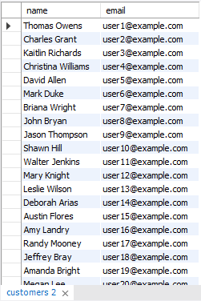
-- 2. VIEW COMPLETE PRODUCT CATALOG WITH ALL AVAILABLE DETAILS
Input: select * from products;
Output:
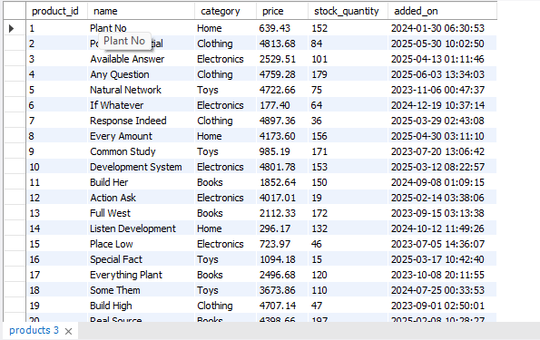
-- 3. List all unique product categories
Input: select distinct category from products;
Output:
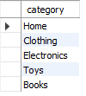
-- 4. Show all products priced above ₹1,000
Input: select * from products where price > 1000;
Output:
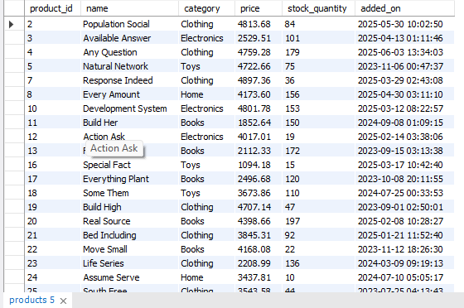
-- 5. Display products within a mid-range price bracket (₹2,000 to ₹5,000)
Input: select * from products where price between 2000 and 5000;
Output:
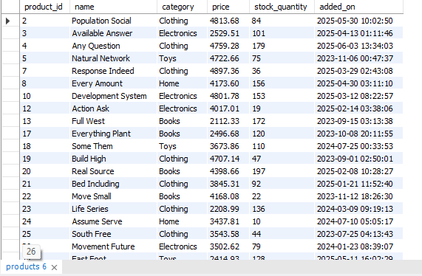
-- 6. Fetch data for specific customer IDs
Input: select * from customers where customer_id in (2,4,6,8);
Output:
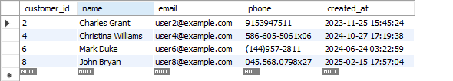
-- 7. Identify customers whose names start with the letter ‘A’
Input: select * from customers where name like 'A%';
Output:
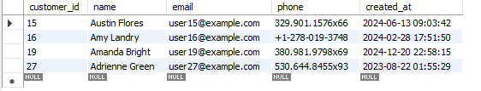
-- 8. List electronics products priced under ₹3,000
Input: select * from products where category = 'Electronics'and price < 3000;
Output:
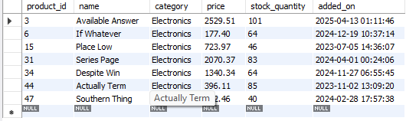
-- 9. Display product names and prices in descending order of price
Input: select name, price from products order by price desc;
Output:
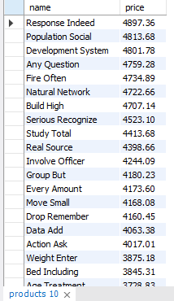
-- 10. Display product names and prices sorted by price and then by name
Input: select name, price from products order by price desc , name asc;
Output:
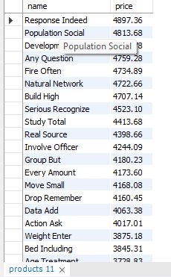
-- Level 2: Filtering and Formatting
--1. Retrieve orders where customer information is missing
Input: select * from orders where customer_id is null;
Output:
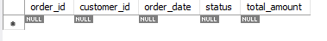
--2. Display customer names and emails using column aliases
Input: select name AS FULL_NAME, email as CUSTOMER_EMAIL_ADDRESS from customers;
Output:
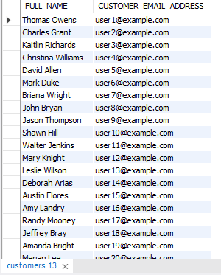
--3. Calculate total value per item ordered
Input: select order_item_id , (quantity * item_price) as total_value_per_item from order_items;
Output:
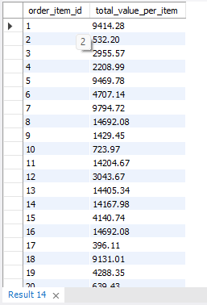
--4. Combine customer name and phone number
Input: select concat( name, ' - ', phone) as customer_contact from customers;
Output:
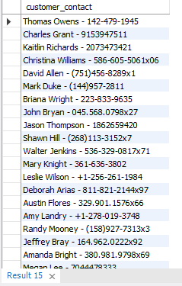
--5. Extract only the date part from order timestamps
Input: select order_id, customer_id, date(order_date) as 'date',status,total_amount from orders;
Output:
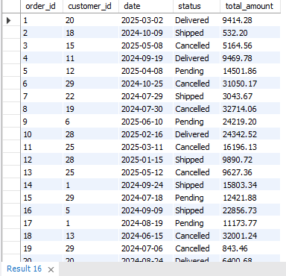
--6. List products that do not have any stock left
Input: select * from products where stock_quantity =0;
Output:
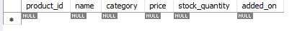
-- Level 3: Aggregations
-- 1. Count the total number of orders placed
Input: select count(order_id) from orders;
Output:
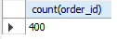
-- 2. Calculate the total revenue collected from all orders
Input: select sum(amount_paid) as total_revenue from payments;
Output:
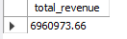
-- 3. Calculate the average order value
Input: select round(avg(total_amount),2) as average_order from orders;
Output:
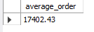
-- 4. Count the number of customers who have placed at least one order
Input: select count(distinct(customer_id)) as active_customer from orders;
Output:
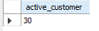
-- 5. Find the number of orders placed by each customer
Input: select customer_id , count(order_id) AS TOTAL_ORDER from orders group by customer_id;
Output:
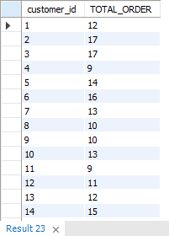
-- 6. Find total sales amount made by each customer
Input: select customer_id, sum(total_amount) as TOTAL_AMOUNT_EACH_CUSTOMER from orders group by customer_id;
Output:
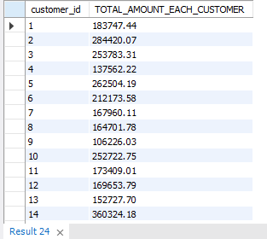
-- 7. List the number of products sold per category
Input:select category, count(product_id) as product_count from products group by category;
Output:
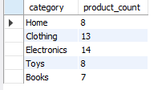
-- 8. Find the average item price per category
Input:select category, round(avg(price),2) as AVG_ITEM_PRICE from products group by category;
Output:
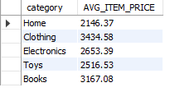
-- 9. Show number of orders placed per day
Input: select date(order_date), count(order_id) as ORDER_PER_DAY from orders group by date(order_date) order by ORDER_PER_DAY desc;
Output:
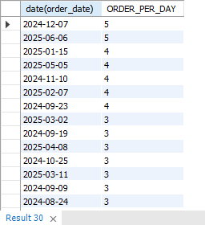
-- 10. List total payments received per payment method
Input: select method, sum(amount_paid) as payment_recieved from payments group by method order by payment_recieved desc;
Output:
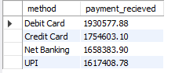
-- Level 4: JOINS
-- 1. Retrieve order details along with the customer name (INNER JOIN)
Input: select o.order_id, c.name, o.total_amount from customers c
inner join orders o on o.customer_id = c.customer_id;
Output:
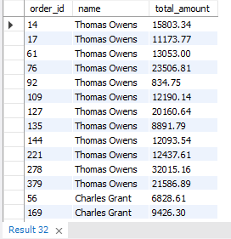
-- 2. Get list of products that have been sold (INNER JOIN with order_items)
Input: select distinct p.product_id, p.name, p.category from products p
inner join order_items o on p.product_id = o.product_id;
Output:
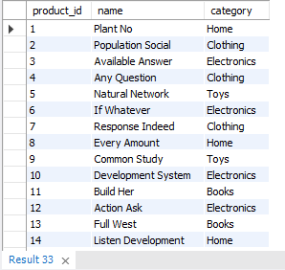
-- 3. List all orders with their payment method (INNER JOIN)
Input:select o.*, p.method from orders o inner join payments p on o.order_id = p.order_id;
Output:

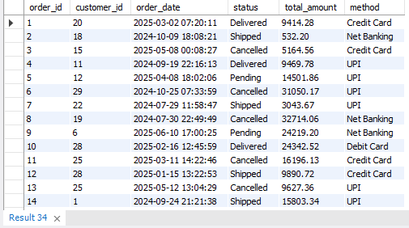
-- 4. Get list of customers and their orders (LEFT JOIN)
Input: select c.name, o.order_id from customers c
left join orders o on c.customer_id= o.customer_id;
Output:
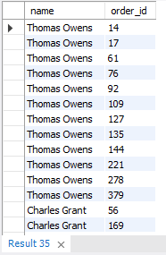
-- 5. List all products along with order item quantity (LEFT JOIN)
Input: select p.name as product_name, p.category, sum(o.quantity) as total_quantity from products p left join order_items o on p.product_id = o.product_id group by p.category , p.name;
Output:
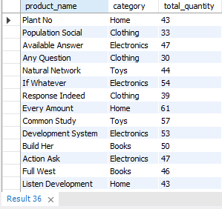
-- 6. List all payments including those with no matching orders (RIGHT JOIN)
Input: select p.* from orders o right join payments p on o.order_id = p.order_id where o.order_id is null;
Output:
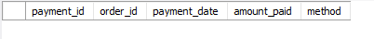
-- 7. Combine data from three tables: customer, order, and payment
Input: select c.name, o.order_id , o.total_amount, p.method, date(payment_date) as order_date from customers c join orders o on c.customer_id = o.customer_id join payments p on o.order_id = p.order_id;
Output:
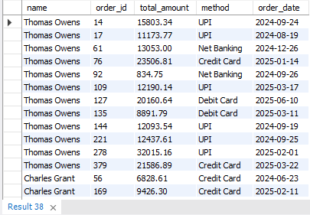

-- Level 5: Subqueries
-- 1. List all products priced above the average product price
Input: select * from products
where price > (select avg(price) from products) order by price desc;
Output:
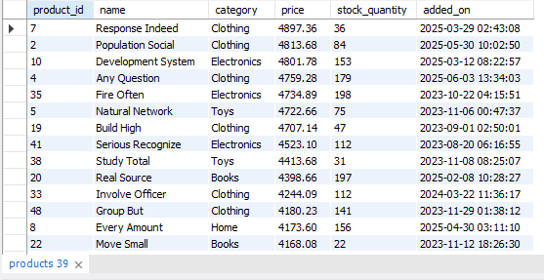
-- 2. Find customers who have placed at least one order
Input: select * from customers c where (select count(*) from orders o where o.customer_id = c.customer_id) > 0;
Output:
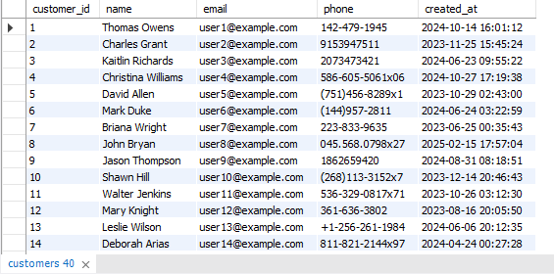
-- 3. Show orders whose total amount is above the average for that customer
Input: select customer_id, order_id, sum(total_amount) as total_spent from orders group by customer_id, order_id having total_spent > (select avg(amount_paid) from payments) order by total_spent desc;
Output:
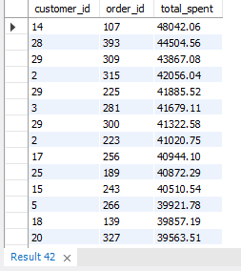
-- 4. Display customers who haven’t placed any orders
Input: select c.* from customers c left join orders o on c.customer_id = o.customer_id where o.order_id is null;
Output:
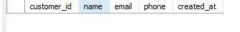
-- 5. Show products that were never ordered
Input: select p.* from products p left join order_items oi on p.product_id = oi.product_id where oi.product_id is null;
Output:
-- 6. Show highest value order per customer
Input: select o.customer_id, o.order_id, o.total_amount from orders o where o.total_amount = (select max(o2.total_amount) from orders o2 where o2.customer_id = o.customer_id ) order by o.total_amount desc;
Output:

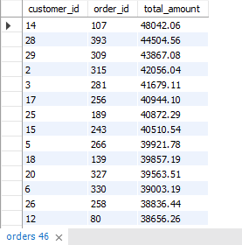
-- 7. Highest Order Per Customer (Including Names)
Input: select c.name, o.customer_id, o.order_id, o.total_amount as highest_order from orders o join customers c on o.customer_id = c.customer_id where o.total_amount = (select max(o2.total_amount) from orders o2 where o2.customer_id = o.customer_id) order by highest_order desc;
Output:
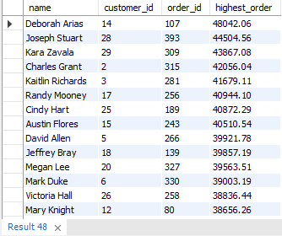
-- Level 6: Set Operations
-- 1. List all customers who have either placed an order or written a product review
Input: select distinct c.customer_id, c.name, c.email from customers c left join orders o on c.customer_id = o.customer_id left join product_reviews pr on c.customer_id = pr.customer_id where o.customer_id is not null or pr.customer_id is not null;
Output:
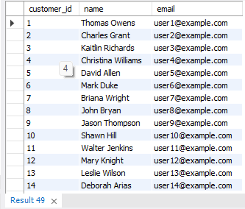
-- 2. List all customers who have placed an order as well as reviewed a product [intersect not supported]
Input: select customer_id, name, email from customers
where customer_id in (select customer_id from orders)
and customer_id in (select customer_id from product_reviews);
Output:
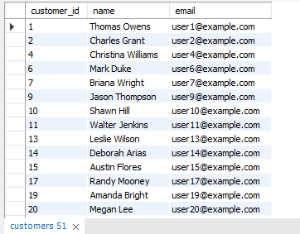

Conclusion
This SQL project demonstrates the practical implementation of database concepts such as filtering, joins, aggregations, subqueries, and reporting using a Retail Shop database. The project helps in understanding how SQL can be used to solve real-world business problems.

