**3. System Design**

**3.1 ER Diagram**

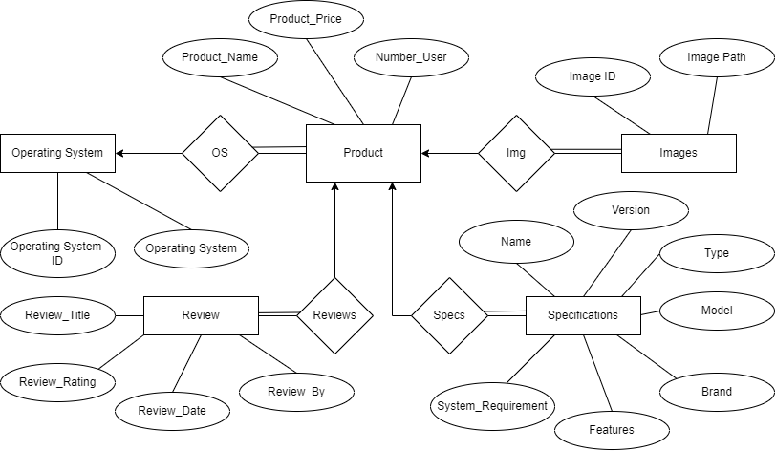

Fig. 3.1 Entity Relationship Diagram

**3.2 Data Flow Diagram**

**DFD Context Level**

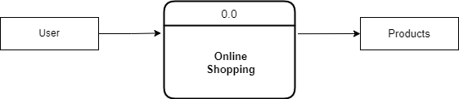

Fig. 3.2 0-Level Data Flow Diagram

**DFD First Level**

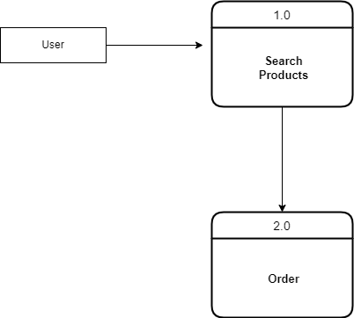

Fig. 3.3 1-Level Data Flow Diagram

**DFD Second Level**

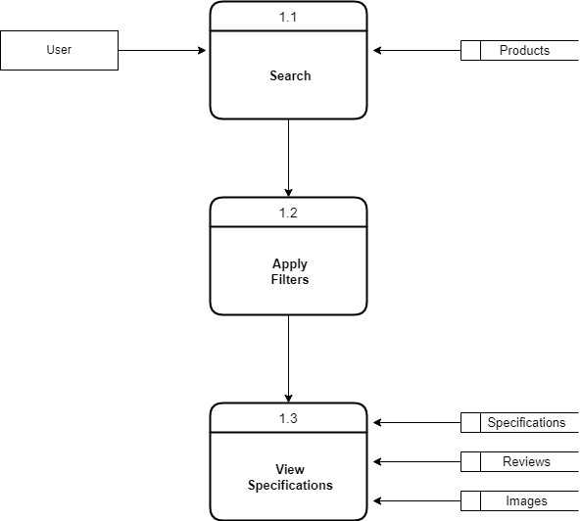

Fig. 3.4 2-Level Data Flow Diagram

**DFD Second Level**

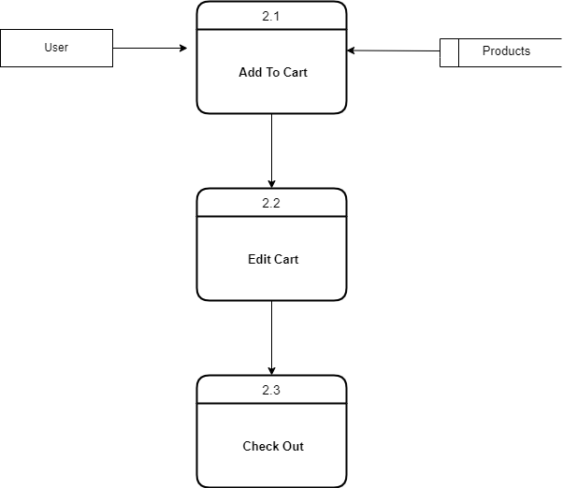

Fig. 3.5 2-Level Data Flow Diagram

**3.3 Use Case Diagram**

Use Case Diagram

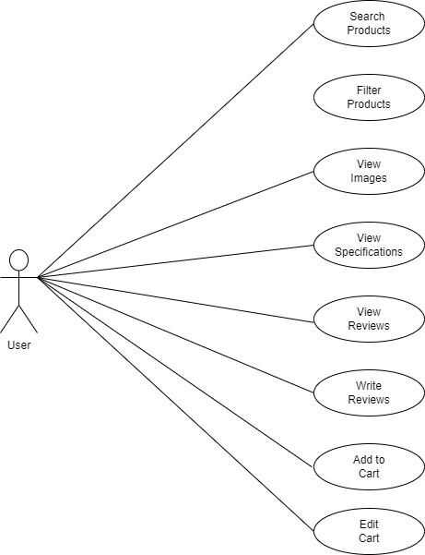

Fig. 3.6 Use Case Diagram