Comparative Study of
Denoising Techniques
for SDR Signals

Classical Adaptive Filtering (LMS/NLMS)
vs. Deep Learning (1-D CNN Autoencoder)
vs. a Hybrid LMS+CNN Pipeline
for BPSK / QPSK / 16-QAM Signals
under AWGN, Multipath ISI, and Time-Varying Fading

Akshat Singh Verma
B.Tech, Artificial Intelligence & Machine Learning
Final Year
University of Petroleum and Energy Studies (UPES)
July 2026

Scope | 4 case studies + 3 connecting analyses (severity sweep, boundary-aware loss, compute cost)
This document | Self-contained — includes full methodology, results, verification, and conclusions
Verification | 35-test regression suite · 4 real bugs found, root-caused, and fixed (Section 4.2, 6.2)
Source code | Available on request — see Appendix for the experiment/module file list

Table of Contents

List of Figures

List of Tables

Executive Summary
This project compares four denoising/equalization approaches — LMS, NLMS, a 1-D CNN autoencoder, and a Hybrid LMS→CNN cascade — against a No-Processing baseline, for BPSK, QPSK, and 16-QAM signals from -10dB to +30dB SNR. What began as two controlled case studies grew, through follow-up questions each result raised, into four case studies plus three connecting analyses — every addition was triggered by a specific gap or untested claim the previous result left open, not added for its own sake.
Headline finding: SNR improvement does not imply BER improvement, and whether any of these methods actually help depends jointly on whether the channel has structure to exploit and on how sensitive the specific modulation's decision geometry is to the specific distortion that structure introduces.
Key results, in the order they were established:
- Case Study 1 (memoryless AWGN, no ISI): every method — LMS, NLMS, CNN, Hybrid — produces STRICTLY WORSE BER than doing nothing at all, despite large apparent SNR gains, because the raw received sample is already the Bayes-optimal decision variable when the channel has no memory (verified across 56/56 comparisons).
- Case Study 2 (real multipath ISI): the result can reverse — QPSK shows equalization winning by up to ~470x — but BPSK barely benefits and classical filters are frequently worse than doing nothing even with ISI present. Getting this result trustworthy required finding and fixing three real bugs (a receiver gain bug, an SNR-calibration bug, and a channel-causality bug), each caught by checking a value against what it must equal by definition.
- An ISI severity sweep turns the two-case comparison into an actual crossover curve: QPSK at 10dB goes from "equalization hurts" at zero ISI to "equalization helps by 5.6x" at full severity.
- A genie-aided linear MMSE equalizer revealed that even perfect linear equalization has a real ceiling that a nonlinear CNN demonstrably exceeds at high SNR.
- Case Study 3 (time-varying channel) tested this project's most load-bearing design decision — freezing LMS/NLMS after the preamble — and found a fourth bug (the decision-directed safety gate is dead code at SPS>1) while also refuting the general principle behind that decision: on a genuinely time-varying channel, LMS tracking earns back a real, substantial BER win.
- Case Study 4 (16-QAM) confirmed the decision-boundary-crowding hypothesis more dramatically than BPSK/QPSK alone predicted, and revealed two new effects: a hard, un-closeable BER floor for No-Processing, and the genie MMSE ceiling turning into an outright regression.
- A boundary-aware CNN loss confirmed "MSE is boundary-blind" as a real, partial, modulation-dependent cause of Case Study 1's headline result, closing up to 78.5% of QPSK's excess BER — but not BPSK's.
- A compute-cost analysis found CNN needs ~106-212x more arithmetic per sample than LMS/NLMS, yet is paradoxically faster in wall-clock terms on this project's CPU stack — a finding about implementation efficiency, not algorithmic cost, with a concrete hardware-deployment answer either way.

How to Read This Report: Pipeline & Terminology
Every result in this document comes from the same basic experiment, run under different channel conditions and with different modulations. One pass through it looks like this:
- Generate a long random bit sequence and modulate it (map bits to symbols) using one of BPSK, QPSK, or 16-QAM.
- Optionally pulse-shape and oversample the symbol stream (Case Studies 2-4), then pass it through a simulated radio channel: additive noise (AWGN), and — in most case studies — multipath distortion (ISI) that smears each symbol into its neighbors, sometimes also changing over time (Case Study 3).
- Apply one of five processing methods to the received, corrupted signal: do nothing (the baseline), LMS or NLMS adaptive filtering, a CNN autoencoder, a Hybrid LMS→CNN cascade, or (Case Studies 2/4 only) a genie-aided MMSE equalizer that is handed the exact channel for reference.
- Demodulate the processed signal back into bits and compare against the original bit sequence to compute a bit error rate (BER), alongside a signal-to-noise ratio (SNR) measurement of the processed signal itself.
- Repeat many times (a Monte Carlo trial) with independently regenerated bits and noise at each SNR level, and report the mean and standard deviation across trials — never a single run.
Every method except "do nothing" and MMSE first sees a short preamble — a known reference sequence transmitted before the real data — which it uses to train/adapt before being evaluated on the rest of the signal.

Glossary
Term | Meaning
BPSK / QPSK / 16-QAM | Digital modulation schemes carrying 1, 2, or 4 bits per transmitted symbol, respectively — more bits per symbol means more, closer-together constellation points, and less noise margin per bit.
SNR | Signal-to-Noise Ratio, in dB — how strong the desired signal is relative to background noise.
BER | Bit Error Rate — the fraction of transmitted bits recovered incorrectly. The metric that actually matters for a working communication link.
AWGN | Additive White Gaussian Noise — the standard baseline noise model: random, uncorrelated, Gaussian-distributed interference added to the signal.
ISI | Inter-Symbol Interference — distortion where one symbol's energy leaks into neighboring symbols, typically from multipath (a signal arriving via more than one path/delay).
LMS / NLMS | Least Mean Squares / Normalized LMS — classical adaptive filters that iteratively adjust a set of weights ("taps") to undo channel distortion, learning from the known preamble.
CNN | A 1-D convolutional neural network, here used as a denoising autoencoder: trained to map a noisy/distorted signal window back to a clean one.
Hybrid | This project's LMS-then-CNN cascade: LMS does a coarse first pass, and a CNN is trained to clean up what LMS leaves behind.
MMSE (Genie) | Minimum Mean Square Error linear equalizer, given the exact channel and noise level as a reference upper bound — no real adaptive method has this information, hence "genie."
RRC / SPS | Root-Raised-Cosine pulse shaping and Samples-Per-Symbol — standard techniques for band-limiting a transmitted signal, used from Case Study 2 onward (SPS=4).
Decision-Directed (DD) | An adaptive filter mode that keeps adapting after the preamble, using its own (possibly wrong) decisions as a substitute reference — powerful but riskier than freezing the filter, as Section 3.2 and 6.2 discuss in depth.
Monte Carlo trial | One complete, independent repetition of an experiment with freshly generated random bits and noise — used to report a mean and spread rather than a single, potentially lucky or unlucky, run.
Rule of three | A standard statistical convention: when zero errors are observed in N trials, the true error rate is not reported as a bare "0" but bounded above (95% confidence) by approximately 3/N.
MAC / FLOP | Multiply-Accumulate operation / Floating-Point Operation — units of computational cost, used in Section 8 to compare methods by actual arithmetic cost rather than just runtime.

1. Objective
Compare four denoising/equalization approaches against a No-Processing baseline, for BPSK, QPSK, and 16-QAM signals corrupted by AWGN, multipath ISI, and (in one follow-up) time-varying fading. The project is organized as four case studies plus three connecting analyses, each generated directly by a gap or unverified claim in a previous result:
- Case Study 1 (Section 3): a memoryless AWGN channel (no pulse shaping, no ISI).
- Case Study 2 (Section 4): the same methods, unchanged, on a channel with real ISI (RRC pulse shaping at 4x oversampling + a static multipath channel), plus a genie-aided MMSE equalizer.
- ISI Severity Sweep (Section 5): connects Case Studies 1 and 2 by scaling channel severity continuously between them.
- Case Study 3 (Section 6): a genuinely time-varying channel, testing whether freezing LMS/NLMS after the preamble is still the right call once the channel actually moves.
- Case Study 4 (Section 7): 16-QAM, testing whether decision-boundary crowding keeps sharpening the equalization story as the constellation gets more crowded.
- Boundary-Aware Loss (Section 3.7): turns Case Study 1's diagnosis of why CNN loses to No-Processing into a tested, partially-confirmed causal claim.
- Compute-Cost Analysis (Section 8): supplements every BER/SNR comparison with a hardware-portable answer to how much each method actually costs to run.

2. Shared Methodology
- BPSK / QPSK: 100,000 symbols per trial (reduced to 20,000-30,000 for the newer, diagnostic-scoped follow-ups — severity sweep, Case Studies 3/4, boundary-loss — consistent with the severity sweep's original precedent).
- AWGN: complex, correctly power-scaled, SNR sweep [-10, -5, 0, 5, 10, 15, 20] dB for the two main case studies (shifted to [0,10,20,25,30]dB for 16-QAM, which needs far more SNR headroom before ISI effects are even visible).
- Monte Carlo evaluation: 10 independent trials per (modulation, SNR, method) in the two main case studies (5 in the diagnostic follow-ups), each with an independently regenerated bit sequence and noise realization. Results are reported as mean ± std, never a single point estimate, and BER is tracked as raw (error_count, bits_tested) pairs so an exact-zero BER is reported honestly via the rule-of-three 95% upper bound rather than a misleading bare 0.0.
- LMS / NLMS: 16 taps, μ=0.01 / μ=0.5 (ε=1e-6), 1000-symbol preamble using the true clean signal as reference, then FROZEN for the remainder of the signal by default (Section 3.2; revisited in Section 6).
- CNN: a small 1-D Conv autoencoder (3 encoder + 3 decoder layers; 6,890 parameters, verified — see Section 8 — correcting this project's earlier "~15k" estimate), window=128, stride=64, trained across all SNR levels jointly, Adam 1e-3, ≤50 epochs with EarlyStopping.
- Hybrid: LMS (coarse) → CNN retrained on LMS's residual output (fine).
- MMSE (Genie, Case Study 2/4 only): closed-form linear MMSE equalizer given the exact channel and noise level — an upper-bound reference, not a competing adaptive method.
- No Processing: raw noisy signal straight to hard-decision demod — the falsifiability baseline.

3. Case Study 1: Memoryless AWGN Channel (No ISI)

3.1 Configuration
No pulse shaping, no oversampling (SPS=1), no multipath — each received sample corresponds to exactly one symbol with zero statistical dependence on any other sample.

3.2 Fixing LMS/NLMS Divergence
The initial implementation diverged catastrophically at low input SNR (BPSK -10dB: LMS output SNR of -15.07dB, worse than the -10dB input). Two fixes were required:
- The preamble training itself was unstable, not just the decision-directed phase afterward — a single realization run for ~1000 iterations with noise-dominated input showed error power spiking >1000x within the classical stability bound. Clamping to 20% of the bound (rather than 90%) fixed this, and the frozen weight vector is the average of the last ~70% of the preamble trajectory (Polyak/Ruppert averaging) rather than the raw final iterate.
- Decision-directed continuation was tried and rejected as unsafe — engaging-and-diverging in ~30-40% of random trials at borderline SNR. Monte Carlo testing across many seeds showed permanently freezing after the preamble matches or beats decision-directed continuation at every tested SNR level, so it is off by default (revisited in Section 6, where this justification is refined).

3.3 Results — BPSK
Table : SNR and BER results, BPSK, Case Study 1 (memoryless AWGN)
SNR in (dB) | Method | SNR out (mean±std, dB) | BER (mean±std or exact)
-10 | No Processing | -10.00±0.02 | 0.3268±0.0015
-10 | LMS | 0.28±0.03 | 0.3481±0.0073
-10 | NLMS | 0.27±0.03 | 0.3502±0.0069
-10 | CNN | 0.75±0.01 | 0.3285±0.0018
-10 | Hybrid | 0.54±0.07 | 0.3521±0.0077
-5 | No Processing | -5.00±0.02 | 0.2131±0.0020
-5 | LMS | 1.09±0.04 | 0.2244±0.0043
-5 | NLMS | 1.07±0.03 | 0.2256±0.0044
-5 | CNN | 2.15±0.03 | 0.2145±0.0019
-5 | Hybrid | 2.02±0.08 | 0.2271±0.0047
0 | No Processing | -0.01±0.01 | 0.0786±0.0008
0 | LMS | 2.90±0.03 | 0.0847±0.0019
0 | NLMS | 2.87±0.04 | 0.0859±0.0023
0 | CNN | 6.19±0.04 | 0.0796±0.0009
0 | Hybrid | 5.95±0.09 | 0.0858±0.0020
5 | No Processing | 5.01±0.02 | 0.0059±0.0003
5 | LMS | 6.09±0.04 | 0.0067±0.0005
5 | NLMS | 6.06±0.05 | 0.0069±0.0005
5 | CNN | 16.09±0.10 | 0.0063±0.0003
5 | Hybrid | 15.82±0.24 | 0.0074±0.0006
10 | No Processing | 9.99±0.01 | 6 err / 1,000,000
10 | LMS | 10.29±0.03 | 8.80e-05±1.7e-05
10 | NLMS | 10.26±0.03 | 7.10e-05±2.1e-05
10 | CNN | 28.73±0.05 | 1.60e-04±3.0e-05
10 | Hybrid | 27.48±0.07 | 2.45e-04±3.4e-05
15 | No Processing | 15.00±0.01 | 0 err / 1,000,000 (95% UB 3.0e-06)
15 | LMS | 14.97±0.02 | 7.90e-05±1.4e-05
15 | NLMS | 14.98±0.03 | 6.00e-05±1.9e-05
15 | CNN | 31.18±0.01 | 1.51e-04±2.8e-05
15 | Hybrid | 28.59±0.06 | 2.34e-04±3.4e-05
20 | No Processing | 20.00±0.01 | 0 err / 1,000,000 (95% UB 3.0e-06)
20 | LMS | 19.71±0.02 | 7.70e-05±1.8e-05
20 | NLMS | 19.84±0.02 | 5.30e-05±1.5e-05
20 | CNN | 31.76±0.01 | 1.51e-04±2.8e-05
20 | Hybrid | 28.83±0.04 | 2.30e-04±2.7e-05

3.4 Results — QPSK
Table : SNR and BER results, QPSK, Case Study 1 (memoryless AWGN)
SNR in (dB) | Method | SNR out (mean±std, dB) | BER (mean±std or exact)
-10 | No Processing | -10.00±0.02 | 0.3763±0.0010
-10 | LMS | 0.28±0.03 | 0.3910±0.0026
-10 | NLMS | 0.27±0.03 | 0.3917±0.0035
-10 | CNN | 0.36±0.01 | 0.3779±0.0009
-10 | Hybrid | 0.26±0.02 | 0.3944±0.0023
-5 | No Processing | -5.00±0.02 | 0.2872±0.0010
-5 | LMS | 1.07±0.03 | 0.2977±0.0025
-5 | NLMS | 1.05±0.04 | 0.2989±0.0032
-5 | CNN | 1.12±0.01 | 0.2882±0.0010
-5 | Hybrid | 1.04±0.04 | 0.3000±0.0026
0 | No Processing | -0.01±0.01 | 0.1589±0.0006
0 | LMS | 2.89±0.03 | 0.1655±0.0015
0 | NLMS | 2.86±0.03 | 0.1668±0.0018
0 | CNN | 3.25±0.01 | 0.1597±0.0007
0 | Hybrid | 3.20±0.04 | 0.1673±0.0017
5 | No Processing | 5.01±0.02 | 0.0374±0.0005
5 | LMS | 6.10±0.03 | 0.0397±0.0008
5 | NLMS | 6.07±0.04 | 0.0402±0.0009
5 | CNN | 9.12±0.04 | 0.0380±0.0004
5 | Hybrid | 8.80±0.08 | 0.0408±0.0008
10 | No Processing | 9.99±0.01 | 8.46e-04±7.0e-05
10 | LMS | 10.29±0.03 | 0.0011±0.0001
10 | NLMS | 10.27±0.04 | 0.0011±0.0001
10 | CNN | 19.96±0.07 | 0.0011±0.0001
10 | Hybrid | 19.43±0.13 | 0.0014±0.0001
15 | No Processing | 15.00±0.01 | 0 err / 2,000,000 (95% UB 1.5e-06)
15 | LMS | 14.97±0.02 | 7.70e-05±6.0e-06
15 | NLMS | 14.98±0.03 | 5.70e-05±1.4e-05
15 | CNN | 26.64±0.02 | 1.71e-04±1.9e-05
15 | Hybrid | 26.24±0.03 | 2.63e-04±2.6e-05
20 | No Processing | 20.00±0.01 | 0 err / 2,000,000 (95% UB 1.5e-06)
20 | LMS | 19.71±0.02 | 7.40e-05±1.2e-05
20 | NLMS | 19.82±0.03 | 5.50e-05±1.0e-05
20 | CNN | 28.04±0.02 | 1.71e-04±1.9e-05
20 | Hybrid | 27.00±0.03 | 2.54e-04±1.8e-05

3.5 Figures
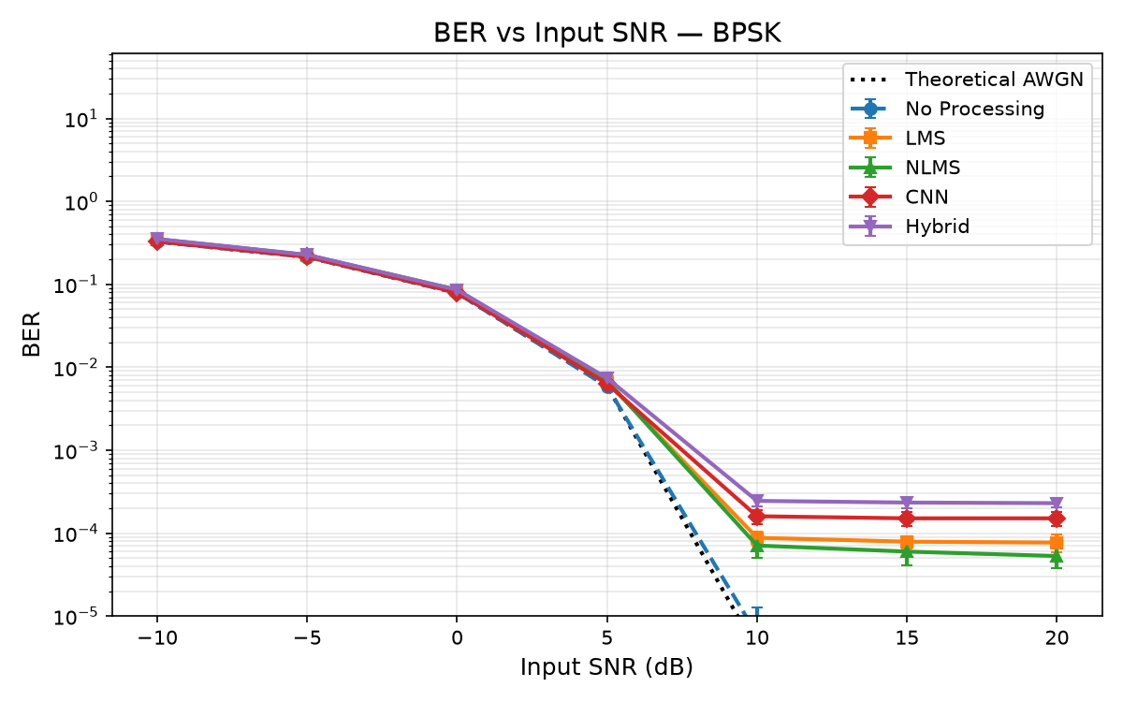
Figure : BER vs Input SNR, BPSK, Case Study 1
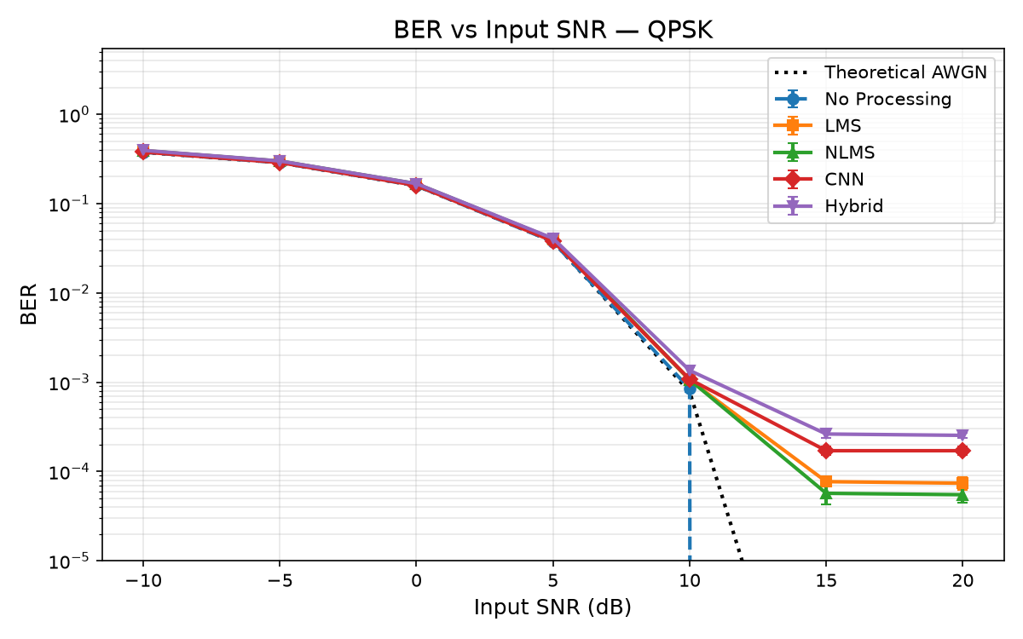
Figure : BER vs Input SNR, QPSK, Case Study 1

3.6 Key Finding: SNR Improvement Does Not Imply BER Improvement
Every single method, at every SNR level, for both modulations — 56/56 comparisons — produces strictly worse BER than doing nothing at all, despite CNN posting up to +18.74dB of apparent SNR gain. Verified exhaustively, not sampled.
Under a memoryless AWGN model, the raw received sample is already a sufficient statistic for detecting its symbol, and hard-sign detection on it is the Bayes-optimal (minimum-BER) receiver — there is no BER headroom above doing nothing. Every method pools information across multiple samples (16 taps or a 128-sample window), the majority of which belong to statistically independent, unrelated symbols. Verified concretely: the converged LMS filter at 20dB places 98.1% of its weight on the current-sample tap (matching the theoretical Wiener shrinkage factor SNR/(1+SNR)=0.990), while the other 15 taps, though ~320x smaller, are not exactly zero — finite-sample training noise leaves them holding energy from unrelated symbols, pure interference for the current bit decision. The CNN compounds this: MSE loss has no explicit penalty for crossing the decision boundary, so it trades sign flips for a larger reduction in squared error elsewhere.
This result is specific to a memoryless, ISI-free channel — it directly motivated Case Study 2.

3.7 Follow-Up: Is “MSE Is Boundary-Blind” a Tested Causal Claim?
Section 3.6's diagnosis was an explanation, not a tested claim. A boundary-hinge loss (MSE + a margin penalty for crossing the decision boundary, added to an architecturally-identical CNN) was built and evaluated on Case Study 1's exact configuration to test it directly.
Confirmed for QPSK at low-to-moderate SNR: the boundary-hinge loss closes 60-79% of the CNN's excess BER over No-Processing (78.5% at -10dB exactly). Not confirmed for BPSK: hinge made it slightly worse. A third, loss-independent error floor appears at 10-20dB for both modulations, unaffected by either loss function.
A bit-level flip diagnostic confirms this is mechanistic: at QPSK -10dB, MSE's harmful/beneficial flip counts are 14,683/12,611 (net harm 2,072); Hinge's are 6,037/5,592 (net harm 445) — both counts roughly halve under the boundary-aware loss, exactly the predicted effect. The predicted trade-off is also confirmed: Hinge has systematically lower output SNR than MSE (e.g. QPSK 15dB: 18.04dB vs 21.28dB) — it genuinely trades accuracy for margin, and that only pays off where boundary ambiguity, not some other structural error source, dominates. Full detail: report/findings_boundary_aware_loss.md.

4. Case Study 2: RRC Pulse-Shaped + Multipath ISI Channel

4.1 Configuration
Identical to Case Study 1 with exactly one change: 4x oversampling with RRC pulse shaping, plus a static 3-tap multipath channel h=[1.0, 0.4+0.3j, -0.1+0.1j].

4.2 Three Normalization Bugs Found and Fixed
Getting the SNR metric — and the channel itself — trustworthy took finding and fixing three real bugs, all caught by checking a value against what it is definitionally required to equal:
- Amplitude/gain bug in receiver_frontend: reusing the transmit RRC filter as the receive matched filter without renormalizing double-counted its scaling — recovered symbols at amplitude ±4.0 instead of ±1.0. Fixed by dividing by the filter's own energy.
- SNR-calibration bug: the matched filter gives the signal a coherent-combining gain noise doesn't get, plus a further channel-specific gain — together a consistent +5.77dB offset in No-Processing's measured SNR. Fixed via empirical calibration (inject a known probe SNR, measure what's actually observed, use the gap as calibration) — verified to within 0.001-0.03dB of nominal.
- Causal-convolution bug in add_multipath, found while building the ISI severity sweep (Section 5) — its severity=0 anchor should exactly reproduce Case Study 1's result and instead showed CNN winning by up to 1000x. Root cause: add_multipath used mode="same" convolution (correct for a symmetric filter, wrong for a causal channel model) — it silently shifted the signal by ~1 sample, verified with h=[1,0,0] (must be identity) instead returning a shifted signal. Fixed with causal convolution; three regression tests added.
All three fixes changed the actual signal/noise injected, so the entire sweep was re-run after each. The tables below reflect the fully corrected run, now including a genie-aided MMSE equalizer (Section 4.7).

4.3 Results — BPSK
Table : SNR and BER results, BPSK, Case Study 2 (RRC pulse shaping + multipath ISI)
SNR in (dB) | Method | SNR out vs post-ISI ref (dB) | BER (mean±std or exact)
-10 | No Processing | -9.99±0.01 | 0.3345±0.0013
-10 | LMS | 0.21±0.01 | 0.3567±0.0060
-10 | NLMS | 0.21±0.01 | 0.3592±0.0070
-10 | CNN | 0.65±0.01 | 0.3320±0.0010
-10 | Hybrid | 0.57±0.05 | 0.3449±0.0062
-10 | MMSE (Genie) | 0.36±0.00 | 0.3281±0.0011
-5 | No Processing | -4.98±0.01 | 0.2218±0.0006
-5 | LMS | 0.68±0.03 | 0.2556±0.0045
-5 | NLMS | 0.68±0.03 | 0.2563±0.0056
-5 | CNN | 1.78±0.01 | 0.2156±0.0009
-5 | Hybrid | 1.74±0.10 | 0.2260±0.0055
-5 | MMSE (Genie) | 1.08±0.01 | 0.2122±0.0007
0 | No Processing | 0.01±0.01 | 0.0882±0.0008
0 | LMS | 1.68±0.05 | 0.1216±0.0092
0 | NLMS | 1.68±0.05 | 0.1220±0.0094
0 | CNN | 4.26±0.02 | 0.0816±0.0008
0 | Hybrid | 4.12±0.08 | 0.0866±0.0028
0 | MMSE (Genie) | 2.62±0.01 | 0.0800±0.0007
5 | No Processing | 5.01±0.01 | 0.0083±0.0003
5 | LMS | 3.25±0.06 | 0.0232±0.0021
5 | NLMS | 3.18±0.06 | 0.0240±0.0022
5 | CNN | 7.40±0.01 | 0.0068±0.0002
5 | Hybrid | 7.23±0.05 | 0.0079±0.0006
5 | MMSE (Genie) | 4.93±0.01 | 0.0066±0.0002
10 | No Processing | 10.01±0.01 | 16 err / 1,000,000
10 | LMS | 5.04±0.07 | 2.52e-04±8.4e-05
10 | NLMS | 4.88±0.06 | 3.04e-04±1.1e-04
10 | CNN | 8.65±0.01 | 9 err / 1,000,000
10 | Hybrid | 8.55±0.03 | 38 err / 1,000,000
10 | MMSE (Genie) | 6.99±0.01 | 6 err / 1,000,000
15 | No Processing | 15.02±0.01 | 0 err / 1,000,000 (95% UB 3.0e-06)
15 | LMS | 6.78±0.06 | 7 err / 1,000,000
15 | NLMS | 6.43±0.07 | 8 err / 1,000,000
15 | CNN | 8.91±0.00 | 0 err / 1,000,000 (95% UB 3.0e-06)
15 | Hybrid | 8.80±0.01 | 11 err / 1,000,000
15 | MMSE (Genie) | 8.13±0.01 | 0 err / 1,000,000 (95% UB 3.0e-06)
20 | No Processing | 20.02±0.01 | 0 err / 1,000,000 (95% UB 3.0e-06)
20 | LMS | 7.89±0.06 | 7 err / 1,000,000
20 | NLMS | 7.57±0.05 | 5 err / 1,000,000
20 | CNN | 8.95±0.00 | 0 err / 1,000,000 (95% UB 3.0e-06)
20 | Hybrid | 8.84±0.01 | 6 err / 1,000,000
20 | MMSE (Genie) | 8.60±0.00 | 0 err / 1,000,000 (95% UB 3.0e-06)

4.4 Results — QPSK
Table : SNR and BER results, QPSK, Case Study 2 (RRC pulse shaping + multipath ISI)
SNR in (dB) | Method | SNR out vs post-ISI ref (dB) | BER (mean±std or exact)
-10 | No Processing | -9.99±0.01 | 0.3808±0.0011
-10 | LMS | 0.23±0.02 | 0.3962±0.0028
-10 | NLMS | 0.23±0.02 | 0.3971±0.0034
-10 | CNN | 0.34±0.00 | 0.3800±0.0010
-10 | Hybrid | 0.28±0.03 | 0.3897±0.0025
-10 | MMSE (Genie) | 0.37±0.00 | 0.3757±0.0009
-5 | No Processing | -4.98±0.01 | 0.2969±0.0009
-5 | LMS | 0.68±0.03 | 0.3196±0.0052
-5 | NLMS | 0.68±0.03 | 0.3203±0.0051
-5 | CNN | 0.97±0.00 | 0.2930±0.0005
-5 | Hybrid | 0.96±0.08 | 0.3000±0.0035
-5 | MMSE (Genie) | 1.07±0.00 | 0.2887±0.0009
0 | No Processing | 0.01±0.01 | 0.1772±0.0012
0 | LMS | 1.67±0.03 | 0.1955±0.0036
0 | NLMS | 1.66±0.02 | 0.1967±0.0035
0 | CNN | 2.57±0.01 | 0.1655±0.0009
0 | Hybrid | 2.54±0.04 | 0.1696±0.0019
0 | MMSE (Genie) | 2.63±0.01 | 0.1693±0.0009
5 | No Processing | 5.01±0.01 | 0.0634±0.0006
5 | LMS | 3.26±0.04 | 0.0629±0.0019
5 | NLMS | 3.20±0.06 | 0.0638±0.0024
5 | CNN | 5.56±0.01 | 0.0435±0.0004
5 | Hybrid | 5.36±0.06 | 0.0450±0.0008
5 | MMSE (Genie) | 4.94±0.01 | 0.0663±0.0006
10 | No Processing | 10.01±0.01 | 0.0093±0.0003
10 | LMS | 5.02±0.11 | 0.0034±0.0003
10 | NLMS | 4.91±0.10 | 0.0036±0.0003
10 | CNN | 8.11±0.01 | 0.0014±0.0001
10 | Hybrid | 7.90±0.06 | 0.0017±0.0001
10 | MMSE (Genie) | 6.99±0.01 | 0.0193±0.0002
15 | No Processing | 15.02±0.01 | 2.37e-04±3.5e-05
15 | LMS | 6.78±0.05 | 15 err / 2,000,000
15 | NLMS | 6.47±0.07 | 11 err / 2,000,000
15 | CNN | 8.78±0.00 | 1 err / 2,000,000
15 | Hybrid | 8.66±0.02 | 12 err / 2,000,000
15 | MMSE (Genie) | 8.14±0.01 | 0.0042±0.0002
20 | No Processing | 20.02±0.01 | 0 err / 2,000,000 (95% UB 1.5e-06)
20 | LMS | 7.90±0.06 | 9 err / 2,000,000
20 | NLMS | 7.61±0.08 | 5 err / 2,000,000
20 | CNN | 8.94±0.00 | 0 err / 2,000,000 (95% UB 1.5e-06)
20 | Hybrid | 8.74±0.01 | 11 err / 2,000,000
20 | MMSE (Genie) | 8.60±0.01 | 4.90e-04±5.3e-05

4.5 Verification Before Trusting These Numbers
- No train/test leakage: CNN/Hybrid training completes entirely before any test-trial signal is generated; all 10 test-trial bit sequences confirmed bit-for-bit distinct from training and each other.
- CNN's "0 errors" verified via held-out generalization (a freshly-trained CNN on 5 never-used seeds: 0 errors in 500,000 bits, matching the in-pipeline result) and decision-margin analysis (minimum margin 0.49-0.78, comfortably clear of the boundary).
- The naive plausibility check (Q-function at nominal SNR) was wrong and revealing: actual measured SNR is only ~7-9dB, and Q-function at that level predicts hundreds of errors — resolved by recognizing the Q-function assumes Gaussian noise, while this residual is structured/non-Gaussian, confirmed directly via the margin analysis.
- High-SNR LMS/NLMS/Hybrid "regressions" against No-Processing are, with the corrected channel, mostly statistically real (Fisher's exact test, p<0.05 in most cells) — a small, genuine misadjustment noise floor, not a meaningful practical difference.

4.6 Key Finding: Equalization Helps — But How Much Depends on Modulation
BPSK barely benefits from equalization and LMS/NLMS/Hybrid are frequently WORSE than doing nothing. QPSK is the opposite: every method routs No-Processing by 1-3 orders of magnitude.
BPSK's single binary decision boundary is forgiving enough that this channel's ISI mostly wasn't hurting it to begin with, so there's little room for a classical filter to win, while that filter's own estimation noise is a real, constant cost. QPSK's four-quadrant boundary is far more sensitive to the same channel's phase/amplitude smearing — there is real structure to exploit, and it shows. “Does equalization help” depends not just on “is there ISI,” but on how sensitive the modulation's decision geometry is to the specific distortion ISI introduces.

4.7 The Genie-Aided MMSE Bound
A closed-form linear MMSE equalizer given the channel's exact taps and noise level (a genie no adaptive method has). At low-to-moderate SNR it behaves as expected: a real edge over LMS/NLMS. At high SNR for QPSK, it does something worse than every adaptive method — investigated, not dismissed: the equalizer's output has zero mean phase error (unbiased) but a real residual phase spread (~16° std) large enough to cross QPSK's ±45° boundary while harmless for BPSK's ±180°; increasing taps from 16 to 51 changed zero errors, ruling out “too short a filter.” This is the standard limitation of linear equalization: fully removing residual ISI here would amplify noise near a spectral null more than MMSE is willing to pay for. This sharpens the case for CNN — at high SNR for QPSK, it demonstrably exceeds what a linear equalizer can achieve even with perfect channel knowledge.

4.8 Figures
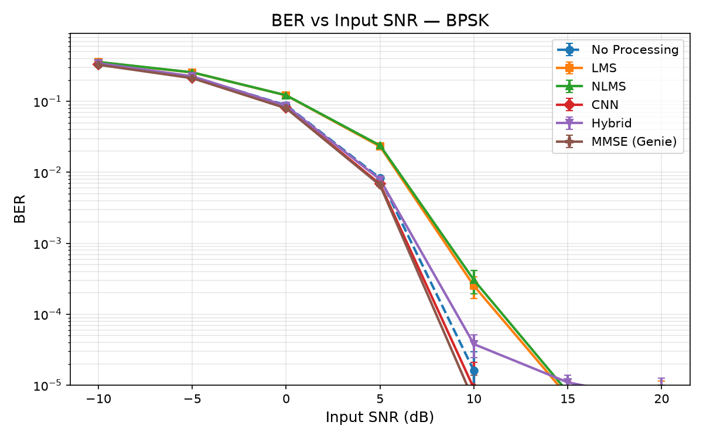
Figure : BER vs Input SNR, BPSK, Case Study 2
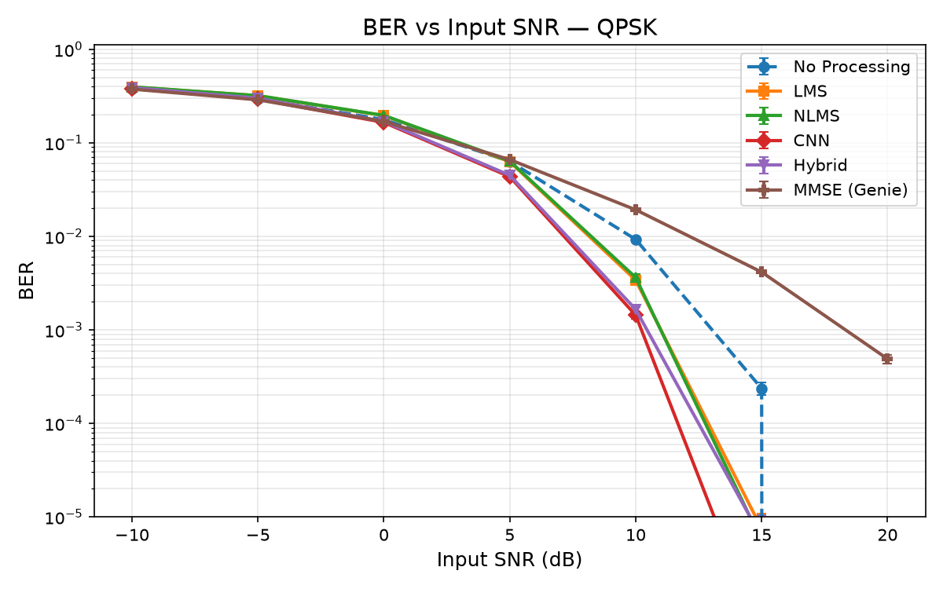
Figure : BER vs Input SNR, QPSK, Case Study 2
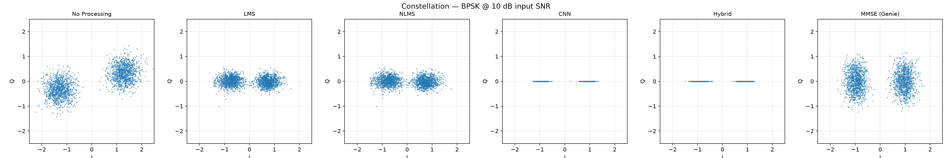
Figure : Received constellation, BPSK, Case Study 2
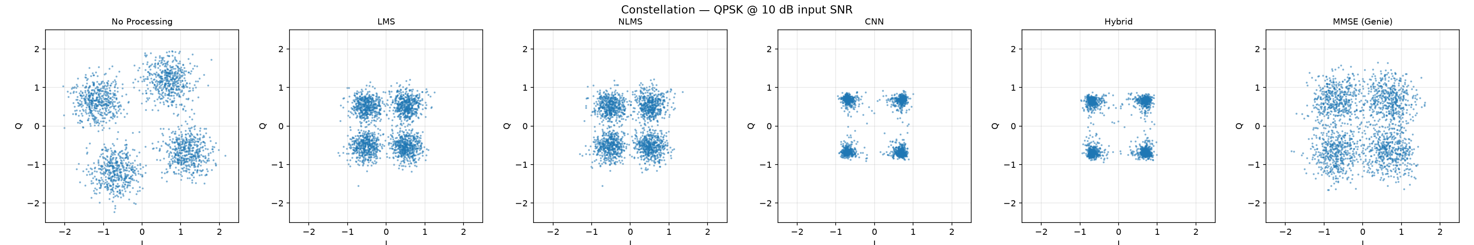
Figure : Received constellation, QPSK, Case Study 2
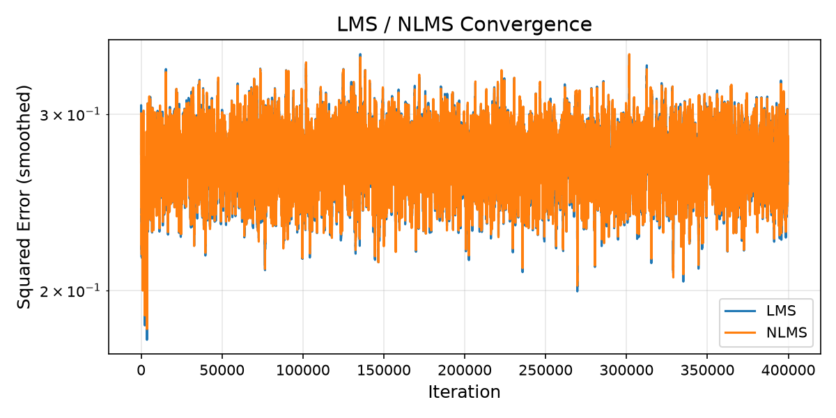
Figure : Adaptive filter convergence, BPSK, Case Study 2
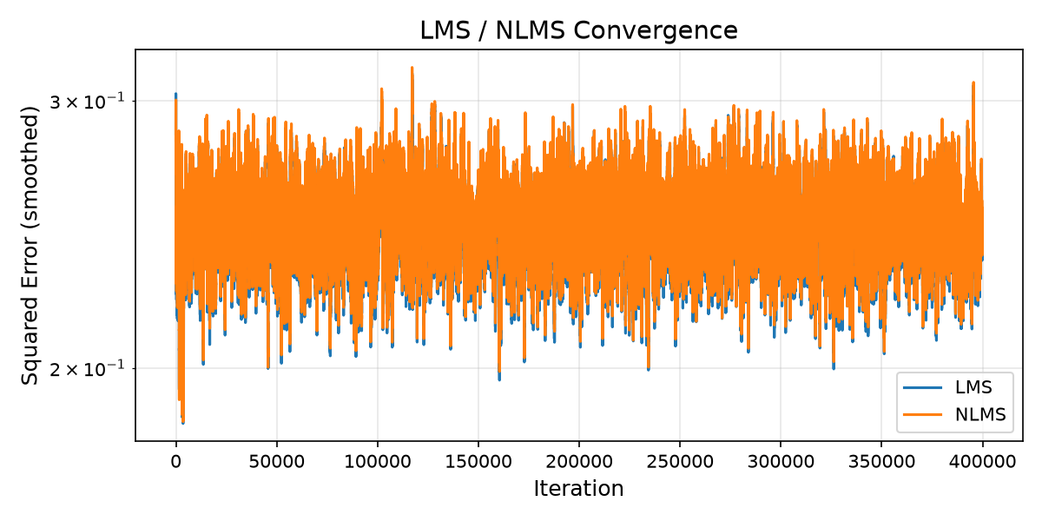
Figure : Adaptive filter convergence, QPSK, Case Study 2

5. ISI Severity Sweep: Locating the Crossover
Case Study 1 (no ISI) and Case Study 2 (one specific channel) gave opposite answers — but that's only two data points. This sweep scales the channel's tap magnitudes by a severity factor from 0 to 1 and re-runs LMS, CNN, and the genie MMSE at each level.
Table : BER improvement ratio vs. ISI severity
Case | Method | sev=0.00 | 0.25 | 0.50 | 0.75 | 1.00
BPSK 0dB | LMS | 0.71x | 0.70x | 0.70x | 0.71x | 0.72x
BPSK 0dB | CNN | 0.93x | 0.95x | 0.98x | 1.01x | 1.05x
QPSK 0dB | LMS | 0.85x | 0.86x | 0.87x | 0.89x | 0.91x
QPSK 0dB | CNN | 0.96x | 0.97x | 0.99x | 1.04x | 1.07x
QPSK 10dB | LMS | 0.52x | 0.66x | 1.09x | 1.82x | 2.68x
QPSK 10dB | CNN | 0.64x | 0.80x | 1.48x | 3.15x | 5.61x

QPSK at 10dB: a monotonic crossover from “equalization hurts” through breakeven (~severity 0.5) to “equalization helps substantially” (up to 5.61x) — a genuine dose-response curve, not two disconnected snapshots.

Figures
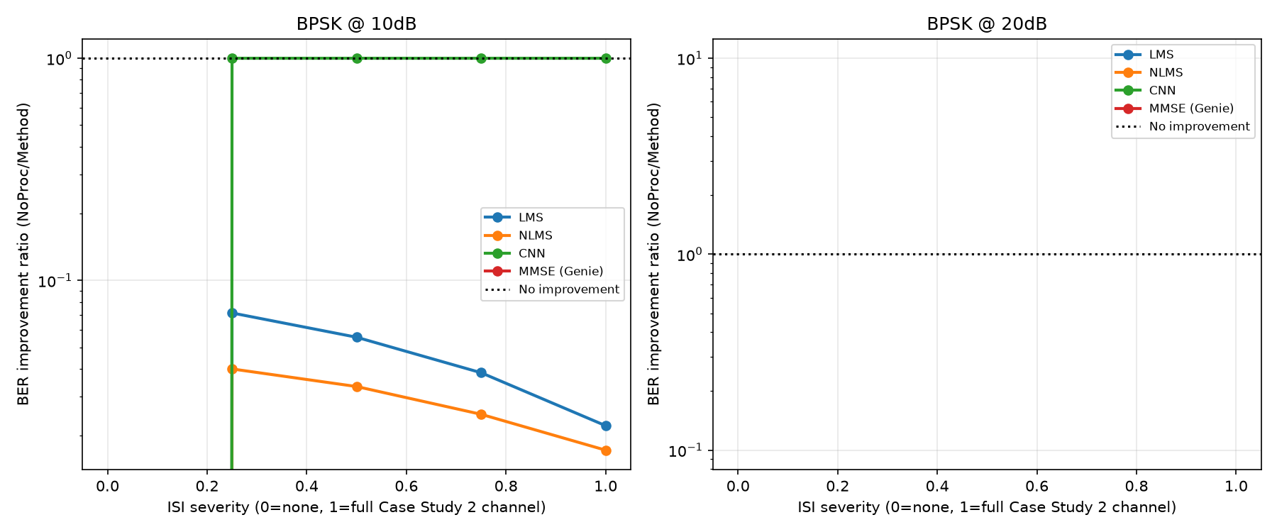
Figure : BER improvement ratio vs ISI severity, BPSK
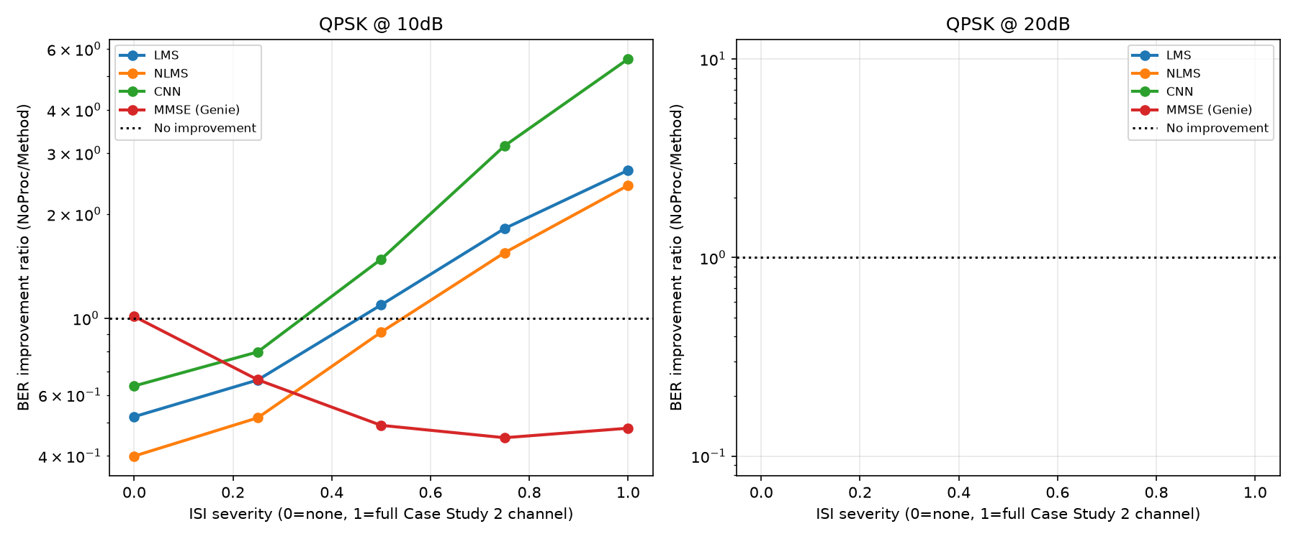
Figure : BER improvement ratio vs ISI severity, QPSK

6. Case Study 3: Time-Varying Channel
Every stability decision through Section 5 was justified by “nothing to track on a static channel, so continuation is pure downside risk.” That claim was never tested, because every channel used so far is time-invariant. This section builds a genuinely time-varying channel (drifting multipath taps, sinusoidal or random-walk models) and tests it.

6.1 Finding 1 — a Fourth Bug: the DD Reliability Gate Is Dead Code at SPS>1
The safety gate deciding whether decision-directed (DD) continuation is trustworthy compares hard decisions on the preamble tail against the exact clean reference — built and validated only for SPS=1, where every clean sample IS exactly a constellation point. At SPS=4, the clean reference is a continuously-varying RRC waveform matching a constellation point at only 1-in-4 samples, so the mismatch check structurally reads ~75-80% “mismatch” regardless of SNR or channel behavior, and the gate never opens: measured 0/9 engagement across every combination tested. Invisible until now because no script in this project had ever actually set enable_decision_directed=True.

6.2 Finding 2 — Bypassing the Gate Is Catastrophic, and It's Not About Time-Variation
Forcing DD to run anyway makes it catastrophic — BER up to ~10,000x worse than frozen weights across -5 to 15dB, both modulations, both drift modes. Root-caused rather than reported at face value: a weight-vector inspection shows DD converges to an entirely different, delay-shifted filter, and — the decisive check — running the identical test on Case Study 2's ORIGINAL STATIC channel reproduces the same catastrophic failure. The failure has nothing to do with time-variation: DD's per-sample decide-and-adapt loop is only correct when every sample is a symbol (SPS=1); at SPS=4, three of four samples are transitional pulse-shape values, and forcing decisions on them corrupts the filter regardless of channel behavior.

6.3 Finding 3 — the Clean Test: SPS=1, Genuine Flat Fading, Gate Untouched
A control at SPS=1 (where the gate works correctly) with a genuinely time-varying flat-fading channel: the gate behaves exactly as designed (0% engagement at low SNR, rising to 20-100% as SNR increases).
LMS decision-directed tracking earns back its keep: pooled BER drops 29-40% vs. Frozen at 10-15dB, both modulations, beating even No-Processing. NLMS does NOT show the same benefit — flat-to-worse at every SNR, with a 37.5% engage-and-diverge rate matching this project's originally-documented “~30-40% of trials” almost exactly.

6.4 Conclusion
Freezing remains the right default today — but primarily because DD's implementation needs a symbol-rate-aware fix before SPS>1 channels can use it at all, not because time-variation would never make continuation worthwhile. The broader stated justification (“nothing to track, pure downside risk”) is refuted as a general principle: on a genuinely time-varying channel, LMS tracking is a real, substantial win at adequate SNR. The original engage-and-diverge concern is reproduced, not eliminated. Full detail: report/findings_timevarying_channel.md.

Figures
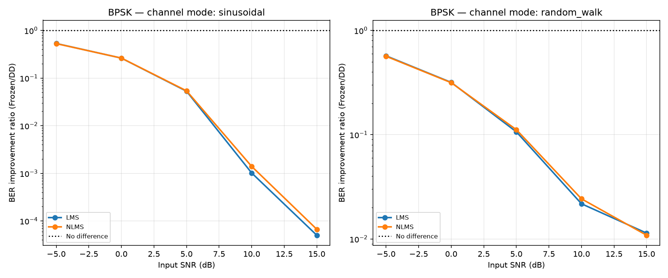
Figure : Frozen vs. Decision-Directed, BPSK, time-varying channel
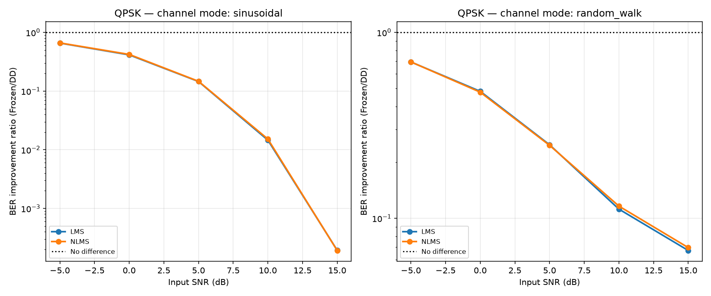
Figure : Frozen vs. Decision-Directed, QPSK, time-varying channel

7. Case Study 4: Higher-Order Modulation (16-QAM)
Case Study 2 found BPSK and QPSK experience the same ISI channel very differently, attributed to decision-boundary crowding. 16-QAM (16 tightly-packed points) tests whether this keeps sharpening. Implementation self-tested with a zero-noise round-trip (0 bit errors over 20,000 bits) before use — this project's standard practice, which caught a real Gray-mapping bug in a bonus 8-PSK implementation before it could contaminate any result.
Table : SNR and BER results, 16-QAM, Case Study 4
SNR in (dB) | Method | SNR out vs post-ISI ref (dB) | BER (mean±std or exact)
0 | No Processing | 0.01±0.03 | 0.3129±0.0017
0 | LMS | 1.62±0.07 | 0.3561±0.0025
0 | NLMS | 1.61±0.07 | 0.3567±0.0025
0 | CNN | 2.43±0.02 | 0.3089±0.0017
0 | Hybrid | 2.25±0.09 | 0.3159±0.0043
0 | MMSE (Genie) | 2.61±0.03 | 0.3032±0.0015
10 | No Processing | 10.04±0.02 | 0.1318±0.0006
10 | LMS | 5.04±0.05 | 0.1453±0.0030
10 | NLMS | 4.93±0.06 | 0.1526±0.0040
10 | CNN | 6.79±0.01 | 0.0695±0.0009
10 | Hybrid | 6.21±0.06 | 0.0820±0.0019
10 | MMSE (Genie) | 7.00±0.02 | 0.1412±0.0008
20 | No Processing | 20.07±0.03 | 0.0814±0.0006
20 | LMS | 7.93±0.06 | 4.48e-04±2.3e-05
20 | NLMS | 7.62±0.08 | 0.0012±0.0001
20 | CNN | 8.61±0.01 | 1.56e-04±3.4e-05
20 | Hybrid | 8.60±0.06 | 6.98e-04±6.8e-05
20 | MMSE (Genie) | 8.59±0.01 | 0.1097±0.0012
25 | No Processing | 25.04±0.01 | 0.0768±0.0006
25 | LMS | 8.49±0.05 | 1.60e-04±3.6e-05
25 | NLMS | 8.32±0.06 | 1.26e-04±2.1e-05
25 | CNN | 8.80±0.01 | 1.38e-04±2.8e-05
25 | Hybrid | 8.95±0.04 | 2.88e-04±1.6e-05
25 | MMSE (Genie) | 8.75±0.01 | 0.1077±0.0014
30 | No Processing | 30.04±0.02 | 0.0755±0.0007
30 | LMS | 8.71±0.03 | 1.58e-04±3.5e-05
30 | NLMS | 8.62±0.03 | 1.26e-04±1.0e-05
30 | CNN | 8.85±0.01 | 1.36e-04±2.7e-05
30 | Hybrid | 9.06±0.02 | 2.70e-04±1.3e-05
30 | MMSE (Genie) | 8.80±0.01 | 0.1067±0.0014

BER Improvement Ratio Comparison
Table : BER improvement ratio vs. No-Processing, by modulation
Method | BPSK best (§4.6) | QPSK best (§4.6) | 16-QAM (this study)
LMS | never wins (≤0.7x) | 31.5x (15dB) | break-even at 0dB, 480x at 25dB
NLMS | never wins | 43.0x (15dB) | break-even at 0dB, 610x at 25dB
CNN | 1.8x (10dB, best) | 473x (15dB) | 557x at 25dB

Confirmed, more dramatically than expected: equalization wins by up to 610x for 16-QAM, versus QPSK's 473x. But the mechanism is richer than just “a bigger ratio.”
- No-Processing hits a genuinely new, hard BER floor (0.0755-0.0814 from 20-30dB) — never seen for BPSK or QPSK — deterministic ISI alone is enough to permanently cross 16-QAM's tight margins regardless of noise level.
- The genie MMSE linear equalizer becomes actively WORSE than doing nothing at high SNR (0.71-0.74x) — a sharper version of Section 4.7's linear-equalizer-ceiling finding, severe enough here to become an outright regression rather than a curiosity.
Full detail: report/findings_higher_order_modulation.md.

Figures
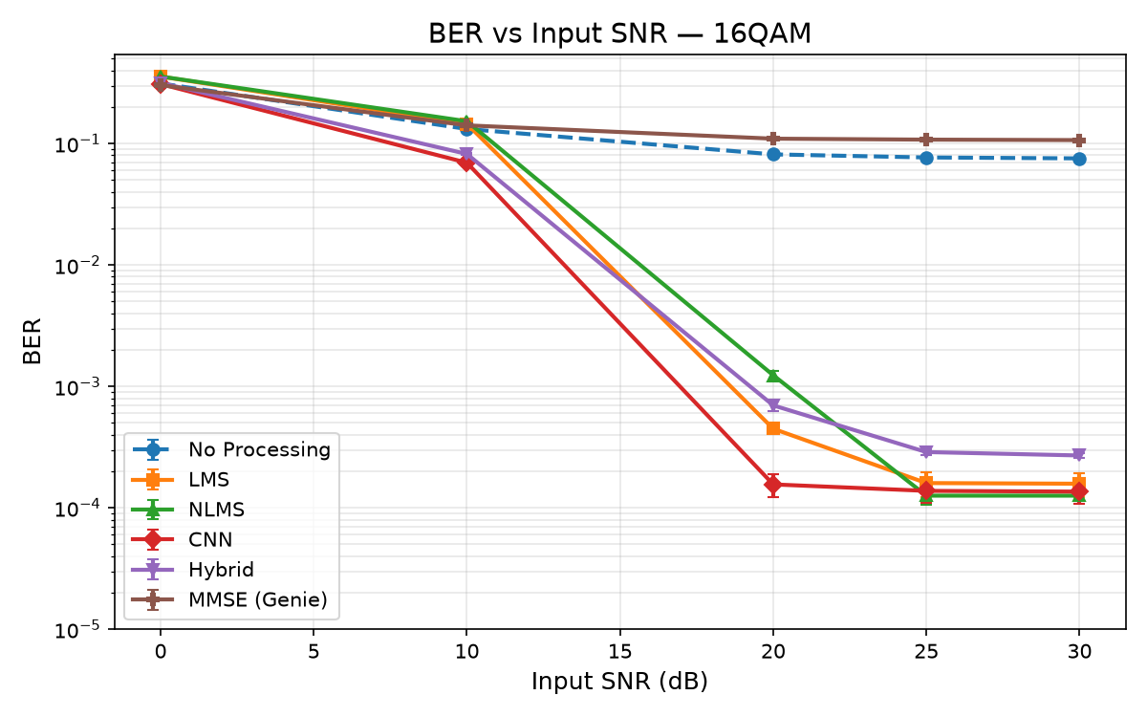
Figure : BER vs Input SNR, 16-QAM
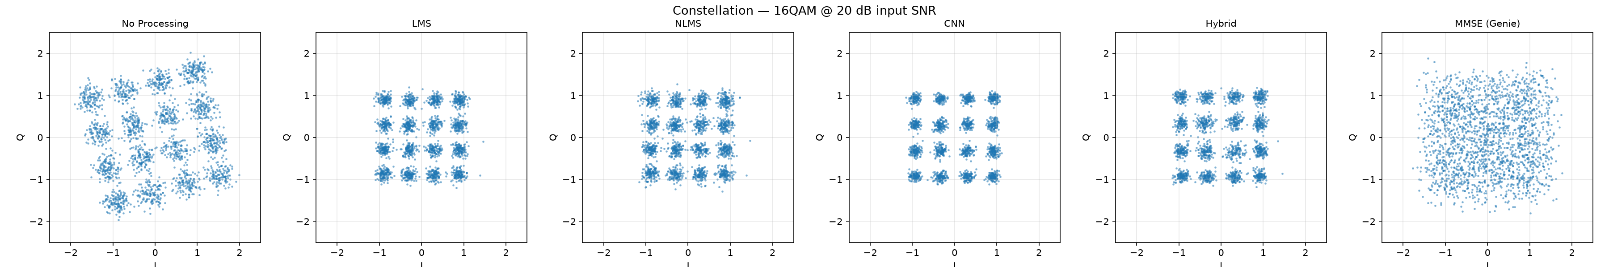
Figure : Received constellation, 16-QAM
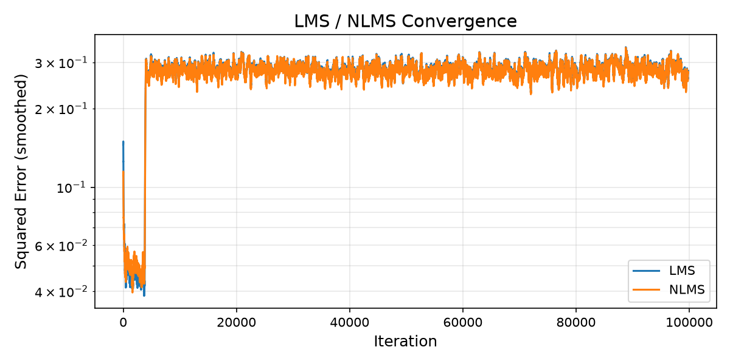
Figure : Adaptive filter convergence, 16-QAM

8. Compute-Cost Analysis: When Is CNN Actually Worth It?
Every comparison above is BER/SNR-only, plus a runtime_sec_mean column that measures this specific software implementation's wall-clock speed — not a hardware-portable answer to how much compute each method fundamentally needs.
Table : Compute cost by method: state size, MACs/sample, and relative cost vs. LMS
Method | State size | Real MACs/sample (window-norm.) | Real MACs/sample (stride-honest) | Relative MAC cost vs LMS
LMS | 16 taps | 64.0 | 64.0 | 1.0×
NLMS | 16 taps | 64.0 | 64.0 | 1.0× (+1 div/sample)
MMSE (Genie) | 16 taps | 64.0 | 64.0 | 1.0× (+ one-time design solve)
CNN | 6,890 params | 6,784.0 | 13,568.0 | 106.0× (up to 212×)
Hybrid | 6,906 | 6,848.0 | 13,632.0 | 107.0×

CNN needs ~106-212x more raw arithmetic per sample than LMS/NLMS/MMSE, yet is FASTER in wall-clock terms on this project's CPU — because LMS/NLMS are pure per-sample Python loops (interpreter overhead dwarfs the actual 64 MACs of useful work), while CNN inference is vectorized, BLAS-backed TensorFlow. This is an implementation-efficiency finding, not an algorithmic-complexity one — dedicated hardware (FPGA/DSP/MCU) would see the 106-212x MAC gap reassert itself as a real throughput requirement.
Concrete decision rule: 64-640 MMACs/s (LMS/NLMS/MMSE) fits comfortably on a basic Cortex-M4/M7-class microcontroller; 6.8-136 GMACs/s (CNN) does not — it needs an applications processor, DSP, or NPU (roughly 20-500x beyond MCU-class throughput). On a bare microcontroller, or with BPSK/no-ISI, CNN is not worth deploying. On a platform with multi-GMACs/s-to-TOPS-class headroom, and a channel with real, modulation-sensitive ISI structure (QPSK or 16-QAM here), CNN's compute multiplier buys a large, measured BER improvement that is a good trade for most platforms above the microcontroller tier. Full derivation: report/compute_cost.md.

9. Cross-Case-Study Discussion
Case Study 1 and Case Study 2 differ in exactly one variable (the channel), and reach opposite conclusions about whether denoising/equalization helps BER. Neither result is “the answer” in isolation — together they establish that the value of adaptive filtering or learned denoising for BER is conditional on the channel actually having structure to exploit. Case Study 4 shows this isn't a two-point BPSK/QPSK curiosity but a continuing trend: 16-QAM's tighter margins push the effect further in the same direction on both ends.
The SNR-vs-BER disconnect recurs three times via three different mechanisms: boundary-blind MSE training (Case Study 1), structured non-Gaussian residual dragging down an average SNR metric (Case Study 2, CNN), and phase-structured residual error from a linear equalizer's noise-enhancement/residual-ISI tradeoff (the genie MMSE bound). One repeated lesson: an aggregate SNR or MSE number should not be trusted as a BER proxy without checking the actual decision-margin distribution.
Case Study 3 revises how this project talks about its most load-bearing design decision: freezing LMS/NLMS after the preamble is still right, but the justification on record was broader than what was actually verified, and testing it surfaced a fourth bug that had been masking a separate, real incompatibility. “We tested it and it works” claims need to specify exactly what was tested.
Taken together, this project's four case studies plus three connecting analyses form a coherent structure in which each new question was generated directly by a gap in a previous result, rather than chosen in advance — arguably the more defensible way to scope an open-ended comparative study.

10. Conclusions
- SNR improvement does not imply BER improvement, and the relationship between them is channel-dependent, not universal — the headline finding of this project. Its corollary: even within one channel regime, an aggregate SNR/MSE metric can misrepresent BER for structural reasons distinct from the cross-channel finding.
- Classical adaptive filters (LMS/NLMS) are prone to real, verifiable instabilities that require deliberate diagnosis and fixing, not just parameter tuning.
- CNN-based denoising outperforms classical filtering once channel structure exists to exploit, but can be actively harmful on a structureless channel — the same architecture, opposite outcomes, purely as a function of the channel.
- The Hybrid cascade's underperformance in Case Study 1 was mostly an artifact of LMS's divergence bug; once fixed, Hybrid is competitive with standalone CNN in Case Study 2.
- Rigorous small-sample-size handling (Monte Carlo averaging, rule-of-three bounds, significance testing) materially changed which findings survived scrutiny and should be standard practice.
- Definitional identities are a cheap, powerful bug-finder — all three Case Study 2 bugs, plus the fourth found in Case Study 3, were caught by knowing what a value must equal by definition.
- A regression test suite (tests/, 35 tests) now codifies every invariant found this way.
- A design decision's stated justification can be narrower, or broader, than what was actually verified — only testing the untested case reveals which (Case Study 3).
- A mechanistic explanation is only as strong as the experiment that tests it — the boundary-aware-loss follow-up turned one explanatory sentence into three separately-evidenced sub-claims.
- Decision-boundary crowding is a continuum, not a BPSK/QPSK-specific curiosity — 16-QAM is the sharpest point on it tested so far, both for equalization's benefit and the linear-equalizer ceiling's cost.
- Compute cost and BER cost do not move together, and both need to be reported — CNN's 106-212x compute multiplier is invisible in this project's own wall-clock numbers, which would mislead anyone judging real-hardware feasibility from them alone.

11. Assumptions, Limitations, and Future Work
- Single static multipath channel in Case Study 2's main run — partially addressed by the severity sweep (varies magnitude, not delay spread or tap count).
- LMS/NLMS use one fixed μ across the entire SNR sweep; the residual ~0.2-0.3dB SNR shortfall at high SNR in Case Study 1 is a direct, quantifiable consequence.
- The theoretical Q-function BER curve is valid for Case Study 1 but has been removed (not just captioned) from Case Study 2's figures, since it is not a bound there.
- The genie MMSE equalizer is a linear, symbol-spaced reference bound, not a universal ceiling — Case Study 4 shows this ceiling gets more consequential, not less, as constellation crowding increases.
- The decision-directed reliability gate is dead code for any SPS>1 signal — affects every experiment using pulse shaping, all of which use the (unaffected-in-practice) default enable_decision_directed=False.
- The boundary-aware-loss and 16-QAM follow-ups were run at reduced scale for speed — treat their exact numbers as indicative, at the same standard as the severity sweep.

Named, Scoped-Out Future Work
Two items from the original future-work list have since been addressed and are marked accordingly; each surfaced new, more specific follow-ups of its own.
- RLS as a third classical baseline (src/rls_filter.py exists, unused) — ISI is exactly the regime where RLS's faster convergence over LMS/NLMS should show a real edge.
- MLSE/Viterbi equalization — the classical gold-standard for ISI channels.
- DONE (Case Study 3) — a genuinely time-varying channel. New follow-ups: fix the DD update rule for SPS>1; root-cause the LMS-vs-NLMS tracking asymmetry; re-run the flat-fading control at SPS=4 once the fix exists.
- DONE for 16-QAM (Case Study 4) — a working, self-tested 8-PSK implementation exists but wasn't run through the full pipeline; also open: root-causing 16-QAM's hard No-Processing floor and MMSE regression more precisely.
- Root-cause the loss-independent high-SNR error floor found in the boundary-aware-loss follow-up (plain-MSE and boundary-hinge CNNs produce identical error counts at 10-20dB).
- Multiple independent training draws — Monte Carlo trials vary test noise/bits; the CNN/LMS/Hybrid models were each trained exactly once per modulation per case study.
- Cycle-accurate hardware validation of the compute-cost analysis — the MAC-count-based throughput requirements were not validated against an actual microcontroller, DSP, or NPU.

Appendix: Project Structure & Regression Test Suite
A 35-test regression suite (tests/, ~25s to run) codifies every invariant discovered during this project:
- test_lms_stability.py — LMS/NLMS never diverge below No-Processing; DD mode off by default.
- test_receiver_frontend.py — matched filter recovers unit gain; No-Processing's SNR matches nominal (the identity that caught two of the three Case Study 2 bugs).
- test_channel.py — add_multipath is a true identity and causal (the identity that caught the third bug).
- test_mmse_equalizer.py — genie MMSE never loses to No-Processing.
- test_no_leakage.py — no train/test bit-sequence collisions.
- test_metrics.py — BER/error-count consistency, rule-of-three sanity.
Every experiment referenced in this report lives as a standalone Python script under experiments/ (e.g. run_case1_no_isi.py, run_case2_isi.py, run_severity_sweep.py, run_timevarying_channel.py, run_16qam_comparison.py, run_case1_boundary_loss.py, compute_cost_analysis.py), with shared logic in src/ (signal_gen.py, channel.py, lms_filter.py, nlms_filter.py, mmse_equalizer.py, utils.py, metrics.py) and a CNN-specific module (cnn_boundary_aware.py). Raw results are stored as CSVs under results/tables/ and figures under results/figures/, organized by case study. This report is the complete, self-contained writeup of that codebase's methodology, results, and conclusions.

