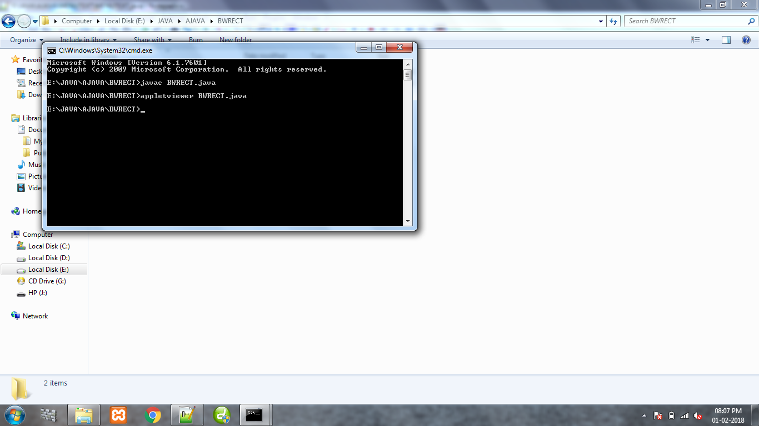

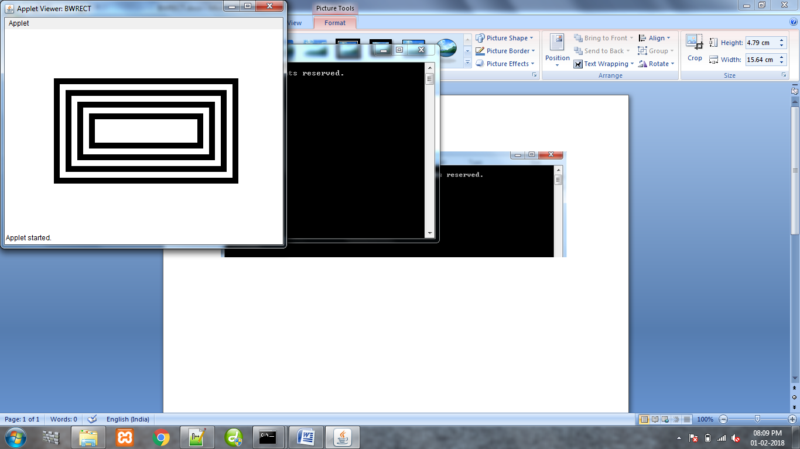

/\*Practical 10: Develop a program that draws two sets of ever-decreasing rectangles one in outline form and one filled alternately in black and white\*/

/\*

<applet code="BWRECT" height="345" width="475"></applet>

\*/

import java.applet.\*;

import java.awt.\*;

public class BWRECT extends Applet

{

public void paint(Graphics g)

{

int x=74,y=74;

int w=335,h=200;

for(int i=1;i<=8;i++)

{

x=x+10;

y=y+10;

w=w-20;

h=h-20;

if((i%2)==0)

{

g.setColor(Color.white);

}

else

{

g.setColor(Color.black);

}

g.fillRect(x,y,w,h);

}

}

}