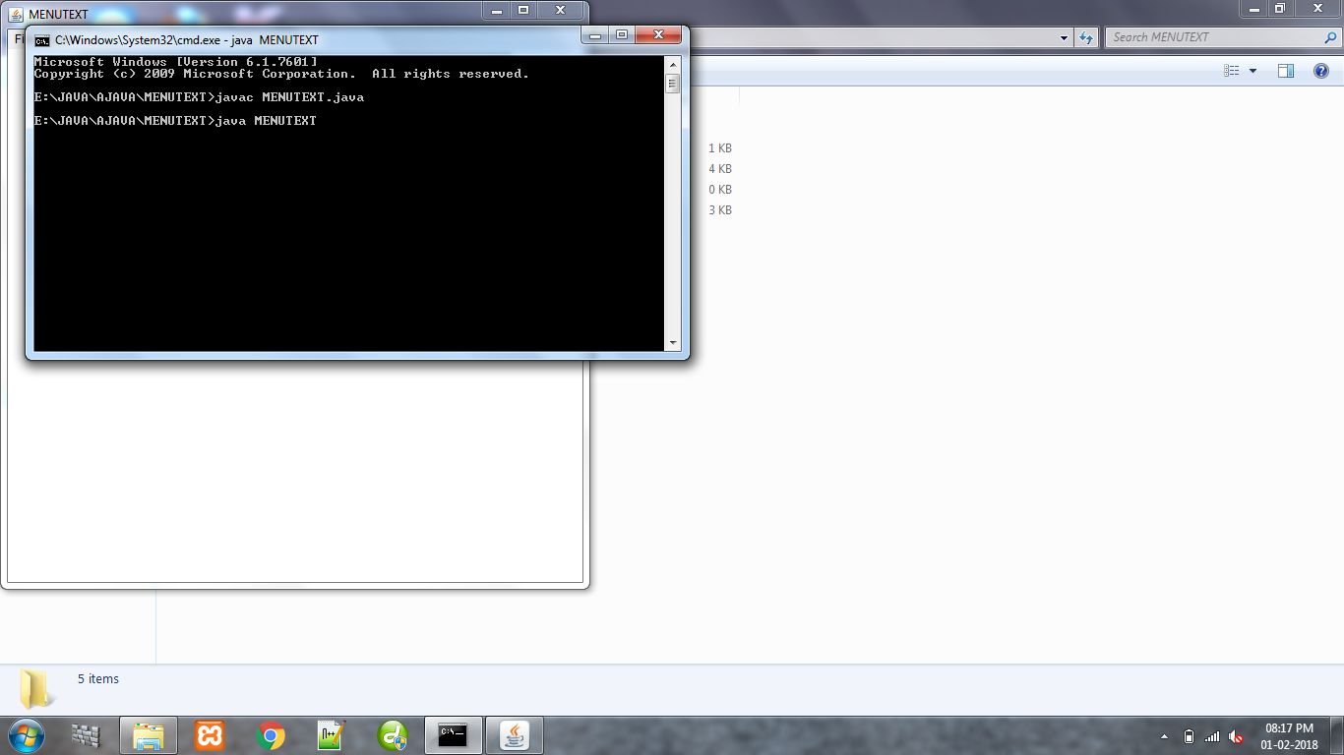

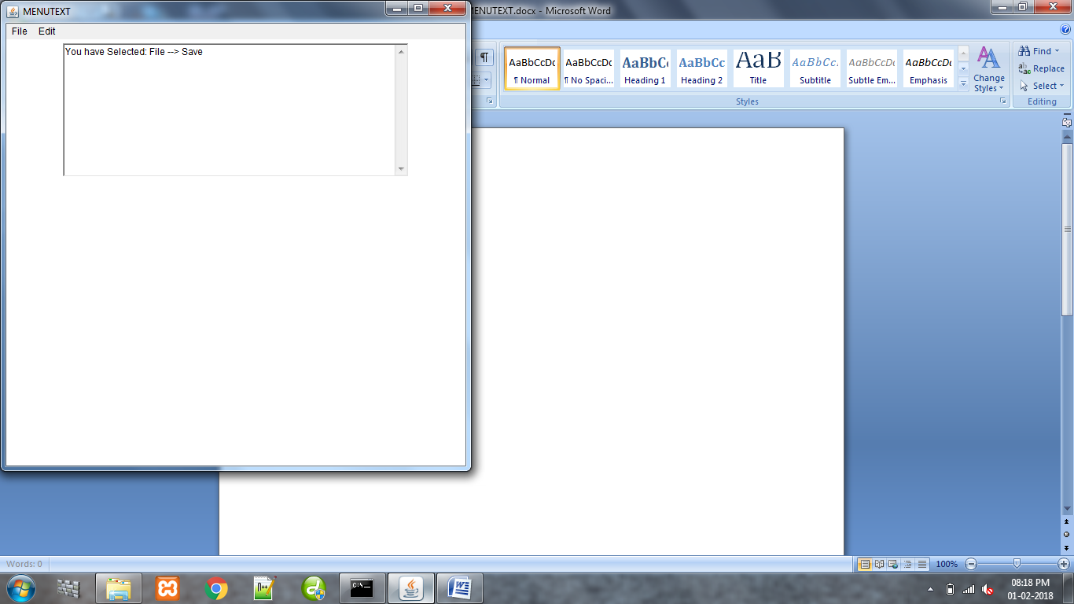

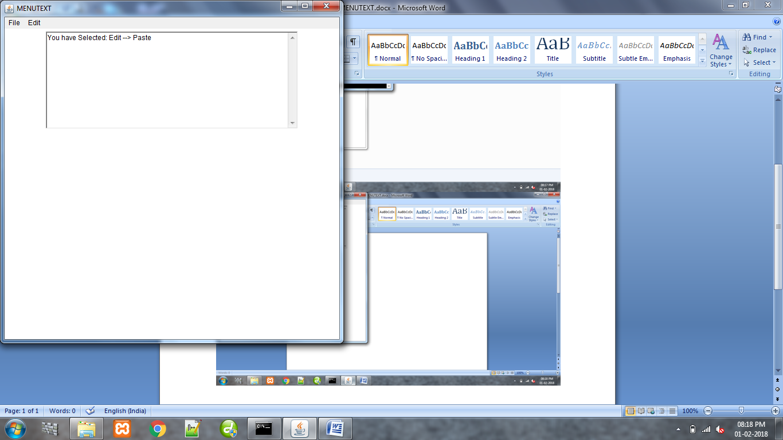

/\*Practical 9: Create an application that displays a frame with a menu bar. When a user selects any menu or menu item,

display that selection on a text area in the center of the frame\*/

import java.awt.\*;

import java.awt.event.\*;

public class MENUTEXT extends Frame implements ActionListener

{

MenuBar mb=new MenuBar();

Menu mFile=new Menu("File");

Menu mEdit=new Menu("Edit");

MenuItem miNew=new MenuItem("New");

MenuItem miOpen=new MenuItem("Open");

MenuItem miSave=new MenuItem("Save");

MenuItem miSaveAs=new MenuItem("Save As");

MenuItem miPrint=new MenuItem("Print");

MenuItem miQuit=new MenuItem("Quit");

MenuItem miUndo=new MenuItem("Undo");

MenuItem miRedo=new MenuItem("Redo");

MenuItem miCut=new MenuItem("Cut");

MenuItem miCopy=new MenuItem("Copy");

MenuItem miPaste=new MenuItem("Paste");

MenuItem miDelete=new MenuItem("Delete");

TextArea txt=new TextArea();

String msg;

public MENUTEXT()

{

addWindowListener(new WindowAdapter()

{

public void windowClosing(WindowEvent we)

{

dispose();

}

});

setSize(600,600);

setTitle("MENUTEXT");

setLayout(new FlowLayout());

this.setMenuBar(mb);

mb.add(mFile);

mb.add(mEdit);

mFile.add(miNew);

mFile.add(miOpen);

mFile.add(miSave);

mFile.add(miSaveAs);

mFile.add(miPrint);

mFile.add(miQuit);

mEdit.add(miUndo);

mEdit.add(miRedo);

mEdit.add(miCut);

mEdit.add(miCopy);

mEdit.add(miPaste);

mEdit.add(miDelete);

mFile.addActionListener(this);

mEdit.addActionListener(this);

miNew.addActionListener(this);

miOpen.addActionListener(this);

miSave.addActionListener(this);

miSaveAs.addActionListener(this);

miPrint.addActionListener(this);

miQuit.addActionListener(this);

miUndo.addActionListener(this);

miRedo.addActionListener(this);

miCut.addActionListener(this);

miCopy.addActionListener(this);

miPaste.addActionListener(this);

miDelete.addActionListener(this);

add(txt);

setVisible(true);

}

public void actionPerformed(ActionEvent ae)

{

//Here MenuComponent is used to get the menu from which the menuItem is clicked,getSource will return the Object that is clicked which is converted to MenuComponent

MenuComponent cp=(MenuComponent)ae.getSource();

//Then here it will return the Menu, getParent will return the MenuContainer which is converted to menu

Menu m1=(Menu)cp.getParent();

if(m1 instanceof Menu)

{

msg = "You have Selected: "+m1.getLabel()+" --> ";//Then that menu object is used here to get the label of the menu

txt.setText(msg+ae.getActionCommand());

}

}

public static void main(String args[])

{

new MENUTEXT();

}

}